Plastic Water-Filled

Longitudinal Barriers

versus

Longitudinal Channelizing Barricades

-Warning Label Guidelines -

Background – The highways in the United States are seeing increased use of plastic water-filled devices that can be pinned together to form continuous “wall-like” structures that separates one area from another. These pinned together devices are used to guide vehicles or pedestrians or to separate one area from another (i.e. – temporary work zones from traffic). Some of these devices are designed to act as positive longitudinal barriers and, as such, have the strength to prevent errant vehicles from penetrating though. These positive water-filled barriers are rated to prevent passenger vehicle penetration at different impact severity levels, as defined by the testing guidelines in NCHRP 350 where the impact speeds are either 50, 70 or 100 km/h and the impact angle is 25 degrees. Some versions of these plastic water-filled devices, when pinned together, simply serve as visual guides and are NOT intended to prevent vehicle penetration. The devices that allow vehicle penetration are referred to as plastic water-filled longitudinal channelizing barricades, or LCBs. The key point to remember is that barriers tend to be strong to control vehicle penetration and barricades (LCBs) tend to be weak and do allow vehicle penetration.

Problem – In the field, some end-users of these devices do not clearly understand the dramatic difference in impact performance between plastic water-filled barriers versus barricades (LCBs). Another concern is that some longitudinal barriers are rated to prevent vehicle penetration at high impact speeds (100 km/h) while others can only prevent penetration at lower speeds (50 or 70 km/h). Because the plastic parts for these two distinct devices are frequently pulled from the same molds, many longitudinal barriers look exactly like their weaker cousins, the barricades (LCBs). The only distinguishing feature between these barriers and barricades (LCBs) may be added steel components or the use of stronger plastic. Because end-users may not clearly understand the performance characteristic of the device they are using, workers or pedestrians may be unintentionally exposed to unsafe conditions. There needs to be an accepted method that can be used by all manufactures to clearly distinguish the performance rating of their plastic water-filled device to distinguish their barriers from their barricades (LCBs).

Solution – The primary problem, as outlined above, is the possible unintentional application of weaker longitudinal devices at sites where stronger versions were intended. It should be noted that there are usually no adverse consequences when (stronger) barriers are used in weaker barricade applications. There is a need to educate end-users about the performance of the device they are installing. Currently manufactures include important product performance information in manuals shipped with their devices. Unfortunately, manuals sometimes do not make it to the field and thus are never seen by end-users. To overcome these concerns the recommended solution is to attach a warning/educational label to each device.

Warning/Educational Label Recommendations:

As outlined above, manufacturers of longitudinal plastic water-filled devices need to affix labels to their devices that warn and educate end-users as to their proper use and performance. The warning label should comply with the following requirements:

- Must following the “Warning” guidelines in ANSI Z535 and should consider the recommendations in ISO 3864 relative to graphics. The key objective of the warning label, as defined by ANSI Z535 (see attached Appendix A and B) is; “A product safety sign or label should alert persons to a specific hazard, the degree or level of hazard seriousness, the probable consequence of involvement with the hazard, and how the hazard can be avoided.”
- Must include a recognizable graphic showing the possible consequences if the device is not used properly. Thus, for longitudinal channelizing barricades (LCBs), a graphic needs to be included that depicts possible vehicle penetration through the device, see possible example in Figure 1.
- If necessary because of visual similarity, the label must include verbiage that indicates how an end-user can distinguish barrier versions of the product from barricade versions.
- Must include verbiage that warns end-users NOT to use longitudinal barricades in applications where barriers are warranted (i.e. – high speed applications, WZs were workers or rigid objects could be struck by errant vehicles)
- Either on this label, or a separate one, include verbiage that follows ATSSA’s recommendations for labeling Work Zone devices.
- If a stick-on decal is used, the decal material as well as the adhesive must be selected so that they will last as long as the product.
- The verbiage on the decal needs to be concise, but accurate in terms of use and warnings.
- The warning label needs to be placed on the product in a location where it is readily visible.
- The verbiage used on the label should use common, establish highway safety nomenclature.
- Devices that meet NCHRP 350 Test Level (TL) 3, which are rated to prevent vehicle penetrations when impacted at 100 km/h at 25 degrees, will NOT require a warning label. However, IF versions of the device are available that prevent vehicle penetrations only at reduced speeds (i.e. – speeds less than TL-2 = 70 km/h or TL-1 = 50 km/h), then these devices need to be labeled to warn end users of this impact speed limitation.

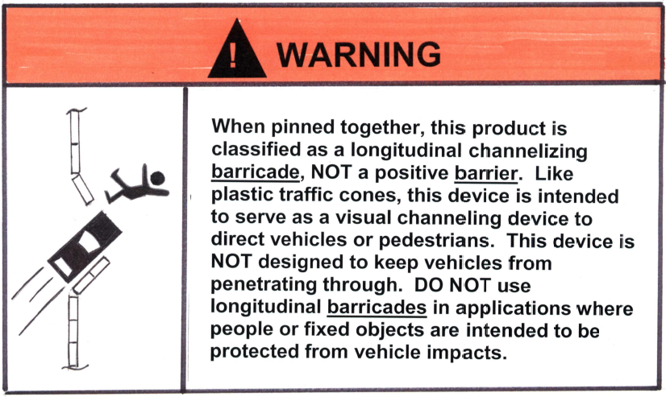

Figure 1 – Example of a possible Plastic Water-Filled Longitudinal
Channelizing Barricade Decal

- Appendix A -
ANSI Z535.4
The American National Standard Institute (ANSI) is the organization responsible for publishing the ANSI Z535 series of standards. The ANSI Z535.4 Standard, titled Product Safety Signs and Labels, defines the content for a safety label.
“A product safety sign or label should alert persons to a specific hazard, the degree or level of hazard seriousness, the probable consequence of involvement with the hazard, and how the hazard can be avoided.”
ANSI Z535.4-1998
The Signal Word communicates the degree or level of hazard seriousness. The other three components: the specific hazard, the probable consequence of involvement with the hazard, and how the hazard can be avoided are communicated through the word message and the use of a pictorial.

Signal Word
The ANSI Z535.4 standard (section 4) contains the following Signal Word definitions:

"DANGER indicates an imminently hazardous situation which, if not avoided, will result in death or serious injury. This signal word is to be limited to the most extreme situations.

WARNING indicates a potentially hazardous situation which, if not avoided, could result in death or serious injury.

CAUTION indicates a potentially hazardous situation which, if not avoided, may result in minor or moderate injury. It may also be used to alert against unsafe practices."
The signal word’s colored background, in accordance with ANSI Z535.1 (Safety Color Code), in combination with the signal word, communicates the seriousness level of the hazard.
The other three components: the specific hazard, the probable consequence of involvement with the hazard, and how the hazard can be avoided are communicated through the word message and a pictorial.
A pictorial is used to communicate a message across language barriers. It is also a quick, attention getting form of communication. There are two distinct formats for the pictorial, a standard graphic, or a graphic formatted to the ISO 3864 standard.

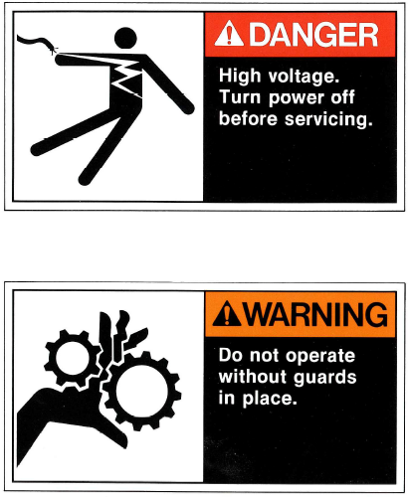
Examples of Product Safety Labels meeting ANSI Z535

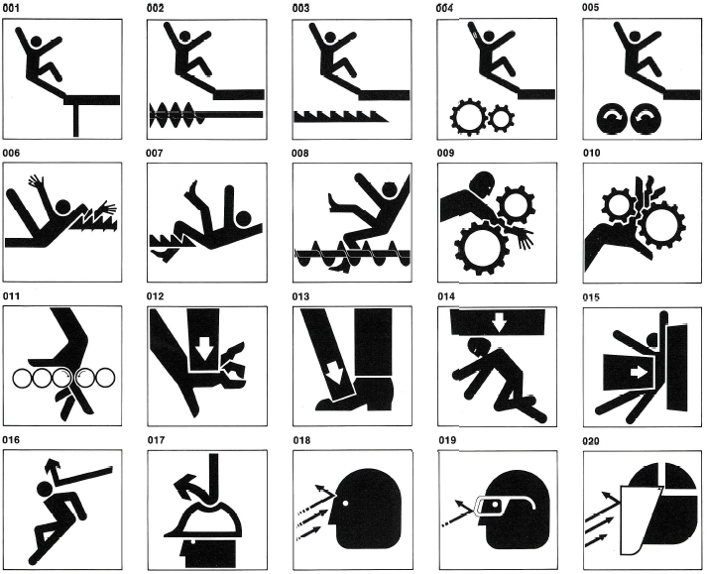

Examples of Product Safety Label Graphics meeting ANSI Z535

- Appendix B -

ISO 3864 - Safety Colors and Safety Signs
The International Standards Organization (ISO) is responsible for publishing the international standard ISO 3864 - Safety Colors and Safety Signs. The standard defines the design criteria for international safety signs. Contained in the standard are three sign formats pertaining to equipment manufacturers:

 | Warning Signs - Identify the Hazard  Electric Shock Hazard
  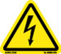
 | Mandatory Action Signs - Communicates an action to be taken to avoid the hazard.  Wear Protective Gloves
  
 | Prohibition Symbols - Define Prohibitive Actions  No Pacemakers
  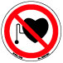

Predominately used internationally, the graphic-only approach communicates the safety label’s message quickly and without the use of words. This is the preferred format in the European community due to the concentration of diverse languages.

