TASK FORCE 13, SARASOTA, FLORIDA
WORK ZONE HARDWARE, SUBCOMMITTEE NO. 6
MAY 11, 2006 LIDO ROOM

CO-CHAIRS: BARRY STEPHENS & PAUL FOSSIER

MINUTES

- Barry Stephens facilitated the meeting with Paul Fossier acting as the recording secretary.
- An attendance roster was routed. Contact Barry Stephens at bstephens@energyabsorption.com if interested in receiving a copy.
- The mission statement for the WZ Subcommittee was briefly reviewed. The mission is to:
- Provide support for the National WZ Clearinghouse website maintained by TTI (http://wzsafety.tamu.edu/ ) which is used as a depository for information and provides links to highway work zone hardware.
- Propose standards be written for WZ devises when justified.
- Provide a forum to express concerns and views pertaining to WZ devices.
- Provide a forum to review new WZ hardware proposed for addition to the web-based Roadside Hardware Guide.
- Briefly reviewed minutes from September 19, 2005 meeting in Perdido Beach, Alabama.
- Reviewed the planned procedures to update the new web-based Hardware Design Guide, which includes both proprietary and non-proprietary devices. (This was reviewed in more detail during the whole-group session led by Will Longstreet.) The “Technical Representatives” for the four (4) main categories were mentioned;
- Guardrails/median barriers (+components) – Karla Polivka (kpolivka2@unl.edu )
- Crash Cushions – John LaTurner (jlaturner@etechtesting.com )
- Terminals – Chad Heimbecker (webadmin@guardrails.com )
- Work Zone Devices – Barry Stephens (bstephens@energyabsorption.com )
- Nick Artimovich, FHWA, gave a brief verbal refresher on:
- Work Zone devices, Categories 1,2, 3, and 4:
  - Category 1 WZ devices – small, lightweight channelizing and delineating devices (without lights)
  - Category 2 WZ devices – devices not expected to produce significant change in vehicle velocity when struck, but may otherwise be hazardous. Includes portable sign stands, Type I , II and III barricades , cones and vertical panels with lights.
  - Category 3 WZ devices – devices that will cause significant vehicle velocity change when struck. Includes crash cushions, end terminals, barriers, fix sign supports, TMAs etc. Must be tested to NCHRP 350.
  - Category 4 WZ devices – a subset of Category 3. Includes portable devices such as trailer-mounted arrow panels , changeable message signs, etc.
- Barricades Types I, II and III – see MUTCD for definitions

- NCHRP 350 devices meeting test levels 1, 2, and 3:
  - TL-1 – tested to NCHRP 350 at 50 km/h
  - TL-2 – tested to NCHRP 350 at 70 km/h
  - TL-3 – tested to NCHRP 350 at 100 km/h
- Nick also briefly mention the confusion caused by the above similar nomenclature

- Discussion on Plastic Water-filled Barriers vs. Channelizing Barricades, with focus on standardization of Warning labels:
    - Discussed the terminology for these devices;
- Barriers – prevent vehicle penetration per NCHRP 350 at defined test levels (TL-1 = 50 km/h, TL-2 = 70 km/h, and TL-3 – 100 km/h)
- Channelizing Barricades – act as visual channelizers but do NOT prevent vehicle penetration through the device.
- These definitions will likely receive further refinement by other committees reviewing these devices.
- Barry mentioned that he’s aware of at least one manufacturer who has requested that pinned, low-profile plastic “curbs” be classified as longitudinal channelizers. This will require further discussion by the National Committee on Uniform Traffic Control Devices.
    - Discussed the problems associated with the application of these devices. Several slides were shown depicting plastic water-filled barriers versus channelizing barricades. The principle concerns mentioned, especially those associated with the use of channelizing barricades, were 1) the misapplication of these products in highway environments 2) potentially creating a false sense of security for workers working behind them 3) inadequate shielding the motoring public from rigid hazards behind these devices 4) use of barriers at high-speed sights when they only prevent vehicle penetrations at low impact speeds and 5) inadequate use of labels on these products to educate and warn end-users as to their proper versus improper use.
    - It was mentioned that four groups were reviewing concerns pertaining to these devices:
- TF-13, Subcommittee on WZ Devices – focusing on terminology and standardization of warning labels
- ATTSA committee on Temporary Traffic Control Devices – focusing on labeling, terminology and use-warrants
- ATTSA Guardrail Committee – interest may be minor
- National Committee on Uniform Traffic Control Devices – focusing on adding information on these devices into the MUTCD
- It was agreed that recommendations developed by our WZ Subcommittee needed to be forwarded to the chairs of these other groups.
    - The key points regarding use of warning labels from the last meeting were presented:
- Adhesion of the label to the product - needs to last the life of the product
- Durability of the label - needs to last the life of the product
- Readability of the label - needs to be concise, but accurate in terms of use and warnings
- Location on the label on the product - needs to be readily visible and accessible for reading
- Verbiage on the label for multi-use products - some devices can be retrofitted to elevate performance from a channelizing barricade to a barrier by attaching extra hardware. The wording on the decal needs to address this.
- Standard wording for the labels - manufacturers of these devices should use common nomenclature recognized in the highway environment.
    - Warning label discussions were then continued –
- Since the last meeting, two manufacturers of these devices, Energy Absorption Systems, Inc. and Yodock Inc. attempted to develop universal warning label verbiage that could be used by all manufacturers. They reported that this attempt had to be abandoned because there are too many product variables that would influence the final verbiage (i.e. – some devices use steel reinforcement and some rely only on plastic, some are tested as barriers at high speeds and some only at low speeds, some have steel on the inside and some on the outside, some can be retrofitted from barricades to a barriers by adding steel beams but others can not, etc.).
- Due to above issues, it was instead recommended to develop “Warning Label Guidelines” for these devices. Using this Guide, different manufacturers could develop their own warning label verbiage, yet there would be common elements to each. An initial draft of these Guidelines was presented to the Subcommittee. The key Guideline points are;
- Must following the “Warning” guidelines in ANSI Z535 and should consider the recommendations in ISO 3864 relative to graphics. The key objective of the warning label, as defined by ANSI Z535 (see attached Appendix A and B) is; “A product safety sign or label should alert persons to a specific hazard, the degree or level of hazard seriousness, the probable consequence of involvement with the hazard, and how the hazard can be avoided.”
- Must include a recognizable graphic showing the possible consequences if the device is not used properly. Thus, for longitudinal channelizing barricades (LCBs), a graphic needs to be included that depicts possible vehicle penetration through the device.
- If necessary because of visual similarity, the label must include verbiage that indicates how an end-user can distinguish barrier versions of the product from barricade versions.
- Must include verbiage that warns end-users NOT to use longitudinal channelizing barricades in applications where barriers are warranted (i.e. – high speed applications, WZs were workers or rigid objects could be struck by errant vehicles)
- Either on this label, or a separate one, include verbiage that follows ATSSA’s recommendations for labeling Work Zone devices.
- If a stick-on decal is used, the decal material as well as the adhesive should be selected so that they will last as long as the product.
- The verbiage on the decal needs to be concise, but accurate in terms of use and warnings.
- The warning label needs to be placed on the product in a location where it is readily visible.
- The verbiage used on the label should use common, establish highway safety nomenclature.
- Devices that meet NCHRP 350 Test Level (TL) 3, which are rated to prevent vehicle penetrations when impacted at 100 km/h at 25 degrees, will NOT require a warning label. However, IF versions of the device are available that prevent vehicle penetrations only at reduced speeds (i.e. – speeds less than TL-2 = 70 km/h or TL-1 = 50 km/h), then these devices need to be labeled to warn end users of this impact speed limitation.
- The comments from the attendees were favorable. It was agreed that this draft would be routed for comments and edits. If interested in receiving a copy please contact Barry Stephens at bstephens@energyabsorption.com .
- A sample Warning label, following the draft of the Warning Label Guidelines, was presented as an example:
Orange

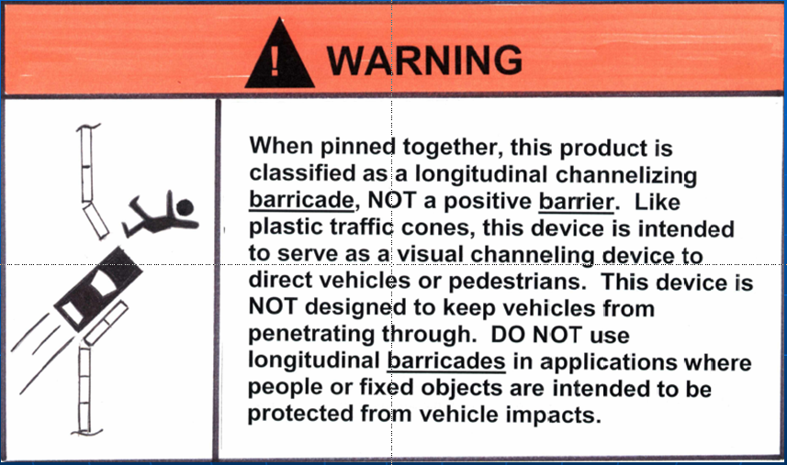

    - A question was asked about the possibility of molding warning label verbiage into the plastic instead of using a decal (decals can be tough to make stick to polyethylene and/or textured plastic). Leo Yodock responded that molded-in verbiage is very hard to see and thus the information would not stand out to end users. To meet ANZI Z535, the decals must incorporate defined graphics and colors, thus negating the possibility of using a single color. Leo indicated that his company is working with a vendor to develop a decal for his products that would meet the proposed guidelines. He indicated that when it’s done, he would be willing to share it with the attendees, with the understanding that it would not be precisely copied. When available, Barry will email the example of the warning label to the attendees.
    - Barry will collate suggested improvements into the Warning Label Guidelines and present a final version for vote during the next TF-13 meeting in Toronto.

- One of the action items from the last meeting was to contact Dean Sicking, the principle investigator for the update of NCHRP 350, and have him include testing verbiage for longitudinal channelizing devices. Barry reported that this task was completed. Nick Artimovich needs to review the verbiage in the re-write to make sure it accurately reflects the desired tests(s).

- Question was asked about what “linked” barrier means. Nick Artimovich stated that WZ devices can be connected together, but doing so does not necessarily make them barriers (i.e. – cones connected together with rope). A barrier is a device that can control vehicle penetration. Barriers are connected, or linked, together with structurally adequate joints that are strong enough to prevent vehicle penetration through the device.

- Old topics from previous meeting:

  - Idea for different glare screen colors ---- send to MUTCD. Std. colors for WZ devices ---- no interest. Flat Panel signs vs. round channelizers in WZ –--- Nick says NTPEP is best group to evaluate this, however there tests are for durability. Comment made that many States no longer accepting NTPEP testing. No further action is needed from the Subcommittee on these topics.

  - ADA requirements for channelizing barricades, there are current devices that cover this issue. No further action is needed from the Subcommittee on this topic.

  - Discussed work zone signs on Type III barricades. Mainly heavier wt. signs give problems. Plywood and aluminum give problems. Lights on barricades require firm attachment. No further action is needed from the Subcommittee on this topic.

- New Business:

- General discussion regarding damage to plastic water-filled barriers, when should they be replaced? And, if kept in the system of barriers with some filled and some leaking, will they perform properly. Should this be crash tested? - The manufacturers currently handle maintenance issues for their own products. Several mentioned that the ability of their individual barrier sections to hold water tends to be a clear sign as to their ability to perform properly. Damage to structural steel parts or connecting joints can also be part of the evaluation. It was recommended that manufactures continue to establish maintenance guidelines for their specific product. No further action is needed from the Subcommittee on this topic.

  - Felipe Almanza (TrafFix Devices, Inc.) – Who is responsible for designing sand barrel arrays; designer or vendor? Barry stated that his company frequently helps customers with the array configurations and, if an array meets their engineering requirements, they are willing to take responsibility. It was mentioned that if an array does not perform properly there will always be a potential for the State, the contractor, the distributor, and the manufacturer to get pulled into a lawsuit. It was recognized that manufacturers of these barrels sell loose barrels, so they frequently do not see how they are being applied in the field. It was acknowledged that many states have developed their own sand barrel array standards for different situations. No further action is needed from the Subcommittee on this topic.

  - Barry – TMA’s – it was noted that in the latest version of the 350 rewrite, for testing, developers can select shadow vehicle weights of their own choosing, with weights ranging from 2270 kg (5000 lbs) to infinity (i.e. - shadow truck blocked so it can’t move). Thus, future TMA developers will be able to select whatever maximum weight shadow vehicle they believe their TMA will work successfully with. Their new TMA would then be sold with a warning label recommending not to attach it to shadow trucks having weights more than the selected weight. Several attendees, upon learning of this change in TMA testing criteria stated that this modification would be bad because an impact could shove a light-weight shadow truck forward into workers, on-coming traffic or into rigid hazards. Several attendees stated that it was not a good idea (to use lighter shadow vehicles) because it would lead to admittedly cheaper products, but would expose numerous groups to injuries and liability problems. One attendee mentioned that every time a cheap product is introduced, even with warning labels, contractors tend to gravitate to it without concern for impact performance or safety. The net effect would be that safety will be compromised. The group consensus was to recommend staying with the current fixed 9000 kg shadow truck weight for all new TMAs. Barry pointed out a possible need for a portable attenuating device to protect lighter weight rolling hardware, not shadow vehicles, such as trailer-mounted arrow boards or message boards. Is there a need for a special stand-alone testing category for these? Can a TMA be used here? It was mentioned that the TMA test pass/fail criteria may need to include a new “Exit Box” evaluation criteria that would defined longitudinal and lateral limits of TMA displacement to ensure safety. Karla Polivka, who works directly with Dean Sicking, attended this discussion. These comments/concerns will be shared with Dean and the Panel.

  - It was mentioned that some states, i.e. Michigan DOT are not using 350 accepted devices for concrete barriers. Nick says they must use 350 after 2002 for all new barriers…. old 230 can be used if in good shape. No further action is needed from the Subcommittee on this topic.

  - Jeff Shoemaker – Noted that many construction sites in California have exposed PCMB ends which are not flared adequately away from the edge of road. It was agreed that the State DOT’s should make efforts to correct this. No further action is needed from the Subcommittee on this topic.

