Falcon Database Information

Purpose
This document provides standard procedures for filling in the Falcon Document Management System’s required database fields, applies to both DGN and TIF files unless otherwise noted, and shall be used in all cases.

Scope
The database information that Falcon provides will be extracted and used by other programs in the electronic plan process. The major uses for the Falcon database information are:

- Producing an Index of Files
  - Status = index

- Archiving files at different stage of Concurrent Engineering Project Development
  - Public Hearing
  - Field Inspection
  - Right of Way Partial
  - Right of Way Total
  - Plan Submission (Advertisement Submission)
  - Pre Award Revision
  - Construction Revision
  - As Built Plans

S&B will always archive files at Plan Submission, Revisions and As Builts and may occasionally need to archive files at one of the other stages, depending on the project.

- Automatic tif file generation for Electronic Plan Submission
  - Tif file created by designer is automatically renamed and placed into Plan File Room environment

It is very important to follow these instructions and complete the database information as soon as possible so it does not cause any delays to a project’s schedule. Falcon settings will force/require all the fields indicated in these instructions to be filled in for creation, checkout and check-in of files. All database information on new projects from receipt of these instructions must have the information keyed in as the files are created.

Falcon has been implemented statewide and is used to share files between multiple disciplines. Designers should be as informative as possible when entering descriptions since someone searching for a document may use the descriptions.

The remaining portion of this document provides illustrations and procedures to follow when filling out the required database fields. If you need more assistance or have questions that were not answered, please call the COLNDHelpDesk at 804 786-1280 or send an e-mail to: COLNDHelpDesk@VDOT.Virginia.gov

COLNDHelpDesk@VDOT.Virginia.gov

- Description – rte. #### over ABC river, etc
- Project location – District and county
- Project #
- PPMS # (File location in Falcon if different from PPMS#)
- Plan #
- Bridge # - (Federal Structure # is a five digit number)
- Point of contact
- Stage of Project – PAC/PRELIMINARY, PLAN COORDINATION REVIEW, ADVERTISEMENT SUBMISSION, CONSTRUCTION REVISION, or AS-BUILT

All subsequent contact/e-mails need only reference the Plan #.

Designer should include (send an e-mail) brief description of the project with the following details BEFORE submitting any TIFF files to the Plan File Room. (1st time only)

Illustrations & Procedures

The following screen captures show the required fields as they will appear in Falcon DocManager (ver. 6). There are times when the field may be left blank. Please read the following carefully.

Most of the fields are self-explanatory. However, a few do require examples:

Falcon ver. 6.xx General Screen
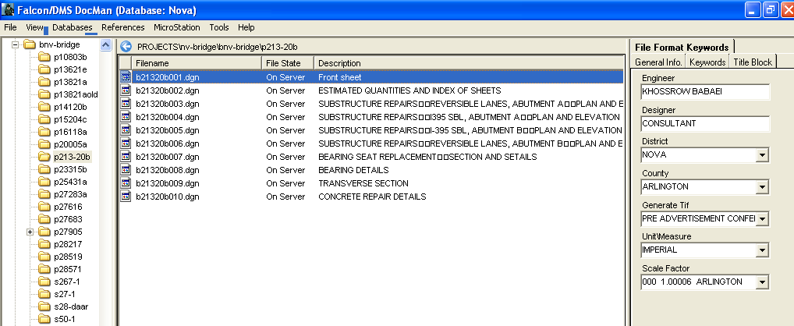

File Format Keywords Tab

All files with the status set to “Index” must have Engineer, Designer, District, and County filled in. If the Engineer and Designer are the same person, then the “Designer” field is not required and may be left blank.

The “Engineer” field should be filled in with the name of the Supervisor of the section or the Sr. Engineer who is overseeing the design.

The “Generate Tif” field should be filled in when tif files are to be generated. The appropriate project stage should be chosen from the list shown.

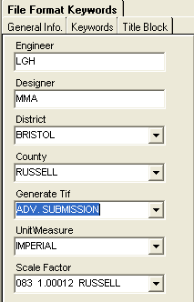
GENERATE TIFF - Several choices – Choose the “stage” that applies to your current submission.
SCALE FACTOR – used by Survey

General Info Tab

The “Description” field for S&B plans should be filled in with the title of the sheet (ex. Abutment A). The “Document #” should ALWAYS be filled in with the FINAL sheet number that applies to the plan unless the sheet is a worksheet that will not be included in the plans, in which case it should be left blank. This may require that the number be modified prior to indexing or archiving.

The “Status” field has several choices. The field must be set to “index” only when the file is going to be a part of the plan assembly. Otherwise set the field to “active”. The “survey” setting is for locking down the survey file when it is being edited. Do not change status field if set to survey.

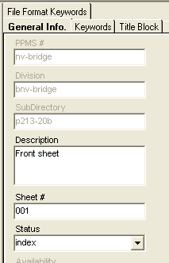

SHEET # - Use “leading” zeroes. This will allow all plan sets to be uniformly numbered and sequentially displayed.
STATUS – All sheets to be included in the plan set should be set to INDEX. (Scratch sheets, etc. should NOT be set to INDEX.)

Title Block Tab

The Title Block provides six additional fields that can be used for indexing.

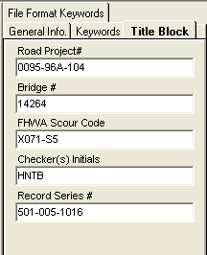
 | Federal Structure # - (a five digit identifier)
RECORD SERIES #
Bridge plans 501-016-1016
http://bioapp13/RecordsRetention/Pages/SearchSeries.aspx

District SAAP & RAAP 501-003-1060
http://bioapp13/RecordsRetention/Pages/SearchSeries.aspx

Keywords Tab

The “Archive” field is required to be used only when you are ready to archive a set of files, otherwise it should be left blank. Instructions about the “Archive” field are shown in more detail below. All files with the “Status” set to index must have the Route, County/City, Section, SB Plan #, and C# or M# etc filled in.

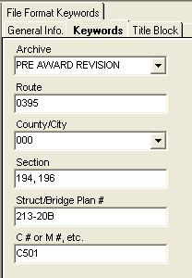 | ARCHIVE – To be used by S&B for projects at the following stages:  Advertisement Submission (old “Final”)  Pre Award Revision  Construction Revision  As-Built
ROUTE # should be four digits
(e.g. Interstate 395 would be 0395)

Archiving Files

The following instructions are for archiving your files. Archiving your files will give you a complete copy of your project at that particular stage of development. After all of the “required” database fields are filled out, you are ready to archive the project when you reach one of the appropriate concurrent engineering stages. In the “Directories & Keywords” tab, set the “Archive” to the appropriate concurrent engineering stage for all project files. Only change the Archive when you are ready to archive the file, otherwise leave it blank.

Falcon will copy all of the files that have the “Archive” field set to an Archives environment on a Falcon server. This process will run nightly. When the process has finished, the “Archive” field will automatically return to a blank status. This will allow different files to be archived at different stages. These files can be accessed for viewing and printing but cannot be changed when in the Archives environment.

The following is an example of what types of files should be archived in the respective concurrent engineering stages:

Public Hearing – DGN files

Field Inspection Stage – DGN files

Right of Way Partial – DGN files

Right of Way Total – DGN files

Plan Submission – DGN, and all related files necessary for the contractor to build the project.

Pre Award Revision – All revised files

Construction Revision – All revised files

As Built Plans – All plan DGN files for the project

S&B will always archive files at Plan Submission/Advertisement Submission (“old” Final submission), Revisions (Pre-Award or Construction) and As Builts and may occasionally need to archive files at one of the other stages, depending on the project. Please note that only DGN files are archived by Structure and Bridge, not TIFF files from the Plan File Room.

Accessing Archived Files

Databases should be set to Central.

Environments should be set to archives. .

After setting the environment to Archives, choose “PPMS#”, then “Stage”, then “Division”. Stage may be any of the plan stages noted in the Archive choices described previously.

The files that have been archived for that stage will be available as shown above. These files are read only and cannot be edited. Use the View button to access these files for reviewing and plotting.

Example Index of Files

An Index of S&B plans would show the information entered on the General Information Tab. The Reference File column will be blank unless the designer has inserted notes.
This is an example of a S&B index.
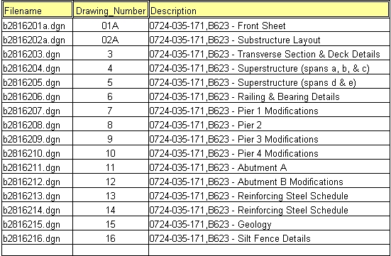

Mass Update Tool in Windows Document Manager

The Mass Update tool can be used to change database information on multiple files. Hi-Light the files in the Files Selected window and go to Tools > Mass Update Tools > Mass Update. This only changes the database fields that you enter data into. All other fields remain as they are. Once all the data is entered, select Process.

Refer to the Instructions for Mass Update in Falcon for more information.

