Using Pluses 3PC Application

- Open MicroStation file that either contains Right of Way/Easement lines or the file that you will be placing Right of Way/Easement lines.

- Open your GEOPAK project. This is necessary so the application can get to your alignments.

- Activate the D & C manager and navigate to the Right of Way folder, then the Special Applications folder.

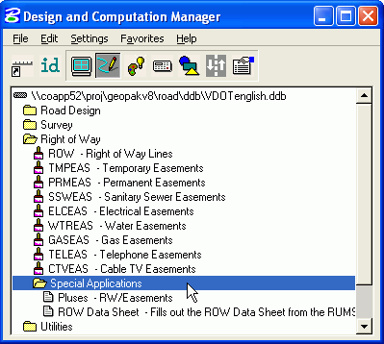

- If Right of Way/Easement lines already drawn, skip to step 6, otherwise select item that you wish to draft from the Right of Way folder in the D & C manager. Make sure the Place Influence button is toggled on, then double click on the item in the D & C manager window. Double clicking will place MicroStation in the correct command for placing the item.

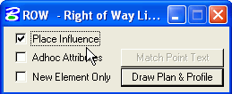

If you do not double click on the item you wish to draw, then make sure you use the Place Line command in MicroStation and NOT the Place SmartLine command.
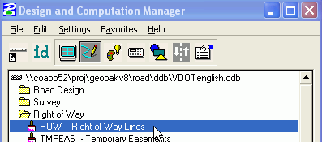

- Using the D & C Manager, draft all of your Right of Way/Easement lines in your design file.

- When you have finished drafting your items, use the element selection tool in MicroStation to select all items along an alignment. The items that you select will have plusses based on a single alignment, so don’t mix your connection route elements with your main route elements. Using the control key on your keyboard will allow you to add multiple items to a selection set.

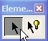

- After you have selected all your elements, double click on the Pluses-RW/Easements special application.

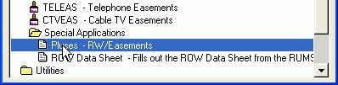

- The following is a series of dialog boxes that will appear. They will need to be filled in with data appropriate to your project. The first prompt is for your GPK Job number. Click on the OK button after you have entered your data.

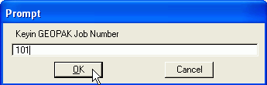

The second is for an alignment (chain) name. Click OK.

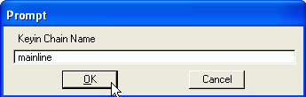
The third prompt is for offsetting the pluses a certain distance from the line it is labeling. Click OK.

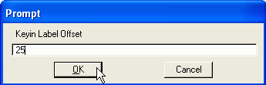

The fourth and final prompt is for setting the scale that the program will use to determine the text size (25, 50, or 100 scale). Click OK.

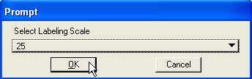

When the process has finished you will need to deselect the items you previously added to your selection set. The pluses can be moved/relocated as necessary by using the MicroStation move command.

