Using Axiom to Fix OLE Errors

Explanation:
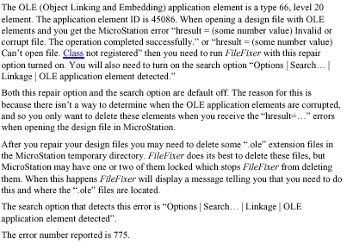

We have created a resource file called (fixerole.rsc) that will set the defaults in Axiom. You can get this file from the following link. \\0501cocadd\proj\ld_sup\axiomrsc you will need to place it in the follow link on your machine C:\Program Files\Bentley\Program\axiom\fixer

Steps to Fix OLE Error

- You can start Microstation by going to Start➔Program ➔Microstation V7.1 ➔Microstion or click on the following shortcut.
- Need to change workspace to user = (Examples) as in the following example.
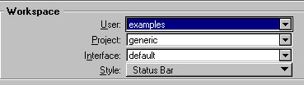

- Open up any design file.
- Start Axiom File Fixer. Axiom ➔ FileFixer
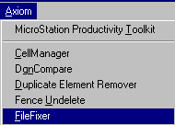

- From the Axiom main menu open up the fixerole.rsc file. File➔ Open Resource File.
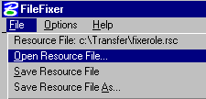
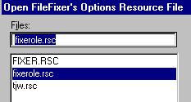

- Next we need to turn on the option to get ride of the OLE errors. Options➔ Repair ➔ Linkage
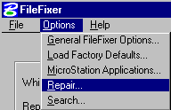

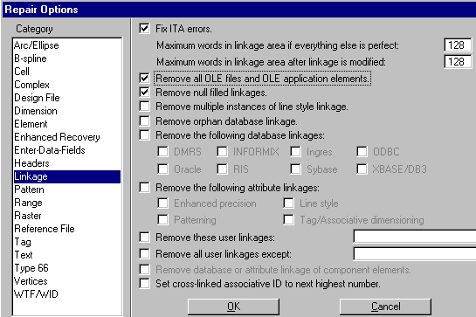
Select the options as shown above.
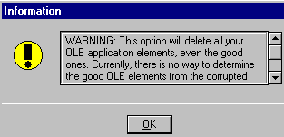

You will Get a Warning. Please choose OK on the Warning Window and OK on the Repair Option Window.

7. You can now pick a single or multiple files by using the Edit List on the main Axiom Menu.
Using the Add or Remove you can add as many files as you need or remove one you didn’t want

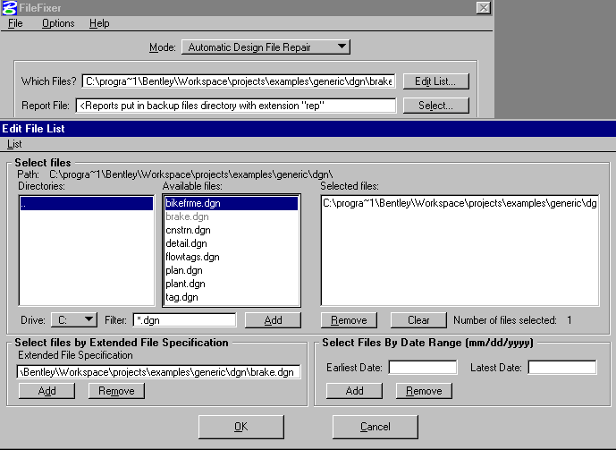

Hit OK when done adding Files

- After picking the list of file hit Start to start the process of fixing the files. It will generate a report for each file with a .rep extension if you need to see what has been done.

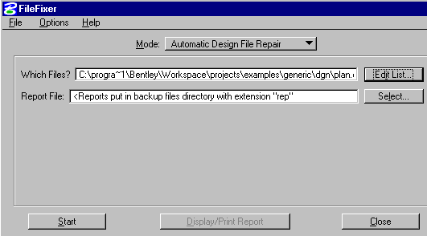

- Check to see if the .ole files on users workstation have been deleted. If not delete the .ole file
with the same name as the .dgn file that had been fixed. If any other .ole files exist find the
corresponding .dgn file and repair. The .ole files will be located in :
C:\Program Files\Bentley\Program\MicroStation\temp .

