Falcon Database Information

Purpose
This document provides standard procedures for filling in the Falcon Document Management System’s required database fields and shall be used in all cases. These standard procedures are effective October 18, 2001.

Scope
The database information that Falcon provides will be extracted and used by other programs in the electronic plan process. The major usage for the Falcon database information is:

- Producing an Index of Files
  - Status = index

- Archiving files at different stage of Concurrent Engineering Project Development
  - As Built
  - Construction Revision
  - Field Inspection
  - Plan Submission
  - Pre Award Revision
  - Public Hearing
  - R/W Partial
  - R/W Total

- Automatic tif file generation for Electronic Plan Submission
  - Tif files created by designer is automatically renamed and placed into Plan File Room environment

It is very important to follow these instructions and complete the database information as soon as possible so it does not cause any delays to a projects schedule. Falcons settings will be changed in the near future statewide which will force/require all the fields indicated in these instructions to be filled in for creation, checkout and check-in of files. . All database information on new projects from receipt of these instructions must have the information keyed in as the files are created.

Falcon has been implemented statewide and is used to share files between multiple disciplines. Designers should be as informative as possible when entering descriptions since someone searching for a document may use the descriptions.

Both the Falcon Windows Document Manager and Falcon MDL Document Manager can be used to key in the information. To update an existing project, the Windows Document Manager would be the best tool to use because the “cut” and “paste” method can be utilized. The Windows Document Manager has another tool to update database fields for multiple files; this tool is called Mass Update. This command is found under Database --> Mass Update. To run the Windows Document Manager go to Start –> Programs – >Falcon_DMS –> Doc. Manager.
The remaining portion of this document provides illustrations and procedures to follow when filling out the required database fields. If you need more assistance or have questions that were not answered please call the AES Helpdesk at 888-683-0345 or 786-1280.

Illustrations & Procedures

The following screen captures show the required fields highlighted in yellow, however there are times when the field may be left blank. Please read the following carefully.

All Files

General Information Tab
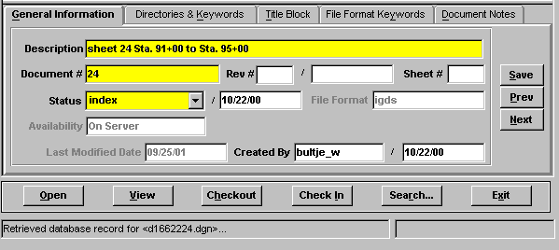

In the “Document #” field, place the sheet number. If the sheet number is 1 thru 9 place a zero in front of the sheet number. (For example if the sheet number is 2e the Document # should be 02e.) If the file is not a plan sheet (IGrds files, CAiCE files, etc.), then the field should be blank. The “Status” field has three choices: index, active, and survey. The field must be set to “index” only when the file is going to be a part of the plan assembly, a reference file or IGrds and CAiCE files relevant to the design of the project. Otherwise set the field to “active”. The “survey” setting is for locking down the survey file when it is being edited. Do not change status field if set to survey.

Directories and Keywords Tab

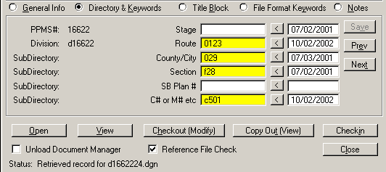

The “Stage” field is required to be used only when you are ready to archive a set of files, otherwise it should be left blank. Instructions about the “Stage” field are shown in more detail on page 7. All files with the “Status” set to index must have the Route, County/City, Section, and C# or M# etc filled in. These should match the project number exactly. The route number will always be four digits. The Structure & Bridge # (SB Plan #) is also required to be filed in if the plans are for a structure.

Title Block Tab
No data fields required

File Format Keywords Tab

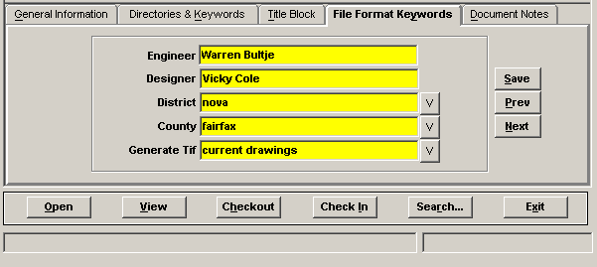

All files with the status set to “Index” must have Engineer, Designer, District, and County filled in. If the Engineer and Designer are the same person, then the “Designer” field is not required and may be left blank. The “Generate Tif” field is required when tiff files are created so they are placed in the proper location within the Falcon Web Suite. The next page shows available choices.

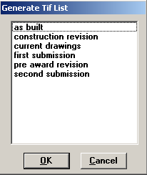

Document Notes Tab

The Document Notes tab is used to place a note that will provide information about which files are attached to the sheet file drawings.

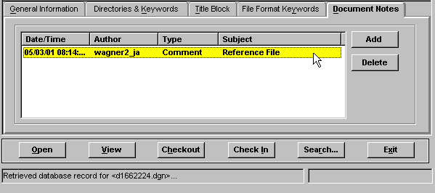

Reference file note is not applicable for Bridge Division.

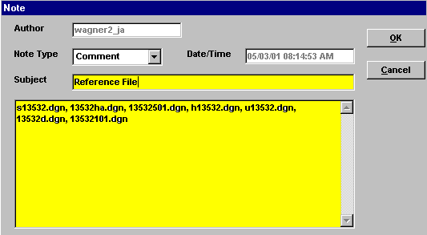

Enter the Subject line as Reference File. Only enter the reference files that have the display turned on when the sheet is plotted.

IGrds Files

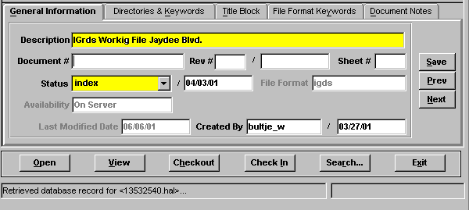

All IGrds files must have the “Description” and “Status” fields filled in. The “Status” should be set to “index” for all usable sets of working files. This does not include working files used for alternate scenarios or test files. IGrds reports and list files should be renamed and saved in accordance with IIM-118. The description should include the type of report and the roadway name. “Status” field should also be set to “index”.

CAiCE Files

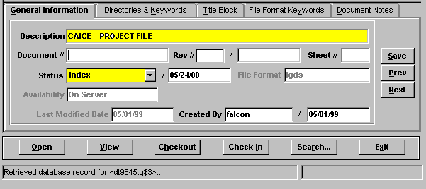

All CAiCE files must have the “Description” and “Status” fields filled in. If you have multiple surfaces, give detailed descriptions for each surface. “Status” field should also be set to “index”.

Survey Files

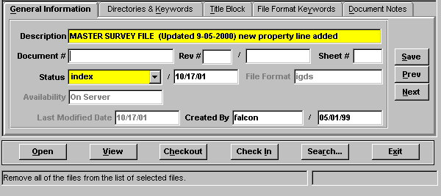

All Survey files must have the “Description” and “Status” fields filled in. The Survey Section will enter information for Survey files. If the “Status” field is set to “survey” do not change it. If the field is set to “active” the designer must change it to “index”.

Cross Section Plot Files

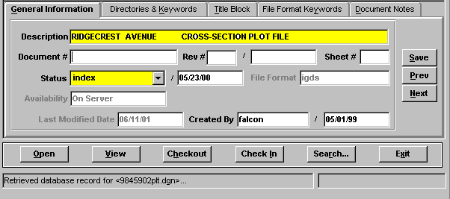

All Cross Section Plot files must have the “Description” and “Status” fields filled in. If you have multiple files, the descriptions should contain road name(s) or route number(s). “Status” field should also be set to “index”.

Archiving Files

The following instructions are for archiving your files. Archiving your files will give you a complete copy of your project at that particular stage of development. After all of the “required” database fields are filled out, you are ready to archive the project when you reach one of the appropriate concurrent engineering stages. The six stages for archiving are Field Inspection, Public Hearing, Right of Way, Plan Submission, Construction Revision, and As Built as shown below. In the “Directories & Keywords” tab, set the “Stage” to the appropriate concurrent engineering stage for all project files. Only change the stage when you are ready to archive the file, otherwise leave it blank.

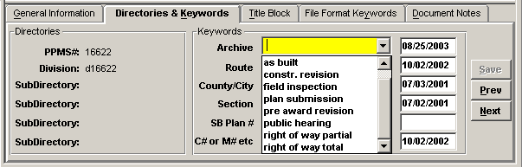

Falcon will copy all of the files that have the “Stage” field set to an Archives environment on a Falcon server. This process will run nightly. When the process has finished the “Stage” field will automatically return to a blank status. This will allow different files to be archived at different stages. These files can be accessed for viewing and printing but cannot be changed when in the Archives environment.

The following is an example of what types of files should be archived in the respective concurrent engineering stages:

Field Inspection Stage – IGrds and DGN files

Public Hearing – DGN files

Right of Way Partial – IGrds and DGN files

Right of Way Total – IGrds and DGN files

Plan Submission – IGrds, CAiCE, DGN, and all related files necessary for the contractor build the project.

Construction Revision – All revised files

Pre Award Revision – All revised files

As Built – All Files

Accessing Archived Files

The next few screen captures show how to access the archived files.

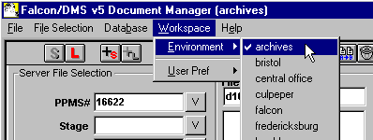

In the Falcon Document Manager under “Workspace” , “Environment” , there will be a choice for “archives”.

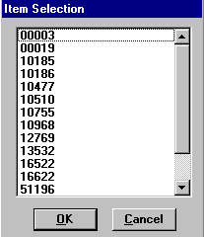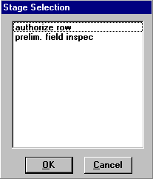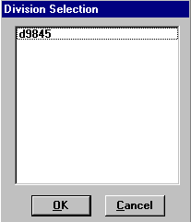

After setting the environment to Archives, choose “PPMS#”, then “Stage”, then “Division”.

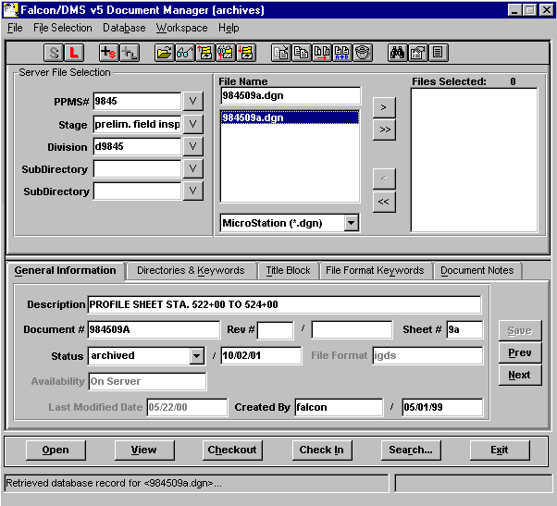

The files that have been archived for that stage will be available as shown above. These files are read only and cannot be edited. Use the View button to access these files for reviewing and plotting.

Example Index of Files
This is only an example. File names may or may not match the Cadd Manual.
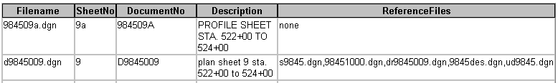

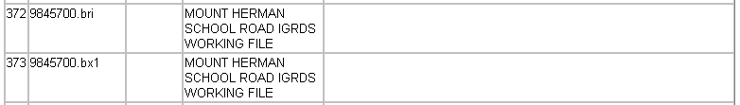

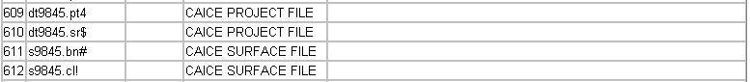

Mass Update Tool in Windows Document Manager

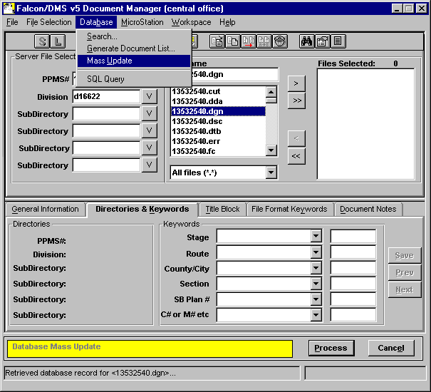

The Mass Update tool can be used to change database information on multiple files. Place the files in the Files Selected window and go to Database --> Mass Update. A yellow bar will appear at the bottom of the Document Manager when in Mass Update mode. This only changes the database fields that you enter data. All other fields remain as they are. Once all the data is entered select Process. For more detailed instructions on using Mass Update click on the link below Instructions For Mass Update in Falcon

