Importing Horizontal and Vertical Alignments Using SDMS (into GEOPAK)

- Once you have activated Project Manager inside of GEOPAK, click on the COGO (Coordinate Geometry) icon.



- Confirm your Project Name, Job Number, and Operator Code, then click on the OK button.

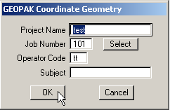

- In the Coordinate Geometry dialog box, click on File, then Import, then SDMS Alignments and Points.

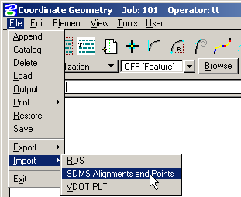

- In the Import SDMS Alignments and Points dialog set the Input to either Horizontal Alignments or Vertical Alignments, then click on the Select button.

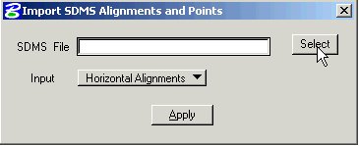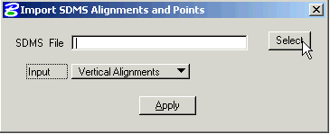

- The dialog box below will appear to allow you to navigate to the folder where you stored your IGrds exported data. This example shows an exported profile file. If you had set your Input choice to Horizontal Alignments ( as shown above left) your selection choices would have an “.ali” extension. Click on the file that you want to import, then click on the OK button.

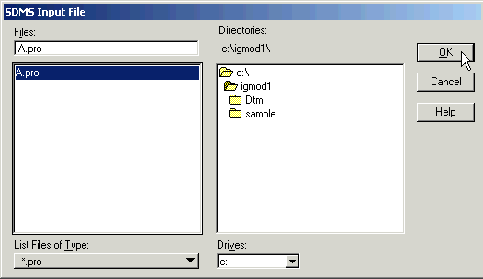

- The file you choose will appear in the blank field to the right of SDMS File. Confirm the file name, then click on the Apply button.

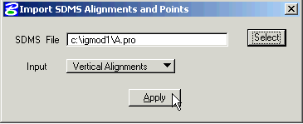

- The Vertical or Horizontal Alignment will then be imported onto COGO. If there are no errors you will see and Information dialog that states that your alignment was imported successfully. If you have errors, then contact the AES Helpdesk @ 1-(888)683-0345 or (804)786-1280.

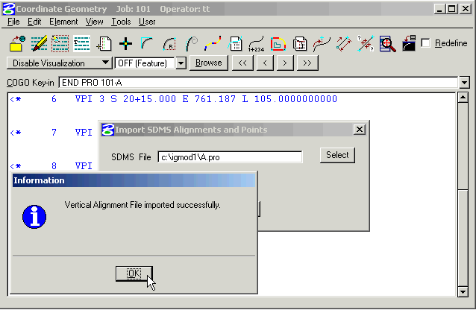

- You may review your data in COGO. If everything looks OK, then exit COGO. You will be asked to save your session, which you should do by clicking on the Yes button. This will save your input data, which can and will serve as a backup of your alignment data.

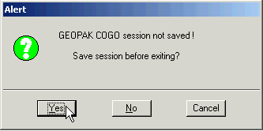

- Key in an appropriate name in the Save As field, then key in a description of that alignment in the Subject field. When you are done click on the OK button. This file will be saved to your GEOPAK project directory on the server.

