IGrds 99 UPGRADE

The following contains information for using Geometry Chains to create profiles.

- Activate IG99 and open a design file called ld2.dgn. This file is located in a folder called ig99train.
- On the Menu Bar in MicroStation select IGrds, then IG99. Open a working file called ld2.hal.
- On the IGrds Menu bar select Tools, then Vertical Alignment, then Reference Line.

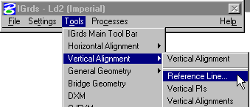

- Create reference line above your horizontal alignment. Place data point in screen to define Origin of grid, then set Elevation Range to Scan DTM and click on Apply button.

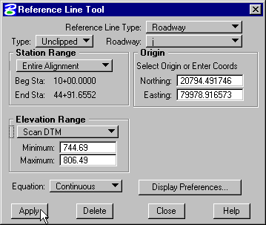

- On the IGrds Menu Bar select Tools, then Vertical Alignment, then Vertical Alignments.

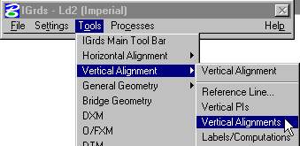

- In the Vertical Alignments Tool Bar select the Draw Orig Button to draw your original ground line based on cross sections.

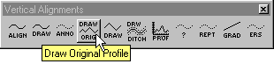

Confirm that Reference Line Type is set to Roadway and Active Roadway is set to j, then click on the Apply Button.

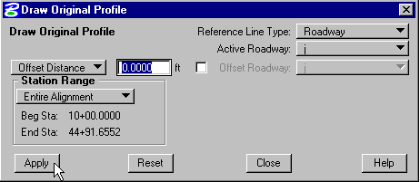

- On the IGrds Menu Bar select Tools, then Vertical Alignment, then Vertical PIs.

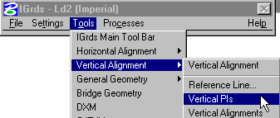

- In the Vertical PIs Tool Bar select Edit Button.

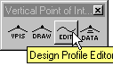

- In the Design Profile Editor change the Type to PNG, then set your Elevation Correction to 0.33.

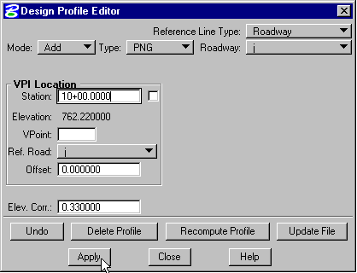

Place a data point in the Station field, snap to beginning of your existing profile, place a data point in your screen, then click on the Apply Button. Snap near the end of your existing profile, place a data point in your screen, then click on the Apply button again. This will create a Design Profile for your roadway based on the existing pavement. Click on the Update File Button to save the profile.

- On the IGrds Menu Bar select Tools, then General Geometry, then Computations.

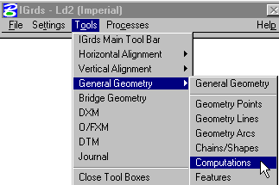

- In the Geometry Computations Tool Bar select the Geom Button.

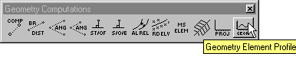

- Select Chain 1(turquoise element to the left of the horizontal center line). Place another data point in your screen to accept the chain, then click on the Apply Button.

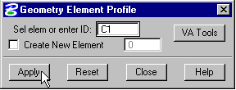

Do the same thing for Chain 2(turquoise element to the right of the horizontal center line).

- On the IGrds Menu Bar select Tools, then Vertical Alignment, then Reference Line.

- Create Reference Line for Chain 1. Confirm that Reference Line Type is set to Geometry Element and Geometry is set to C1. Define your origin point for the grid, set Elevation Range to Scan DTM, then click on the Apply Button.

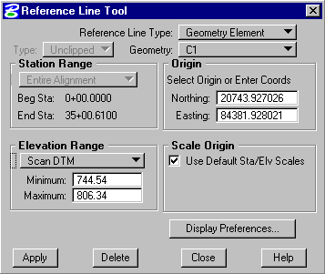

- In the Vertical Alignments Tool Bar select the Prof Button to draw your original ground line based on DTM.

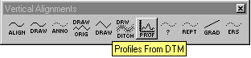

- In the Profiles From DTM dialog box confirm Ref. Line Type is set to Geometry Element, Geometry is set to C1, Profile Type is set to Geometry Element with C1 in the blank. Click on the OK Button.

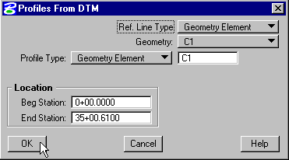

- In the Vertical PIs Tool Bar select Edit Button.

- In the Design Profile Editor confirm Reference Line Type is set to Geometry Element and Geometry is set to C1. Change Type to DTM, turn on the Filter Points check box, then click on the Apply Button.

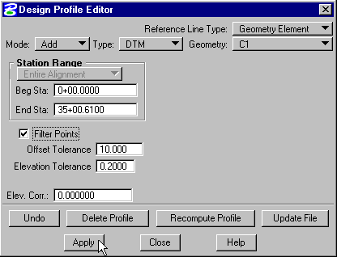

Click on the Recompute Profile Button and if everything looks OK click on the Update File Button.

- Repeat steps 16 through 21 replacing C1 with C2.

- Develop roadway templates and sideslope templates, etc. accordingly.

- Apply shapes to station ranges. Apply Geometric Template Modification for Chains 1 and 2.

- Use Design Section Display to view.

