How to Use WinZip

Zipping Up Files

- Open Windows NT Explorer and navigate to location of files.

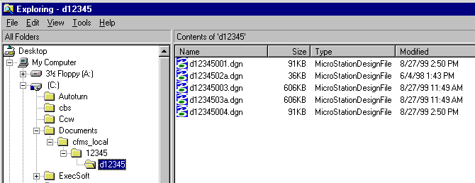

2. Select files to be added to Zip file. You may use the Control and/or Shift key to select multiple files. Holding the Control key down allows non-consecutive files in the list to be selected and grouped together. Holding the Shift key down allows consecutive files to be added to the list. Select top file in list then select bottom file in list. This will select all the files in the list.

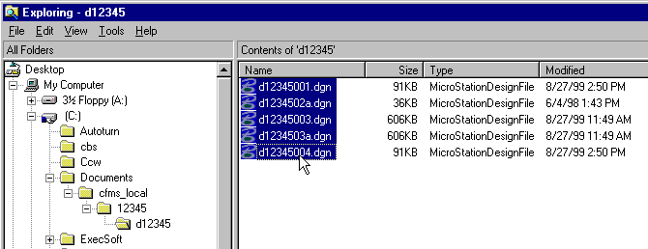

3. Right click on a file and select “Add to Zip”.

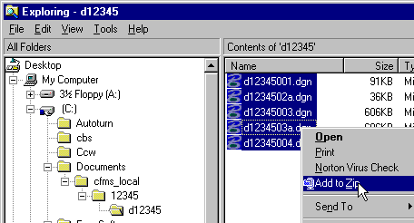

4. Key-in directory path and name of zip file, then click on “Add” button.

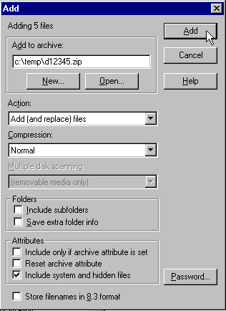

5. The dialog box that now appears shows you the files that you have zipped up.

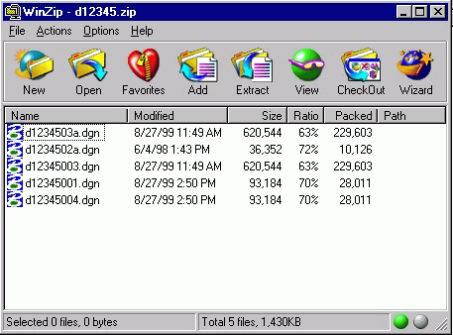

6. Click on “File”, then “Exit”.

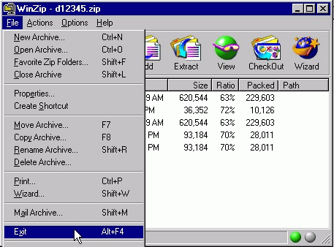

- Copy the Zip file to appropriate location (floppy drive, shared directory, ftp site, etc.)

Unzipping Files

1. Double click on file to be “unzipped”.

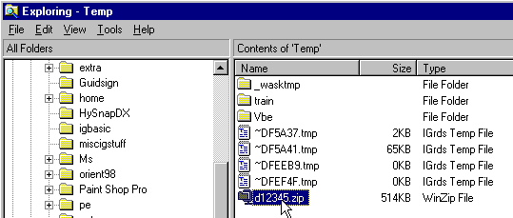

2. In the dialog box that appears, select the files you want to unzip.

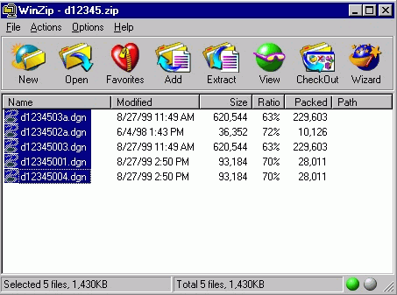

3. Click on the Extract button.

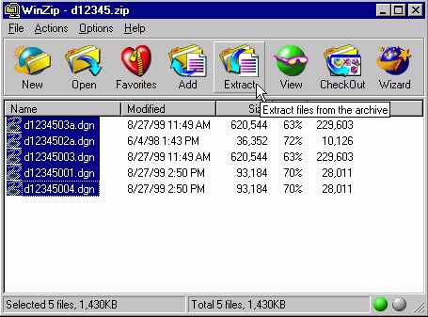

4. In the dialog box that appears, key-in or select the directory that you wish to place the files in, then click on the “Extract” button.

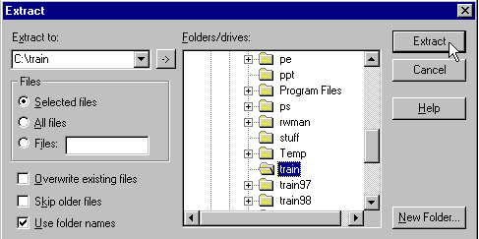

- Exit “WinZip”.

