General Notes Plan Sheet

INSTRUCTIONS FOR LABELING GENERAL NOTES PLAN SHEET

STEP 1. Create a general note plan sheet file by creating a file in MicroStation by using the SEEDGEN.DGN seed file. Also make sure that the LGENNOTE.CEL is part of the workspace search list for MicroStation cell library. (If you are using the LD workspace, then this is all ready set.) In the key in windows, type macro gnote. This will start a MicroStation macro command, which will prompt you for information about your plan sheet.

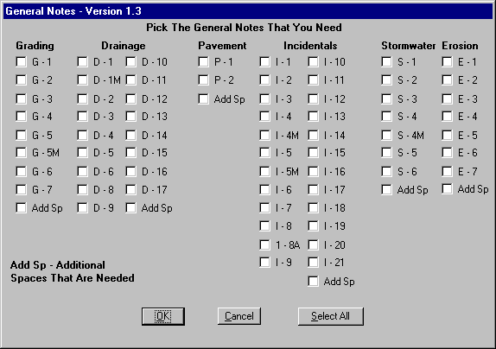

STEP 2. Select which notes you need or you can select the Select All button, then deselect the ones that you don’t need. The Add Sp button will prompt you for additional spaces that you may need between each note header.

