GEOPAK Merging Surfaces

- Open MicroStation, and then open one of your project files (it doesn’t matter which file, because no data will be placed in file). Make sure GEOPAK is activated, then use Project Manager to access your project.

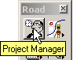

- You will need to have cross sections all ready created for project. Create design surface in accordance with Lab 16 in the GEOPAK Road 1 Course Manual, Section 16.1, steps 3 - 5, 14 – 17, and Section 16.2, steps 1 – 5.

- Access the merge surfaces tool. From step 2 you should have accessed the DTM Tool pallet. Tear off the Build tool bar, and then click on the third button, Build Merge TIN’s.

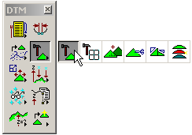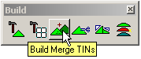

- Fill out the dialog box, substituting your file names for the ones shown. Make sure to include full path to file location.

