The process for generating TIF files has basically stayed the same, except one more database field is now required for the TIF files to be created and renamed properly.

The File Format Keyword Field for “Generate Tif” is now a required database field. The user must select the down arrow and select one of the choices.
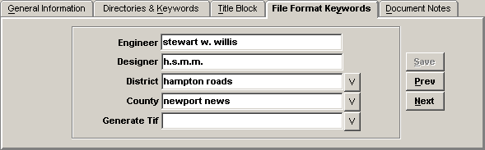

The choices to select are:
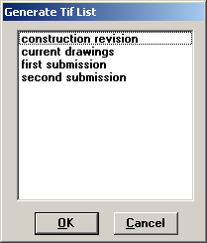

Remember to select “SAVE”. The choices above will indicate what they are actually for. The AES support staff will make the TIF files available on the Electronic Plans Web Page if “current drawings” is selected. If first submission or later is selected the TIF goes directly into the Plan File Room.

After the Generate Tif database field is set, the TIF files are ready for the user to use eQuorum Plotting software (PRF Generator) to generate the TIF files as they have done in the past.

The options above do not affect Archiving. Archiving of native files such as MicroStation, IGrds, CAiCE files will still need to be archived as we have in the past.
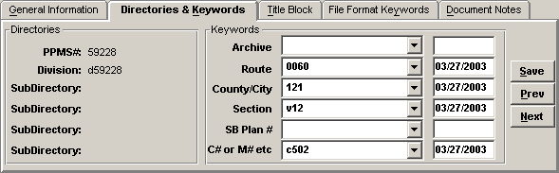.

The choices to select for Archiving are:
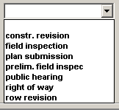

The “authorize row” stage and “final row” have been removed. Use “right of way” for both partial and whole takes.

