Instructions For Using Falcon V6

Falcon V6 now has a new look. If you are familiar with using Windows Explorer then you will not have any problems with the new Falcon. There is only one form of Falcon now called DocMan. It works inside Microstation and outside as well.

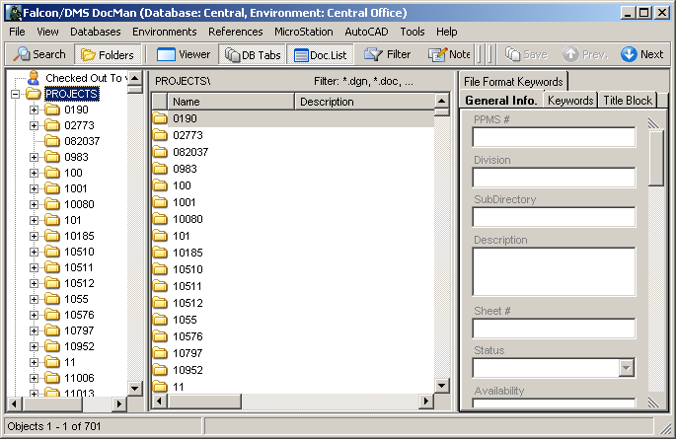

Falcon/DMS DocMan (Overview)

The DocMan user interface for the Falcon/DMS document management suite is a “panes-based” application used to manage, search for and view documents. The panes can be resized and toggled on and off in various combinations to produce an interface that is easily configured for different document management tasks. The DocMan’s Windows Explorer- like interface allows you to view both files and information stored in each document’s database record and to easily identify a documents “Availability”.

The interface components fall into three categories: panes, toolbars, and menus (shortcut- or context – and dropdown).

Because the toolbar contains commands that permit you to control, among other things, the display of panes (that allows you to “organize” the interface), you should familiarize yourself with the toolbar operations first.

The Toolbars

Under File you have all the document functions – open, check out, copy etc. Environments are now located under Databases. Under Databases pick the district you want. Under Environments is where you will find Archives, Plan Files Room and Priority Letters. Tools is where Mass update is located. The others will be discussed below.

Panes:

The Panes toolbar (above) controls the display of the DocMan’s panes and, in several cases, the type of information they contain. For example, pane 1 can display either a search form or a folder hierarchy; pane 2 can display the DocList by itself or with notes.

Search – Sets the mode for pane 1 to Quick Search.
Folders – Sets the mode for pane 1 to Folder View (the default).
Viewer – Toggles the display of the Viewer in pane 2. (When the Viewer is off, it is replaced by the DocList.)
DB Tabs – Toggles the display of the Database Property Tabs in pane 3.
Doc.List – Toggles the display of the DocList . (When the Viewer is off the DocList displays in pane 2; when on the DocList displays in pane 4.)
Notes – Toggles the display of Notes beneath the DocList.
View Document: The View Documents command displays the selected document in its own viewing window.

Panes

The DocMan interface is comprised of panes that can be toggled on and off, replaced, and depending upon the pane, resized.
The default DocMan configuration (below) uses three panes. Because the Viewer is not active in the default configuration, the View command opens a floating window to display the selected document.

DocMan’s Default panes configuration

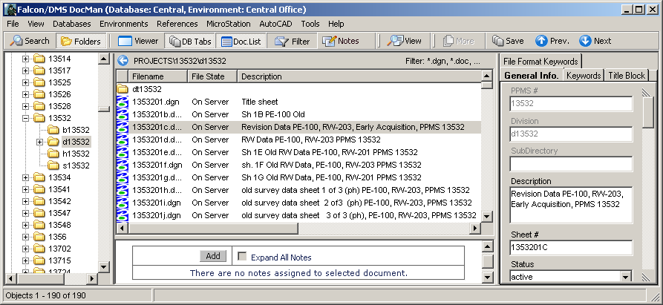

Pane 1 is set to Folders mode – also referred to as Folders View; click Search to switch to Search mode.
Pane 2 contains the DocList.
Pane 3 contains the Database Properties Tabs.
The floating Viewing Window opens when you select a document and then choose View.

Locating Documents – Folders View & Quick Search

The DocMan provides two methods for locating documents:

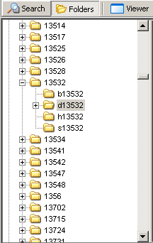
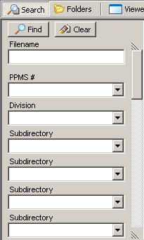

Folders View – (above, left) pane 1 displays the hierarchical structure of folder and files in a fashion similar to that of the Windows Explorer.
Quick Search – (above, right) pane 1 displays a form which allows you to use the descriptive information stored in each document’s database record.

Folders View
When in Folders View (or Folders mode) the DocMan is similar in both appearance and behavior to the Windows Explorer.

Checked Out to User – Click this item to display all the documents checked out to you. This feature is especially useful when you have checked out files from multiple folders. You can perform all the management commands valid for checked out documents from this list.

Projects – Expand the Projects folder to display all the projects to which you have access. As with the Explorer, you can expand project folders to show their subfolders.

Local Documents – Expand the Local Documents folder to display all the folders located in the area on your workstation to which the DocMan has access. This is used primarily for creating database records for local documents. When local files are added to the database the selected files are automatically moved to user-designated folders on the file server.

Quick Search

While Quick Search can produce results based on as little as a portion of a filename (e.g. *.dgn) and perhaps some location information (e.g. project folder), Falcon makes a lot of descriptive information available in order to produce increasingly refined results. The categories of descriptive information include an actual document description, status information, access information, and keywords, among others. Typically, the Quick Search form contains fields representing the most common criteria for documents controlled by Falcon; the number and types of fields differ substantially or only slightly between environments.

Database Keyword – An important element in defining or redefining search criteria is the database keyword. A keyword is an attribute assigned to a document’s database and are grouped by category. A database keyword category can present a list of predefined keywords on a drop-down menu (e.g. Sheet Type), or can appear as a text field. A keyword category that appears as a text field e.g. Contract #, Plat #) usually indicates a category for which a list would be too long and cumbersome to manage or use.

The search forms use two field types:

Text Field – this field type allows you to key in a search value. PPMS #, Description and File name are examples of Text fields.

Drop-down menu – this field type allows you to enter a search value or select a value from a drop-down menu. PPMS # is an example of a drop-down menu.

Overview: Open & Checkout

To open a file just highlight the file and right mouse click and select Open (Modify).

To check out to modify you would highlight all the files you want to check out and then right mouse click and select check out (Modify)

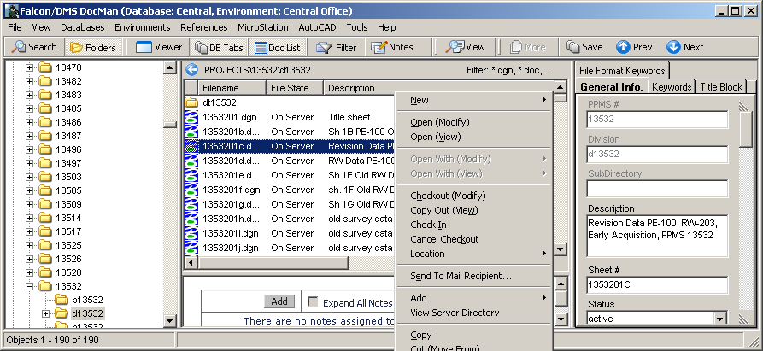

Reference File Check and Igrds Files

The reference file check and include Igrds files is under References at the top of the DocMan screen. They are turned on when the check is showing beside them.

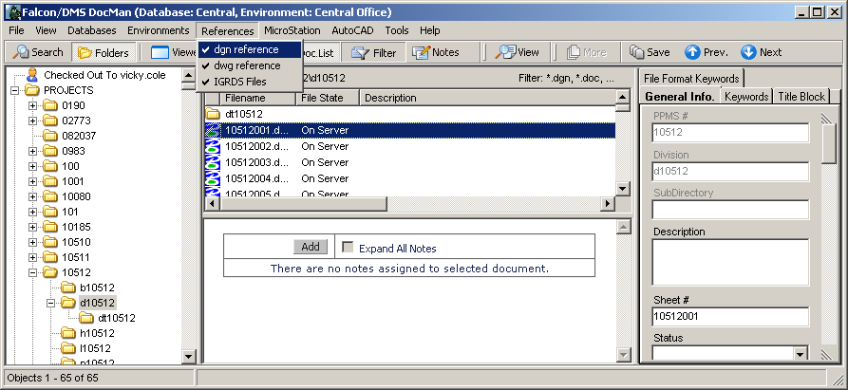

Checking In Files

You can navigate to Local Documents or Checked Out To highlight the file or files and right mouse click and pick Check In

Creating New Files

To create a new file navigate to your project and the division then right mouse click. Select New – IGDS Document

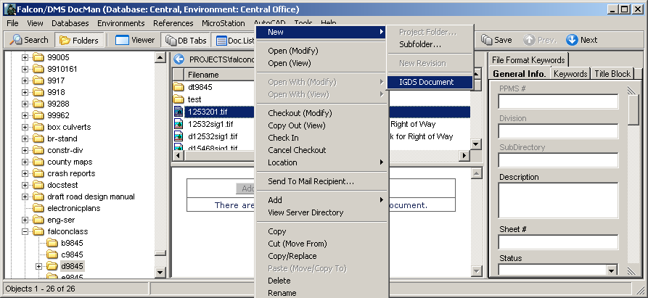

Then you will get the box below. Pick the correct seed file. Then click Next.

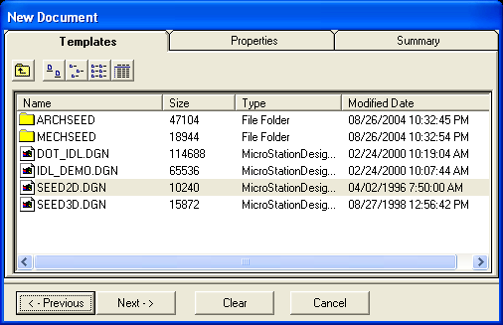

Then you will get the box below. Fill in the Filename, Document Number and Description and any other information you may know. Then click Next

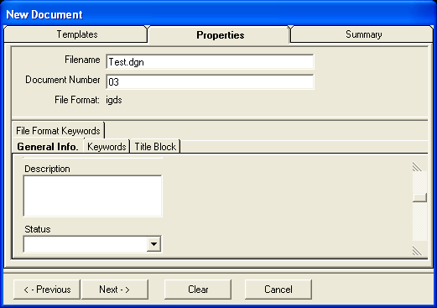

At the bottom you have Options to Create Document, Create/Checkout Document or Create/Open Document. Pick one and then click Finish

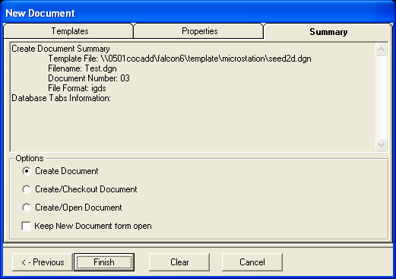

Add Local Document

You must navigate to the Local Documents folder - c:\documents\cfms_local. The file must be in this directory. High light the file and right mouse click. Pick Add – Add Local Document.

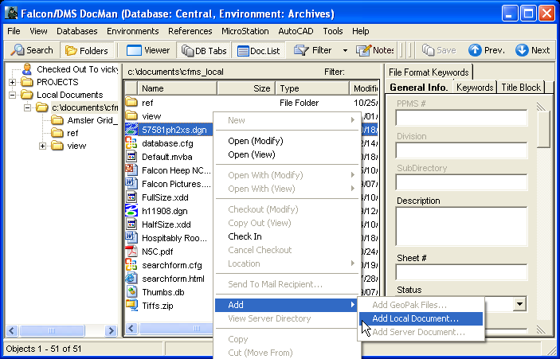

Then you will get the box below. The Filename will be filled in with the name of the file you are adding. Document Number must be the sheet number if the file is a sheet file. If not Document Number should be left blank. Then pick the correct File Format.

On the left side of the box double click on the PROJECTS folder and navigate to the UPC number and directory you want to add the file. You can fill in any of the tabs below then click Next. Make sure the file is going to the right place and click Finish.

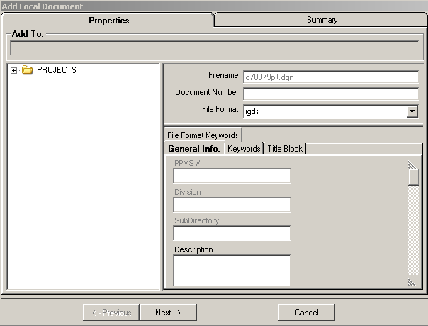

On the left side of the box double click on the PROJECTS folder and navigate to the UPC number and directory you want to add the file. You can fill in any of the tabs below then click Next.

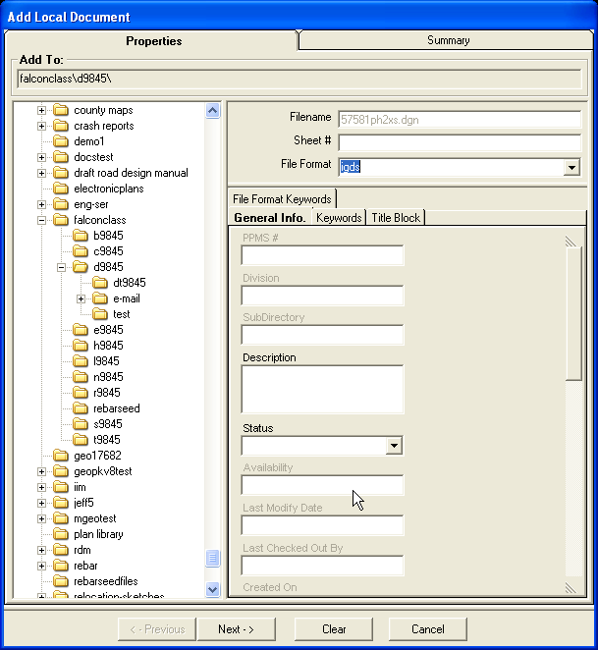

Make sure the file is going to the right place and toggle on the Checkin Document at the bottom of the box then click Finish.

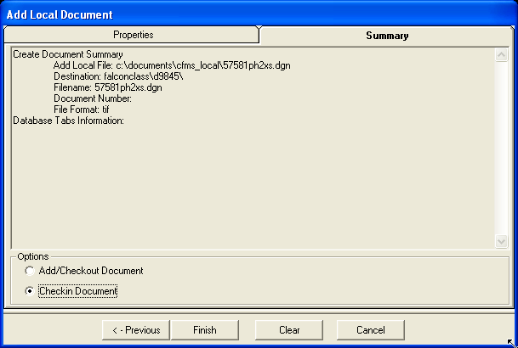

Attaching Reference Files

Use Falcon to open (modify) the file you want to reference another file to. Once you have the file open in MicroStation, open Falcon and highlight the file you want to reference then click on MicroStation at the top.

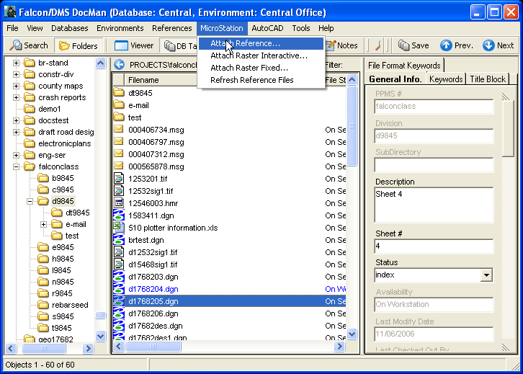
Then click on attach reference. The box below will open. Fill in the Logical name then click OK. The file will be attached.

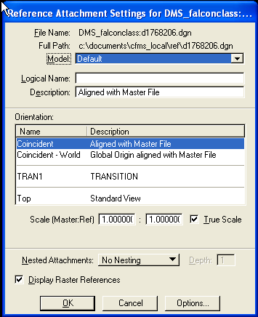

Detaching a reference file has not changed. This command is found under MicroStation – File – Reference.

Mass Update

The following steps can be used to update multiple database fields for multiple files in Falcon. Activate DocMan, and then navigate to the appropriate UPC folder. Select the files you wish to update. Then go to Tools –Mass UpdateTools- Mass Update

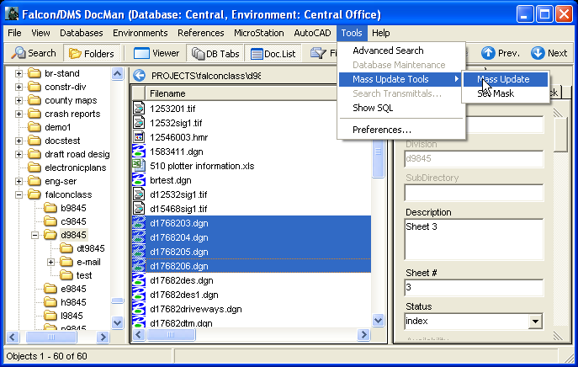

The box below will open. You can move this box out of the way if nessecey. Click in the blank field under one of the database tabs (General Information, Directories & Keywords, ect.) that you wish to update. Key in the information and then click the Process button.

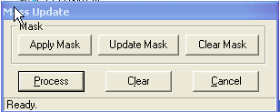

Then you will get this box, just click OK.

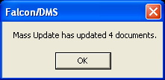

The information will be saved.

12/04/06

