10/2/03

Generating and Submitting TIF Files / Archiving Instructions

Generating and Submitting TIF Files

When you are ready to create TIF files for Current Drawings, First Submission, Second Submission, Pre-Award Revision or Construction Revisions you must first make sure the following fields are filled in correctly in Falcon to insure that the TIF files are submitted properly.

General Information
The “Description” and “Document #” must be filled in for each plan sheet. In the “Document #” field, place the sheet number. If the sheet number is 1 thru 9 place a zero in front of the sheet number. (For example if the sheet number is 1c the Document # should be 01c.) If the file is not a plan sheet (IGrds files, CAiCE files, etc.), then the field should be blank.

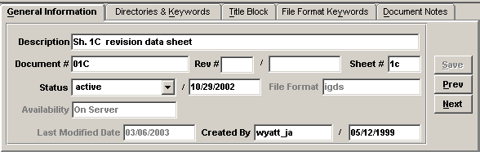

Directories & Keywords
The project information must be filled in with your project number as shown below. The route number should be 4 digits, such as 0123. County/City is a pick list.

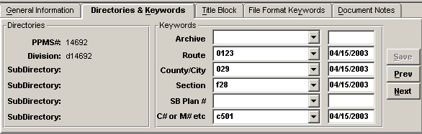

File Format Keyword
The Engineer, Designer, District and County should be filled in for informational purposes. The File Format Keyword Field for “Generate TIF” is a required database field. The user should use the down arrow to select one of the choices.

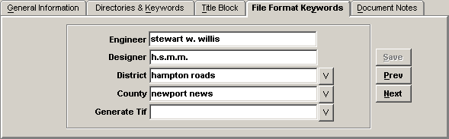

The choices for Generate TIF are:

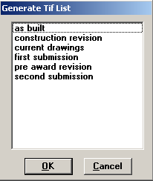

Remember to select “SAVE”. The choices above will indicate what the TIF files are being submitted for. The AES support staff will make the TIF files available on the Falcon Web Suite under Current Drawings if “current drawings” is selected. If first submission or later is selected the TIF files go directly into the Falcon Web Suite under Plan File Room.

Once all the required database fields are set, the dgn files are ready for the user to use eQuorum Plotting software (PRF Generator) to generate the TIF files. To create a TIF file open the dgn file in MicroStation. Fence the file the same as if you were going to plot the sheet. Then go to Application - eQuorum Plotting – PRF Generator. A box will open. At the top you will see Active Cfg: Click the Select button. Scroll down and select the CONFIG Tif File Generator, then click ok.
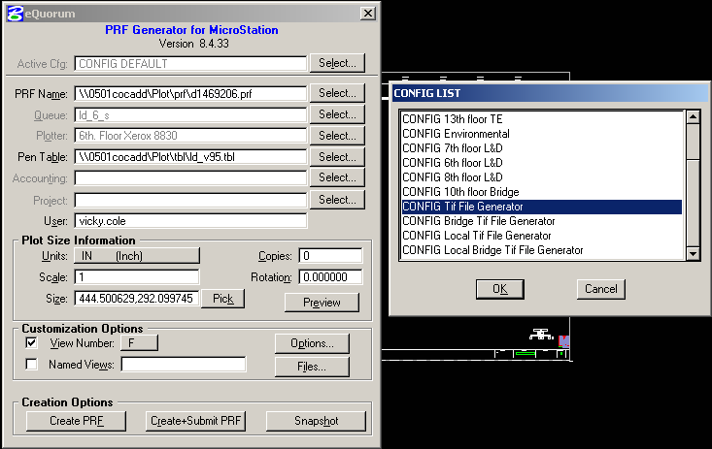

This will set the scale to 35, 23. Do not change any of the setting even if it’s metric. Then click the Create+Submit PRF button. This will create the TIF file.

Archiving Instructions

Archiving Files At Selected Milestones

Archiving is a totally separate function from the generation and submission of TIF files. Archiving of native files such as MicroStation, GEOPAK, IGrds, and CAiCE files will still continue to be archived as we have in the past.

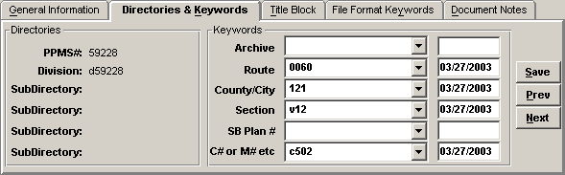.

The choices to select for Archiving are:

