Creating Cross Section Plot File For Electronic Submission

The following procedure will not work properly if you have dropped status of cross section sheet cells.

Create a new microstation file using the appropriate seed file (seed.dgn or mseed.dgn) and name the file the same as the project number _x.dgn (Example: 0172-114-v02 c501_x.dgn ). Reference up mainline cross section plot file. Make sure you reference the files in order starting with file that contains cross section sheet 1. Rotate the file 90 degrees so the cross sections are running vertically up the screen. Then fence and copy the cross sections into the file. Reference up all other pertinent cross section files. They will all come in at the same place so you will have to move each reference file. File >Reference> Tools> Move

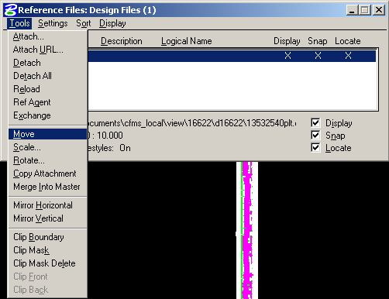

Move the files so they are just above the previous cross section sheets. They should be in the same order they would come in the plan assembly (bottom to top). Fence copy and then detach all reference files.

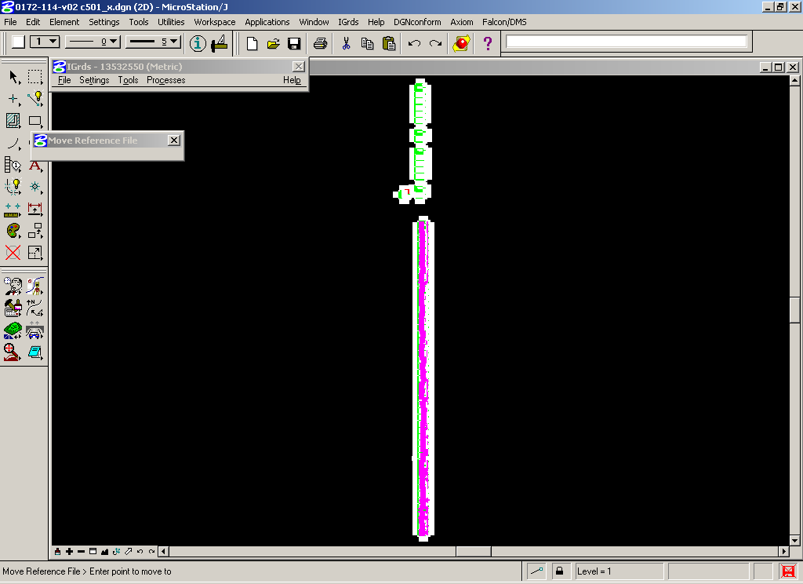

For Geopak cross sections - Reference up the cross sections and click on Nested Attachments - Copy Attachments. Then fence and copy into file.

