IGrds Cross Sections

INSTRUCTIONS FOR LABELING CROSS SECTIONS PLAN SHEETS

STEP 1. Create a cross section plot file in IGrds using the CROSS SECTION PLOTTING command, which is found in the DESIGN DATA MANAGER. Once this is done, close the working files and open up the MicroStation design file that contains the cross sections. The name of this file will consist of the first five letters of your working file plus the letters plt.dgn. In the key in windows, type macro xslabel. This will start a MicroStation macro command, which will prompt you for information about your plan sheets.

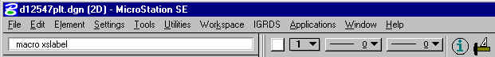
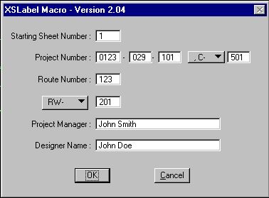

STEP 2. Enter the beginning plan sheet number.

STEP 3. Enter the project number. Select either C (Construction) or M (Minimum Plan).
If you leave the construction or minimum plan number blank. Then it will not place one on the plan sheet.
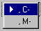
STEP 4. Enter the route number.

STEP 5. Enter the Right of Way, Preliminary Engineering Number or select None. If you select none it will leave that field blank on the plan sheet.

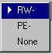

STEP 6. Enter the project manager name.

STEP 7. Enter the designer name.

Once the designer name is entered the macro then will count how many plan sheets are in the file. Once the macro finish counting the plan sheets it will use the Change Text MDL program and make all the changes the plan sheets and then exit the MDL program.

