ACCUSNAP – The AccuSnap feature enables you to snap to the regular snap locations automatically. That is, when you move the cursor over the element you wish to snap to a small cursor slides to the nearest snap location.
When you move closer to the snap location a yellow snap cursor appears along with the symbol for the current snap mode.
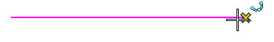

AccuSnap Settings may be adjusted by going to Settings; Snap; Button Bar; Right Click on the first icon, select Properties.
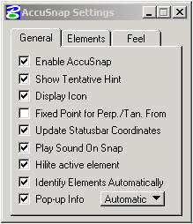

Enable AccuSnap – Toggles AccuSnap On/Off

Show Tentative Hint – As you move the pointer over an element, AccuSnap finds the nearest snap point and displays its location with an X denoting a tentative snap point.

Display Icon – The current snap mode icon displays at the snap point, for both the tentative hint and tentative point.

Fixed point for – With Perpendicular Snap, AccuSnap sets the snap override to
Perp/Tan. from Perpendicular From.
With Tangent snap, AccuSnap sets the snap override to Tangent From.

Update Coord. – Updates the status bar Coordinates.

Play sound on snap - A sound plays when you snap.

Highlight Elem. - Element highlights when AccuSnap is within snap tolerance.

Identify Elements - Element highlights when cursor is over the element.
Pop-up Info. - When you Identify or snap an element a tool tip displays showing element type and level the element is on.

LEVELS – The level display is entirely changed in appearance but not in function.

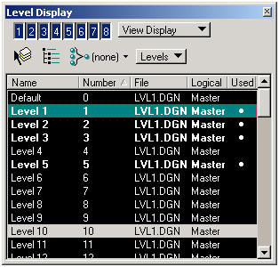

Each line in the display may be clicked to turn the level off or on, or double clicked to make it the active level. The dark lines are on, light lines off. The level display size is adjustable. Levels that are used appear bold.

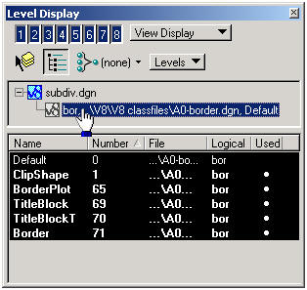

If you wish to view the levels in a reference file, just activate the Target Tree
as shown above, then click on the desired file in the list presented.

TEXT –

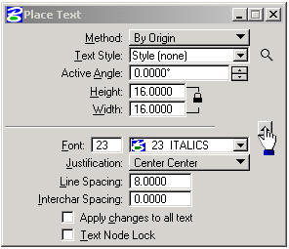
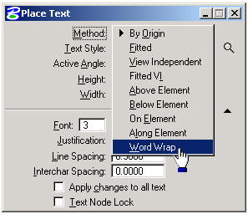

Tool Settings now shows Font, Justification, Line Spacing, and Intercharacter Spacing for the various methods. (Click on the little arrow at the lower right.)

The tool settings box now has Word Wrap instead of line length (in Method)

Text Editor –

The text editor/word processor window has a little different look. You can now set the Style (font), Bold (if applicable), Italics, Underlining, Spell Checker, Fraction Style, and Color of the text before you place it, right in the text editor.
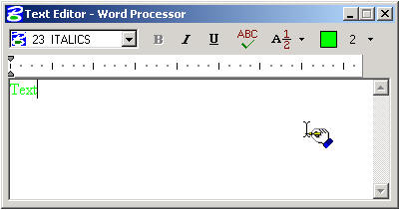

Editing text – Existing text may be edited by selecting the Edit Text tool, then placing a datapoint on the text to be edited. Change the text in the editor, and accept with a datapoint (the apply button is gone).

You can also use element selection to select the text to be edited, and then double click the text. This will bring the text into the text editor for editing.

CELLS –
Cell names are no longer restricted to six characters.
The Cell Library Dialog box is now resizable.
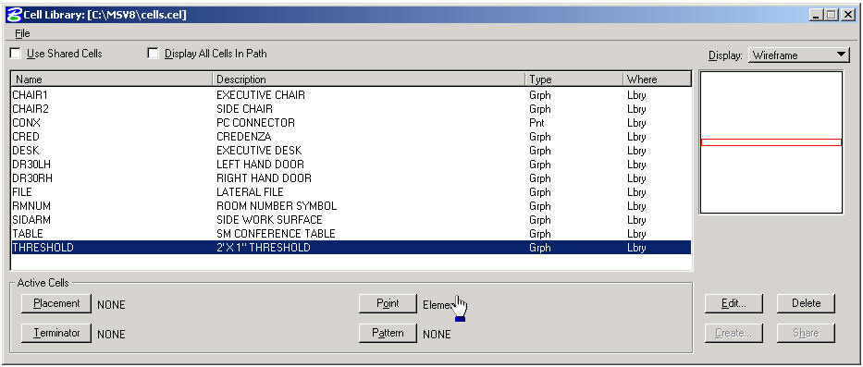

If you close the cell library dialogue box, the magnifying glass in the tool settings will bring it back.
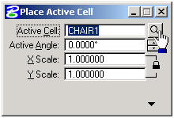

True Scale – If you wish to place a cell that has working units that are different from the file you are in, enable True Scale in tool settings (lower portion). True Scale adjusts the scale of the cell to fit the current file.
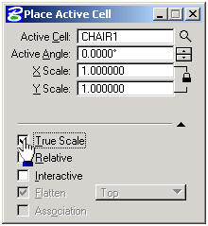

REFERENCE FILES –

This is the Attach Reference dialog box. Please note the Save Relative Path check box on the lower left, and the Attachment Method pull down on the lower right.

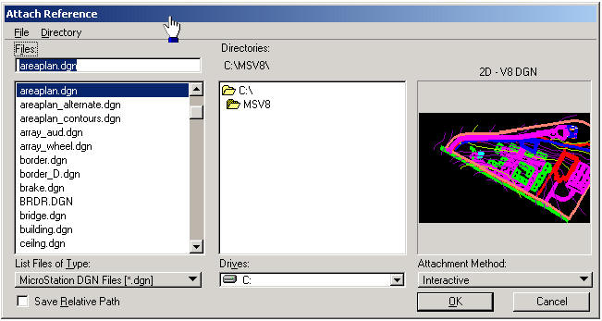

Reference Attachment Settings – Here you can assign a logical name and description, set true scale, choose the level of nesting, and set the options (as shown below).

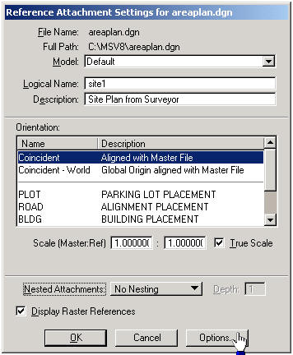

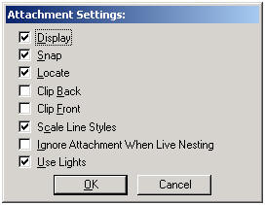

This is the new reference file dialog box.
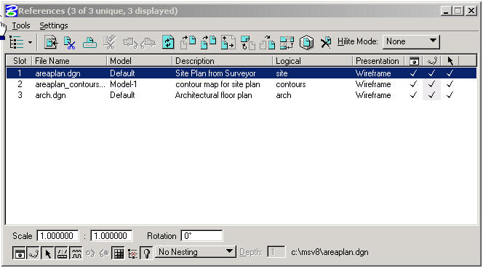

Please note, the reference file tools have been added at the top of the dialog box.

Notice the symbols across the bottom for : Display, Snap, Locate, True Scale, Display Raster References, Ignore Attachment When Live Nesting, Use Lights, Nesting, and Nest Depth.

Miscellaneous :

Save Settings on exit may now be set in preferences, without undesirable effects.

Element Selection – Handles will be displayed for one element selected.
Highlighting will be used for multiple elements.

Rotate Element – the option to rotate an element about its own center is offered in the tool settings box.

File – Ten file names are presented in the go to list at the bottom of the File column (menu bar).

Arcs by center now can go either counterclockwise or clockwise.

Copy Element – You may now specify the number of copies.

Fence Copy – You may make multiple copies from the original location.

