USING THE PLACE NOTE COMMAND

This command is used to place a line(s) of text with a leader line and an arrowhead for labeling items.

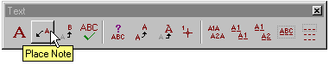

After you have selected the command, a dialog box will open that looks like one of the two images shown below.

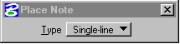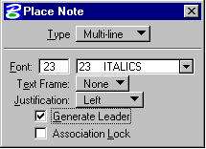

If the dialog box has the Type set to Single-line, change it to Multi-line. This will allow you to set some options for how the text will look and be justified. Font should be set to 23 (Italics), Text Frame should be set to None, and the Generate Leader toggle box should be turned on.

The Justification choice box has three options: Left, Right, and Dynamic.

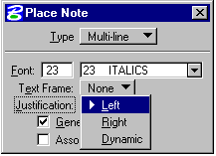

- Left – Multiple lines of text are aligned along their left side.

- Right – Multiple lines of text are aligned along their right side.

- Dynamic – Multiple lines of text are aligned based on the relationship between the last and the next to last data points. For example, if the next to last data point is to the right of the last data point, the text id right justified.

Once you have made the appropriate choice, focus into the Text Editor window and then begin to key-in your text.

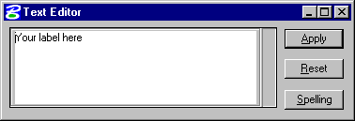

Place a data point to position the arrowhead, then place a second data point to position the text. Move the mouse left or right to determine where text will be anchored (either left or right side).



Using the above method to label items on your plan sheets does have some restrictions. The text cannot be placed at an active angle other than 0 degrees. If you try to rotate the text, after placement, the leader line and arrowhead will also rotate. Also unless you created this design file after April 15, 2002, you will have to make some dimension changes to get the arrowhead to show up properly. Listed below are the steps you will need to follow to set your design file up correctly.

- In the MicroStation Menu Bar click on Element, then Dimensions.

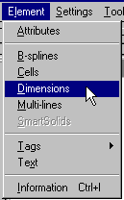

- In the Dimensions Settings dialog box click on Placement, then set Alignment to View, and Location to Automatic. Also turn on Adjust Dimension Line toggle.

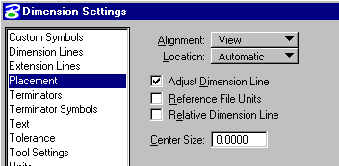

- In the Dimensions Settings dialog box click on Terminators, then in the Orientation area set Terminators to Automatic and Arrowhead to Open. In the Geometry area set Width to 0.6 for imperial or metric, Height to 0.25 for imperial or metric, and Min. Leader to 3.5 for imperial or 1 for metric.

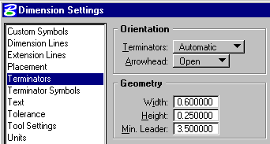

- In the Dimensions Settings dialog box click on Terminator Symbols, then set Arrow to Cell and keying Term in the Name field. Either dsym95 or mdsym95 cell library must be attached for proper terminator cell.

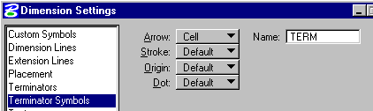

After you have completed the above, Save Settings so that the above options will stay set.

