ATTACHING SIGNATURE BLOCKS AS RASTER REFERENCE FILES OR AS IMPORTED IMAGES

The below processes will only work on non-rotated files.

The signature block will be sent to you via E-mail as an attachment. The attachment will be a TIFF File.

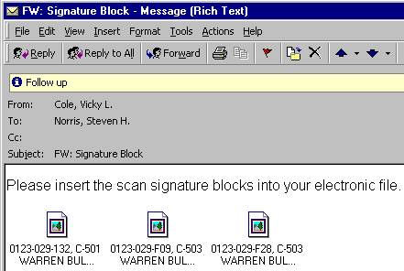

- Start by saving the TIFF image file in your local project directory. To do this, “right-click” on the tiff file icon, then scroll down to “Save As…” .

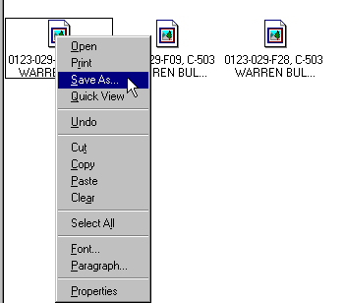

A dialog box will prompt you for a location to save your file. You should navigate to your local Falcon directory (c:\Documents\cfms_local). In the File name field key-in “dppms#sig1.tif”, then click on the “Save” button. Substitute ppms# with the appropriate numbers(see File name field in image on next page).

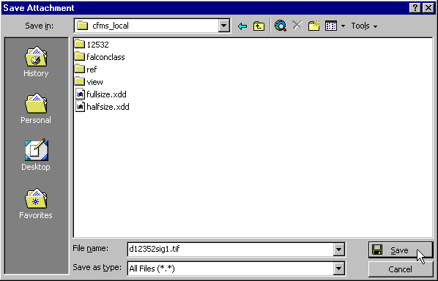

- Once the file has been saved locally you can add it to the Falcon Database through the Falcon Document Manager inside of MicroStation. In MicroStation click on “Falcon/DMS” , then on “Document Manager” .

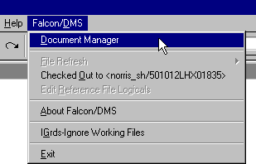

- From the “File Selection” drop-down menu, click on “Local File Selection” .

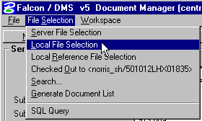
- Navigate to your local Falcon directory in the “Local File Selection” window (c:\Documents\cfms_local). Your file should appear in the “File Name selection” window. (Make sure the file extension setting is set to “all files (*.*)” as shown below. If not your signature file will not appear.

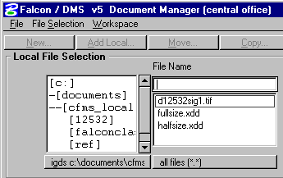

- You should “highlight” the signature file to add it to the “File Name” window, then click on the “Add Local…” button to add the file to the Falcon Database.

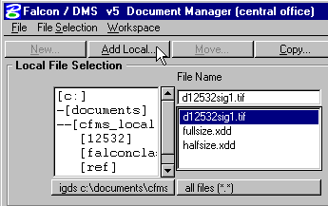

- You will now be prompted to “Assign File Format” for your file. Click on the radio button next to “Prompt for each doc.” , then select “tif” from the “Existing File Formats” window, then click “OK” to continue.

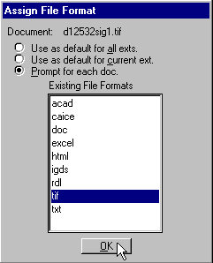
- The “Add Local Document” window will appear. Your signature block file should appear in the “File Name” window. ***Before you select the “OK” button you need to fill in the “PPMS#” window, the “Division” window (dppms#), and the “Description” field. Also make sure that Only the “Display Database Tabs” box is checked. Once you have verified that the above has been filled in, then click on the “OK” button.

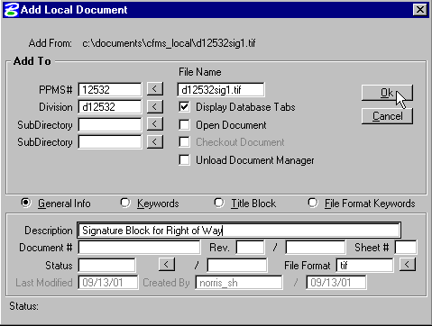

When the process has finished, unless you had the “Unload Document Manager” box checked, you will have to click on the “Cancel” button to dismiss the above dialog box. If the “Unload Document Manager” box was checked, then both the “Add Local Document” and the “Falcon Document Manager” will disappear and you will need to re-activate the “Falcon Document Manager” . In the document manager, confirm that the file has been added to the database. Look at the bottom of the dialog box, the Status Field should read “Retrieved record for dppms#sig1.tif” and the Availability Field should show workstation name and the current users name.

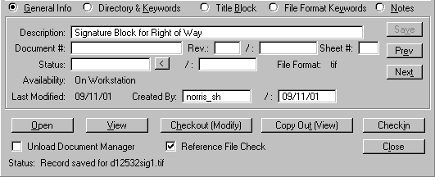

- Next, click on the “File Selection” pull down menu, then click on “Server File Selection” .

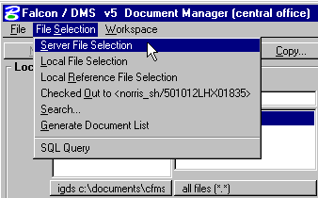

- Find your Title Sheet file, highlight it, then click on the “Open” button.

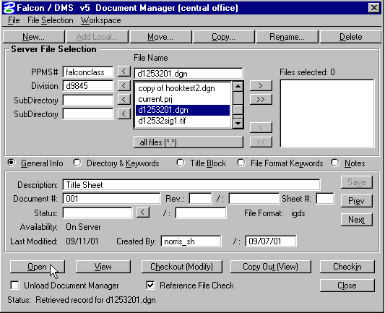

With the title sheet file now open, we can place the TIFF image file over our existing signature block(s). Window around the appropriate signature block.


- There are now two acceptable methods for placing raster images (tiff files) on Title Sheets. One is by “referencing” the tiff image(s), the other is by importing the tiff image(s). The following steps are for referencing the tiff image(s). If you want to import the tiff image(s), skip to step 16.

REFERENCE FILE METHOD

- Since this is a raster image, we will not attach this reference file through “Falcon” . Instead, click on “File” in the MicroStation Menu Bar, then click on “Reference” .

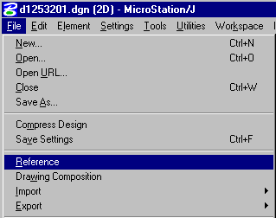

This will bring up your “Reference File” dialog box. Since we are attaching a raster image file, we must change our reference file display to raster. To do this, click on “Display” in the Reference File Dialog box, then click on “Raster” .

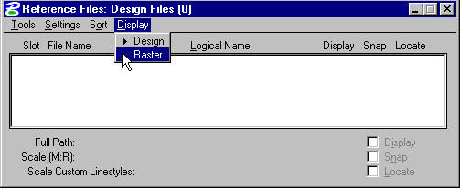

This will change the Reference File Dialog box to allow for the display and attachment of Raster Images.

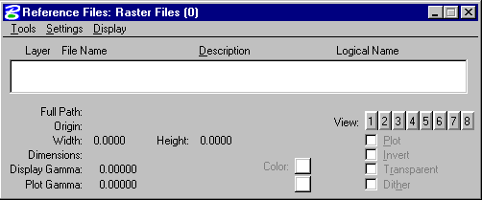

- In the “Reference Files” dialog box click on “Tools” , then “Attach” , then “Interactive” .

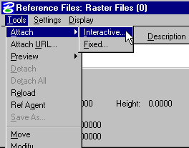

Using the “Attach Raster Reference File” dialog box, navigate to your project directory (c:\Documents\cfms_local\ppms#\dppms#), then highlight your “.tif” image file, and then click on the “OK” button.

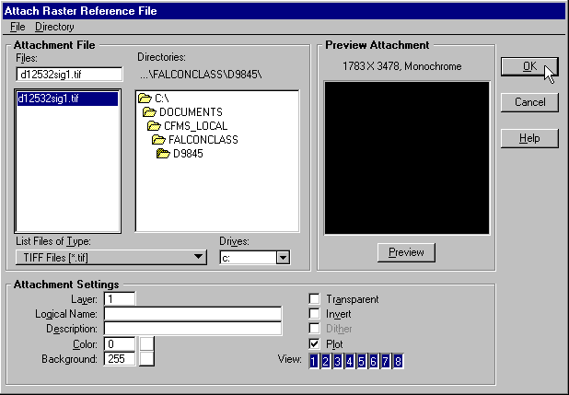
- When you click “OK” the above dialog box will disappear. You will be prompted in the lower left corner of your MicroStation window to “Enter reference origin” .

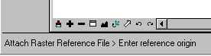

To enter your “Reference origin” you will need to place a data point just outside of the existing signature block at the upper left corner (if you cannot see the details of the existing signature block, zoom in, window area, etc. until you do).

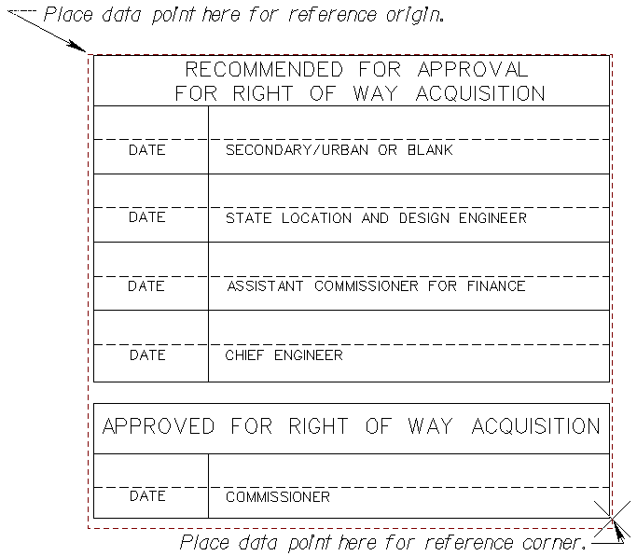

You will then be prompted to “Enter Reference corner” for sizing the raster image. Place a data point as shown above or if the signatures are for both Right of Way and Construction, place a data point at the bottom right of the entire signature block area. You will see a dashed line that will represent the size of the raster image to help guide you. When you place the second data point your raster image file should appear.

- Close the “Reference Files” dialog box to complete the process.

- When you have finished with any other changes to your title sheet, check the title sheet file and the raster image file(.tif) back in to the server. To make sure that the raster reference file stays attached, check the title sheet back out or have someone else check it out. If the raster image does not show up, you will need to create a new file using the “seedtitl.dgn” seed file, then copy the contents of your original file to the new file and then repeat the attachment process.

IMPORT IMAGE METHOD

- After windowing around the appropriate signature block, in the MicroStation Menu Bar click on “File”, then “Import”, then “Image…”.

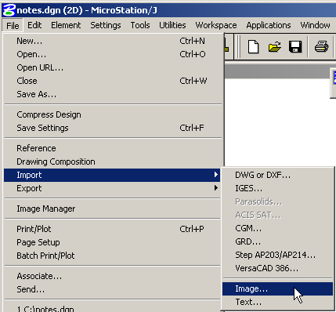

- Using the “Select Image File” dialog box, navigate to your project directory (c:\Documents\cfms_local\ppms#\dppms#), then highlight your “.tif” image file, and then click on the “OK” button.

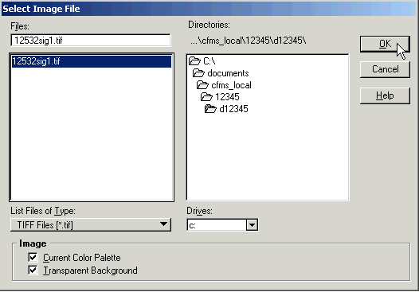
- When you click “OK” the above dialog box will disappear. You will be prompted in the lower left corner of your MicroStation window to “Select rectangle origin” .

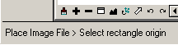

To enter your “Rectangle origin” you will need to place a data point just outside of the existing signature block at the upper left corner (if you cannot see the details of the existing signature block, zoom in, window area, etc. until you do).

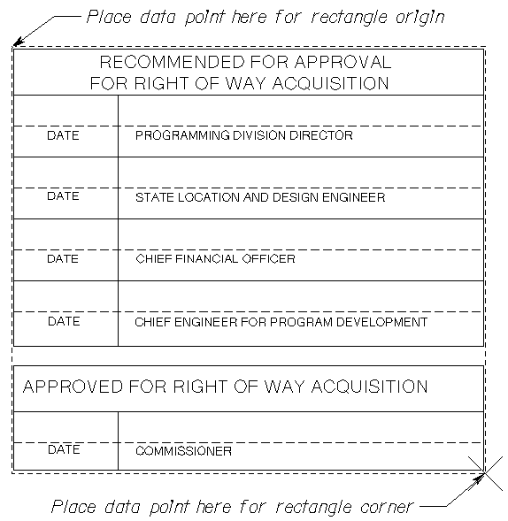

You will then be prompted to “Enter Rectangle corner” for sizing the raster image. Place a data point as shown above or if the signatures are for both Right of Way and Construction, place a data point at the bottom right of the entire signature block area. You will see a dashed line that will represent the size of the raster image to help guide you. When you place the second data point your raster image file should appear.

- Check your file back in to the server.

