Exporting Horizontal and Vertical Alignments Using SDMS
(from IGrds)

- From the IGrds menu bar select File, then Export, then SDMS.

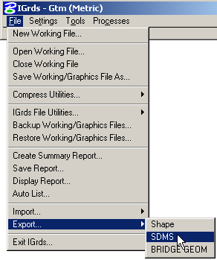

- In the SDMS Data Export, set your Data type to either HA or VA for horizontal alignment or vertical alignment.

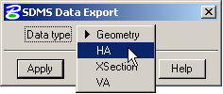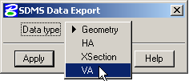

After you’ve made your selection, then click on the Apply button.

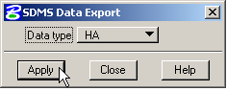

- One of the below dialog boxes will appear to allow you to select the location that you will save your file to. They will default to whatever directory your IGrds working files are located. Once you have chosen where you want the files to be stored, click on the Apply button.

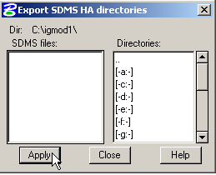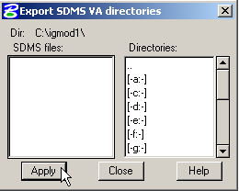

- If you are exporting horizontal alignments the below dialog box will show up. Make sure you set the Output type to PI data. If you have multiple alignments, then click on the All button. This will add all of your alignments to the list. It will use the IGrds roadway name as the name of the export file to be created (SDMS roadway). You may choose to delete the entry or revise the SDMS roadway name if necessary. Once you have all the roadways in the list, click on the Apply button.

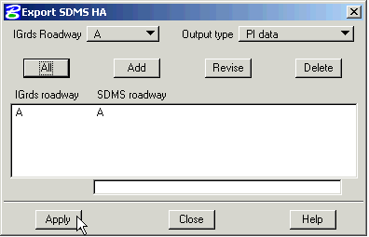

- If you are exporting vertical alignments, select the IGrds Roadway name from the pull down list, confirm the SDMS file name is the same, then click on the Apply button. Vertical alignments are exported one at a time, so if you have multiple vertical alignments, then you must change the IGrds Roadway, confirm the SDMS file name and click on the Apply button again.

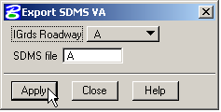

The above steps will create two types of files, a .ali file and a .pro file. These files will be used by GEOPAK’s COGO dialog to import your alignment data into GEOPAK (see Importing Horizontal and Vertical Alignments document).

