SECTION 9
PLOTTING WITH eQUORUM PRF GENERATOR

The Department is currently using the eQuorum plotting software version 8.4.33 or later to plot all design files. The following is a step-by-step procedure for creating and submitting plots from the eQuorum PRF Generator menu.
1. Place a fence around the area that you wish to plot. This area will generally be the boundary of the border.
2. Select Applications from the MicroStation Command Window, then eQuorum Plotting, then PRF Generator. This will bring up the eQuorum PRF Generator dialog box (menu) as shown below.
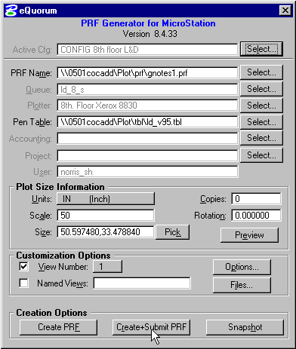
3. The first field titled Active Cfg. allows the user to select the floor that the plot will be sent to. This field will also automatically set the Queue, Plotter, and Pentable.
4. The second field titled PRF Name shows the user the name of the plot being generated. eQuorum automatically assigns a name for the plotfile using the CADD file name with a .prf extension. Unless you have a specific reason to change this, accept the default PRF Name.
5. The third and fourth fields titled Queue and Plotter respectively, identifies which plot queue and plotter your plotfile will be submitted to. These fields are configured based on the choice in the Active Cfg. field. If you need to change the default settings for these fields, place a data point on the select button next to the field to open up a new dialog box containing all of the available options. Even though the field may be "grayed out" , the select button will allow changes to the field, however keyins for those fields are not allowed.
6. The fifth field in this dialog box titled Pen Table identifies which pen table to use to create your plot. The pen table is software that instructs the plotter how wide to make lines, which fill pattern to use, etc. This option is also dependent on the plotter that you are submitting your plot to and is configured correctly for your workstation. However, if you do need to change the pen table, place a data point on the Select button next to the field and choose the desired pen table. Below is a list of available Location and Design Pen tables.

Pen Table | Description
ld_v86.tbl | pre July 1995 level structure
Ld_v95.tbl | post July 1995 level structure
ld_xsc.tbl | Cross Section plots
half_v95.tbl | half size prints, post July 1995 level structure
vdotcolr_v95.tbl | color plots

7. The sixth, seventh, and eighth fields are auto configured and should not be changed.
8. The next block of fields is the Plot Size Information. The first field here is configured to default to IN (inch). If the plot is metric this field must be changed to M (meter). This variable instructs the plotter to plot your drawing in inches or meters.
9. The next field titled Scale represents the scale of the final hard copy plot. To change this value just double click on the value in the field. When the current value is highlighted, key in the desired scale value. Notice that when you enter a new scale that the field titled Size changes to represent the overall size of the plot when plotted at this new scale factor. You can easily confirm that you have entered the correct value for scale by reviewing the values in the Size field. For full size plots, the value will be 35.00,23.00.
10. The next field titled Size represents the final hard copy plot size in the units represented in the above field. This value will change automatically as you change the plot Scale in the preceding field. Therefore, if you need a plot that is to scale, you do not need to change this value. However, if you need a specific size plot and are not concerned with the scale, then you will need to change the value in this field. To change the value here, double-click on the field to highlight the entire entry. When the current entry is highlighted, key in one of the two sizes, that is, either the x (horizontal) size or the y (vertical) size. After you key in one of the two sizes, TAB to the next field. Notice that the computer automatically interpolates the other size and changes the scale to match the overall plot size. The Pick button has not been configured for use.
11. The next field titled Copies indicates how many additional copies of the plot are desired. This value will usually remain at the default value of zero (no additional copies). If you need multiple copies of the plot, then double click on the field to highlight the current value and then key in the desired number of additional plots.
12. The next field titled Rotation should not need to be changed. If your drawing has been clip-bound while at a rotated view, then key-in the angle of that rotation in the rotation field to obtain the entire plot.
13. The Preview button allows the user to preview the plot before submitting plot request (Preview is not active, Vdot does not have necessary license).
14. The Customization Option fields titled View Number and Named Views are set correctly by default if you are plotting using the Fence method. If you are not using a fence but are instead plotting the contents of one of your eight available views, place a data point on the button on the left of View Number. This will darken in this option box. Next, hold down your data point on the box next to View Number and slide down to the appropriate view number that you want to plot and release the data point. If you are plotting a particular named view, then place a data point on the button on the left of Named Views. This will darken in this option box. Now key-in the name of the saved view which you wish to plot.
15. The last step to follow is to select the Create + Submit PRF button under Creation Options. The plot will now be processed by the eQuorum plotting software using the instructions, which you defined, in the preceding dialog box.

