DGN Preparation for Batch Plotting

The following instructions will aid you in setting up your MicroStation design files for batch plotting. Batch plotting will allow users to plot files without having to open the file and place a fence around the data to get a plot. These steps must be applied to all plan sheets that are to be plotted.

- If you created your design file after February 1, 2002, you should skip to step 3. If you are unsure when you created the file, click on the Windows pull down menu and see if Window 5 appears as a choice. If so, skip to step 3.

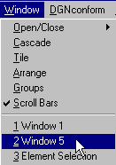

- If Window 5 does not appear, then go to Open/Close and then click on number 5.

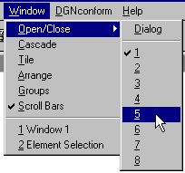

- Make sure you have followed instructions in Cadd Manual Chapter 3 Section 6 for Preliminary Design Creation, Alignments, Cadd Development, and Development for Field Inspection. It is imperative that you have all the necessary reference files attached and that you have rotated your view so that the plan sheet appears right side up. Then follow instructions for Clip Bounding as described in Appendix D Section 1. After finishing with clip bounding, window area closely around the sheet boarder so that the plan sheet fills Window 1.

- Confirm that all necessary View Attributes and correct Levels are turned on in Window 1.

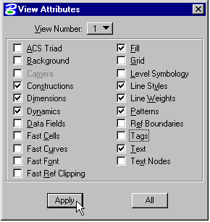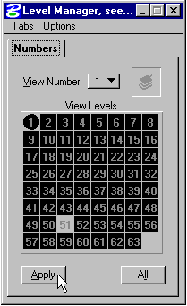

- Click on Utilities, then Saved Views. In the Name Field key-in Plot, and if you would like to key-in some info in the Description Field, confirm that View is set to 1, then click on the Save button.

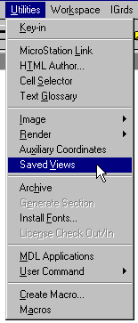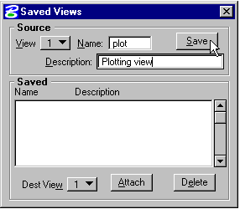

- Now attach the saved view to Window 5. Highlight the saved view in the field in the middle of the dialog box, change Dest View to 5, then click on the Attach button.

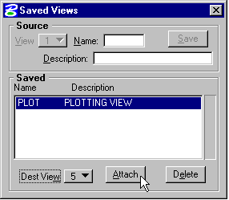

- Make sure data appears in Window 5 correctly, then you may bring Window 1 to the foreground, then Save Settings.

Window 5 may stay in the background as the plotting process just looks to see if Window 5 is on and then plots data in that window.

