Creating IGrds Reports

There is a new macro that will re-format your Igrds reports so they will look better
when printed. To use the macro you must copy the file Normal .dot from \\0501cocadd\proj\ld_sup\macros to C:\Documents and Settings\username\Application Data\Microsoft\Templates directory. You cannot use the Design Data Report or the Summary Report. Use tmp or lis files only. The report cannot be edited in any way before you run the macro or it will not work. (Note: Use “lis” file only for Design Xsection, Earthwork, Slope Stake, Staking Detail, and Toe Slope.)

Create your report in IG and then open the report (tmp or lis) in Microsoft Word.
You will get a File Conversion box.

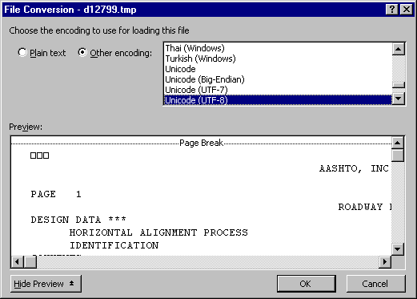

Click OK.

The first page maybe blank so if you scroll down you will see your report. On the menu bar go to Tools ➔ Macro and then click on Macros.

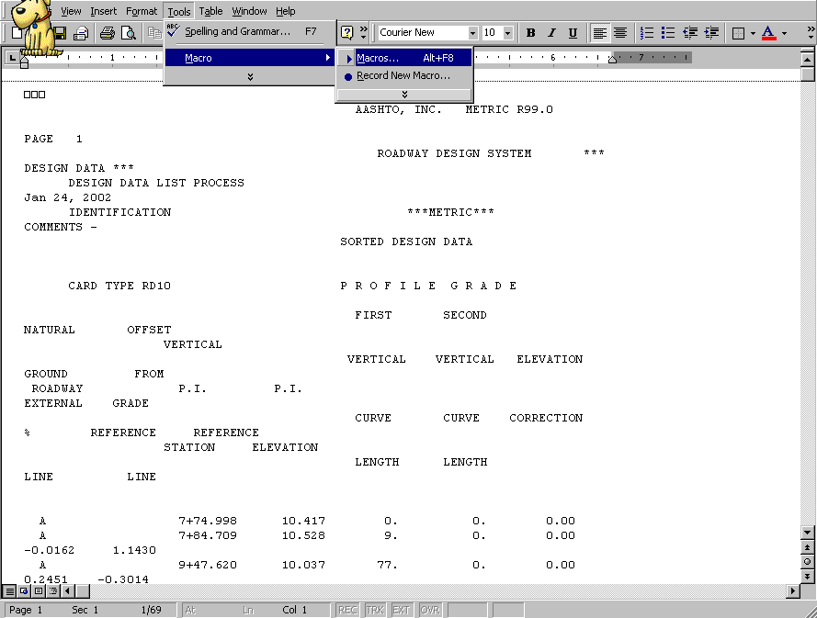

You will get a box with macro names. Pick the one for the type of report you have open.

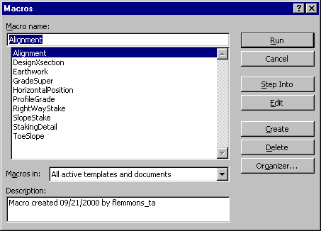

Click run.

You will get a box to key in your project number. Key in the project number you want to show on the cover sheet.

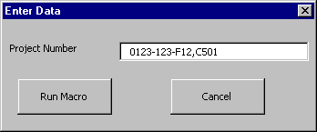

Click Run Macro.

You should get your report with a cover sheet

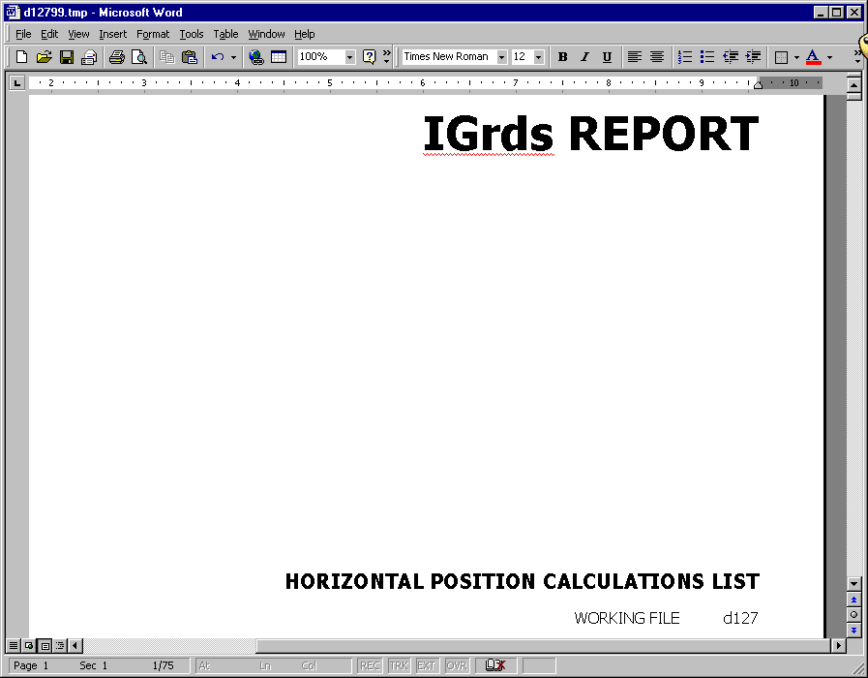

Then go to file ➔ save as and name the file in accords with IIM 118.2(Creating IG Reports). Click save. Make sure you save the file in the C:\Documents\cfms_local\PPMS#\dPPMS# so you can add the file to Falcon

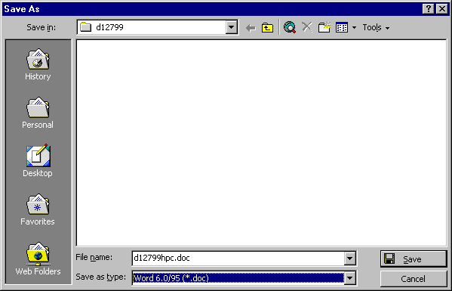

If you wish to create all your reports and rename them in text pad or explorer you can. Then open them in word and run the Macro, but when you go to save them you will get this box. Always click no and then click save.

