Creating PDF Files for Electronic Plan Submission using MicroStation V8i

When it becomes time to submit PDF files in accordance with the Electronic Plan Submission Process Flow Chart for various milestones, you must first make sure you have all required Falcon Database Information filled out correctly. Failure to do so could result in files not being processed, named incorrectly, and possibly delaying the project.

Consultants are required to submit PDF files in accordance with department guidelines.

Creating PDF Files for Electronic Plan submission for VDOT staff:

Turn the line weights “On” in the file. This is not required for Bridge Plans.

Place a Fence around the drawing.

Go to File on the Main MicroStation Menu and select Print:

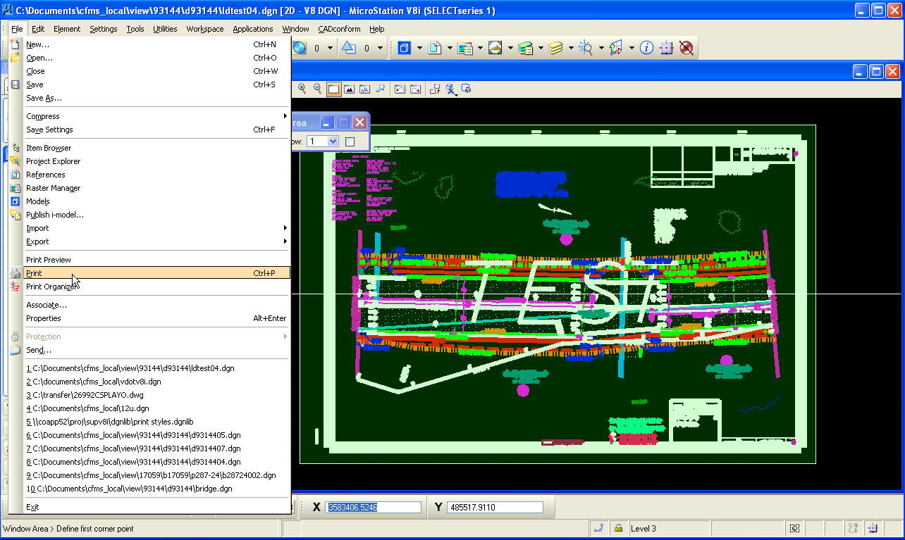

The following Print Menu dialog box will appear:

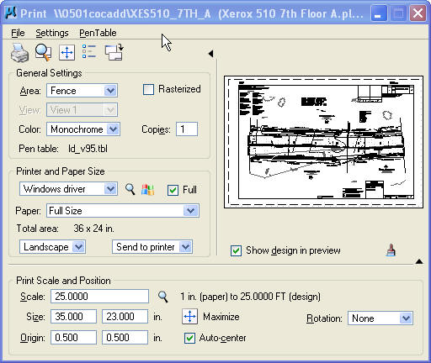

Select a Printer Driver Configuration file by clicking on the Magnifying Glass icon to browse to the driver list.

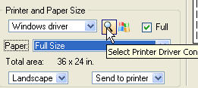

Choose the appropriate Printer Driver Configuration file to create the PDF Files:

Bridge Plans : Bridge PDF File Generator.pltcfg

Roadway Plans : LD PDF File Generator.pltcfg

Traffic Plans : Traffic PDF File Generator.pltcfg

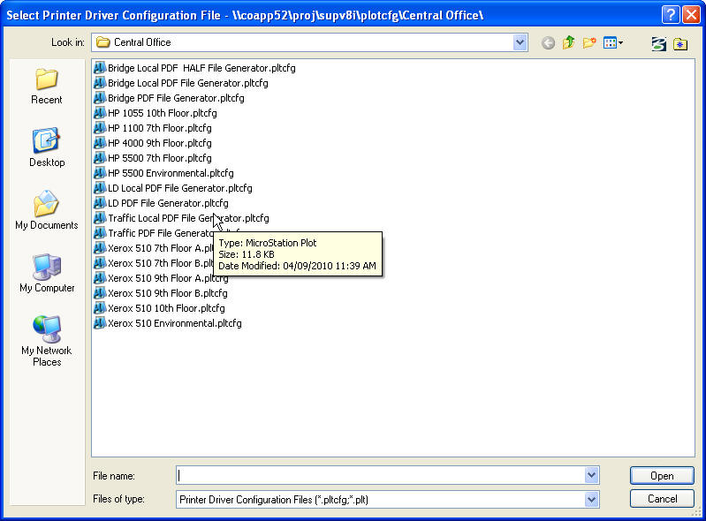

Note: Defaults are set within the Driver Configuration. You only have to pick the driver once. MicroStation will remember which driver you used last.

Verify the following information is correct before submitting the plot:

- Area – Set it to Fence

- Color – Set it to Monochrome

- Paper – Set it to Full Size

- Pen table – Select the appropriate pen table if not already set

- Scale – Key in the appropriate scale if not already set

Select File → Print:

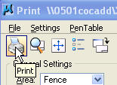

Once Print is selected the following dialog box will pop up. The default location for where the PDF files will be created is pre-defined in the Printer Driver Configuration file.

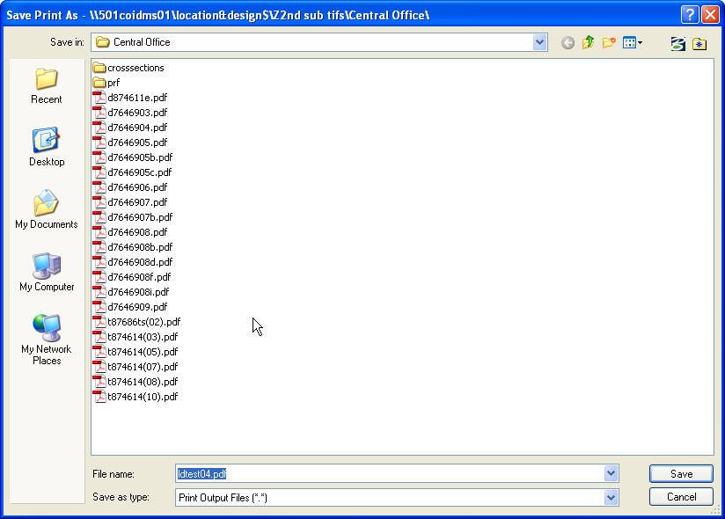

Select → Save

The PDF files are stored on the server with the same name as the DGN at first. The Cadd Support Section periodically runs a program call “Release Drawings” that renames and moves the files to a holder area. From there, the files are added to “Current Drawings” or “Plan File Room” depending on how the database field was defined.

It is imperative to have the “Keywords” Database fields filled in correctly so that the new PDF file names are correct and the plans sheets will be in order for printing within Falcon.

