USING FALCON TO ACCESS CENTRAL OFFICE PLAN FILE ROOM FILES

Since the files that you will be accessing are TIFF image files, the following screen captures are showing the Windows version (Document Manager) of Falcon instead of the MicroStation MDL version.

To access Falcon, go to Start, then Programs, then Falcon_DMS, then Doc. Manager.

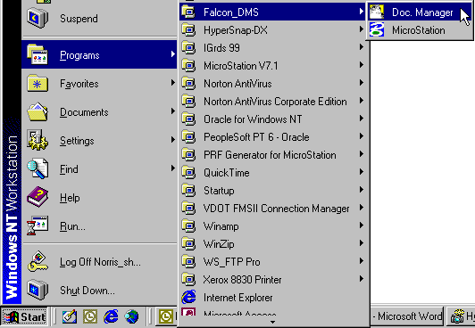

When the Falcon Dialog box opens up, click on Workspace, then Environments, then Plan File Room.

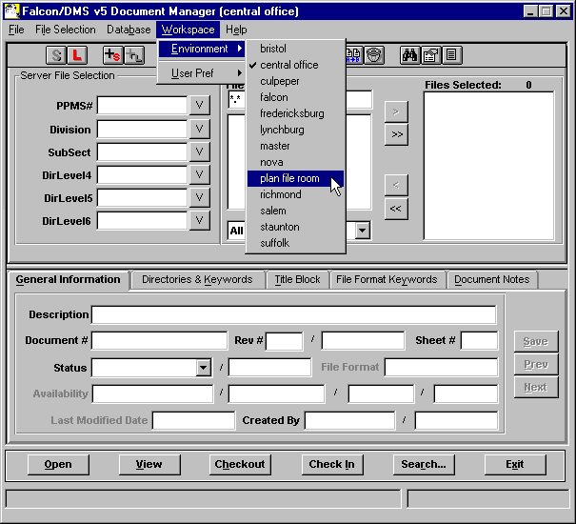

The dialog box will change to show choices for File Room, District, Projects, and Sub Projects. Click on the down arrow next to the File Room field. You will then see three choices for types of plans to view. Click on Road Plans, then click on the OK button.

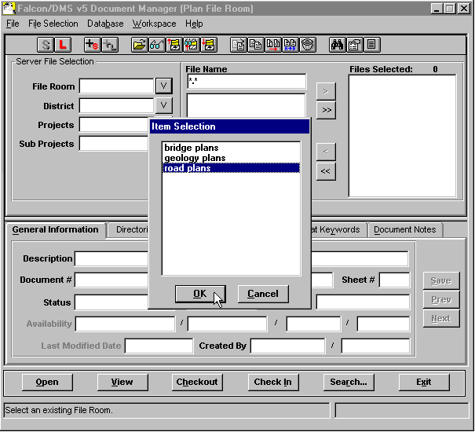

Next, click on the down arrow next to the District field. Select the District that the project is located in, then click on the OK button.

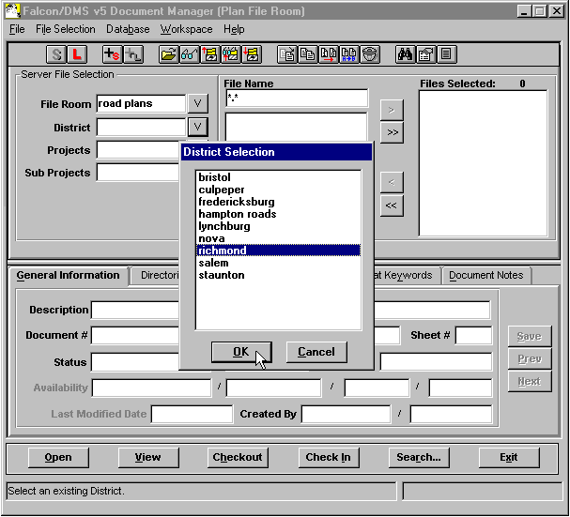

Next, click on the down arrow next to the Projects field. Select the project that you are interested in, then click on the OK button.

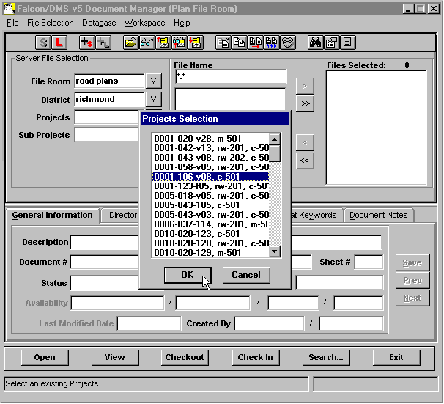

Files should show up in the File Names field. File names are set up using the base project number, the sheet number, and the .tif extension. When you select a file the database tabs at the bottom will show appropriate information.

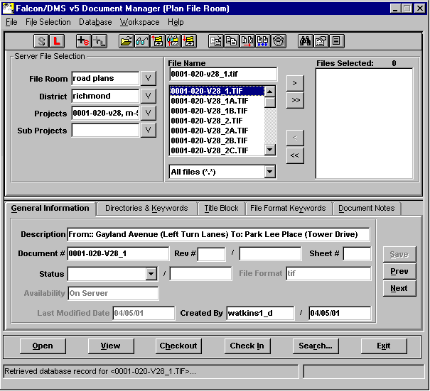

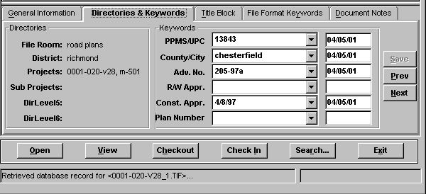

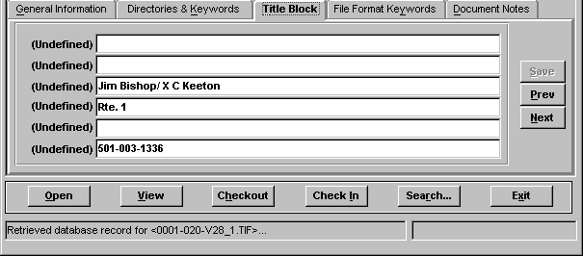

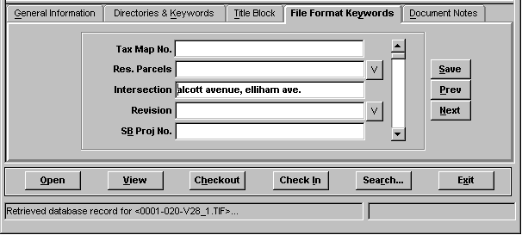

If you are not sure of the project District, number, etc. , then you can use Falcons search engine to find it. To start the search, click on the Search button at the bottom of the dialog box. You may search the database by keying-in info in one of the blank fields. The following screen captures show an example of the description field on the General Information tab and the PPMS number field in the Directories & Keywords Tab.

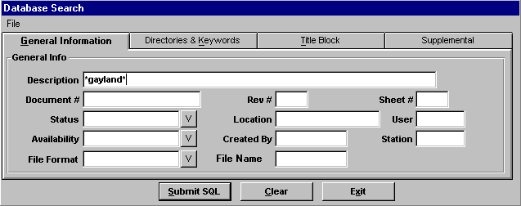

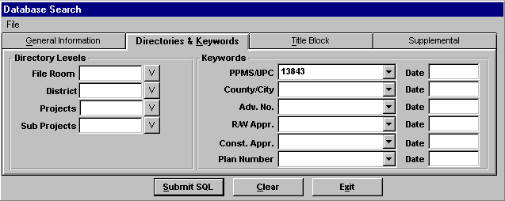

Once you have filled the appropriate field, click on the Submit SQL button to initiate the search. If the search is successful, Falcon should give you a choice list of all the files that match your search request.

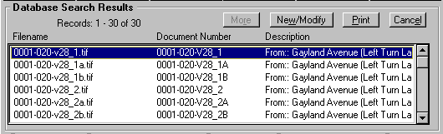

When you have found the project information you were looking for, click on the file that you wish to view, then click on the View button at the bottom of the dialog box. A Select Application dialog box will appear. Select imaging if you are using a Windows NT machine or imaging_win95 if you are using a Windows 95 machine, then click on the OK button.

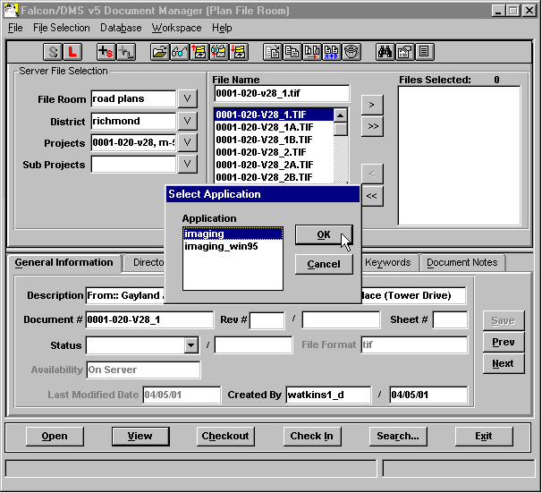

The file will open in an application called Imaging, which will view and print the file only. These are TIFF image files and they are not editable.

