Falcon Web Users Guide

As more projects are being designed by both VDOT staff and consultants collectively, it has become evident that file integrity is extremely important to the overall project development process. Some consultants have primarily been using the FTP server or other methods to transfer files to the project managers or design teams as needed during the design phase. Moving forward, all Consultants will need to obtain Falcon access as outlined below and work through VDOT’s web based Falcon CADD File Management System. Falcon is the document management program used by the Department to store and manage files. This will allow all design teams to access the latest and most up to date files on each of their projects. Files can be posted along with metadata and checked in and out using the web based Falcon system.

Each employee of the firm who will be using the Falcon Web Site will need an individual login and password. You can request access by downloading the forms using the hyperlink below. Once you have downloaded the Falcon Access & Security Agreement form and the LD-894 form, please complete the forms and send them via fax or e-mail as indicated on the form.

Link to instructions on how to request a login/password and access to projects in Falcon:
http://www.virginiadot.org/business/resources/LocDes/How_To_Obtain_Falcon_Access.pdf

If you have any questions please contact the CADD Support Helpdesk by email CADDSupport@vdot.virginia.gov or call toll free (888) 683-0345 or local (804) 786-1280.

Once your login and password has been received, log into the Falcon Web site using this web address: http://falcon.virginiadot.org/falcon/. This will bring up the VDOT Electronic Plans login window, key in your login and password.

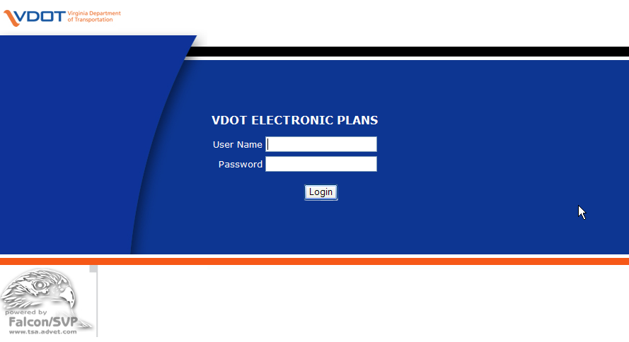

Once logged in, the user will see his or her consultant firm name. Double click on firm name.
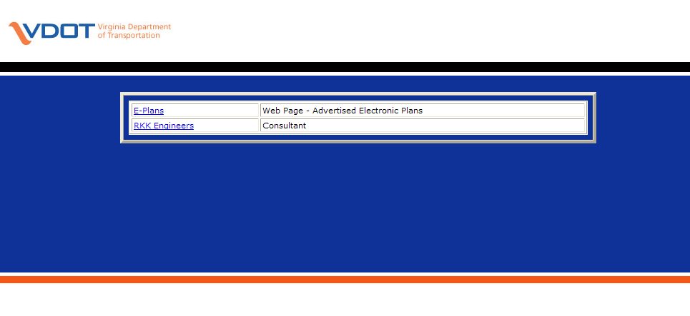

This will bring the user to the “Search Screen”. Click on the folder to the right of the “PPMS” box first to select the UPC number that you would like to access and then select the folder beside the “Division” to choose the subfolder of the files. You will only see projects in the list that you have requested access to.
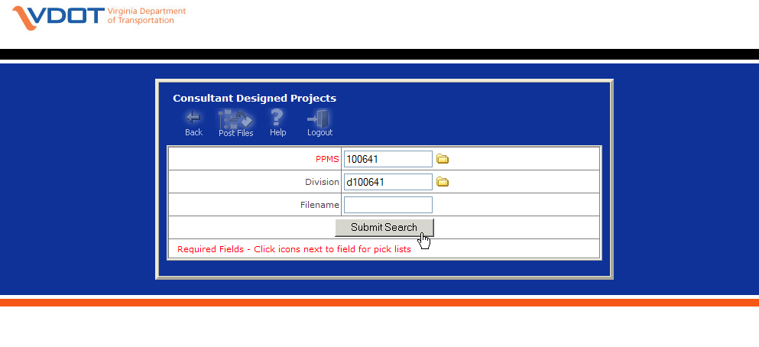
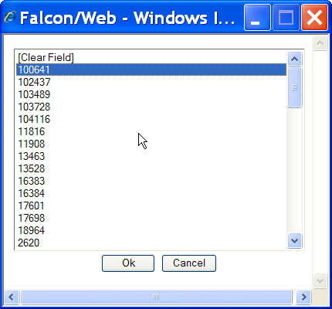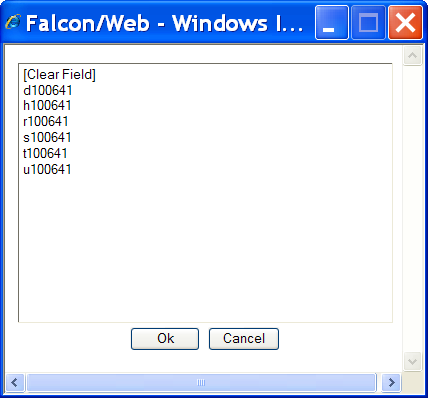

Select the Submit Search button.
Once the Search is completed, the Search Results screen will appear.

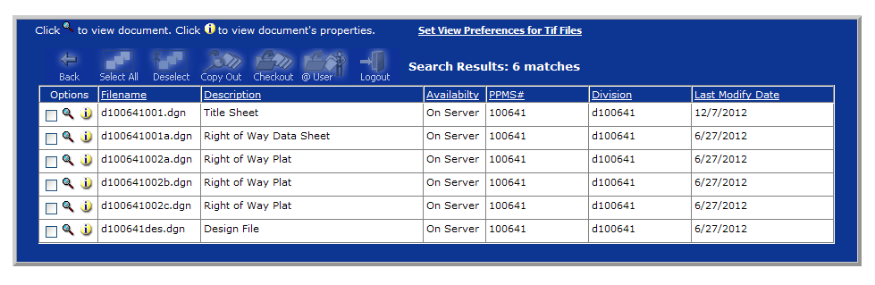

From here several commands are available. The two most common are the “View Document” and “View Document Properties”. They can be found on the far left under the options column.

View Document 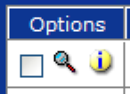 View Document Properties

The Icons across the top of the Internet Explorer window can be used to do various operations.

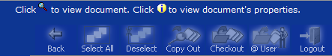

Back – Used to navigate to the previous window

Select All – Puts a check beside all items in window

Deselect – Removes the checks on all selected items

Copy Out – Copies the selected files down from the server to the user’s PC for view only

Checkout – Copies the selected files down from the server to the user’s PC for modify purposes. This command is used to check out files that need to be updated and then checked back in.

@User – Queries to see which files are checked out to the user so they can be checked back in

Logout – Logout
Posting Files –
This command is used to add new files from the local PC to the VDOT Server. While at the “Search Screen”, select the icon for “Post Files”.
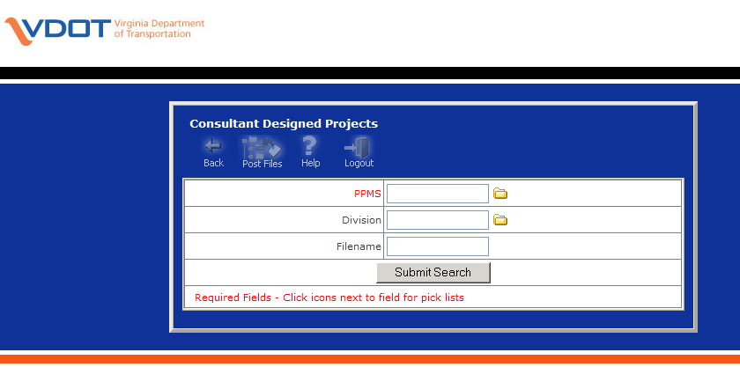
This will take you to a window that will allow the user to #1 Browse for Files to Post from local hard drive, #2 Select Storage Location for Files on the Server, #3 Assign Attributes & Add to the Database (metadata). One or multiple files can be added at once.
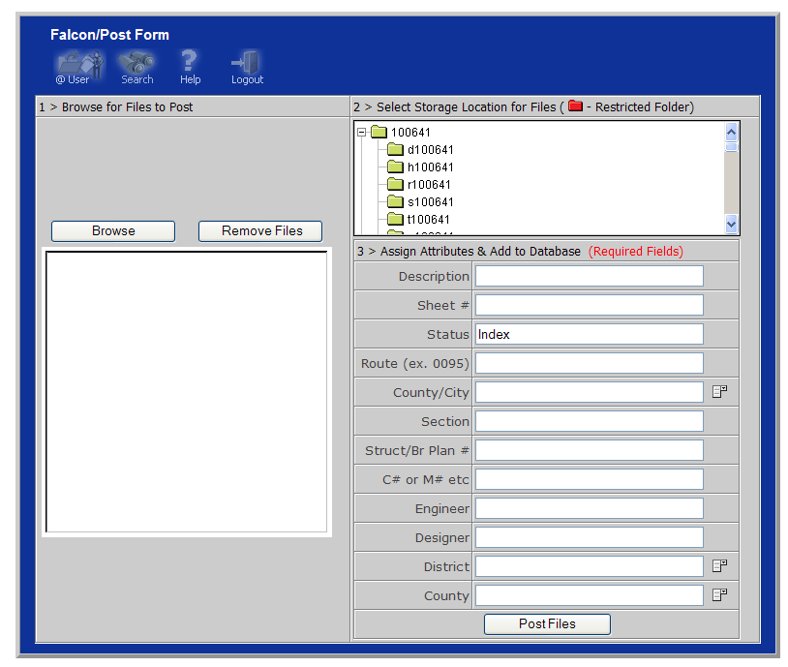
Updating Database Information (Metadata) –
Once a file has been updated, the user can add or edit the required database fields by selecting the “View Document Properties” button beside the file.
Once this is selected, the Document Properties window will appear. All rows are to be filled in for each file to ensure the files move through the project development process smoothly.
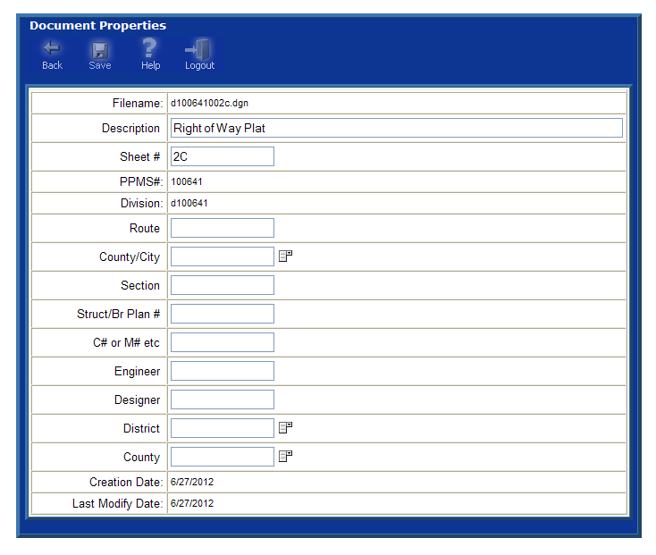
Click on the “Save” button at the top to save the metadata to the database.

If you have any questions please contact the CADD Support Helpdesk by email CADDSupport@vdot.virginia.gov or call toll free (888) 683-0345 or local (804) 786-1280.

