Falcon Database Information

This document was generated using Falcon documentation and information initially compiled by the L&D AES group. The content has been modified to be applicable to the Structure and Bridge division processes.

Purpose
This document provides standard procedures for filling in the Falcon Document Management System’s required database fields and shall be used in all cases. These standard procedures are effective October 18, 2001.

Scope
The database information that Falcon provides will be extracted and used by other programs in the electronic plan process. The major uses for the Falcon database information are:

- Producing an Index of Files
  - Status = index

- Archiving files at different stage of Concurrent Engineering Project Development
  - Preliminary Field Inspection
  - Public Hearing
  - Authorize Right of Way
  - Field Inspection
  - Final Right of Way
  - Right of Way Revision
  - Plan Submission
  - Pre Award Revision
  - Construction Revision
  - As Built Plans

S&B will always archive files at Plan Submission, Revisions and As Builts and may occasionally need to archive files at one of the other stages, depending on the project.

- Automatic tif file generation for Electronic Plan Submission
  - Tif files created by designer is automatically renamed and placed into Plan File Room environment

It is very important to follow these instructions and complete the database information as soon as possible so it does not cause any delays to a projects schedule. Falcon settings will be changed December 1, 2001 statewide which will force/require all the fields indicated in these instructions to be filled in for creation, checkout and check-in of files. . All database information on new projects from receipt of these instructions must have the information keyed in as the files are created.

Falcon has been implemented statewide and is used to share files between multiple disciplines. Designers should be as informative as possible when entering descriptions since someone searching for a document may use the descriptions.
Both the Falcon Windows Document Manager and Falcon MDL Document Manager can be used to key in the information. To update an existing project, the Windows Document Manager would be the best tool to use because the “cut” and “paste” method can be utilized. The Windows Document Manager has another tool to update database fields for multiple files; this tool is called Mass Update. This command is found under Database --> Mass Update. To run the Windows Document Manager go to Start –> Programs – >Falcon_DMS –> Doc. Manager.

The remaining portion of this document provides illustrations and procedures to follow when filling out the required database fields. If you need more assistance or have questions that were not answered, please call the S & B Computer Operations Helpdesk at 786-2359.

Illustrations & Procedures

The following screen captures show the required fields highlighted in yellow as they will appear in both the Microstation Document Manager (DM) and the Windows DM. There are times when the field may be left blank. Please read the following carefully.

All Files
General Information Tab
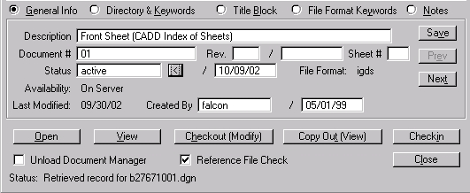
Front Sheet
01
active
MicroStation Document Manager

Leave blank
Sheet # - 2 digits
min. w/ Leading zero

Revision info

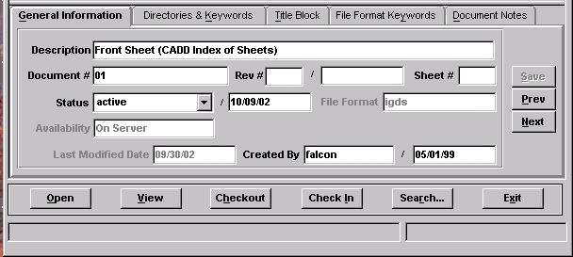

01
Front Sheet
active
Windows Document Manager

The “Description” field for S&B plans should be filled in with the title of the sheet (ex. Abutment A). The “Document #” should ALWAYS be filled in with the FINAL sheet number that applies to the plan unless the sheet is a worksheet that will not be included in the plans, in which case it should be left blank. This may require that the number be modified prior to indexing or archiving.

The “Status” field has several choices. The field must be set to “index” only when the file is going to be a part of the plan assembly. Otherwise set the field to “active”. The “survey” setting is for locking down the survey file when it is being edited. Do not change status field if set to survey.

Directories and Keywords Tab

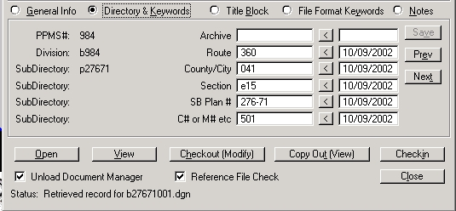
0360
041

E15
276-71
C501
MicroStation Document Manager

Plan #

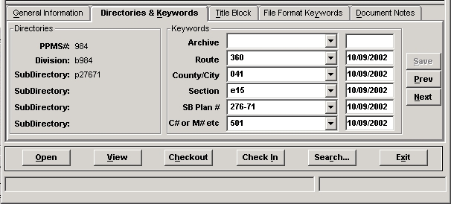

0360
041

E15
276-71
C501
Windows Document Manager

The “Archive” field is required to be used only when you are ready to archive a set of files, otherwise it should be left blank. Instructions about the “Archive” field are shown in more detail on page 8. All files with the “Status” set to index must have the Route, County/City, Section, SB Plan #, and C# or M# etc filled in.

Title Block Tab

The Title Block provides six additional fields that can be used for indexing. The current version of Falcon does not allow renaming of the left hand captions, however the user can still search on these fields as they are labeled Title Block 1, etc. on the Database Search window.

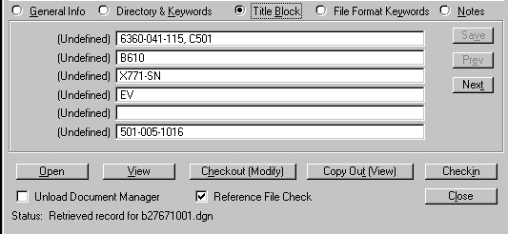
6360-041-E15, C501

B610

X771-SN

EV
501-005-1016
(Road Project #)
(Bridge #)
(FHWA & Scour Code)
(Checker(s) Initials)
(Record Series #)

MicroStation Document Manager

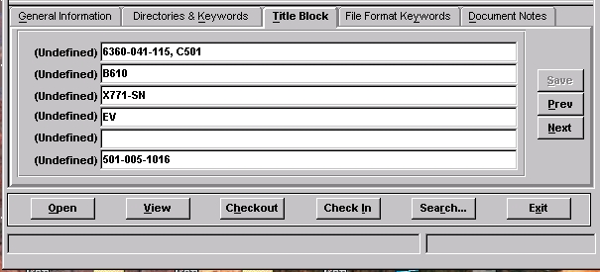

6360-041-E15, C501

B610

X771-SN

EV
501-005-1016
(Road Project #)
(Bridge #)
(FHWA & Scour Code)
(Checker(s) Initials)
(Record Series #)

Windows Document Manager

The items shown in the two views, as identified by the information in parenthesis, will be included for all S&B plans. The Record Series # shown applies for all CADD plans.

File Format Keywords Tab

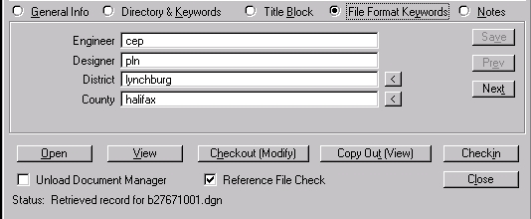
cep
pln
lynchburg
halifax

MicroStation Document Manager

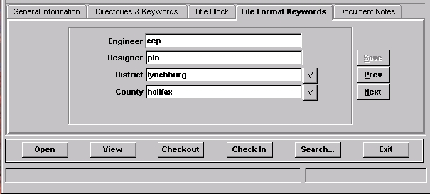
cep
pln
lynchburg
halifax
Windows Document Manager

All files with the status set to “Index” must have Engineer, Designer, District, and County filled in. If the Engineer and Designer are the same person, then the “Designer” field is not required and may be left blank.

The “Engineer” field should be filled in with the name of the Supervisor of the section or the Sr. Engineer who is overseeing the design.

Document Notes

Completing the “Document Notes” is not required for projects in S&B, however it may be used by the designer for special notes that need to be preserved with the plan sheet.

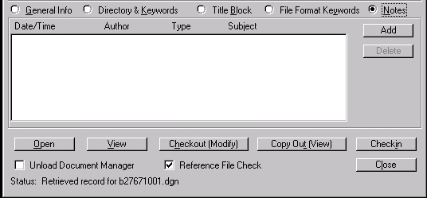
MicroStation Document Manager

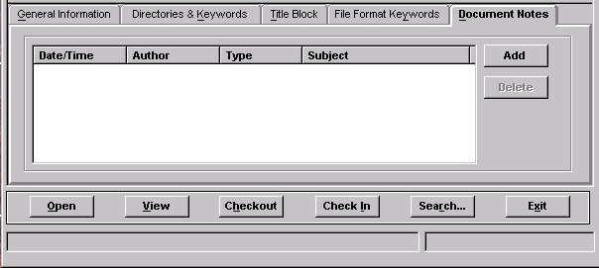
Windows Document Manager

The snapshot below is an example of how notes will appear once they have been entered into Falcon.

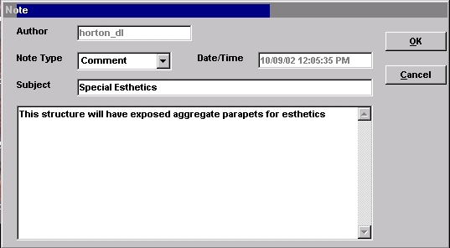

Archiving Files

The following instructions are for archiving your files. Archiving your files will give you a complete copy of your project at that particular stage of development. After all of the “required” database fields are filled out, you are ready to archive the project when you reach one of the appropriate concurrent engineering stages. In the “Directories & Keywords” tab, set the “Archive” to the appropriate concurrent engineering stage for all project files. Only change the Archive when you are ready to archive the file, otherwise leave it blank.

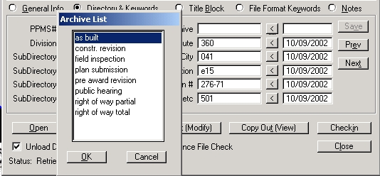

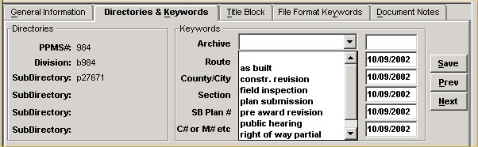

Falcon will copy all of the files that have the “Archive” field set to an Archives environment on a Falcon server. This process will run nightly. When the process has finished the “Archive” field will automatically return to a blank status. This will allow different files to be archived at different stages. These files can be accessed for viewing and printing but cannot be changed when in the Archives environment.

The following is an example of what types of files should be archived in the respective concurrent engineering stages:

Preliminary Field Inspection – DGN files

Public Hearing – DGN files

Authorize Right of Way –DGN files

Field Inspection Stage – IGrds and DGN files

Final Right of Way – IGrds and DGN files

Right of Way Revision – All revised files

Plan Submission – IGrds, CAiCE, DGN, and all related files necessary for the contractor build the project.

Pre Award Revision – All revised files

Construction Revision – All revised files

As Built Plans – All plan DGN files for the project

S&B will always archive files at Plan Submission, Revisions and As Builts and may occasionally need to archive files at one of the other stages, depending on the project

Accessing Archived Files

The next few screen captures show how to access the archived files.

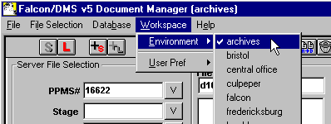

In the Falcon Document Manager under “Workspace” , “Environment” , there will be a choice for “archives” .

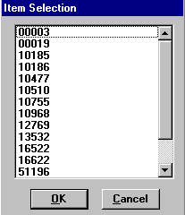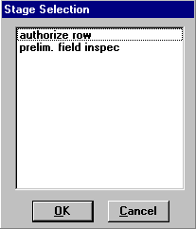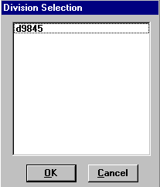

After setting the environment to Archives, choose “PPMS#”, then “Stage”, then “Division”. Stage may be any of the plan stages noted in the Archive choices described previously.

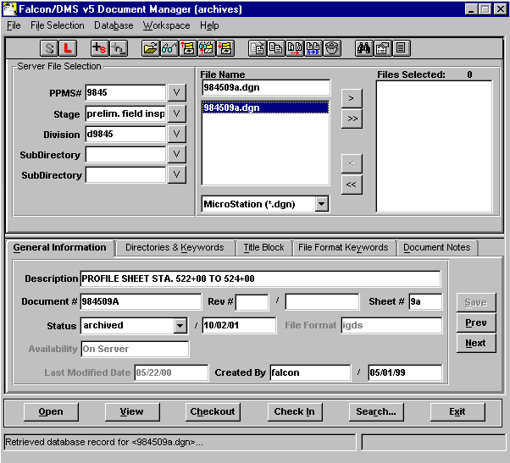

The files that have been archived for that stage will be available as shown above. These files are read only and cannot be edited. Use the View button to access these files for reviewing and plotting.

Example Index of Files

An Index of S&B plans would show the information entered on the General Information Tab. The Reference File column will be blank unless the designer has inserted notes.

This is an example of an L&D index.
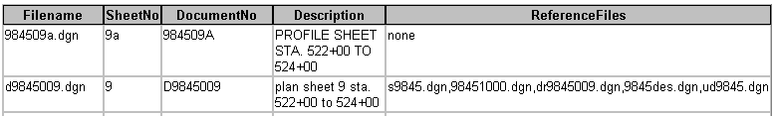

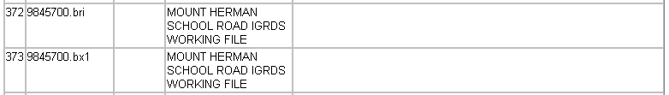

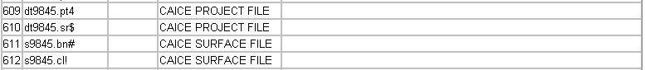

Mass Update Tool in Windows Document Manager

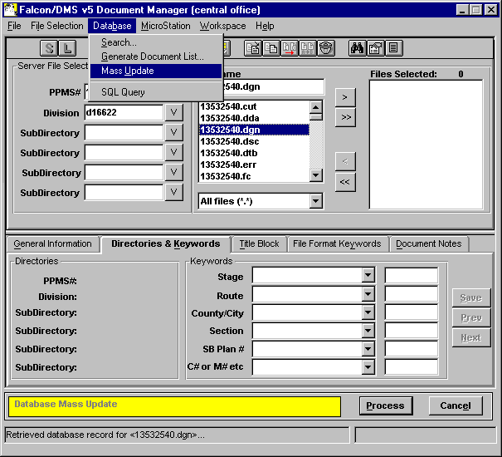

The Mass Update tool can be used to change database information on multiple files. Place the files in the Files Selected window and go to Database --> Mass Update. A yellow bar will appear at the bottom of the Document Manager when in Mass Update mode. This only changes the database fields that you enter data into. All other fields remain as they are. Once all the data is entered, select Process. Refer to the Instructions for Mass Update in Falcon for more information.

