To Generate LOCAL TIFF files from Microstation
- Fence object as if you were going to plot.
- Then, go to: Applications > eQuorum Plotting > PRF Generator
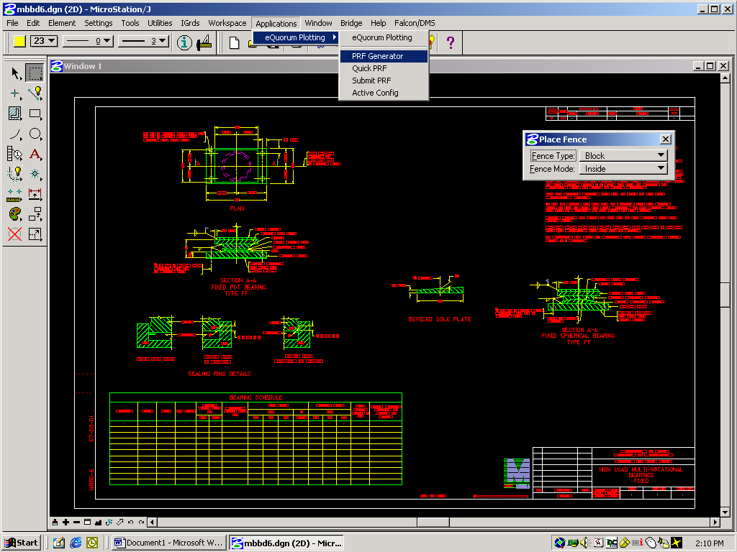
- In the Active Cfg: box, select CONFIG Local Bridge TIF File Generator

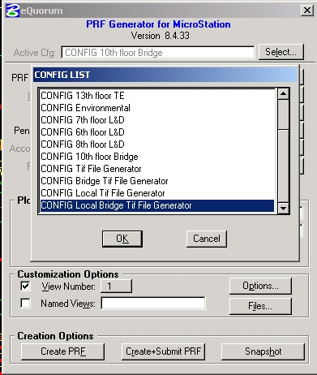

A TIFF file will be created after “clicking” on the “Create+Submit PRF” button
The newly created file will have the same name as the Microstation DGN file but it will have a TIF extension. It will be located at:
\\0501cocadd\proj\br_stan\tif files
for users in the Central Office. District users will need to contact their CADD support for the location of their files.

The user will then need to transfer the file to an appropriate folder.

