To Generate TIFF files from Microstation for use with electronic plan submission:
- Fence object as if you were going to plot.
- Then, go to: Applications > eQuorum Plotting > PRF Generator
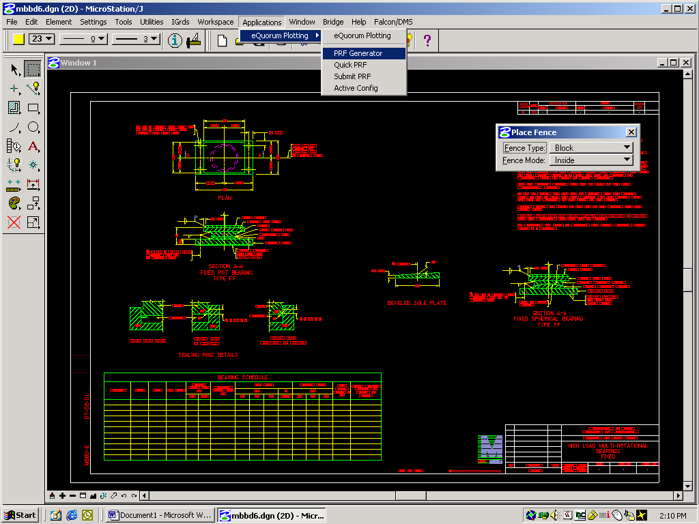
- In the Active Cfg: box, select CONFIG Bridge TIF File Generator

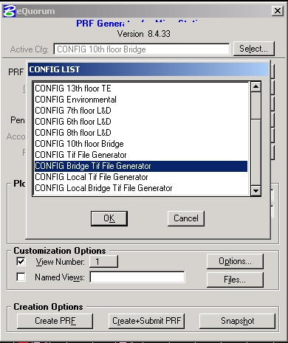

A TIFF file will be created after “clicking” on the “Create+Submit PRF” button
The newly created file will have the same name as the Microstation DGN file but it will have a TIF extension. It will be automatically moved to a directory, renamed and processed according to the Generate Tif choice made under the File Format Keywords tab in the Falcon Document Manager.

