Falcon Database Information

Archiving Files

The following instructions are for archiving your files. Archiving your files will give you a complete copy of your project at that particular stage of development. After all of the “required” database fields are filled out, you are ready to archive the project when you reach one of the appropriate concurrent engineering stages. In the “Directories & Keywords” tab, set the “Archive” to the appropriate concurrent engineering stage for all project files. Only change the Archive when you are ready to archive the file, otherwise leave it blank.

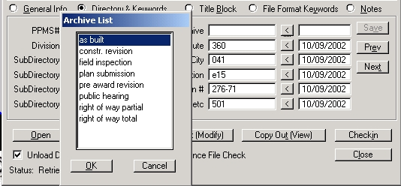
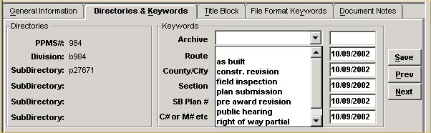

Falcon will copy all of the files that have the “Archive” field set to an Archives environment on a Falcon server. This process will run nightly. When the process has finished the “Archive” field will automatically return to a blank status. This will allow different files to be archived at different stages. These files can be accessed for viewing and printing but cannot be changed when in the Archives environment.
The following is an example of what types of files should be archived in the respective concurrent engineering stages:

Public Hearing – DGN files
Field Inspection Stage – IGrds and DGN files
Right of Way Partial – IGrds and DGN files
Right of Way Total – IGrds and DGN files
Plan Submission – IGrds, CAiCE, DGN, and all related files
necessary for the contractor build the project.
Pre Award Revision – All revised files
Construction Revision – All revised files
As Built Plans – All plan DGN files for the project

S&B will always archive files at Final Plan Submission, Revisions and As Builts and may occasionally need to archive files at one of the other stages, depending on the project

Accessing Archived Files

The next few screen captures show how to access the archived files.

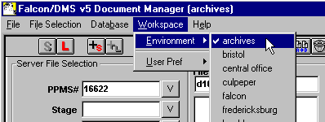

In the Falcon Document Manager under “Workspace” , “Environment” , there will be a choice for “archives” .

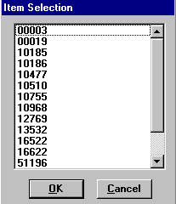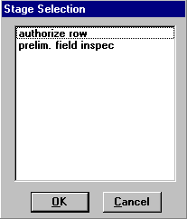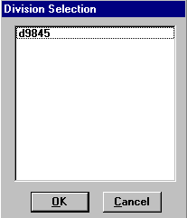

After setting the environment to Archives, choose “PPMS#”, then “Stage”, then “Division”. Stage may be any of the plan stages noted in the Archive choices described previously.

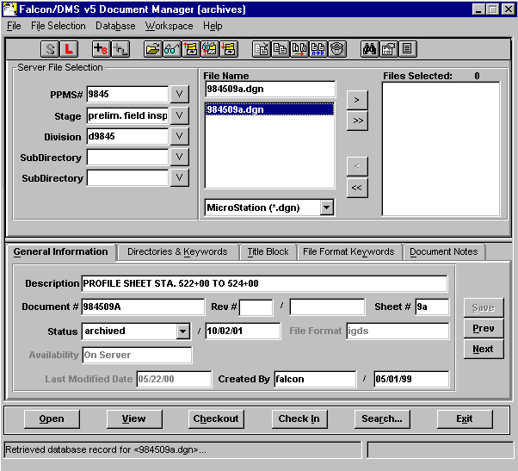

The files that have been archived for that stage will be available as shown above. These files are read only and cannot be edited. Use the View button to access these files for reviewing and plotting.

Example Index of Files

An Index of S&B plans would show the information entered on the General Information Tab. The Reference File column will be blank unless the designer has inserted notes.
This is an example of a S&B index.
