Archiving Files

The following instructions are for archiving your files. Archiving your files will give you a complete copy of your project at that particular stage of development. After all of the “required” database fields are filled out, you are ready to archive the project when you reach one of the appropriate concurrent engineering stages. The nine stages for archiving are Preliminary Field Inspection, Field Inspection, Public Hearing, Right of Way Partial, Right of Way Total, Final Submission, Construction Revision, Pre Award Revision, and As Built as shown below. In the “Directories & Keywords” tab, set the “Stage” to the appropriate concurrent engineering stage for all project files. Only change the stage when you are ready to archive the file, otherwise leave it blank.

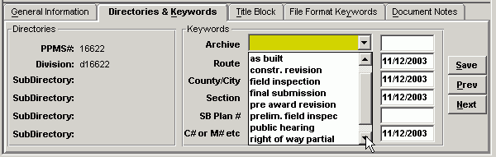

Falcon will copy all of the files that have the “Stage” field set to an Archives environment on a Falcon server. This process will run nightly. When the process has finished the “Stage” field will automatically return to a blank status. This will allow different files to be archived at different stages. These files can be accessed for viewing and printing but cannot be changed when in the Archives environment.

The following is an example of what types of files should be archived in the respective concurrent engineering stages:

Preliminary Field Inspection – IGrds/GEOPAK* and DGN files
Public Hearing – IGrds/GEOPAK* and DGN files
Field Inspection Stage – IGrds/GEOPAK* and DGN files
Right of Way Partial – IGrds/GEOPAK* and DGN files
Right of Way Total – IGrds/GEOPAK* and DGN files
Final Submission – IGrds, CAiCE, GEOPAK*, DGN, and all related files necessary for the contractor to build the project.
Constr. Revision – All revised files
Pre Award Revision – All revised files
As Built – All Files

* Note: Please contact AES Helpdesk to Archive any GEOPAK files.

Accessing Archived Files

The next few screen captures show how to access the archived files.

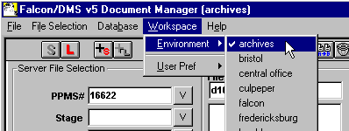

In the Falcon Document Manager under “Workspace” , “Environment” , there will be a choice for “archives”.

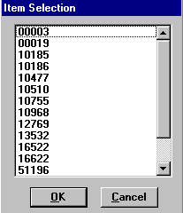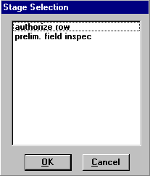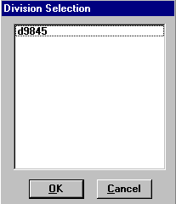

After setting the environment to Archives, choose “PPMS#”, then “Stage”, then “Division”.

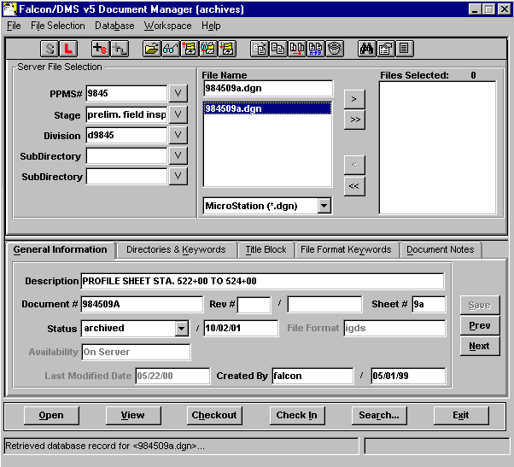

The files that have been archived for that stage will be available as shown above. These files are read only and cannot be edited. Use the View button to access these files for reviewing and plotting.

Example Index of Files
This is only an example. File names may or may not match the Cadd Manual.
