Chapter 4: Commuter Parking Lots
4.1 Commuter Lot signing 1
4.1.1 Commuter Lot Signing Design Elements 1
4.1.2 Commuter Lot Signing Preliminary Design 1
4.1.3 Commuter Lot Signing Plan Development 3
4.2 Commuter Lot MARKING 3
4.2.1 Commuter Lot Marking Design Elements 3
4.2.2 Commuter Lot Marking Preliminary Design 3
4.2.3 Commuter Lot Marking Plan Development 4
4.3 Commuter Lot Facility Lighting 4
4.3.1 Commuter Parking Lot Lighting Design Elements 5
4.3.2 Visibility and Lighting Quality in Parking Facilities 6
4.3.3 Commuter Parking Lot Lighting Preliminary Design 7
4.3.4 Commuter Parking Lot Lighting Plan Development 7

4.1 Commuter Lot signing
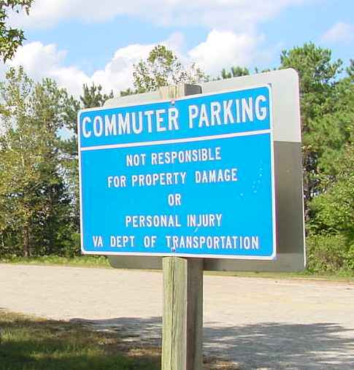
Commuter lot facilities serve as collector sites for vanpools and carpools, and may be located near bus or transit stops. Commuter lots can be fully improved or simple gravel parking lots. While the type of improvements vary widely, the facilities typically require guide signs to lead motorist to the site. Additional signs will depend on site utilization and circulation.
Figure 4-1: Commuter Parking Entrance Sign

The following issues should be addressed in the development of the signing plans for a Commuter Lot.
- Signs should be designed to meet MUTCD and VDOT standards.
- Signs should be sized and located to be highly visible to motorists as shown in Figure 4-1.
- Guide signs should be adequately spaced in advance of the commuter lot.
- Signs should be located to provide good sight distance for entrance and exit.
- Signs should provide messages to direct the motorists to proper parking areas.

4.1.1 Commuter Lot Signing Design Elements
Information obtained during the Scoping and Preliminary Field Inspection (PFI) Meetings should provide guidance regarding the on-site traffic flow, restricted areas and amenities of the Commuter Lot. This information will serve as the basis for the sign design. Design elements that are typically used on most sign plans will involve:
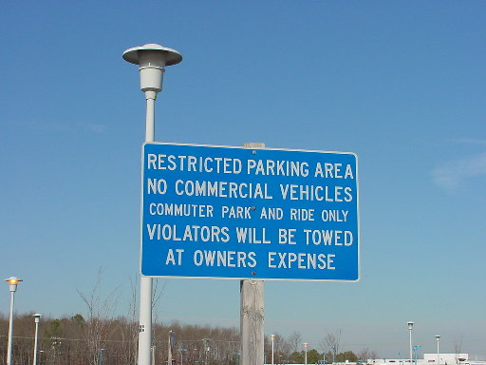
- Ground mounted and/or overhead signs
Figure 4-2: Commuter Lot Signing
- Sign post types
- Guide sign messages
- Size and type of letter series
- Sign lighting requirements
- Luminaire retrieval system and/or catwalk
- Supplemental signing. See Figure 4-2.

4.1.2 Commuter Lot Signing Preliminary Design
A sign inventory will need to be prepared prior to developing the preliminary design plans. The access roads will need to be inventoried to ensure guide signs can be properly located. The existing signs will need to be shown on the preliminary design plans in accordance with VDOT CADD requirements. For an example of this drawing see TEDM Section II – Signing, Appendix IIA-3.

The conceptual sign plan is based on guidance provided during the PFI Meeting. The sign plan should be prepared for review and comment by the district and other interested agencies.

A meeting should be scheduled with the district and or the agencies that have an interest in the project sign design to discuss and mark up the concept plan. This meeting should consider and finalize the following:
- Guide sign messages/color
- Regulatory and warning signs
- Size and type of letter series (upper and lower case)
- Sign Lighting
- Spacing of signs, longitudinally along the roadway
- Identification of utilities, wall and/or drainage structure conflicts
- Sign structure types

Based on the direction provided at the meeting, a preliminary sign design using the latest software can proceed and should be prepared using the most recent design files for the facility to be signed.

There are two areas of the sign design that will require special attention. They involve guide signs (approaching and within the Commuter Lot) and regulatory signs.
4.1.2.1 Guide Signs
Locations for guide signs should be considered during the site selection process for the Commuter Lot. Signing should be considered for all approaches that would contribute to or generate users for the commuter parking lot. It would be wrong to assume that motorists will not travel in the opposite direction to capitalize on the benefits of using the commuter parking lot. That is, if a motorist sees an opportunity to exit or enter a parking lot, without proper signing he is likely to use that avenue, and possibly disrupt the smooth flow of traffic in and around the facility.

Guide signing for Commuter Lot must be designed in compliance with the MUTCD as well as with state and local critieria and policies. Trailblazers should be used where traffic must be directed from a major highway to a facility not visible from the highway.

Guide signs should be placed at the entrance to a Commuter Lot and at each point that motorists must make a decision. These signs should be placed in advance of the require movement, such that motorists not knowledgeable of the facility’s location have enough distance and time to perform lane change maneuvers.

Guide signs within the Commuter Lot must be properly sized and located where they can provide the necessary direction to motorists within the facility.
4.1.2.2 Regulatory Signs
Regulatory signs controlling speed and prohibiting traffic movements are design issues that promote a safe driving environment. These signs will also require considerable attention during the preliminary design phase. An evaluation of the on-site traffic circulation will identify locations where wrong way vehicular movements are possible. Appropriate signs prohibiting these movements will be required.

4.1.3 Commuter Lot Signing Plan Development
The steps required for the development of a Commuter Lot signing plan are similar to those described in TEDM Section VI – Rest Areas, Park & Ride and Commuter Lots, Chapter 2, 2.1.3 for rest areas.

4.2 Commuter Lot MARKING

4.2.1 Commuter Lot Marking Design Elements
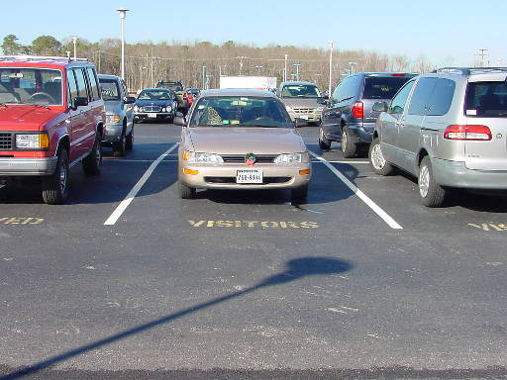
Pavement marking design parameters and requirements for the facility should be addressed early in the design process. The major issues that need to be addressed for the Commuter Lot facility are:
Figure 4-3: Spacing and Special Message Marking
- Type of markings needed
- Width of lines
- Lengths of spaces
- Widths of spaces
- Number handicap spaces
- Type special messages (See Figure 4-3.)

4.2.2 Commuter Lot Marking Preliminary Design
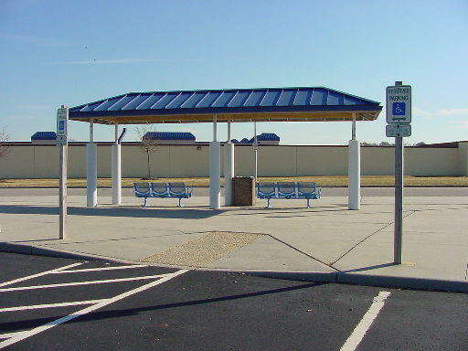
The conceptual pavement marking plan is based on the direction provided during the PFI. Conceptual markings plans should be drawn on the most recent proposed construction plans. A pavement marking inventory should be performed if the site exists and the project is for modification of the site.
Figure 4-4: Bus Loading and Handicapped Area

A meeting should be scheduled with the District and agencies having an interest in the commuter lot. The concept plan should discuss design issues during this meeting. This meeting should address and finalize the following design features:
- Activity Areas:
- Transit/Bus loading and unloading areas as shown in Figure 4-4.
- Taxi areas.
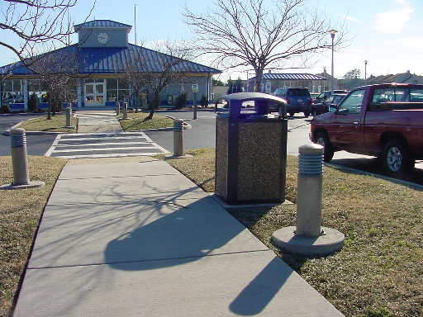
- Pedestrian routes and conflict points as shown in Figure 4-5.
Figure 4-5: Pedestrian Route to Commuter Drop-off Area
- Parking Areas
- Bicycle parking locations.
- Handicapped parking locations.
- Commuter Lot patron parking locations.
- Circulation and drive aisle widths:
- Bus travel way should be a minimum 20 ft. wide.
- Drive aisle width for right-angle parking should be 20 ft. wide.
- Drive aisle width for 45° angle parking should be 18 ft. wide.
- Site should provide at least one exit and entrance for every 500 spaces within lot.
- Site exits and entrances should be at least 300 ft. from other intersections.
- Parking space dimensions:
- 10 ft. by 20 ft. for normal cars.
- 9 ft. by 15 ft. for subcompact cars.
- Curb returns should be at least 30 ft. radius.

4.2.3 Commuter Lot Marking Plan Development
The steps required for the development of a Commuter Lot Pavement Marking plan are similar to those described in TEDM Section VI – Rest Areas, Park & Ride and Commuter Lots, Chapter 3, 3.2.3 for Park-and-Ride.

Commuter Lot Facility Lighting
As discussed in the chapter on Rest Area lighting, lighting for parking facilities must address not only the motorists, but also the pedestrians. Unlike rest areas, Commuter Lot facilities cater to pedestrians focused on moving directly from one vehicle to another vehicle.

As with Park-and-Ride facilities, the adults are frequently tired and may not be watching for on-coming traffic. Also, unlike rest areas, there are seldom children moving between parked cars. Most people using a Commuter Lot are coming from or going to work and are apt to step in front of a moving car. The pavement markings, handicapped curb cuts, and placement of the islands and medians should be lighted to draw people toward the pedestrian avenues. See Figure 4-5. It is paramount to provide a visual environment focused on the safe movement of vehicles mixed with pedestrians.

Along commuter corridors, public parking lots have also been set aside to provide motorists an area to meet and share a ride into a metropolitan area. Figure 4-6 provides an example of a remote facility focused on commuter ride-share. These parking lots vary in size; however, the lighting designer must understand the functional purpose of each facility when developing the lighting plan.
Figure 4-6: Remote Commuter Lot Facility

In some situations the motorists utilizing the parking lot may be shift-workers. In this case, the area should be lighted throughout the night. Light levels should not be reduced during the early hours of the morning.

The Commuter Lots may be in a very remote area, or located in a wooded section adjacent to an Interstate ramp. Some of these parking lots may service only a few vehicles each day and may not be paved, but they still require lighting to provide security. (See Figure 4-6.)

4.3.1 Commuter Parking Lot Lighting Design Elements
The lighting equipment used in a Commuter Lot facility is similar to the items used in a Rest Area. See TEDM Section VI – Rest Areas, Park & Ride and Commuter Lots, Chapter 2, 2.3.1 of this Section.

Larger commuter parking facilities found throughout Virginia typically use standard VDOT roadway lighting items. These items are discussed in detail in TEDM Section V – Roadway Lighting, Chapter 2, 2.8.

The lighting designer may need to address reducing the lighting of the parking lot during hours of low utilization. The VDOT Standard CCW-1 Control Center Type E (single-phase voltage) and Type F (three-phase voltage) provide a time clock to disable a portion of the area lighting during these times.

Small Commuter Lot facilities may be lighted using equipment provided by a local power company. In this case, the VDOT lighting designer may be required to specify only the number and location of lighting standards along with the location and type of electrical service. The power company, working with the VDOT contractor, will provide the lighting poles, luminaires and supporting electrical equipment. The VDOT Local Assistance Division, Urban Division Manual has a section on Roadway Lighting that fully describes the procedures related to this work.

4.3.2 Visibility and Lighting Quality in Parking Facilities
Commuter Lot lighting design must provide an effective visual environment for the pedestrians moving to and from their cars and those navigating their vehicles through the area.

Four distinct areas exist within a Commuter Lot facility. Each area requires lighting specific to the needs of the motorists and pedestrians:
- The parking lot,
- The entrance/exit,
- The Commuter Drop-off area,
- Sidewalks.

Parking lot lighting is discussed in detail in TEDM Section VI – Rest Areas, Park & Ride and Commuter Lots, Chapter 2, 2.3.2 of this Section. This discussion includes Parking Lot Lighting Levels and the procedures necessary to achieve those levels.

For the purposes of lighting, the entrance and exit to the Commuter Lot should be considered an intersection. TEDM Section V – Roadway Lighting, Chapter 3, 3.10.7 discusses both signalized and remote intersection lighting.

Lighting in the Commuter Drop-off area can be considered similar to lighting in the pedestrian areas discussed in TEDM Section VI – Rest Areas, Park & Ride and Commuter Lots, Chapter 2, 2.3 of this Section. However, the roadway along the drop-off area is heavily traveled by slow moving vehicles and pedestrians walking between cars. The light levels along this roadway are discussed in IESNA RP-8-00, Table 5, Recommended Values for High Pedestrian Conflict Areas. Architectural pedestrian lighting in this area can be used to increase to overall illumination and aesthetics of the area. However, the lighting designer should pay close attention to the glare produced from these fixtures. Due to the low mounting height, a full-cutoff fixture is recommended over the use of a colonial or acorn fixture. See Section V – Roadway Lighting, Chapter 3, 3.11.

The sidewalks should be lighted such that they encourage people to migrate toward them. Architectural lighting on 14’ poles, for example, adds to the aesthetics of the area, however, in Figure 4-6, bollards also work well for this task. Many manufacturers offer a variety of landscape lighting that can be recessed below trees and provide illumination of the sidewalk using light reflected from the tree canopy. However, the lighting designer must recognize that these fixtures may be subject to vandalism.

During hours of reduced activity, the lighting levels may be lowered through the use of a time clock at the control center. The light levels, however, should meet the “Basic” requirements referenced in IESNA RP-20-98, Lighting for Parking Facilities during these hours and TEDM Section VI – Rest Areas, Park & Ride and Commuter Lots, Chapter 2, 2.3.2.1 of this Section.

4.3.3 Commuter Parking Lot Lighting Preliminary Design
The preliminary lighting design considerations for a Commuter Lot facility are similar to those discussed in TEDM Section VI – Rest Areas, Park & Ride and Commuter Lots, Chapter 2, 2.3.3 for rest areas.

4.3.4 Commuter Parking Lot Lighting Plan Development
The steps required for the development of a Commuter Lot lighting plan are similar to those described in TEDM Section VI – Rest Areas, Park & Ride and Commuter Lots, Chapter 2, 2.3.4 for rest areas.

