Chapter 3: Park-and-Ride Facilities
3.1 Park-and-Ride Facility SIGNING 1
3.1.1 Park-and-Ride Sign Design Elements 1
3.1.2 Park-and-Ride Sign Preliminary Design 2
3.1.3 Park-and-Ride Sign Plan Development 3
3.2 Park-and-Ride Facility MARKING 3
3.2.1 Park-and-Ride Marking Design Elements 4
3.2.2 Park-and-Ride Marking Preliminary Design 4
3.2.3 Park-and-Ride Marking Plan Development 5
3.3 Park-and-Ride facility Lighting 6
3.3.1 Park-and-Ride Lighting Design Elements 6
3.3.2 Visibility and Lighting Quality in Parking Facilities 7
3.3.3 Park and Ride Lighting Preliminary Design 7
3.3.4 Park-and-Ride Lighting Plan Development 8

Park-and-Ride Facility SIGNING
A Park-and-Ride facility is generally an area used to park vehicles, while the vehicle owner uses a transit agency or some other form of transportation to commute. Park-and-Ride facilities are generally established at collector sites for rail or bus service.

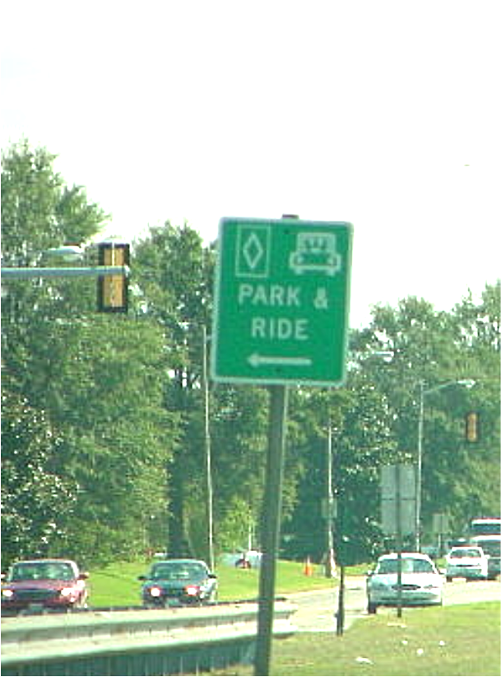
A Kiss-N-Ride facility is generally located within a Park and Ride facility. It provides an area to drop-off commuters who are moving to or from mass transit.
Figure 3-1: Park-and-Ride Advance Sign

The following issues should be addressed in the development of the signing plans for a Park-and-Ride facility.
- Signs should be designed to meet MUTCD and VDOT standards.
- Signs should be sized and located to be highly visible to motorists.
- Guide signs should be adequately spaced in advance of a Park-and-Ride facility. (See Figure 3-1)
- Signs should be located to provide good sight distance for entrance and exit.
- Signs should provide messages to clearly direct the motorists to proper areas.
- Signs should be provided for Bus, Taxi, Kiss-N-Ride, Park-and-Ride, Bicycle / Motorcycle and Handicapped parking areas.

3.1.1 Park-and-Ride Sign Design Elements
Information obtained during the Scoping and Preliminary Field Inspection (PFI) Meetings should provide guidance regarding the on-site traffic flow, restricted areas and amenities of the Park-and-Ride facility. This information will serve as the basis for the sign design. Design elements that are typically used on most sign plans will involve:
- Ground mounted and/or overhead signs
- Sign post types
- Guide sign messages
- Size and type of letter series
- Sign lighting requirements
- Luminaire retrieval system and/or catwalk
- Supplemental signing

3.1.2 Park-and-Ride Sign Preliminary Design
A sign inventory will need to be prepared prior to developing the preliminary design plans. The access roads will need to be inventoried to ensure guide signs can be properly located. The existing signs will need to be shown on the preliminary design plans in accordance with VDOT CADD requirements. For an example of how to indicate and label signs for this plan, see TEDM Section II – Signing, Appendix IIA-3.

The conceptual sign plan is based on guidance provided during the PFI Meeting. The sign plan should be prepared for review and comment by the district and other interested agencies.

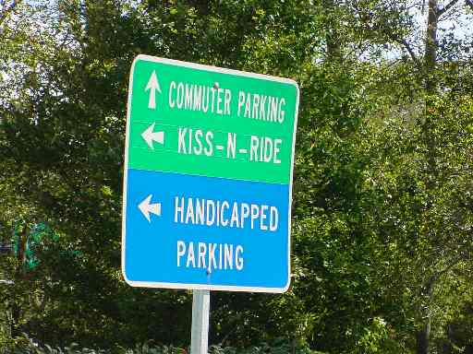
A meeting should be scheduled with the district and or the agencies that have an interest in the project sign design to discuss and mark up the concept plan. This meeting should consider and finalize the following:
Figure 3-2: Park-and-Ride Guide Sign
- Guide sign messages/color as shown in Figure 3-2
- Regulatory and warning signs
- Size and type of letter series (upper and lower case)
- Sign Lighting
- Spacing of signs, longitudinally along the roadway
- Identification of utilities, wall and/or drainage structure conflicts
- Sign structure types

Based on the direction provided at the meeting, a preliminary sign design can proceed and should be prepared using the latest design files for the roadways to be signed.

There are two areas of the sign design that will require special attention. They involve guide signs (approaching and within the Park-and-Ride area) and regulatory signs. Other signs within the Park-and-Ride facility should clearly identify designated areas for handicap parking, Kiss-N-Ride drop off facilities, as well as other specialty signs that may be necessary depending on the amenities at the facility.
3.1.2.1 Guide Signs
Locations for guide signs should be considered during the site selection process for the Park-and-Ride lot. All approaches should be considered as potential contributors to the Park-and-Ride facility. Guide signing should be provided for motorist that may travel away from their destination in order to capitalize on the benefits of using the Park-and-Ride facility.

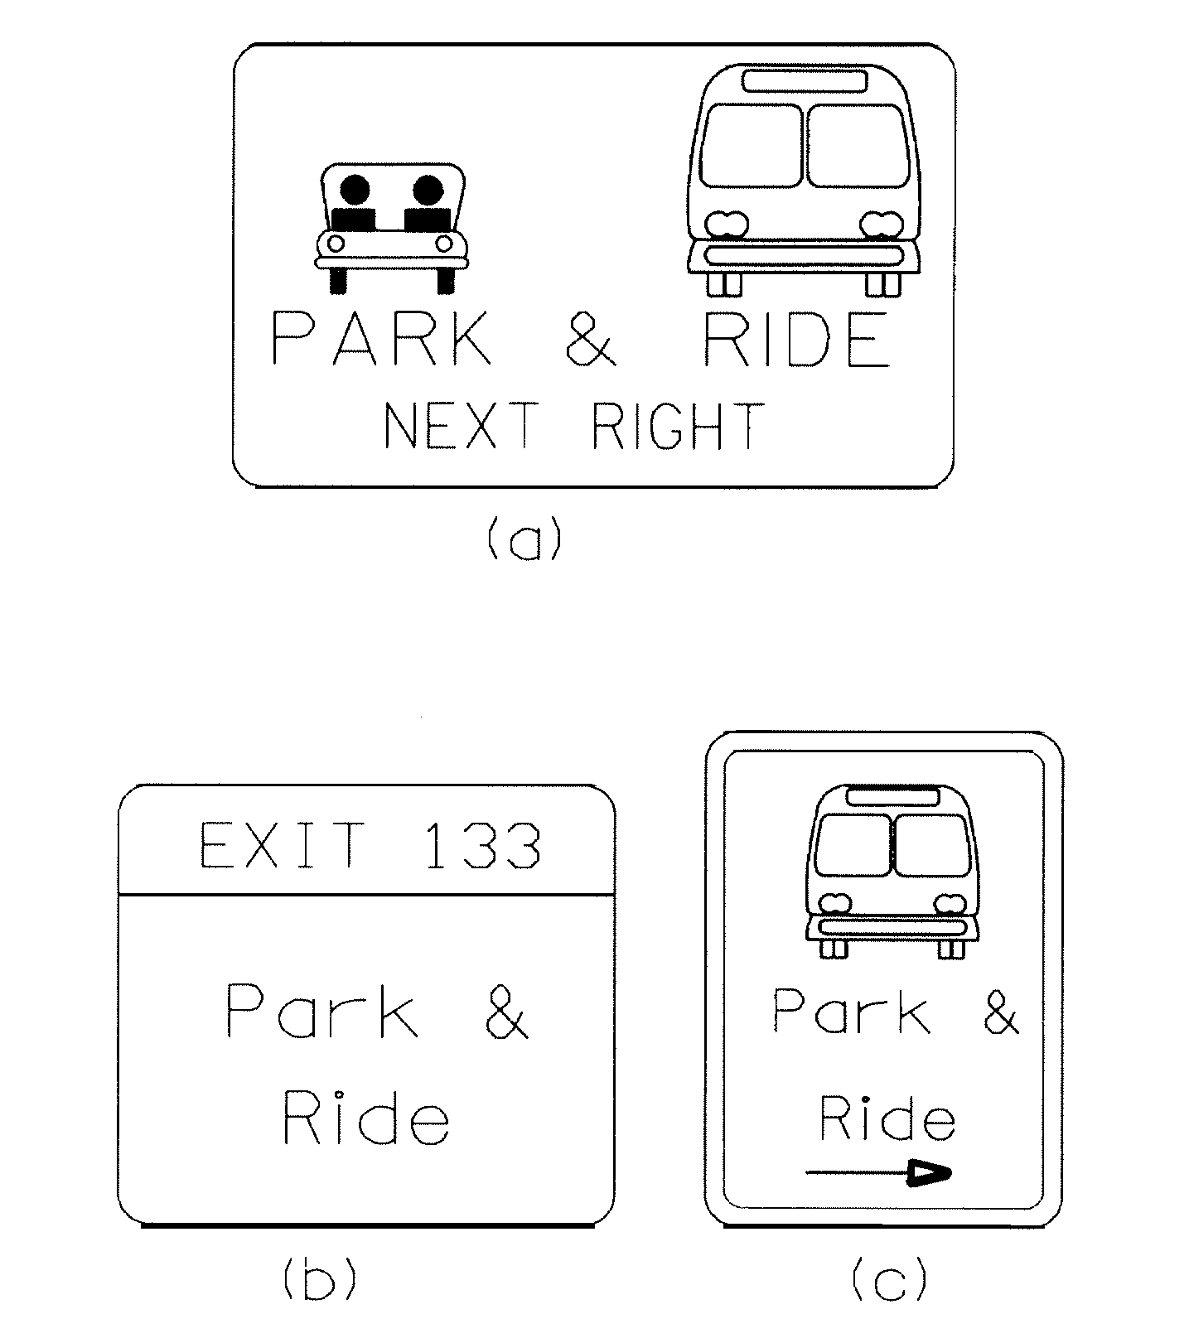
Guide signs for Park-and-Ride facilities must be designed in compliance with the MUTCD, as well as state and local criteria and policies. Park-and-Ride facilities that are not visible from the highway will require trailblazers to direct motorists. These trailblazer signs should use the park-and-ride symbol and directional arrows to attract the attention and guide the motorist to the facility. Figure 3-3 provides some examples of guide signs for Park-and ride facilities.
Figure 3-3: Guide Sign for Park & Ride

Guide signs should be placed at the entrance to a Park-and-Ride facility and at each point that motorists must make a decision. These signs should be placed in advance of the required movement, such that motorists not familiar with the facility’s location will have adequate time and distance to maneuver into the proper lane.

Guide signs within the Park-and-Ride facility must be properly sized and located where they can provide the necessary direction to vehicles within the facility. Guide signs located at decision points, such as the entrance where parking or dropping off passengers are directed to different areas, should be clearly visible to the motorist.
3.1.2.1 Regulatory Signs
Regulatory signs controlling speed and prohibiting traffic movements are design issues that promote a safe driving environment. These signs will also require considerable attention during the preliminary design phase. An evaluation of the on-site traffic circulation will identify locations where wrong way vehicular movements are possible. Appropriate signs prohibiting these movements will be required.

3.1.3 Park-and-Ride Sign Plan Development
The steps required for the development of a Park & Ride signing plan are similar to those described in TEDM Section VI – Rest Areas, Park & Ride and Commuter Lots, Chapter 2, 2.1.3 for rest areas.

Park-and-Ride Facility MARKING
Pavement marking design parameters and requirements for the facility should be addressed early in the design process. The major issues that need to be addressed for the Park-and-Ride facility are:
- Turning space requirements
- Parking lot layout (diagonal vs. perpendicular parking spaces)

After the Preliminary Field Inspection Meeting, there should be adequate information in the design to review key areas of the plan layout to ensure that the pavement markings can be properly provided.

3.2.1 Park-and-Ride Marking Design Elements
The following pavement marking design elements should be addressed early in the design process:
- Type of markings
Figure 3-4: Handicapped Marking
- Type of parking surface material
- Width of lines
- Lengths of spaces
- Widths of spaces
- Drive aisle and turning space requirements
- Number handicap spaces as shown in Figure 3-4
- Type of special messages

3.2.2 Park-and-Ride Marking Preliminary Design
The conceptual pavement marking plan is based on the direction provided during the PFI. Conceptual markings plans should be drawn on the most recent proposed construction plans. A pavement marking inventory should be performed if the site exists and the project is for modification of the site.

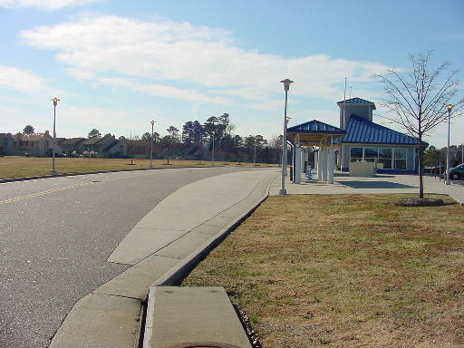
A meeting should be scheduled with the district and or the agencies that have an interest in the pavement marking design. The concept plan should be discussed and marked-up during this meeting. This meeting should address and finalize the following design features:
Figure 3-5: Bus Loading and Unloading Area
- Activity Areas:
- Transit/Bus loading and unloading areas as shown in Figure 3-5.
- Taxi areas.
- Pedestrian routes and conflict points.
- Parking Areas
- Bicycle parking locations.
- Handicapped parking locations.
- Park-and-ride patron parking locations.
- Circulation and drive aisle widths:
- Bus travel way should be a minimum of 20 ft. wide.
- Drive aisle width for right-angle parking should be 20 ft. wide.
- Drive aisle width for 45° angle parking should be 18 ft. wide.
- Site should provide at least one exit and entrance for every 500 spaces within lot.
- Site exits and entrances should be at least 300 ft. from other intersections.
  - Parking space dimensions:
- 10-foot wide by 20-foot long for normal cars.
- 9-foot wide by 15-foot long for subcompact cars.
- Curb returns should be at least 30-foot radius.

A review of the Park-and-Ride Lot amenities will identify pedestrian routes within the site. Conflicts between pedestrians and vehicles should be minimized. It may be necessary, to provide appropriate pavement markings that will identify these conflict areas.

See the VDOT Road Design Manual for dimensions and other spacing details regarding “Handicapped” parking space and truck parking space details.

3.2.3 Park-and-Ride Marking Plan Development
The methodology for the pavement marking plan development is discussed in TEDM Section III – Marking, Markers and Delineation, Chapter 4. This section should be referenced when developing the Park-and-Ride pavement marking plans.

A complete set of example pavement marking plans are available in TEDM Section III - Marking, Markers and Delineation, Appendix IIIA and should also be referred to when developing the rest area pavement marking plans.

The design tasks that may be required for completing the pavement marking plans are noted as follows with references made to the appropriate section of the TEDM.
3.2.3.1 Prepare Base Plans
The pavement marking base plan is developed using the current roadway and site construction plans similar to the rest area plans shown in Appendix VIA-2.

It is important to note that a clear understanding of the proposed surface materials to be used within the site needs to be identified in order to properly specify the type of pavement marking material. The appropriate pavement marking material for different surfaces can be found in the VDOT Road and Bridge Specifications.
3.2.3.2 Detail Pavement Markings
The pavement marking plan is based on refining the preliminary design plans. Special needs marking, such as bus loading areas and handicap symbols, will need to be shown in the plans. Special hatching and no parking messages may be necessary and should also be shown in the pavement marking plans.

The following design issues should be considered in developing the pavement marking plans:
- The appropriate pavement marking type is dependent upon the paved surface material.
- “No Parking” message markings may be beneficial in areas to compliment, “No Parking” signs.
- Proper space dimensions for handicap parking are provided in the VDOT Road Design Manual.

3.3 Park-and-Ride facility Lighting
As discussed in the previous chapter on Rest Area lighting, parking lot lighting must address not only the motorists, but also the pedestrians. The layout of a Park-and-Ride facility focuses on channeling the flow of pedestrians toward the entrance of the mass transit facility or to the Kiss-N-Ride Area. Unlike rest areas, most people in a Park-and-Ride facility using mass transit are typically coming from or going to work. It is paramount to provide a visual environment focused on the safe movement of vehicles mixed with pedestrians.

3.3.1 Park-and-Ride Lighting Design Elements
The lighting equipment used in a Park-and-Ride facility is similar to the items used in a rest area and can be referenced in TEDM Section VI – Rest Areas, Park & Ride and Commuter Lots, Chapter 2, 2.3.1 of this Section.
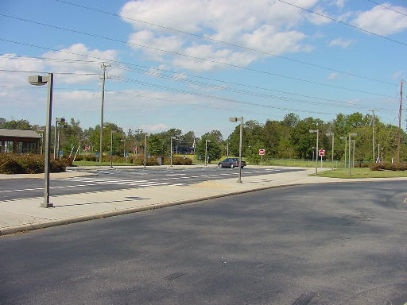
Figure 3-8: Lighting in the Kiss-N-Ride Area
Larger Park & Ride facilities found throughout Virginia typically use standard VDOT roadway lighting items. These items are discussed in detail in TEDM Section V – Roadway Lighting, Chapter 2, 2.8.

The lighting designer may want to consider reducing the lighting of the parking lot during hours of low utilization. The VDOT Standard CCW-1 Control Center Type E (single-phase voltage) and Type F (three-phase voltage) provide a time clock to disable a portion of the area lighting during these time periods.

Small Park-and-Ride facilities may be lighted using equipment provided by a local power company. In this case, the VDOT lighting designer may be required to specify only the number and location of lighting standards. The power company, working with the VDOT contractor, will provide the lighting poles, luminaires and supporting electrical equipment. The VDOT Local Assistance Division, Urban Division Manual has a section on Roadway Lighting that fully describes the procedures related to this work.

3.3.2 Visibility and Lighting Quality in Parking Facilities
Park-and-Ride area lighting design must provide an effective visual environment for pedestrians and motorists moving to and from their vehicles and those navigating their vehicles through the area.

Three distinct areas may exist within a Park-and-Ride facility:
- The parking lot
- The entrance and exit to the facility
- The Kiss-N-Ride area

Each of the above areas require lighting specific to the needs of the motorists and pedestrians

Parking lot lighting is discussed in detail in TEDM Section VI – Rest Areas, Park & Ride and Commuter Lots, Chapter 2, 2.3.2 of this Section. This discussion includes Parking Lot Lighting Levels and the procedures necessary to achieve those levels.

For the purposes of lighting, the entrance and exit to the Park & Ride area should be considered an intersection. TEDM Section V – Roadway Lighting, Chapter 3, 3.10.7 discusses both signalized and remote intersection lighting.

Lighting along the sidewalks in the Kiss-N-Ride area can be considered similar to lighting in the pedestrian areas discussed in TEDM Section VI – Rest Areas, Park & Ride and Commuter Lots, Chapter 2, 2.3.3 of this Section. However, the roadway along the Kiss-N-Ride area is heavily traveled by slow moving vehicles, and pedestrians walking between cars. The light levels along the Kiss-N-Ride drop-off roadway are discussed in IESNA RP-8-00, Table 5, Recommended Values for High Pedestrian Conflict Areas. Architectural pedestrian lighting in this area can be used to increase the overall illumination and aesthetics of the area. The lighting designer should pay close attention to the glare produced from these fixtures. Due to the low mounting height, a full-cutoff fixture is recommended over the use of a colonial or acorn fixture. Section V – Roadway Lighting, Chapter 3, 3.11 discusses these issues in greater detail.

During hours of reduced activity, the lighting levels may be lowered through the use of a time clock at the control center. The light levels during these hours, should meet the “Basic” requirements referenced in IESNA RP-20-98 Lighting for Parking Facilities and TEDM Section VI – Rest Areas, Park & Ride and Commuter Lots, Chapter 2, 2.3.2.1 of this Section.

3.3.3 Park and Ride Lighting Preliminary Design
The preliminary design considerations for Park-and-Ride facilities are similar to those discussed in TEDM Section VI – Rest Areas, Park & Ride and Commuter Lots, Chapter 2, 2.3.4 for rest areas.

3.3.4 Park-and-Ride Lighting Plan Development
The steps required for the development of a Park & Ride lighting plan is similar to those described in TEDM Section VI – Rest Areas, Park & Ride and Commuter Lots, Chapter 2, 2.3.5 for rest areas.

