Chapter 2: Rest Areas
2.1 Rest Area SIGNING 1
2.1.1 Rest Area Sign Design Elements 2
2.1.2 Rest Area Sign Preliminary Design 2
2.1.3 Rest Area Sign Plan Development 4
2.2 Rest ARea MARKING 5
2.2.1 Rest Area Marking Design Elements 6
2.2.2 Rest Area Marking Preliminary Design 6
2.2.3 Rest Area Marking Plan Development 7
2.3 Rest Area Lighting 9
2.3.1 Rest Area Lighting Design Elements 10
2.3.2 Visibility and Lighting Quality in Parking Facilities 11
2.3.3 Rest Area Light Levels 13
2.3.4 Rest Area Lighting Preliminary Design 13
2.3.5 Rest Area Lighting Plan Development 15

2.1 Rest Area SIGNING
Rest areas are high congestion areas for vehicles and pedestrians. The typical layout of a rest area promotes separation of pedestrian and vehicles, as well as separation of automobiles from buses and truck, while also accommodating ease of vehicular ingress and egress within the site. Signs within the rest area must therefore be clearly visible, as well as easily understood by the motorist.

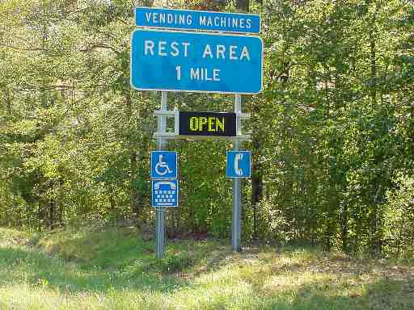
The need for advanced notice when approaching a facility allows the motorists enough time to see and comprehend the presence of the area. Figure 2-1 provides an example of an advanced notice sign used along an interstate highway. Sight distance conditions along the highway should be favorable, preferably well above minimum for the highway design speed.
Figure 2-1: Advance Information Guide Sign

In no case should a rest area entrance or exit be placed on or adjacent to speed-change lanes of other access connections. The fatigued driver is less capable of making the necessary maneuvers when approaching decision points. It is equally important to provide positive guidance in advance of movements to separate the vehicular traffic, such as cars to one location in the rest area and buses and trucks to another.

The challenge in preparing the sign plans is integrating the sign design to address the multi-modal nature of the rest area site. The sign plans must provide positive guidance for vehicles and pedestrians alike.

A number of design issues should be considered early in the development of the Sign Design Plans. Resources and guidelines for sign design can be found in TEDM Section II - Signing. Guidance in the design and placement of specialty signs can be found in the Traffic Engineering Division (TED) Memorandums located in Appendix VIB.
- Signs are to be designed to meet MUTCD and VDOT standards.
- Signs need to be sized and located such that they are visible and can be read by the motorist.
- Signs need to provide messages that will direct the motorists to proper areas.
- Guide signs, as shown in Figure 2-1, need to be located with adequate spacing in advance of a rest area.
- Guide signs are to be located where obstructions (overpasses) or vertical curves do not limit the sight distance to the sign.
- Special signing for handicapped parking and other special needs should provide clear guidance to the motorists.

2.1.1 Rest Area Sign Design Elements
Information obtained during the Scoping and Preliminary Field Inspection (PFI) Meetings should provide guidance regarding the on-site traffic flow, restricted areas and amenities of the rest area site. This information will serve as the basis for the sign design. Design elements that are typically used on most sign plans will involve:
- Ground mounted and/or overhead signs
- Sign post types
- Guide sign messages
- Size and type of letter series
- Sign lighting requirements
- Luminaire retrieval system and/or catwalk
- Supplemental signs
- Reuse, dispose and/or salvage existing signs

2.1.2 Rest Area Sign Preliminary Design
A sign inventory will need to be prepared prior to developing the preliminary design plans. At a minimum, the interstate or limited access highway will need to be inventoried, if the rest area is new construction. The existing signs will need to be shown on the preliminary design plans in accordance with VDOT CADD requirements. For an example of how to indicate and label signs for these plans, see TEDM Section II – Signing, Appendix IIA-3.

The conceptual sign plan is based on guidance provided during the PFI Meeting. The plan should be prepared for review and comment by the district and other interested agencies.

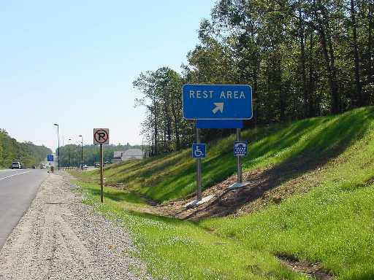
A meeting should be scheduled with the district and or the agencies that have an interest in the project sign design to discuss and mark up the concept plan. This meeting should consider and finalize the following:
Figure 2-2: Rest Area Guide Signs
- Guide sign messages/color
- Regulatory and warning signs
- Size and type of letter series (upper and lower case)
- Sign Lighting
- Spacing of signs, longitudinally along the roadway
- Identification of utilities, wall and/or drainage structure conflicts
- Sign structure types

Based on the direction provided at the meeting, a preliminary sign design can proceed and should be prepared using the latest design files for the roadway and rest area site.

There are several areas of the sign design that will require special attention. They involve guide signs (approaching and within the rest area) and regulatory signs. Other signs within the rest area site should clearly identify designated areas for handicap parking, State Police parking, as well as other specialty signs that may be necessary depending on the amenities at the facility.
2.1.2.1 Guide Signs
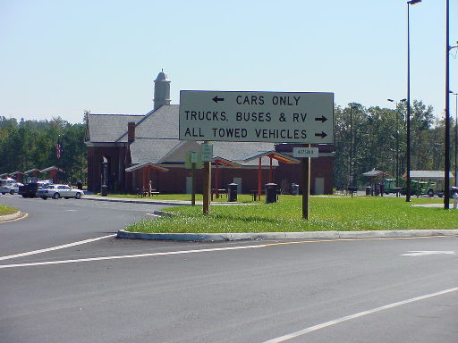
Guide signs along the interstate must be properly spaced to allow the motorists time to see, recognize and make the necessary lane changes to access the facility as shown in Figure 2-1 and 2-2. The appropriate spacing for advanced guide signs are provided in the MUTCD. In addition to these requirements, the TED Memorandum TE-273 requires a sign to be placed between the first guide sign for the Rest Area and the deceleration lane to indicate the distance to the next Rest Area. A copy of TED Memorandum TE-273 is provided in Appendix VIB-4.
Figure 2-3: Rest Area Guide Signs

Guide signs within the rest area must be properly sized and located where they can provide the necessary direction to vehicles. These signs should be located at decision points, such as the entrance to the rest area where vehicles and trucks are directed to different areas. They should be clearly visible well in advance of the decision point. Information on these guide signs should be kept to a minimum, as illustrated in Figure 2-3.
2.1.2.2 Regulatory Signs
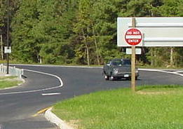
Regulatory signs controlling speed and prohibiting traffic movements are critical design issues that promote a safe driving environment. These signs will also require considerable attention during the preliminary design phase. An evaluation of the on-site traffic circulation will identify locations where wrong way vehicular movements are possible. An example of “Do Not Enter” signs where vehicles could inadvertently drive the wrong way is shown in Figure 2-4.
Figure 2-4: Regulatory Signs

Rest areas that generate high use experience problems with improper parking. “No Stopping/Standing” signs should be considered on the main line adjacent to the rest area. Signs should also be posted for “No Parking” along the limited access highway shoulder and along the travel way within the rest area. “No Pedestrian” and “No Hitchhiking” signs should be placed to discourage pedestrians from wandering on to ramps or areas near the mainline.

2.1.3 Rest Area Sign Plan Development
Using the latest design file for the roadway, the sign plan is developed in accordance with the MUTCD and the Virginia Department of Transportation Supplement. Appendix VIA-1 provides an example Rest Area Signing Plan.

The methodology for the sign plan development is discussed in TEDM Section II – Signing, Chapter 4. This section should be referenced when developing the rest area sign plans.

A complete set of example sign plans are available in TEDM Section II – Signing, Appendix IIA and should also be referred to when developing the sign plans.

When developing the sign plans, take advantage of other available design features, to reduce the number of signposts in the rest area. Opportunities may be available to combine signs with other structures, such as light poles, will reduce the number of fixed objects and reduce costs and maintenance. When opportunities are available, stainless steel brackets should be used as the mounting device when mounting to metal poles.

The following design tasks may be required for completing the sign plans. They are presented with references to the appropriate section of the TEDM.
2.1.3.1 Prepare Sign Plan Sheets
The sign plan sheets are developed from the latest available construction plan drawings for the project. Refer to: TEDM Section II – Signing for instructions, and Appendix IIA-3 for an example of the plan sheet layout.
2.1.3.2 Prepare Sign Panel Special Details
The sign panel special detail sheets provide sign dimensions and letter positions for fabrication of non-standard signs. Refer to: TEDM Section II – Signing for instructions, and Appendix IIA-4 for examples of the details.
2.1.3.3 Prepare Sign Schedule
The sign schedule provides detailed information regarding the sign and structure types and sizes for all signs on the project (standard and non-standard). Refer to: TEDM Section II - Signing for instructions and Appendix IIA-6 for an example of the schedule.
2.1.3.4 Wood Post Structure Calculations
The wood post structure calculation sheet is used to determine the structure type and dimensions when using wood post sign structures. Refer to: The VDOT Road and Bridge Standards, Volume II, Section 1300, for typical details.
2.1.3.5 Type VA Sign Structure Details
The Type VA sign structure details are used to determine the dimensions, foundations and other design features used to constructing these sign structures. Refer to The VDOT Road and Bridge Standards, Volume II, Section 1300, for typical details.
2.1.3.6 Type VIA Sign Structure Details
The Type VIA sign structure detail is used to determine the dimensions, foundations and other design features used to construct these sign structures. Refer to TEDM Section II - Signing and Appendix IIB-10 for work sheets that may be used in this process.
2.1.3.7 Overhead (O/H) Sign Structure Elevation Detail Sheet
The Overhead Sign Structure Elevation Detail Sheets provide detailed information regarding the overhead structure such that the contractor can submit the plans to a manufacturer for design and fabrication. Refer to TEDM Section II - Signing and Appendix IIA-8 for an example.
2.1.3.8 Notes for Safety Improvement Items Sheet
The Notes for Safety Improvement Items Sheet provides the contractor with detailed instructions on the work required for existing signs on the project. Refer to TEDM Section II - Signing and Appendix IIA-9 for an example.
2.1.3.9 Exit Number Panel Details
The Exit Number Panel Detail Sheet provides typical details for mounting these sign panels. Refer to TEDM Section II - Signing and Appendix IIA-10 for an example.
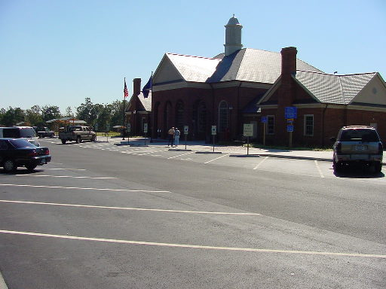
2.1.3.10 Summary Sheet
Figure 2-5: Parking Space Layout
The Summary Sheet is used to identify all pay items and quantify those pay items for the project. Refer to TEDM Section II - Signing and Appendix IIA-12 for an example.

2.2 Rest ARea MARKING
The parking spaces should be of adequate size and arrangement to accommodate the anticipated number of vehicles utilizing the facility.

The roadway through the parking area should allow sufficient width for vehicles to easily maneuver during parking operations and use of the facility. (See Figure 2-5.) Separate parking spaces for passenger cars and trucks are advantageous.

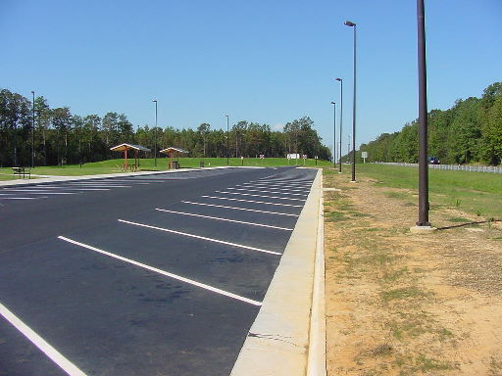
Pavement marking requirements for the facility should be addressed early in the design process. Two example issues are:
Figure 2-6: Diagonal Markings
- Transitional areas
- Perpendicular vs. diagonal parking (See Figure 2-6)

After the Preliminary Field Inspection (PFI) Meeting, there should be adequate information in the construction design to review key areas of the plan layout to ensure that the pavement markings can be properly provided.

2.2.1 Rest Area Marking Design Elements
The following pavement marking design elements should be addressed early in the design process:
- Type of markings
- Type of driving/parking surface material
- Width of lines
- Lengths of spaces
- Widths of spaces
- Drive aisle and turning space requirements
- Number handicap and State Police parking spaces
- Special messages or Legends

Early development of pavement marking plans in the project’s transition areas should reveal any geometric deficiencies in the road design. Transitional areas are typically where deficiencies are found and should be noted and reviewed with the project designers and district representatives at the earliest stages of design.

2.2.2 Rest Area Marking Preliminary Design
Figure 2-7: Conceptual Marking Plan
The conceptual pavement marking plan is based on the direction provided during the PFI. Conceptual markings plans should be drawn on the most recent proposed construction plans as shown in Figure 2-7. A pavement marking inventory should be performed if the rest area site exists and the project is for modification of the site.

A meeting should be scheduled with the district and or the agencies that have an interest in the pavement marking design. The concept plan should be discussed and marked-up during this meeting. The meeting should address and finalize the following design issues:
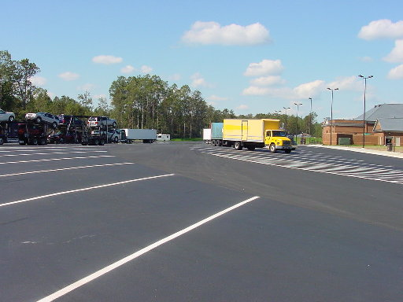
- Transitional lanes:
Figure 2-8: Truck and Camper Pavement Markings
- Ensure that the roadway and rest area geometry is adequate for pavement markings.
- Location and number of parking spaces:
  - Handicapped and State Police parking.
  - Truck, bus and camper parking area as shown in Figure 2-8.
  - Cars and SUV parking.
- Circulation and drive aisle widths:
- Buses: Roadway minimum should be 20 ft. wide.
- Drive aisle width for right-angle parking should be 20 ft. wide.
- Drive aisle width for 45° angle parking should be 18 ft. wide.
- Parking space dimensions:
- 10-foot wide by 20-foot long for normal cars.
- 9-foot by 15-foot long for subcompact cars.
  - Loading areas:
    - Loading areas should be 12-ft. wide
    - Curb returns should be at least 30-ft. radius

A review of the rest area amenities will identify pedestrian routes within the site. Conflicts between pedestrians and vehicles should be minimized. It may be necessary, to provide appropriate pavement markings that will identify these conflict areas.

See the VDOT Road Design Manual for dimensions and other spacing details regarding “Handicapped” parking space and truck parking space details.

2.2.3 Rest Area Marking Plan Development
The methodology for the pavement marking plan development is discussed in TEDM Section III – Marking, Markers and Delineation, Chapter 4. This section should be referenced when developing the rest area pavement marking plans.

A complete set of example pavement marking plans are available in TEDM Section III - Marking, Markers and Delineation, Appendix IIIA and should also be referenced when developing the rest area pavement marking plans.

It is important to note that a clear understanding of the proposed surface materials to be used within the site and access ramps needs to be identified in order to properly specify the type of pavement marking material. For Example, a coal tar pitch may be used in the parking area. This material requires a specific marking material and application method. The appropriate pavement marking material for standard surfaces can be found in the VDOT Road and Bridge Specifications.

The design tasks that may be required for completing the pavement marking plans are indicated as follows with references made to the appropriate section of the TEDM.
2.2.3.1 Prepare Base Plans
The pavement marking base plan is developed using the current roadway and site construction plans as shown in Appendix VIA-2.
2.2.3.2 Review the Typical Section
The typical section will provide the starting points for placement of the edge lines and the lane widths.
2.2.3.3 Left Edge Line
The left edge line, when applicable, should be the starting point for the pavement marking plans. The location and placement of the edge line depends on the edge of pavement and whether the pavement design has incorporated additional roadway pavement outside of the proposed edge line. The edge line labeling should include width and color on each plan sheet. Further discussion is provided in the TEDM Section III – Marking, Markers and Delineation, Chapter 4.
2.2.3.4 Travelway Skip Lines
The skip lines should be aligned adjacent to each other at the planned distance for the lane widths provided in the typical section. The skip lines labeling should include width and color on each plan sheet. Further discussion is provided in the TEDM Section III – Marking, Markers and Delineation, Chapter 4.
2.2.3.5 Right Edge Line
The right edge line follows the same general guidelines as the left edge with reference to the location in respect to the edge of pavement. The edge line labeling should include width and color on each sheet. Further discussion is provided in the TEDM Section III – Marking, Markers and Delineation, Chapter 4.
2.2.3.6 Develop Pavement Markings between Typical Sections
When developing the marking layout, care should be taken in determining whether there is a lane drop or transition area within the marking location. The marking for the lane drops or transitions is to be in accordance with the MUTCD. Line labeling should include width and color on each sheet. Further discussion is provided in the TEDM Section III – Marking, Markers and Delineation, Chapter 4.
2.2.3.7 Detail Pavement Markings for Specific Needs
Special needs marking, such as handicap symbols, need to be shown in the pavement marking plans. Special hatching and no parking messages may be necessary and should also be shown in the pavement marking plans. Further discussion is provided in the TEDM Section III – Marking, Markers and Delineation, Chapter 4.
2.2.3.8 Develop the Pavement Marker Layout
Pavement markers should be used in the exit and entrance gores, as shown in the VDOT Road and Bridge Standards, VDOT Standard PM-9, to enhance the exit and entrance during inclement weather. Wrong way pavement markers may be used to deter wrong way driving and to enhance the wrong way signing during inclement weather.
2.2.3.9 Develop the Object Marker Layout
Most of the facilities addressed in this section will not require object markers. However, should they be needed you should refer to the section on object markers in TEDM Section III - Pavement Markings, Chapter 4.
2.2.3.10 Develop the Delineation Layout
Delineation along the ramps for rest stops should be in accordance with the VDOT Road and Bridge Standards, VDOT Standards ED-1, ED-2, and ED-3. Additional delineation within the rest area facility may be necessary in areas where there is no guardrail installed to outline the parking areas. This step would most likely be necessary in the area for truck, bus and camper parking.
2.2.3.11 Develop Pavement Marking Detail Sheet
This detail indicates the typical placement for the roadway marking. The placement detail can be located on the marking plan sheet. However, if several details are required they can be placed on a separate sheet in the marking plan set. Further discussion is provided in the TEDM Section III – Marking, Markers and Delineation, Appendix IIIA-2

2.3 Rest Area Lighting
Rest areas adjacent to interstate highways offer comfort stations and picnic areas. The lighting design must include provisions for motorists arriving and leaving the area, pedestrian movement to and from the rest rooms and information centers, and pedestrian activity within the picnic and dog walk areas.

Rest area lighting design must include provisions for a variety of visual requirements.
- Motorists are quickly decelerating from 65-mph, where their attention has been focused on other vehicles, to speeds less than 25-mph, where pedestrian conflicts are possible.
- The lighting designer must consider not only creating a safe and secure environment, but must also utilize the lighting to enhance the aesthetics of the area.
- The area lighting must transition the driver’s eyes from the highway to the rest area, and into the parking area.
- The lighting must allow drivers to distinguish features of the area, such as telephones, as well as discern pedestrian movements.
- The AASHTO guidelines separate Pedestrian Area Lighting as:
- Major activity centers such as walkways to and from rest rooms, the information center, and the parking areas.
- Minor activity centers include picnic tables and dog walks.

2.3.1 Rest Area Lighting Design Elements
Rest areas found along Virginia’s Interstate highways typically use standard VDOT roadway lighting items. These items are discussed in detail in TEDM Section V – Roadway Lighting, Chapter 2, 2.8. The following subjects are specific to Rest Area Lighting.
2.3.1.1 Luminaires, Poles and Foundations
- Standard lighting poles and luminaires with typical mounting heights of 35’ to 50’ generally provide sufficient lighting to rest areas.
- High mast lighting standards provide a cost effective installation and maintenance alternative in large parking lots. The lighting designer must recognize the resulting spill light outside the VDOT right-of-way from high mast lighting and its effects on the surrounding areas.
- High mast towers may conflict with navigable airspace. See TEDM Section V – Roadway Lighting, Chapter 3, 3.10.4.
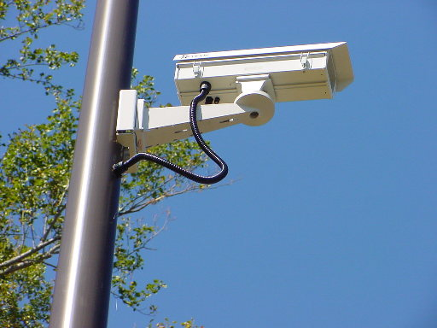
- Luminaires and poles in pedestrian areas should match the aesthetics associated with the area. Architectural lighting intended for pedestrian areas should be limited to 70-watt to 150-watt HPS luminaires mounted at 14’ to 18’ above the surface to be lighted. Refer to TEDM Section V – Roadway Lighting, Chapter 3, 3.11 for a more detailed discussion of architectural lighting.
Figure 2-9: CCTV Mounted to Light Pole
- Every effort should be made to locate poles along the outside edge of a parking area. Lighting standards located in the center of a parking area will present an obstacle to snow removal activities and traffic circulation.
- Foundations associated with light poles supporting a CCTV camera must include a cable entrance for the communications cable. Figure 2-9 shows an example of a CCTV power and the communication cable run inside a standard light pole.
- VDOT customarily uses a single photoelectric control cell at the electrical service control center to turn on the lights at night. This wiring method would require a separate, unswitched power feed for any auxiliary equipment, such as CCTV.
2.3.1.2 Electrical Service
Rest area lighting is typically powered by 120/240-V or 120/208-V, single-phase electrical service. The VDOT standard SE-6 provides sufficient room for the large loads associated with rest areas. The VDOT standard SE-8 may also be used in small rest areas. The determining factor is the number of circuit breakers that are needed to operate the facility. The control center associated with the SE-8 will support no more than 1-main breaker (typically 60-amps per line) and typically 8 branch circuits. Refer to TEDM Section V – Roadway Lighting, Chapter 2, 2.8.5.3 for a more detailed discussion of the SE-8.

2.3.2 Visibility and Lighting Quality in Parking Facilities
The lighting designer should reference TEDM Section V– Roadway Lighting Chapter 2 for discussions of:
- Visibility
- Photometry
- Lighting Analysis
- Computer Design Programs

This Section of the Traffic Engineering Design Manual also covers issues related to standard VDOT lighting equipment found in most parking facilities. However, issues specific to all parking areas are discussed below.

The illumination requirements of parking facilities are affected by the layout, operation and vehicular traffic issues, plus the visibility and security needs of pedestrians walking to or from their vehicles. Parking facilities have vehicular speeds much lower than roadways. More important, the primary purpose of lighting a parking area is to benefit the pedestrian. It should be noted that 2/3 of the accidents within parking lots involve moving vehicles striking parked vehicles. Most of these accidents involve vehicles avoiding pedestrians. (Reference IESNA RP-20-98)
2.3.2.1 Parking Lot Lighting Levels
The lighting levels for all parking areas are discussed in IESNA RP-20-98. However, a more complete discussion specific to lighting in Rest Areas is presented in the AASHTO Guide for Roadway Lighting.

Within a parking lot, the intended design is to allow drivers or pedestrians looking at the brightest spot in the field of view to also be able to see an object in dark areas. This visual detection can only occur if the maximum-to-minimum illuminance is limited to a range that the human eye can see. Average illuminance has no practical bearing on the range of illuminance compatible with seeing. Thus, average-to-minimum uniformity, as discussed in previous IESNA Recommended Practices and the AASHTO Informational Guide, is used only in the early development of a parking area lighting plan. The final plan must be based on maximum-to-minimum ratio of illuminance.

Although light levels and uniformity are printed in RP-20-98, the discussion is not straightforward. The parking lot lighting levels are thus presented in this document and compiled for clarity in the table that follows.

Parking Lot Lighting Levels
 | Basic Security | Enhanced Security
Average Maintained Horizontal Illuminance | 1.0 fc | 2.5 fc
Average to Minimum Illumination Ratio* | 5:1 | 5:1
Minimum Horizontal Illuminance | 0.2 fc | 0.5 fc
Maximum to Minimum Illuminance Ratio | 20:1 | 15:1
Minimum Vertical Illuminance | 0.1 fc | 0.25 fc
* The Avg./Min. uniformity ratio is developed only to establish the minimum and maximum light levels needed for the final design. This uniformity ratio is not required for the final design of the lighting system.
The steps applied in developing a lighting design for a parking area are as follows:
- Establish the Average Horizontal Illumination requirements on the pavement based on the level of security needed.
- Develop a lighting plan based on Average-to-Minimum Horizontal Uniformity of 5:1. This step will provide direction in establishing the maximum and minimum illumination levels required for the final design.
- Insure the lighting plan meets the Minimum Horizontal Illumination level on the pavement.
- Advance the lighting plan based on the Maximum-to-Minimum Horizontal Uniformity Ratio.
- Refine the plan to meet the minimum levels of Vertical Illumination presented in RP-20-98. The light levels are intended to provide pedestrians with a sense of security as they move across the parking lot. The vertical lighting level is required at points in the parking lot where the horizontal illumination on the pavement is lowest. However, the calculations for vertical illumination (made at 5’ above the pavement) can be restricted to only those areas were pedestrians should be capable of recognizing facial features. Further discussion of vertical illuminance is available in TEDM Section V – Roadway Lighting, Chapter 3, 3.11.1.
- Glare within a parking lot is recognized through the Maximum Veiling Luminance Ratio (L_{v}/L_{ave}). It should be limited to 0.30 to 1.10.

There is no documented procedure for calculating L_{v}/L_{ave} within a parking area. However, practical experience suggests that the ratio should be based on point calculations made along the aisles between the parking slots. The lighting design software package, AGI32, provides the designer with a Veiling Luminance Calculation grid. This calculation grid should be placed along a straight section within the parking area for a distance of at lease 270-ft (83-meters). (IESNA RP-8-00)

2.3.3 Rest Area Light Levels
The AASHTO Informational guide for Roadway Lighting delineates rest area lighting into four, separate areas:
- Entrance & Exit Gores
- Interior Roadways
- Parking Area
- Pedestrian Activity Areas; Minor and Major

The AASHTO guide provides the lighting designer with very clear direction in developing the lighting design for each of the above areas. This guide, however, references Average-to-Minimum Uniformity Ratios. As noted above, within the parking area, the Maximum-to-Minimum Uniformity Ratio should be used to recognize the quality of lighting.

At the gore areas and along the interior roadways, specific levels of illuminance, luminance and veiling luminance must be recognized. The designer should reference the values stated in the AASHTO guide. Quality of lighting should be determined based on the Average-to-Minimum Uniformity Ratio.

Within the parking area, the lighting designer should reference the IESNA RP-20-98 values for lighting levels and use the Maximum-to-Minimum Ratios, as noted in the preceding table.

Within the pedestrian activity areas the lighting designer should reference the AASHTO guide and utilize the Average-to-Minimum calculations to recognize the quality of the area lighting.

It should be noted that within the pedestrian activity areas, there is no requirement to meet specific levels of luminance or veiling luminance. However, the designer must consider levels of Vertical Illuminance as discussed above.

2.3.4 Rest Area Lighting Preliminary Design
The Scoping and Preliminary Field Inspection Meeting should provide some insight on the options available and the design parameters used for lighting the rest area, such as lighting standard types and aesthetics. The preliminary design will need to incorporate these design parameters. TEDM Section V – Roadway Lighting, Chapter 3, 3.3 provides an overview of each luminaire type and pole type available to use on a typical project.

Unlike roadways, lighting a parking facility requires throwing light across the area to be lighted.
- High mast lighting provides optimum performance, but may detract from the aesthetics, or spill into local properties.
- Offset luminaires may be used with a 0-degree tilt angle. That is the lighting must be directed straight down. A complete discussion of this topic is located in TEDM Section V – Roadway Lighting, Chapter 1, 1.3 and Chapter 2, 2.3.4.
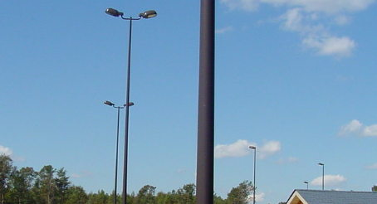
- Shoebox luminaires may be classified as either an offset lighting standard with a 0-degree tilt, as shown in Figure 2-10, or architectural lighting. They are unobtrusive to the environment and enhance the area, but may not function well in lighting the wide expanse of a parking lot.
Figure 2-10: Offset lighting with near 0-degree tilt
- The engineer must be very clear to specify the optics required to satisfy the lighting criteria. For Example:
“Luminaires installed on this project shall have an IESNA optical distribution of Medium-Type IV-Full Cutoff.”
- A luminaire arm will extend a cobrahead luminaire as much as 25’ from the pole, thus physically placing the light over the pavement or parking area. However, these lighting standards can be less appealing to the eye.
- The project may require specifications that address the color of the pole, arm and luminaire, as well as the texture and appearance of the pole; i.e., a “black spun-fiberglass pole” or “architectural pole with fluted shaft”.
2.3.4.1 Rest Area Pole Placement
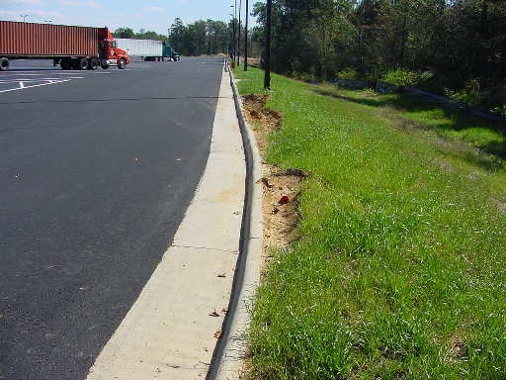
Within a parking lot it is desirable to locate the face of the pole 7.5’ behind the face-of-curb. This distance may be reduced to a minimum of 6’ from the face-of-curb to the face-of-pole. Typically this arrangement requires placing the center of the pole/foundation 8’ (or a minimum of 6.5’) from the face of curb. The poles shown in Figure 2-11 barely meet the clear zone requirements for this area. The ruts shown in this Figure were made by trucks unable to turn without jumping the curb. In this area, poles placed too close to the curb would have been knocked down.
Figure 2-11: Parking Lot Pole Placement outside clear zone

Poles should be placed outside the clear zone for the roadway. TEDM Section V – Roadway Lighting, Chapter 3, 3.5 can be referenced for examples of clear zone requirements, however, the VDOT Road Design Manual, Section A-2 – Clear Zone Guidelines provides clear discussion on this issue. See Figure 2-12.

Poles placed behind guardrail must be located outside the deflection zone for the guardrail. See Figure 2-13.
Figure 2-12: Parking Lot Recommended Lighting Pole Clear Zone Distance

In large parking lots, where medians or islands are not available to protect a pole, the pole foundation should be extended at least 2.5’ above grade. This issue is particularly important when installing high mast lighting. Collision and knockdown of a high mast tower would be devastating to nearby pedestrians and vehicles.
2.3.4.2 Power Distribution
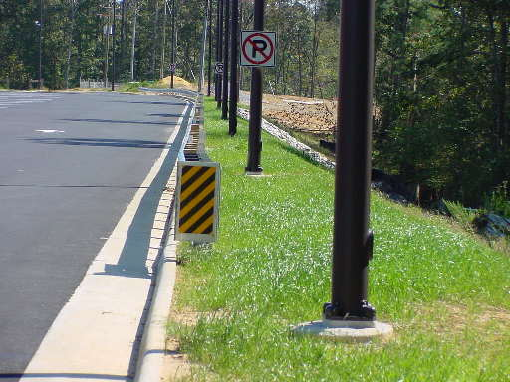
TEDM Section V – Roadway Lighting, Chapter 3, 3.7 and 3.8 provide discussion related to locating the electrical service point. This chapter also provides an example calculation of preliminary power requirements.
Figure 2-13: Parking Lot Pole Placement behind guardrail

The rest area lighting is usually served by one control center operating at 120/240-V or 120/208-V, single-phase. The electrical service and associated meter is typically shared with the buildings in the rest area. An example conduit layout and voltage drop spreadsheet is provided in Appendix VIB-6 – Electrical Distribution.

The VDOT Standard CCW-1 Control Center Type C (single-phase voltage) or the Type D (three-phase voltage) provides a photocell for dusk to dawn control of the lights.

2.3.5 Rest Area Lighting Plan Development
The engineer for a Rest Area Lighting project can employ the lighting plan development steps discussed in TEDM Section V – Roadway Lighting, Chapter 4.

TEDM Section V – Roadway Lighting, Appendix VA provides a complete example of a lighting plan and should be referenced in developing the lighting plans for a rest area.
2.3.5.1 Step #1 – Establish Performance Criteria
Rest area lighting criteria is stated in the IESNA and AASHTO documents noted in Chapter 2.3.2 of this Section.
- The lighting designer must coordinate with the VDOT TE/L&D Manager to understand specific needs of pedestrians within the Activity Areas.
- The designer should also coordinate with the area architect to understand the overall desires for aesthetics.
2.3.5.2 Step #2 – Selection of Equipment
The choice of light poles and luminaires is typically based on the aesthetics associated with the rest area.

Discussion of the various VDOT standard lighting items is provided in TEDM Section V – Roadway Lighting, Chapter 2, 2.8.3.
2.3.5.3 Step #3 – System Characterization
The initial pole spacing along the interior roadways can be performed using the AGI32 Roadway Optimizer. Several iterations using a variety of luminaires will be necessary to establish the pole spacing suitable to allow at least three manufacturers to bid on the project. Further discussion on this topic is provided in TEDM Section V – Roadway Lighting, Chapter 4, 4.4.

The pole spacing within the parking lot and the activity areas must be developed based on a trial-and-error layout of the system over a section of the project typical of the entire area. This simplified layout should use a variety of luminaires from several manufacturers to develop a general concept of the lighting system plan.

Pole spacing at the gore areas should transition the driver’s eyes to the changing light level. This transition should be made by increasing/decreasing the pole spacing. A complete discussion of a lighting transition zone is available in TEDM Section V – Roadway Lighting, Chapter 3, 3.10.3.

The lateral pole offset will be based on the clear zone requirements associated with the area.
- Within the parking lot, speeds are low and poles can be placed relatively close to the curb. However, placing poles within 6’ of the curb may result in a collision related to either a truck turning too wide or a car backing into the pole.
- Along the interior roadways and gore area, the speeds are higher and the clear zone requirements are greater.

The results of the System Characterization should be delivered to the VDOT TE/L&D Manager prior to developing the full lighting plan layout. These results should demonstrate the suitability of the chosen luminaires, arm lengths, mounting height, lateral offset and pole spacing to meet the illuminance, luminance, and veiling luminance criteria established in the IESNA and AASHTO publications as noted in Chapter 2.3.2 of this section.
2.3.5.4 Step # 4 – Lighting System Layout
The discussion steps noted in TEDM Section V – Roadway Lighting, Chapter 4, 4.5 should be referenced in the development of the rest area lighting plan.

Appendix VIA-3 provides an example rest area layout showing the overlay of the luminaire templates discussed in TEDM Section V – Roadway Lighting, Chapter 2, 2.4.1.1.
2.3.5.5 Step #5 – Layout the Conduit and Wiring System
The entire site plan should be printed at a large scale to develop the electrical plan. This method allows the designer to route conduit such that the length of wire run throughout the system is as low as possible. This effort will reduce the voltage drop, maintenance and overall installation cost.

The discussion steps noted in TEDM Section V – Roadway Lighting, Chapter 4, 4.6 should be referenced in the development of the rest area electrical plan.
2.3.5.6 Step #6 – Calculate Voltage Drop, Wire Size, Conduit Size and Junction Box Size
The discussion steps noted in TEDM Section V – Roadway Lighting, Chapter 4, 4.7 should be referenced in the development of the rest area electrical plan.

Appendix VIB-6 provides an example rest area voltage drop spreadsheet and electrical schematic based on 120/240-V, single-phase electrical service.
2.3.5.7 Step #7 – Plan Sheet Development
The discussion steps noted in TEDM Section V – Roadway Lighting, Chapter 4, 4.8 should be referenced in the development of the rest area lighting plan set. This chapter provides sample plan sheet conduit callouts, luminaire and pole designations, electrical references, and survey and alignment procedures.

The lighting plan set presented in TEDM Section V – Roadway Lighting, Appendix VA provides examples of the various plan sheets necessary to complete the lighting plan. Appendix VIA provides example sheets used in a rest area lighting plan set:
- Appendix VIA-5 provides an example rest area plan sheet.
- Appendix VIA-4 provides an example pole detail sheet showing an architectural light pole and foundation.
- Appendix VIA-6 provides an example Panelboard Schedule derived from the voltage-drop calculation performed in Step #6 above.

The proposed location for lighting poles can be accomplished using, either station and offset from a baseline, swing-ties from a known point, or specifying the pole locations based on a coordinate system. See TEDM Section V – Roadway Lighting, Chapter 4, 4.8.3 for a discussion of these procedures.
2.3.5.8 Step #8 – Determining Quantities
Issues related to pay items to be removed or salvaged are discussed in TEDM Section V – Roadway Lighting, Chapter 4, 4.9.

Issues related to new items to be installed with the rest area lighting project are discussed in TEDM Section V – Roadway Lighting, Chapter 4, 4.10. An example Summary of Quantities is available in TEDM Section V – Roadway Lighting, Appendix VA-3.
2.3.5.9 Step #10 – Plan Preparation
The engineer must recognize if the lighting plans will be advertised as part of a complete project that will include not only traffic control devices, but also construction of a rest area. Or, will the rest area lighting plans be constructed as a separate, stand-alone project. These issues are discussed in TEDM Section V – Roadway Lighting, Chapter 4, 4.11.

The topics regarding lighting pay items, and General Notes are discussed in TEDM Section V – Roadway Lighting, Appendix VB and may be helpful in completing the lighting design for a rest area.

