Chapter 1: Introduction
1.1 general 1
1.2 Acknowledgements 2

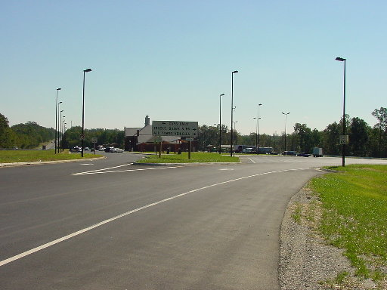
1.1 general
Figure 1-1: Rest Area TCD (Signing, Marking & Lighting)
This section of the Traffic Engineering Design Manual provides a design guide for developing traffic control devices (TCD) plans for rest areas, park and ride lots and commuter parking lots. Properly designed, adequately signed, marked and lighted facilities are of the utmost importance to provide positive guidance and safety to the motorists and pedestrians. The section addresses each type of facility separately.

Well-spaced rest areas on the interstate system provide relief for the motorist. A consequence of long duration driving trips is a reduction in attention and vigilance, resulting in a slower reaction time. A facility should provide clear guidance in the safe movement for motorists and pedestrians. Even an acceptable design may not operate properly without the appropriate design and placement of traffic control devices. An example of these devices is shown in Figure 1-1.

The rest area facility must also be designed to accommodate the needs of the handicapped and elderly along with the proper control devices to assist and provide positive guidance for this group of motorists.
Figure 1-2: Example Park & Ride Lot

The design of traffic control devices for park-and-ride lots is included in this section with emphasis on accommodating handicapped motorists and pedestrians, and providing adequate lighting to promote safety within the facility. (See Figure 1-2.)

The design of traffic control devices for commuter parking lots will also be addressed with attention given mostly to signing and lighting.

1.2 Acknowledgements
The following references were used to provide information for this section of the manual:

- A Policy on Geometric Design of Highways and Streets – AASHTO
- A Guide on Safety Rest Areas for the National System of Interstate and Defense Highways – AASHTO
- Guide for the Design of Park-and-Ride Facilities – AASHTO
- FHWA Roadway Lighting Handbook
- AASHTO, An Informational Guide for Roadway Lighting
- IESNA Recommended Practices Lighting for Parking Facilities IESNA RP-20. The most current edition of this document is, RP-20-98.
- IESNA Recommended Practices for Roadway Lighting IESNA RP-8. The most current edition of this document is, RP-8-00.
- The National Electric Code, NEC.

