CHAPTER 3: PRELIMINARY Design
3.1 GENERAL 1
3.2 LIGHTING WARRANTS 1
3.3 SELECTION OF POLE AND LUMINAIRE TYPES 1
3.3.1 Conventional or Cobrahead Pole 2
3.3.2 Offset 2
3.3.3 Architectural Lighting 2
3.3.4 High Mast Luminaire and Pole Combination 2
3.4 POLE PLACEMENT ISSUES 3
3.5 CLEAR ZONE AND THE BREAKAWAY BASE 5
3.6 MEDIAN BARRIER LIGHTING 7
3.7 DETERMINING THE POWER SOURCE 9
3.8 PLACEMENT OF ELECTRICAL SERVICE AND LIGHTING CONTROL CENTER 10
3.9 TRANSFORMER BASES VERSUS JUNCTION BOXES 11
3.10 Standard LIGHTING SYSTEMS UTILIZED BY VDOT 11
3.10.1 Items to be installed by Others 12
3.10.2 Underpass Lighting 13
3.10.3 Lighting on Bridges 13
3.10.4 Lighting Near Airports 14
3.10.5 Tunnel Lighting 14
3.10.6 Lighting for Other Streets and Highways 15
3.10.7 Lighting at Intersections or Other Isolated Traffic Conflict Areas 15
3.11 ARCHITECTURAL LIGHTING 16
3.11.1 Mixed - Architectural/Roadway Lighting System 17
3.11.2 Architectural Roadway Lighting 18
3.12 Sign lighting 19

3.1 GENERAL
The Chapter presents various considerations that the lighting designer must recognize in the early stages of design. Some of these issues are discussed during the Scoping Meeting, but most of them must be established by Field Inspection and Public Hearing. Reference the TEDM Section 1 – General, Chapter 2, 2.2 for a complete discussion of the Concurrent Engineering Process.

3.2 LIGHTING WARRANTS
The TE/L&D Manager will determine the need to perform lighting warrants.

The primary purpose of warrants is to assist administrators and designers in evaluating locations for lighting needs and selecting locations for installing lighting. Warrants give conditions that should be satisfied to justify the installation of lighting. Meeting these warrants does not obligate the state or other agencies to provide lighting or participate in its cost. Conversely, local information in addition to that reflected by the warrants, such as roadway geometry, ambient lighting, sight distance, signing, crash rates, or frequent occurrences of fog, ice, or snow, may influence the decision to install lighting. The design stage can begin once the decision has been made to install new lighting.

The AASHTO Informational Guide for Roadway Lighting provides three separate warrants for freeway lighting:

- Continuous Freeway Lighting
- Complete Interchange Lighting
- Partial Interchange Lighting

Several cases are described under each lighting warrant. The cases discuss warranting conditions based on average daily traffic volumes, roadway geometry, and night-to-day accident rates.

The National Cooperative Highway Research Program (NCHRP) Report #152 “Analytical Approach to Illumination Warrants” may also be used for determining the priority of freeway lighting projects. This warranting procedure is the primary method used by VDOT. It is heavily weighted on night-to-day accident data. For new road construction, this data must be based on similar roadways found within the State.

3.3 SELECTION OF POLE AND LUMINAIRE TYPES
The VDOT District Traffic Engineer may have a general concept on how the facility should be lighted. Together with the Resident Engineer, they best understand the requirements of the residents and the flow of traffic through the facility. The designer should review lighting options with the TE/L&D Manager and local VDOT personnel prior to the initial selection of light pole and luminaire equipment.

A detailed discussion of standard VDOT lighting equipment is provided in Appendix VB-2. The following items should be considered when selecting poles and luminaires:

3.3.1 Conventional or Cobrahead Pole
- The most common equipment used is the 30-foot to 50-foot pole with a luminaire and bracket arm.

- The bracket arm typically places the luminaire directly over the edge of the travel lane, as shown previously in Figures 2-11 and 2-12.

- Maintenance of these luminaires will, almost certainly, require a shoulder closure, and, in many cases, will require a lane closure.

- Generally, this type of pole allows greater spacing between luminaires than the offset style pole.

3.3.2 Offset
- The offset pole is typically a 30-foot to 50-foot pole with a luminaire mounted to the top without a bracket arm.

- Tilting the luminaire upward, to aim its optical distribution, may be required. However, under current VDOT lighting practices, the offset luminaire is normally installed with a 0-degree tilt, or pointing straight down, as shown previously in Figure 2-13, with single or double tenon.

- The pole is typically placed offset from the roadway, beyond the edge of the shoulder (i.e. in the grass). This location reduces the need for a lane closure to perform installation or maintenance.

- Generally, this type of pole requires closer spacing between luminaires when compared to the conventional style pole.

3.3.3 Architectural Lighting
- Shoebox style or architectural luminaires are often appropriate for rest areas, park & ride areas, or to provide some aesthetic value to outdoor lighting.

- Architectural lighting is non-standard to VDOT, and requires modification of the Specifications for completion of the bid documents.

3.3.4 High Mast Luminaire and Pole Combination
- High mast lighting provides an area type of lighting with 3 to 12, 250-watt, 400-watt, 750-watt, or 1000-watt HPS luminaires mounted on poles (also referred to as towers), at heights varying from approximately 60 feet to 150 feet, as shown previously in Figure 2-14.

- At these mounting heights, high-output luminaires develop a uniform light distribution.

- High mast lighting is used principally where continuous lighting is desirable, such as:
- Interchange lighting,
- Lighting of toll plazas,
- Rest areas and parking areas,
- General area lighting,
- Continuous lighting on highways having wide cross-sections and a large number of traffic lanes.

- The lighting system is not desirable where there is residential impact from spill light.

- The system is desirable where maintenance of conventional lighting units may be a hazard to the traveling public and maintenance personnel.

- High mast lighting typically provides reduced glare levels when compared to conventional or offset lighting.

- Several roadways can usually be illuminated from a single high mast tower.

- High mast lighting provides the motorist with an exceptionally wide field of vision.

- Performance of the system under adverse weather conditions is good.

- The cost of a single high mast lighting tower and luminaire assembly is higher than that of a conventional or offset lighting standard. As a rule of thumb, the light that is provided by one high mast tower should replace 6 to 8 conventional lighting standards.

- The high mast tower cannot be fitted with a breakaway base and thus must be located outside the clear zone or protected from traffic by means of guardrail or barrier service.

- High mast lighting standards must be located such that they are accessible to a crane for maintenance crews in the event the luminaire ring becomes hung at the top of the tower.

3.4 POLE PLACEMENT ISSUES
Pole placement is an engineering decision which should be based upon geometry, character of the roadway, physical features, environment, available maintenance, economics, aesthetics, and overall lighting objectives, a few of which are shown in Figures 3-1 and 3-2. Physical roadside conditions may require adjustment of the spacing determined during the conceptual lighting design. The following points should be considered in every lighting design:
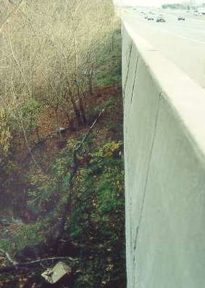
- The lighting designer should plan a site visit early in the design process. Terrain features may alter the choice of lighting equipment, and the routing of conduit. In some cases, the terrain may make pole placement, conduit routing, and maintenance of the system, impossible within the available budget.
Figure 3-1: Difficult Terrain Features. 25-foot drop to ground level with steep grade.

- Site considerations affecting pole placement include the presence of noise walls, retaining walls, existing guard rail, rock, narrow roadside clearances, power lines, nearby airports, traffic signals and nearby residential neighborhoods.

- The placement of light poles near power lines requires the lighting designer to coordinate with the local power company. In many cases, poles cannot be placed within 10-feet of a distribution line. However, this exclusion sphere varies with the amplitude of the power company’s line voltage. Transmission lines, usually carrying mega-volt lines, will have an easement granted to the power company. It is seldom that light poles will be allowed within this easement.

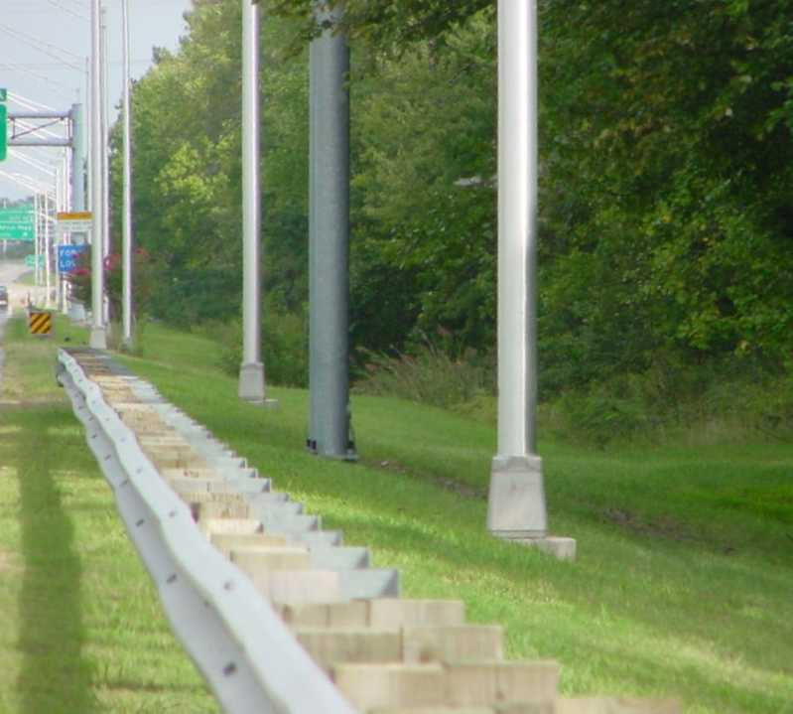
- Poles should be placed behind noise walls only if the site permits access for maintenance. The location of required doors should be noted and brought to the attention of the Project Manger.
Figure 3-2: Pole Placement

- The lighting designer should recognize that pole foundations placed directly behind a retaining wall might be in conflict with the tiebacks associated with the wall.

- Poles should also be placed outside the roadway clear zone, discussed in TEDM Section V – Roadway Lighting, Chapter 3, 3.5, and located to minimize knockdowns. For example, light poles located on the inside of a banked curve should be placed such that trucks will not hit them. Furthermore, poles located in a gore area are susceptible to removal by collision.

- Luminaires mounted on the inside of a short radius curve require closer spacing in order to produce adequate pavement brightness on the curved section, but are a preferred placement over the outside of a short curve.

- Poles should be placed behind guardrail at a distance that will allow ample clearance for guardrail deflection upon impact. Refer to TEDM Section V – Roadway Lighting, Chapter 3, 3.5 for a more detailed discussion of this subject.

- Pole offset and luminaire placement should be uniform. Inconsistencies in the luminaire positioning over the roadway, and the distance from the shoulder to the base of the pole, can be a source of distraction to the driver.

- Areas requiring higher light levels are discussed in RP-8-00 under the heading, Situations Requiring Special Consideration. These locations include areas that are complicated by pedestrians or decision points such as a gore area. Typically, reducing the pole spacing without changing the lamp wattage, luminaire mounting height or optical distribution can increase the light level.

- When streetlights are installed in conjunction with traffic signals, the lights should be installed on the same poles as the traffic signals (i.e., VDOT Standard Combination Signal Pole, MP-1 as shown in the VDOT Road and Bridge Standards, Section 1300). In some cases, these luminaires are powered by the same electrical service providing power for the signal. However, it is not unusual for these luminaires to be powered from a separate source. In this case, the lighting designer should coordinate with the Signal Designer for the location of junction boxes and signal conduits, and the position of the luminaires and bracket arms.

- Light pole placement should consider maintenance issues. Bucket trucks must be nearly level to operate and are limited in the height and distance from the roadway that the bucket can reach. Different types of trucks may have different working ranges. The lighting designer should verify with the VDOT District Maintenance section as to the availability and attributes of their bucket trucks.

3.5 CLEAR ZONE AND THE BREAKAWAY BASE
Clear zone requirements can be found in the VDOT Road Design Manual, Section A-2 – Clear Zone Guidelines. Poles should always be placed outside the clear zone. Poles placed within the clear zone should be fitted with a breakaway base.

Where poles are placed behind guardrail, they must be located outside the deflection zone of the guardrail and should not be fitted with a breakaway base. The guardrail deflection zone can be found in the VDOT Road & Bridge Standards, Section 500 under the GuardRail Installation Criteria.

The following is a discussion of several points to consider in the placement of light poles:

- The clear zone requirements vary with design speed, Average Daily Traffic (ADT), and the grade of the paved and unpaved shoulder.

For example:
A section of roadway without guardrail requires 32 feet to the clear zone. In this example, the face of the pole should be placed a minimum of 32 feet from the edge of the travel lane. Recognizing that the pole has a diameter of 12 inches, the lighting designer can reference the survey baseline to locate the pole center at least 33 feet from the edge of the travel lane.

- The clear zone at the gore of an interstate exit ramp can be as long as 414 feet from the beginning of the theoretical gore. It is imperative that the lighting designer does not place a lighting standard in this area. The pole will be prone to removal by collision. Elimination of this lighting standard will greatly reduce visibility at this critical location. The example shown in Figure 3-3 is very specific to roadway geometry. The lighting designer must review the clear zone requirements as discussed in the Road Design Manual.

- The transformer base may be configured with an AASHTO approved breakaway system or constructed of frangible material as discussed in the VDOT Road and Bridge Specifications, Section 229 and Section 700. Alternatively, a breakaway base may be provided with a set of couplings and a skirt having only 4-inches of clearance from the top of the concrete foundation.

- A lighting pole located outside the clear zone or beyond the deflection zone of the guardrail should not be fitted with a breakaway base.

For example:
The breakaway base is intended to be hit by a vehicle moving at high speed, causing the pole to flip over, and land behind the vehicle. Guardrail will slow the vehicle before it strikes the pole, causing the breakaway base to shear, and the pole to fall on the roof of the vehicle.
Pole Dia.:12"
Guardrail: 24”
3’ min. guardrail deflection
7’ optimal setback

Specifically:
VDOT standard GR-2 metal guardrail has a deflection of 3 feet. The distance from the back of the guardrail to the face of the pole must exceed this distance. Roadway plans for new guardrail and survey of existing guardrail reference the face of guardrail. Recognizing that the guardrail measures approximately 24-inches face-to-back and the pole typically has a 12-inch diameter; the lighting designer may find it convenient to set the center of each lighting pole at 7 feet behind this type of guardrail. This distance will provide an 18-inch gap between the deflection zone of the GR-2 guardrail and the face of the pole.

- Limited right-of-way or terrain restriction may prevent the placement of lighting standards outside the deflection zone for standard GR-2 metal guardrail. In this situation, the lighting plans may require strengthening the guardrail to a GR-2A with a 2-foot deflection zone.

- When all alternatives have been exhausted, and placement of the lighting standard results in a location within the guardrail deflection zone, concrete barrier service should replace the guardrail.

3.6 MEDIAN BARRIER LIGHTING
Median barrier lighting can be a very attractive option in areas of limited right-of-way. The lighting system can be powered from a single conduit and wire run, versus two trenching and conduit runs placed along both edges of the roadway.

Both conventional and offset lighting standards can be mounted on median barriers utilizing a twin arm mounting system. This lighting configuration provides several benefits, but may not be the best answer for every situation:

- The median barrier technique of mounting lighting poles reduces the number of poles and conduit runs, and has the added benefit of utilizing the house-side light from the luminaire.

- However, without the presence of trees or a sound wall along the outside shoulder, light may be thrown toward residential communities adjacent to the roadway.

- Maintaining the lighting system requires placing service vehicles on the inside shoulder directly adjacent to the fast lane. Median barrier mounted lights should not be used in high volume areas without a 10-foot minimum inside shoulder.

- Vehicles stopped in the breakdown lane, on the outside shoulder, may receive only the minimum amount of illumination.

- Coordination with the median barrier designer must be made to insure the pole foundation dimensions and bolt circle configuration match the attributes of the proposed lighting pole.

- The lighting designer must recognize the dimensions of the pole foundation blister, and location of the shy-line as described by the VDOT Standard Median Barrier (MB-7, MB-8, MB-12, MB-13).

- The lighting design must consider the location of drainage structures under the median barrier.

- The beginning and ending of a median barrier typically requires a section of wall that tapers in height. Lighting standards should not be placed on this section of the wall.

- The lighting designer must insure that the median barrier design provides for a junction chamber of sufficient size to accommodate the conduit and conductor cables at the base of each pole.

For example:
A junction chamber (d=6” x h=12” x l=18”) at the base of the pole, embedded in the median barrier, would provide a pull box for a 2” conduit with five #2 AWG cables (3-phase conductors, 1-neutral, and 1-ground). This chamber would also provide a splice point for the 1” conduit coming down from the pole base, and the four #10 AWG wires delivering power to the luminaires and grounding for the pole (2-phase conductors, 1-neutral, and 1-ground). Information on junction box fill can be found in Appendix VB-4.

- At locations where dual mount lighting standards provide illumination to roadways of differing elevations, the mounting height for both luminaires should be measured from the roadway with the higher elevation. The lighting designer should provide a detail of this lighting standard in the plans clarifying the placement of the luminaire relative to the roadway. Refer to Appendix VA-4 for an example of this detail.

3.7 DETERMINING THE POWER SOURCE
A field visit with the power company representative should be organized shortly after completing the system characterization. The lighting designer should provide the power company representative with an estimated transformer (kVA) power requirement.

For example:
Prior to meeting with the power company representative, the lighting designer recognizes that the facility should be powered with a 277/480Y-VAC supply and lighted as follows:
- The ramps of an interchange have a combined length of 4000 feet. The 250-watt offset luminaire chosen during system characterization, discussed in TEDM Section V – Roadway Lighting, Chapter 4, 4.4, will light these roadways when spaced at 210 feet apart. Nineteen luminaires, plus one extra for each gore area (8-gore areas), are required. ((4000’/210’=19) + 8 = 27, 250 watt lamps)
- Eight-high mast towers with four, 400-watt fixtures on each tower are required to light the cross street and mainline.
- The total wattage required for this interchange is:
8 (high mast towers) x 4 (400-watt luminaire on each tower) = 12.8kW
27 (offset luminaires) x 250-watt = 6.75 kW
Total power demand = 19.55 kW
Total energy demand:
19.55 Kw ÷ 0.8 (typical HPS luminaire power factor) = 24.44 kVA.

In this example, the smallest transformer Virginia Power will provide is 150-kVA, far in excess of the power demand.

The lighting designer must meet and discuss the source of power prior to completing the layout of the lighting system. Appendix VB-3 highlights issues that should be discussed with the power company representative.

Every service feed provided by the local power company must be coordinated with a field representative. The lighting designer should never assume that power is easily accessible.

- Grid Maps. Prior to meeting the power company representative, the lighting designer should request grid maps indicating the location of primary electrical feeders that are local to the proposed facility. Reviewing these maps will enable the designer to develop a conceptual conduit layout plan.

- Primary Power. During a field visit, the designer should make an effort to identify potential sources of primary power. The typical primary power delivered by the local power company is 13,900 VAC or 19,500 VAC. The power company will step down this primary power through a transformer to provide secondary power at the voltage required for the lighting system.

Overhead 3-phase primary power can be recognized as three small wires running at the top of wooden utility poles. The lighting designer should take the time to notice these lines during the field reconnaissance and note the pole numbers for later reference.

- Easements and Right-of-Way. The lighting designer can not assume that a property owner will allow the power company to cross privately owned land to deliver power to the VDOT right-of-way.

- Locate primary power directly adjacent to the VDOT right-of-way if possible. The power company will typically place transformers at the top of the utility pole, step down the voltage, and run the secondary power to the meter base on the VDOT electrical service.

The distance from the source of primary power should be kept as short as possible to minimize losses due to voltage drop.

- Secondary 277/480Y VAC power is never run in excess of 2,000 feet from the transformer to the meter base.
- Secondary 120/240 VAC single-phase power is never run more than 700 feet from the transformer to the meter base.

If these distances are exceeded, primary power must be pulled to the VDOT electrical service and a step down transformer placed near the meter base.

3.8 PLACEMENT OF ELECTRICAL SERVICE AND LIGHTING CONTROL CENTER
The lighting designer must recognize the following issues when selecting a location for the electrical service and control center cabinet:

- Clear-Zone. The structure must be placed well outside the clear-zone or located behind guardrail or barrier service.
- Accessibility. In many VDOT districts, the local power company meter reader is not permitted to stop on an interstate roadway to read the meter. Thus, the meter must be located within the VDOT right of way, but easily accessible from a side street. Furthermore, the control center must be accessible to the VDOT electrician.

For example:
A lighting control center located behind a noise wall should be accessible either through a door in the wall, or a local street behind the wall, or within walking distance of the end of the wall.

In another example, where the VDOT electrical service is located directly adjacent to the right-of-way fence, the fence should be routed around the electrical service such that the power company representative and VDOT electrician can access the equipment without jumping over the fence.

3.9 TRANSFORMER BASES VERSUS JUNCTION BOXES
Conventional and offset lighting poles may be mounted to the concrete foundation anchor bolts using a transformer base, similar to that shown previously in Figure 2-15.

The transformer base provides a convenient splice point for the electrical system and can provide an economical alternative to placing a junction box at the base of each pole.

For example:
A typical transformer base stands 18” high and has a volume of 1.76-cu-ft. This space can accommodate a splice point for two, 2” conduits with eight, #1 AWG conductor cables in each conduit (five, #1 phase conductors, two, #1 neutral wires, and one, #1 ground wire), plus the splices required to power the luminaire (two, #10 AWG wires), and a 1” conduit carrying the #6 AWG grounding cable to the ground rod. Further information regarding volume requirements in junction boxes can be found in Appendix VB-4 and Section 314 of the 2002 NEC code.

Although, in the above example, the use of a transformer base as a splice point is allowed under NEC recommendations, utilizing a VDOT standard junction box near the base of the pole will provide a more convenient splice point.
- When working with #0 AWG or larger conductor cable, the lighting designer should always provide a junction box at the base of the pole.
- Conductor cables #1 AWG or smaller can be spliced in a transformer base with little difficulty.

The requirement to install a transformer base with a light pole does not necessarily imply the use of a breakaway base. The breakaway base can be installed with or without a transformer base. Refer to TEDM Section V – Roadway Lighting, Chapter 3, 3.5 for a more complete discussion of the breakaway base.

3.10 Standard LIGHTING SYSTEMS UTILIZED BY VDOT
VDOT lighting systems are generally designed for state maintained roadways. The systems typically include poles, luminaires, conduit, wire, and lighting control centers. The systems are frequently designed as complete, stand-alone systems that are maintained by the state.

Typical VDOT roadway lighting projects include the following types:
- Partial Interchange Lighting is the lighting of ramp terminals and on/off ramps found along a freeway or interstate road design.
- Complete Interchange Lighting places lights in the merging traffic and gore areas in the same locations as partial interchange lighting. In addition, lighting is placed along the ramps and on the crossroad between the ramp terminals. This configuration may not include lighting the mainline running trough the interchange.
- Continuous Freeway Lighting includes complete interchange lighting and also includes lighting between interchanges along the mainline. Continuous lighting can include a number of interchanges and is usually provided in urban areas.

Each of the above typical roadway designs is discussed in detail in both the AASHTO and FHWA lighting warrant sections.

3.10.1 Items to be installed by Others
Not all lighting systems will be owned and maintained by the State after installation.

For example, the lighting system may be part of an urban roadway project. In this situation, the State may design the system, the local power utility may install and maintain it, and the local government may pay for the cost of operating the lighting system. These systems may not include some of the typical VDOT lighting system components, such as a lighting control center.

The lighting designer must determine those items to be installed by the VDOT Contractor and those items to be installed by “Others” at the project Scoping Meeting. The following checklist provides an example of items that need to be considered:

 | Items to be installed  by VDOT Contractor | Items to be  installed by Others
Locations where conduit or pipe sleeve must be jacked or bored under roadways
Junction Boxes
Lighting Control Center
Electrical Service
Pole Foundations, e.g.; ground mount, bridge parapet, median mount, retaining wall,
other:
Poles, e.g.; architectural, ground mount, bridge parapet, median mount, retaining wall,
other:
Luminaires, e.g.; standards roadway luminaires, architectural, under bridge, recessed wall or ceiling,
other:
Conduit, e.g.; buried, bridge parapet systems, exposed,
other:
Conductor Cable, e.g.; direct bury, buried conduit, bridge conduit, median/retaining wall conduit,
other:

The selection of other components, such as poles and luminaires, may be restricted to units stocked in the power company’s inventory. In this case, the VDOT lighting designer may be required to specify only the number and location of lighting standards as well as any junction boxes, conduit and jacked pipe installations. The power company, working with the VDOT contractor, will provide the lighting poles, luminaires and supporting electrical equipment. The VDOT Local Assistance Division, Urban Division Manual has a section on Roadway Lighting that fully describes the procedures related to this work.

3.10.2 Underpass Lighting
Where the AASHTO Guide indicates that underpass lighting is desirable, the luminaires used are typically high-pressure sodium fixtures mounted on the abutment of the bridge or on a pier cap.

Note: In all cases, VDOT Bridge and Structures Section must be consulted to approve placement of any item on a bridge or tunnel structure.

Luminaires are typically located on the bottom of the bridge deck or fixed to the bridge girders when mounting would otherwise place them more than about 10 feet from the edge of the paved shoulder. This option, when compared to mounting locations further away, can improve light level uniformity, reduce the number of required luminaires, and discourage vandalism.

AASHTO recommends that the lighting level duplicate the lighting values on the adjacent roadway. However, due to the luminaire mounting height it is typically necessary to provide higher light levels in order to achieve the required uniformity. Thus, it is not unusual for the underpass light level to be twice that of the adjoining roadway.

3.10.3 Lighting on Bridges
The roadway on a bridge is normally treated the same as other parts of the roadway. If there is no lighting on the adjacent roadway, there is normally no need for lighting on the bridge. An exception is a very long bridge, which may be lighted even though the roadway is not lighted at other locations. In this situation, the lighting designer should consider placing roadway lighting in advance of the bridge to allow the driver’s eyes to transition into the brighter roadway on the bridge.

The transition zone is discussed in general terms in IESNA RP-8-00. However, a thorough discussion of the subject is presented in IESNA RP-22-96 (Tunnel Lighting). Specifically, increasing the light pole spacing, or using a staggered pole arrangement to reduce the roadway illumination to 1/3 creates the transition zone the average level on the bridge. Many times this reduced lighting level can be accomplished using the same type and wattage luminaire installed on the bridge. The length of the transition zone is based on the wet pavement safe stopping distance.

For example:
A bridge is illuminated at 1.2 ft-ca. The approach roadway, with a design speed of 40 mph, should have a transition zone extending 300 feet in advance of the bridge. The approach roadway should be illuminated at 0.4 ft-ca.

Where lights are to be installed on a bridge, the lighting designer should submit the proposed lighting standard locations to the bridge designer through VDOT Traffic Engineering Design Section. Reference the TEDM Section I – General, Chapter 2, 2.5 for a discussion of Bridge Data Requests. The bridge designer will review the structural impact of the proposed pole locations. He may then suggest alternate pole locations for the lighting designer to review and determine compatibility with the lighting criteria. This iterative procedure applies to any bridge structure requiring lighting.

The installation of navigation and air obstruction lights can, occasionally, be an integral part of the bridge and lighting design. The VDOT Bridges and Structures Section may ask the lighting designer to coordinate electrical service points for the roadway lighting and navigational/air obstruction lighting. FAA, Coast Guard, and Corps of Engineer circulars should be consulted for more detailed recommendations of the placement of these lights.

3.10.4 Lighting Near Airports
TEDM Section I – General, Chapter 4, 4.5 discusses the various FAA references regarding on the placement of objects near airports and heliports. These documents describe clear zones where objects are prohibited. Slopes extending from various points relative to the runway define the clear zones. Light poles can easily extend into the clear zone if the designer does not recognize changing elevations around the airport. The lighting designer should make every effort to contact the airfield safety officer to review the placement of light standards. Local and military regulations may be more stringent than FAA standards.

3.10.5 Tunnel Lighting
A tunnel is defined as a structure over a roadway that restricts the normal daytime illumination, such that the driver’s visibility is substantially reduced. Unlike an interstate roadway underpass, vehicular tunnels greatly reduce visibility either due to their length or due to the reduced size of the tunnel portal. Vehicular tunnels are classified by AASHTO and IESNA RP-22-96 as:

- Long Tunnel: Having a length greater than the minimum wet pavement stopping sight distance. Distances are then established delineating the Entrance Zone, Transition Zone, and Interior Zone. AASHTO recommendations provide the lighting designer with illumination levels in these zones that effectively taper the lighting levels, allowing the driver’s eyes to adapt to the reduced lighting within the interior of the tunnel. The length of each zone is based on the design speed of the roadway and the minimum safe stopping distance.

- Short Tunnel: Having a length of less than the minimum wet pavement stopping sight distance. Lighting levels are not typically tapered because the driver’s eyes never have a chance to adapt to the darkness.

For example:
A two-lane roadway under an airport taxiway with a design speed of 30-mph may be as short as 180 feet. However, due to the small portal size (28 feet across, and 14 feet in height), and the north-south orientation of the roadway, very little daylight passes beyond the tunnel entrance, the tunnel is thus classified as a short tunnel. There is no need to taper the lighting in the tunnel since the driver’s eyes never have a chance to adapt to the darkness.

The AASHTO criteria for tunnel lighting provide a range of illuminance values and uniformity ratios. The IESNA RP-22-96 recommendations provide a range of luminance values and ratios. Recent advancements in the AGI32 lighting design software allow the designer to consider reflectance of the tile walls within a tunnel and calculate the resultant luminance of the tunnel’s roadway surface. The luminance method is much preferred over using a simple illuminance model.

3.10.6 Lighting for Other Streets and Highways
Lighting levels and uniformity ratios for local streets and urban arterial roadways are contained in IESNA RP-8-00. The lighting designer should fully understand the unique requirements of the municipality and pay close attention to the lighting levels at intersections.

3.10.7 Lighting at Intersections or Other Isolated Traffic Conflict Areas
Luminaires should be placed on or near prominent decision points. Intersection lighting should be provided from the signal pole using a luminaire bracket arm to avoid excessive poles at an intersection. Additional light poles may be necessary when the intersection has channelization or has complex turning lanes.

Luminaires on traffic signal poles may be powered from the traffic signal service point and will require a photocell for day/night control. Additionally, luminaires on MP-1 Combination Signal Poles may be powered from a local power company feeder. In this situation, the feeder is routed into a fused safety switch located on one of the signal poles. Branch circuits are then run from the fused safety switch to each luminaire/signal pole.

Lighting at isolated intersections or other traffic conflict areas serve to alert the driver approaching the conflict area. These situations are discussed in detail in the IESNA RP-8-00 section, Situations Requiring Special Consideration. Intersections, such as a remote fire station entrance, have no continuous roadway lighting leading to them. The lighting designer should make an effort to taper the lighting levels leading up to and away from the brighter intersection. Providing too much illumination, without tapering the lighting near this intersection, will cause excessive glare, and will reduce the contrast between the traffic signal and the background lighting. Effectively, the driver will require more time to notice a changing traffic signal.

The level of illumination of a signalized intersection is dictated by the area classification of the roadway. Suggested levels of illumination are given in the IESNA RP-8-00 section, Recommended Illumination Levels for Intersections.

3.11 ARCHITECTURAL LIGHTING
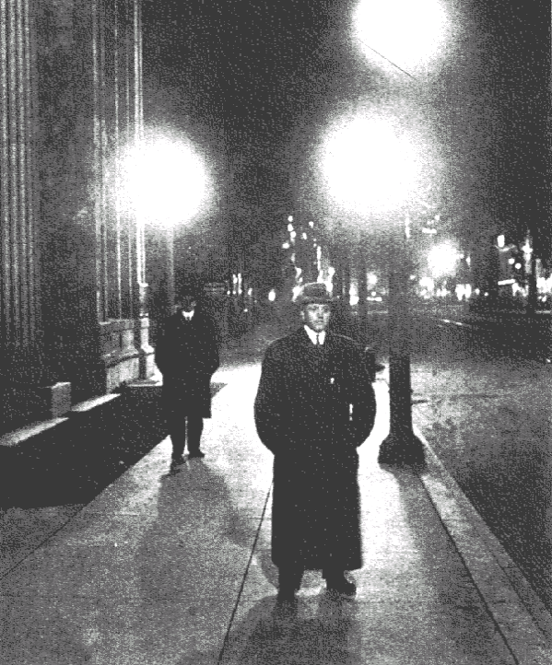
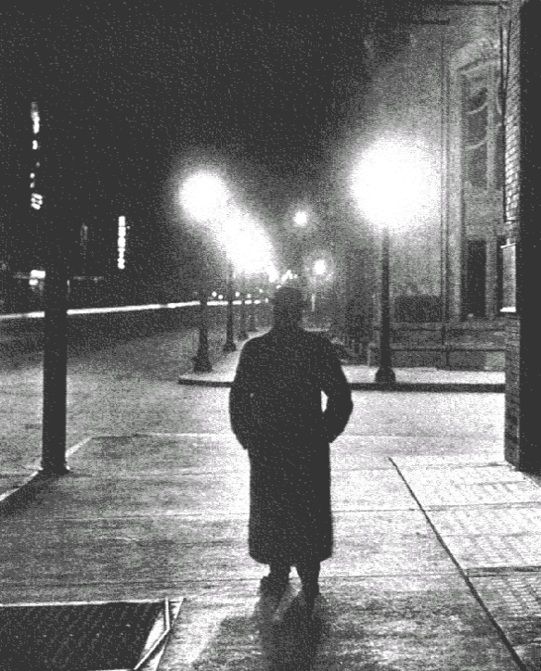
VDOT roadway projects, such as downtown revitalization involving local municipalities, may require the installation of architectural roadway lighting. Although VDOT typically does not maintain these lighting systems, they are sometimes required to design them. The purpose of this section is to familiarize the lighting designer with the basic characteristics of these lighting systems and the issues related to creating adequate visibility.
Streetscape #1
Streetscape #2
Photos courtesy of Holophane Lighting.

Architectural lighting is best described as historic luminaire and pole styling. The luminaires are usually ornate globes known as acorns or four-sided glass fixtures having a colonial character. The luminaries are mounted with decorative poles either directly at the top or with a short bracket arm. The mounting height is lower than standard roadway luminaires; nominally 14 feet but may be as high as 22 feet.

The lighting designer and the landscape designer must coordinate their individual efforts early in their respective designs to avoid problems related to the placement of trees and light poles. Within AGI32 lighting design software, the lighting designer can develop a simple model of the roadway, place poles at the desired spacing and offset from the curb, and then insert objects into the plan that represent trees to block the light. The AGI32 model of the tree should closely match the typical dimension of the trees in summer. A cylinder can model the canopy of the tree. For example, the canopy (cylinder) may be 10’ above ground level and rise to 30’, and have a diameter of 15’ from center. Typically, trees placed too close to a light pole will block light from the roadway. However, through some trial and error, the lighting designer will be able to tell the landscaper a minimum distance that trees can be placed from a light pole before the canopy begins to block the light.

The light-loss factor for architectural lighting is discussed in TEDM Section V – Roadway Lighting, Chapter 2, 2.6.

The lighting designer must also recognize the diameter of the tree pit and the location of the conduit. The tree pit may be as much as 4’ in diameter. Although the landscape contractor may have some concern for digging the pit and the location of the electrical conduit, with all likelihood, the electrical contractor will not take precautions to avoid damaging roots during trenching operations.

The basic plan for an architectural lighting design can be:
- A mix of standard roadway lighting poles/luminaires supplemented with architectural lighting to illuminate crosswalks and intersections.
- Standard roadway lighting with architectural lighting along multipurpose trails.
- Architectural lighting providing illumination to both the roadway and the sidewalk.

3.11.1 Mixed - Architectural/Roadway Lighting System
The first two architectural lighting designs discussed above rely on standard roadway lighting to provide illumination for the driver. The lighting designer should add the architectural lighting, also known as pedestrian lighting, after the roadway lighting plan is developed. The following issues should be addressed:

- The architectural poles and luminaires are intended to provide aesthetic value to the area. They are typically low wattage (70-watt) and have little effect in lighting the roadway. The lighting designer should first recognize the desired locations of the architectural lighting. Their placement should not interfere with the location of signal poles or roadway lighting standards and should match well with the landscaping plans.

- The type of pole, luminaire, and lamp to be installed should be discussed with the municipality responsible for their maintenance. Specific issues that should be addressed include:
- The potential for vandalism will affect the choice of luminaire refractor and pole finish.
- Light trespass issues may require shielding.
- Metal halide lamps provide enhanced color rendition and may be preferred over HPS.
- The complete roadway lighting plan should be developed based on the IESNA recommendations, and the VDOT requirements discussed in this manual. To simplify the development of the lighting design, the architectural lighting photometry should be ignored until the entire roadway lighting plan is developed. This step requires the roadway lighting plan to provide the required illumination at intersections without including the supplemental illumination provided by the architectural lights.

- Lighting designers that intend architectural lighting to enhance pedestrian movement at intersections should carefully choose the location of the poles. Poles should be placed such that they do not block the driver’s view of the crosswalk.

- Creating an environment of contrast between the pedestrian and the roadway will enhance visibility near the crosswalk. Examples of creating positive contrast at crosswalks are presented in the RP-8-00 section, Design Guides and Examples.

- The lighting plan should consider providing sufficient levels of vertical illumination along sidewalks and multi-purpose trails. The primary concern in vertical illumination is providing facial recognition. Unlike roadway lighting criteria, vertical illumination is concerned with providing sufficient light striking the subject 5-feet above ground level, or at chest level. In Streetscape #1 shown above, there is insufficient light to recognize the man’s face. Streetscape #2 allows the observer full recognition of the individuals. This subject is covered in detail in the RP-8-00 section, Pedestrian and Bikeway Design Criteria.

3.11.2 Architectural Roadway Lighting
A lighting plan that utilizes only architectural lighting to illuminate the roadway should carefully consider the issue of glare. Architectural lighting is notorious for creating unacceptable levels of veiling luminance.

- The typical lamp wattage is 150-watt or 250-watt, but can be as low as 70-watt along a residential street or 2-lane roadway through a small town. The 400-watt lamp at the low mounting height will blind the driver.

- Increasing the luminaire mounting height greatly enhances the veiling luminance ratio and results in a more comfortable driving experience.

- Many times, however, the municipality is very limited in their choice of poles. In this case, the pole spacing must be decreased to improve the level of glare. Of course, decreased pole spacing will incur higher installation costs and more obstacles for drivers.

- Reducing the lamp wattage will reduce the level of glare, but will require shorter pole spacing, and increased installation costs.

- The designer must recognize the operational cost of the system. This issue is best addressed by considering the factor of “watts-per-mile”. Reducing the luminaire wattage may decrease the overall watts-per-mile. Effectively, the long-term operational cost would be lower.

- Architectural lighting provides very little house-side shielding. The designer must consider the impact of these lights on the residents. If the lights are too bright, the municipality may be forced to retrofit the fixtures with lower wattage lamps. As a result, the intended lighting design will be compromised.

- Architectural roadway lighting is normally placed in a utility strip between the curb and the sidewalk or multipurpose trail. The lighting designer must closely check the clear zone requirements not only for the roadway, but also for the multipurpose trail.

- The lighting designer must coordinate with landscapers to insure the poles, junction boxes and trenching operations do not conflict with trees and shrubs. Tree pits are typically 5 feet in diameter. Depending on the sequence of construction, the electrical contractor may cut the tree roots, or the landscaper may damage the installed conduit.

3.12 Sign lighting
Overhead sign structures must be lighted wherever roadway lighting is employed. The number of luminaires installed on a sign structure must be determined before the design engineer can develop the electrical plan for the lighting system. Refer to TEDM Section V – Roadway Lighting, Chapter 4, 4.5.1 for a complete discussion of these procedures.

VDOT installs and maintains only 150-watt HPS sign luminaires. Luminaires on overhead sign structures are mounted 2 feet below the lower edge of the sign and 4 feet in front of the sign (reference VDOT Road and Bridge Standards, Section 1300, OSS-1 & BSS-1).

The illumination criteria for sign structure lighting are found in the IESNA RP-19 and the AASHTO Informational Guide for Roadway Lighting.

