# CHAPTER 2: ENGINEERING CONCEPTS/GUIDANCE

2.1 GENERAL 1

2.2 VISIBILITY OF OBJECTS AND LIGHTING QUALITY 1

2.2.1 Visibility 1

2.2.2 Quality 1

2.3 PHOTOMETRY 2

2.3.1 Coefficient of Utilization and Iso-footcandle Chart 2

2.3.2 Vertical Light Distributions 2

2.3.3 Lateral Light Distributions 3

2.3.4 Luminaire Cutoff Classification, Spill Light, and Sky Glow 4

2.4 LIGHTING ANALYSIS METHODS 5

2.4.1 The Illuminance Method 5

2.4.2 The Luminance Method and the Small Target Visibility (STV) Method 8

2.5 LIGHTING LEVELS 9

2.6 LAMP AND LUMINAIRE DEPRECIATION FACTORS 9

2.7 LIGHTING DESIGN COMPUTER PROGRAMS 11

2.8 roadway lighting equipment 11

2.8.1 General 11

2.8.2 Luminaires 13

2.8.3 VDOT Lighting Standards 16

2.8.4 VDOT Lighting Pole Foundations 18

2.8.5 Supporting Electrical Equipment 19

## 2.1 GENERAL

Good visibility under day or night conditions is one of the fundamental requirements enabling motorists to move along roadways in a safe and coordinated manner. Properly designed and maintained street lighting should produce uniform lighting levels conforming to industry standards. Those levels should facilitate the visibility of motorists, pedestrians, and other objects at night or in situations in which light levels are diminished (i.e., a tunnel).

This chapter will discuss the subjects of:

* Visibility, including quality of lighting.
* Photometry, including a discussion of the types of light distributions provided by roadway luminaires.
* The types of lighting analysis.
* Light levels.
* Lumen depreciation.
* Lighting analysis computer programs.

## 2.2 VISIBILITY OF OBJECTS AND LIGHTING QUALITY

### 2.2.1 Visibility

Good visibility enables the motorist (and pedestrian) to quickly discern significant details of the roadway. Some factors that directly influence visibility are:

* The brightness of an object on or near the roadway.
* Ambient light.
* The size of objects and identifying details.
* The contrast between an object and its surroundings.
* The contrast between pavement and its surroundings as seen by the observer.
* The time available for seeing the object.
* Glare (both disability glare and discomfort glare).
* The quality of the driver’s vision.

### 2.2.2 Quality

The quality of lighting refers to the relative ability of the light to provide the contrast difference in the visual scene so that drivers and pedestrians may recognize the cues required for the seeing task. **The following issues are involved in producing a lighting system and care should be taken in balancing them to obtain maximum quality:**

* Reduction in disability glare will improve visibility, and reduction in discomfort glare should improve driver performance.
* Reflected glare will conceal some contrast differences and should be reduced.
* A change in pavement luminance (for example, changing the roadway surface from concrete to asphalt) will change contrast and uniformity.
* Changes to other background areas (for example, adding noise walls along the shoulder) will also effect lighting quality.

Changes made in some of these areas may adversely affect others. Care must be taken to obtain the proper compromise by adjusting luminaire type, mounting height, uniformity, and luminaire locations.

## 2.3 PHOTOMETRY

The term Photometry is used to define any test data that describes the characteristics of a luminaire's light output. The most common types of photometry includes:

* Iso-footcandle performance charts
* Coefficient of utilization (CU) curves
* Vertical and lateral light distribution data
* Lumen maintenance curves and dirt depreciation curves

The following is a review of the more frequently used types of photometry.

### 2.3.1 Coefficient of Utilization and Iso-footcandle Chart

A coefficient of utilization (CU) refers to the ratio of lumens which ultimately reach the work plane to the total lumens generated by the lamp. A coefficient of utilization curve, as shown in figure 2-1, is provided for luminaires intended for outdoor use. Two curves are shown in the graphic, one for the street side (normally the desired area to be lit) and one for the house side (or the direction away from the primary lighted direction). The street curve represents the utilization of the bare lamp, in percent, as the ratio of lateral distance to mounting height.

An iso-footcandle chart, as shown in Figure 2-1, is used to describe the light pattern a luminaire produces. These charts show exact plots or lines of equal footcandle levels on the work plane with the fixture at a designated mounting height.

### 2.3.2 Vertical Light Distributions

Vertical light distributions are characteristics of the luminaire and should be considered early in the design process. Vertical light distributions are divided into three groups. Classification is based on the distance from the luminaire to where the beam of maximum candlepower strikes the roadway surface.

* *Short distribution -* The maximum candlepower beam strikes the roadway surface between 1.0 and 2.25 mounting heights from the luminaire.
* *Medium distribution -* The maximum candlepower beam strikes the roadway at some point between 2.25 and 3.75 mounting heights from the luminaire.
* *Long distribution -* The maximum candlepower beam strikes the roadway at a point between 3.75 and 6.0 mounting heights from the luminaire.

On the basis of the vertical light distribution, the theoretical maximum spacing is such that the maximum candlepower beams from adjacent luminaires are joined on the roadway surface.

### 2.3.3 Lateral Light Distributions

As with vertical light distributions, lateral light distributions are characteristics of the luminaire and should be considered early in the design process. The Illuminating Engineering Society of North America (IESNA) has established a series of lateral distribution patterns designated as Types I, II, III, IV, and V, as illustrated in Figure 2-2.

* Types I and V are classes of luminaires mounted over the center of the area to be lighted. Type I applies to rectangular patterns on narrow streets. Type V applies to areas where light is to be distributed evenly in all directions. Type V and a modified Type I are, generally, the class of luminaires applied in high mast lighting systems.
* Types II, III, and IV are classes of luminaires to be mounted near the edge of the area to be lighted.
* Type II applies to narrow streets.
* Type III applies to streets of medium width.
* Type IV applies to wide street applications.

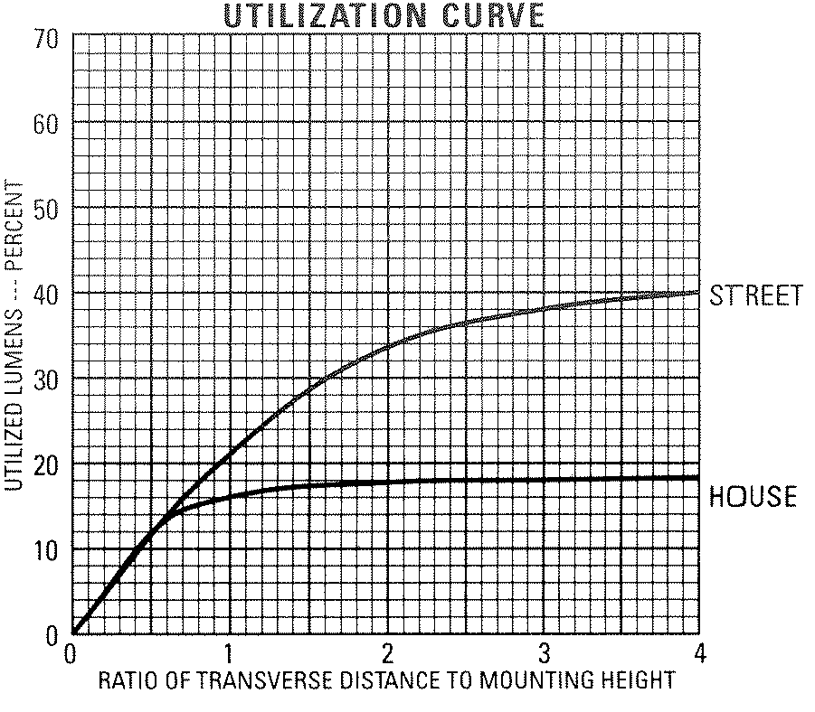

Figure 2-1: Photometric Data



### 2.3.4 Luminaire Cutoff Classification, Spill Light, and Sky Glow

The IESNA classifications of cutoff relate to the luminaire’s light intensity near the horizontal. (For a more detailed discussion of luminaire cutoff classification refer to IESNA RP-8.) The classifications were developed to help recognize the level of glare associated with a luminaire. Community associations and astronomers, however, have adapted the classifications, in an effort to reduce sky glow. Sky glow produces a luminous haze and limits our ability to see the stars. Astronomers are concerned with sky glow, as they must filter it from their observations. The growth in popularity of amateur astronomy is producing an increased awareness of sky glow.

Some efforts to reduce sky glow are rather straightforward – use shields and visors on floodlights to limit up-light. Other attempts are not as simple as they seem. For example, eliminating high angle light (above horizontal) from street lighting fixtures so that they cast all light downward will dictate that fixtures are placed closer together, increasing energy demand and increasing light reflected from the ground, thus sky glow may actually intensify. When lighting is installed near a major astronomical observatory or an intrinsically dark area (National Park), sky glow must be limited to low levels. For areas where observatories are not a concern, addressing the two other objectionable issues, *glare* and *spill light*, will often reduce sky glow to acceptable levels.

In the development of a roadway lighting plan, and in accordance with the Virginia State Law, the design engineer should make every effort to:

1. Reduce glare to provide a safe driving experience.
2. Reduce spill light (light trespass) outside the VDOT right-of-way.
3. Reduce sky glow and light pollution that effect the quality of our lives.

In order to meet all of these goals, the lighting designer should first develop a conceptual lighting plan based on “Full Cutoff” fixtures readily available from several manufacturers. This fixture restricts any light from being emitted above the horizontal, but may produce unacceptable levels of glare and light trespass.

Alternative lighting concepts should be developed using “Cutoff” fixtures and “Semi-Cutoff” fixtures. These fixtures limit the light intensity near the horizontal, but do not restrict the total amount of light emitted above the horizontal.

The final choice of luminaire optical distribution will be based on functionality:

* Which lighting system provides the highest quality lighting at the lowest cost? Specifically, the most effective illumination, at the lowest installation, maintenance, and energy cost.
* Which luminaire restricts the light to areas inside the VDOT right of way?
* Which lighting system provides the most effective reduction of sky glow? This issue can not be simply addressed by limiting the choice of luminaire to “Full Cutoff”. Due to the effects of light reflectance from pavement and grass, reducing pole spacing, and in turn, increasing the energy demand (sometimes referred to as: “watts-per-mile”) has been shown to increase up-light and sky glow.

## 2.4 LIGHTING ANALYSIS METHODS

VDOT requires all roadway lighting designs to meet the lighting criteria as discussed in the current IESNA publication, Recommended Practices for Roadway Lighting (RP-8). The **illuminance criteria** must be met for all sections of a roadway project. This guideline also includes meeting the criteria for the Veiling Luminance Ratio (Lv/Lave).

The lighting designer should also attempt to meet the **luminance** and **STV** criteria. Meeting all three criteria along a straight section of roadway is typically not feasible. It may be possible to meet only the illuminance criteria in more complex roadway geometry. Specifically, the algorithm for Veiling Luminance Ratio is based on a straight roadway section and cannot be adapted to a roadway with even a gentle curve.

The lighting designer should attempt to design the roadway lighting system based on illuminance and luminance lighting criteria and should coordinate with the TE/L&D Manager to determine the lighting design that will provide the best visibility.

### 2.4.1 The Illuminance Method

The roadway optimizer found in the AGI-32 lighting design software calculates the minimum illumination and provides the designer with the average-to-minimum uniformity. However, the designer must understand where the minimum illumination levels lie on the roadway and adjust the design parameters to provide a high quality design.

The luminaire spacing calculated by the roadway optimizer is based on the average level of illumination and/or the minimum illumination on the area of roadway. This establishes the *quantity* of illumination. The uniformity ratio, relating the average illumination level to the value of minimum illumination, is used as one way of specifying the *quality* of lighting. Because the design process already defines the average level of illumination, the next step involves finding the minimum point of illumination.

2.4.1.1 The Iso-footcandle template

Referring to the iso-footcandle diagram in Figure 2-3, the lines defining the illumination levels will occur at various mounting heights from the luminaire. These lines form what is known as a **template**.

The AGI-32 lighting design software can produce a set of iso-footcandle lines based on the luminaire mounting height. The lines should be defined as the **minimum** and **half-minimum** illumination levels required for the final roadway light plan. The example template shown in Figure 2-3 displays the 0.2 fc iso-footcandle line (minimum) and 0.1 fc iso-footcandle line (half-minimum).

The templates shown in Figure 2-3 represent two luminaires. The IESNA illumination criteria for a particular roadway will set the average illumination and uniformity levels. The minimum illumination is calculated from these two values.

For example:

* Average maintained illumination: 0.6 fc
* Uniformity (Average/Minimum): 3:1
* Minimum illumination = (0.6 / 3.0) = 0.2 fc
* ½ Minimum illumination = 0.1 fc

In the overlay region the total illumination will be the sum of the light from both luminaires.

Once it is understood how the iso-footcandle values are defined, the next step is to locate the point of minimum illumination expected to occur on the roadway. Depending on the roadway width, luminaire mounting height, type of luminaire, and mounting configuration, the minimum point will usually occur at one of several typical locations as identified in Figure 2-4 as areas **A, B, C,** or **D**. After checking the illumination at each of the anticipated low points, the design parameters can be adjusted to improve the uniformity ratio:



Figure 2-3: Iso-footcandle Templates

* In most cases, the luminaire offset (which can be altered by increasing or decreasing the length of the luminaire arm), the mounting height, or the pole spacing must be altered.
* Other situations will require choosing a different optical distribution.
* In some cases, the luminaire wattage will need to be adjusted to improve the uniformity. Typically, however, this effort will only increase (or decrease) the average light levels without affecting the uniformity.

The illuminance method for lighting a roadway also requires meeting the **Veiling Luminance ratio** criteria (Lv/Lave). The roadway optimizer will calculate this value based on the reflectance value (R) assumed for the roadway. Decreasing the luminaire spacing can reduce the veiling luminance ratio and reduce the resulting glare. Consequently, this action will increase the average illuminance on the roadway.

The **reflectance value** (R) should be set to match the type of material used in constructing the roadway. Lacking a clear understanding of the type of roadway surface (i.e., asphalt or concrete), the reflectance value should be set to **R3**.

### 2.4.2 The Luminance Method and the Small Target Visibility (STV) Method

Figure 2-4: Minimum Illumination Points



Meeting both the Luminance criteria and STV criteria, together with the Illuminance criteria, is not always feasible. The lighting designer should make every effort to satisfy both the Illuminance and luminance requirements and report the results to the TE/L&D Manager. The STV requirements should only be considered when comparing various arrangements of the lighting system. For example, using either an “opposite” or “ staggered” pole placement may satisfy both the illuminance and luminance criteria, however, placing the poles opposite each other improves the STV values.

* Typically, on wide interstate roadways, it is necessary to decrease the pole spacing to meet the average luminance criteria. This scenario will impact the overall cost of the project.
* The STV Weighting Average is greatly improved by using an opposite pole configuration. This arrangement typically has very little effect on either the illuminance or luminance average values, but will slightly degrade the uniformity.

## 2.5 LIGHTING LEVELS

The design must be appropriate for the site and must provide the level and uniformity of light suggested in the current IESNA publication, Recommended Practices for Roadway Lighting (RP-8). The recommended design values represent the **minimum maintained lighting level**. Facilities may be designed with higher average lighting levels, but must provide the required uniformity. In all cases, the TE/L&D Manager must approve higher lighting levels.

## 2.6 LAMP AND LUMINAIRE DEPRECIATION FACTORS

The lighting system designer must consider the luminaire maintenance factor, or light loss factor (LLF), in determining the light output for a luminaire. The light loss factor is applied to the light output of a new luminaire (initial light output) to determine the light output of the luminaire after a fixed period of time (maintained light output). The LLF represents a loss of the initial lumen output due to burn time and dirt covering the luminaire, as shown graphically in Figure 2-5. See the FHWA Roadway lighting handbook for further information.

The AASHTO Guide suggests that the LLF for H.P.S. fixtures is typically 0.60 to 0.66. However, the guide notes that higher values can be mitigated when considering:

* Low voltage drop
* Use of electronic ballast
* Improvements in lamp manufacturing

For the purposes of VDOT lighting design, and referencing the charts in Figure 2-5, the LLF is considered a function of the following factors:

* Burn time is accounted for in the Lamp Lumen Depreciation (LLD) factor (typically: 0.8).
* Dirt is accounted for in the Lamp Dirt Depreciation (LDD) factor (Typically 0.85 for conventional and offset lighting standards, 0.95 for high mast lighting standards. In areas of low traffic volumes, architectural lighting may use LDD = 0.95).
* Photometric data produced under laboratory conditions is the result of a ballast that is closely tuned to the lamp; that is, the ballast factor is 1.00 during testing. However, the VDOT Specifications for ballast note that the voltage regulation may varry by +/-5% to +/-10% depending on the lamp wattage. For the purposes of VDOT lighting design, the ballast loss factor should be considered 0.95.

Specifically: The LLF for a conventional luminaire is:

LLF = 0.8(LLD) x 0.85(LDD) x 0.95(ballast factor) = 0.65

***The following values for LLF are used on VDOT lighting projects:***

**Conventional and Offset lighting standards:**

**LLF = 0.65**

**High Mast lighting standards:**

**LLF = 0.72**

**Architectural lighting**

**LLF = 0.72**



Figure 2-5: Light Loss Factor

## 2.7 LIGHTING DESIGN COMPUTER PROGRAMS

VDOT currently uses AGI32 software for lighting design. The primary features of this software package are:

* A roadway optimizer capable of delivering expected illumination, luminance, and STV results.
* The ability to import any manufacturer’s photometry data in IES format.
* The ability to import a MicroStation or DXF survey file.
* The ability to place calculation points on to an imported survey file at the same scale at varying elevations. These points will provide a calculation of illuminance, luminance, and STV. The calculation points can be placed as a matrix or as a series of points on a line.
* The ability to evaluate the occlusion of light due to bridges, overhangs, noise walls, trees, etc.

## 2.8 roadway lighting equipment

### 2.8.1 General

The general features of lighting equipment are discussed in this section. For information related to pay items, please refer to Appendix VB-2.

Lighting equipment is generally grouped together in terms of their functions. Those functions include the optical system, the structural system, and the supporting electrical components.

* The optical system is comprised of the lamp, reflector, and refractor of the luminaire.
* The structural system supports the luminaire and associated equipment and is comprised of mounting brackets, poles, transformer bases, and foundations.
* Supporting electrical equipment includes electrical service cabinets, junction boxes, conduit, conduit support systems, and wiring.

If a lighting system is to serve its intended purpose, efficiently and economically, it is very important that the proper equipment be selected and applied correctly. It is important that the designer be knowledgeable of fundamental characteristics of lighting equipment and remains current on hardware developments within the industry.

### 

Figure 2-6: Conventional or Cobrahead Luminaire

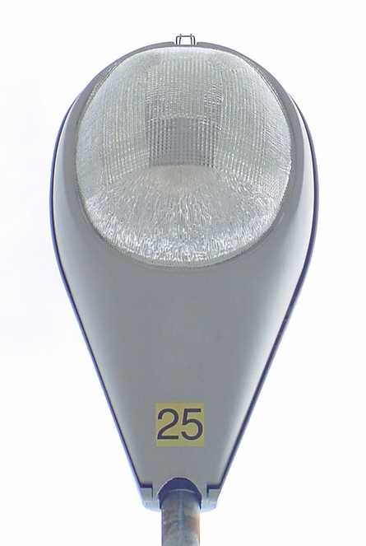

Figure 2-8: High Mast Luminaire Assembly

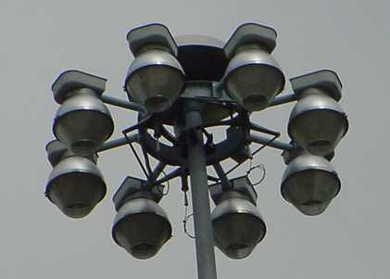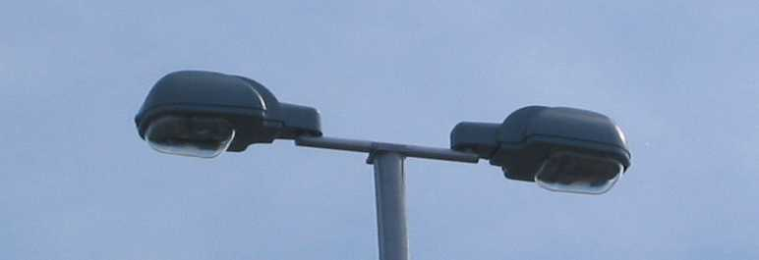

Figure 2-10: Dual Offset Luminaires

Figure 2-9: Offset Luminaire Note: VDOT lighting designs no longer use non-cutoff tilted luminaires.

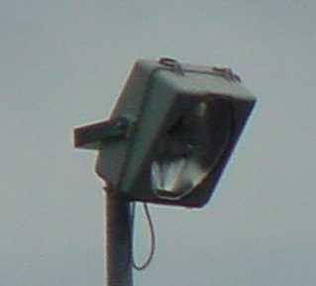

Figure 2-7: Shoebox Luminaire



### 2.8.2 Luminaires

A luminaire is defined as a complete unit consisting of a lamp, together with the parts designed to distribute the light, to position and protect the lamp, and to connect the lamp to the power supply. Components that make up a luminaire include:

* The **housing** encases the components and protects them from the weather. The components include the reflector, lamp, ballast, wiring, photocells, and other minor components.
* The **lamp** provides the light. Lamp criteria are further discussed in TEDM Section V – Roadway Lighting, Chapter 2, 2.8.2.1.
* The **reflector** changes the direction of the light output. It is designed to redirect otherwise wasted light into the desired direction.
* The **refractor** is similar in concept to a globe except that it may have a prismatic construction. It controls and redirects the light emitted from the lamp and the reflector by means of its prismatic construction. The refractor also protects the lamp and reflector from external damage.
* The **ballast** controls the electrical input to the lamp. Ballast criteria are further discussed in TEDM Section V – Roadway Lighting, Chapter 2, 2.8.2.2.

Several factors have influenced the choice of luminaires that VDOT currently uses. The luminaires should be a standard type that is maintained by the local VDOT District maintenance section, or, where applicable, the local power company. Luminaires for roadway lighting are classified as cobrahead or conventional style, offset, shoebox

style, and high mast style. TEDM Section V – Roadway Lighting, Chapter 2, 2.8.2.3 provides further information on each of these items.

Where a municipality is maintaining the lights, specific luminaires types or models, including decorative luminaires, may be used.

The VDOT Road and Bridge Specifications, Section 700 provides for the installation of a photoelectric control (also known as a photocell) on luminaires. However, lighting fixtures should only have a photocell installed when the electrical service point (lighting control center) does not provide photoelectric control.

2.8.2.1 Lamps

The light source is the principal determinant of the visual quality, economy, efficiency, and energy conservation aspects of the illumination system. Two general types of lamps are presently in use for roadway lighting: fluorescent and high intensity discharge (HID). High intensity discharge lamps include high-pressure sodium (HPS), and metal halide (MH). The HPS lamp is very efficient and is often the best choice for most roadway lighting applications. HPS lamps are also used on overhead signs. Factors which affect the cost and effectiveness of installing, operating, and maintaining the lights, and, hence, affect the choice of the light source include:

* The efficiency of a lamp in converting electrical energy to light.
* The ability of the lamp to maintain its light output over the course of the lamp life.
* The length of the lamp life.
* The color of the light.
* The distribution of the light.

The HPS lamp is most commonly used by VDOT. The lamp emits light across the visible spectrum, with predominance in the orange-yellow region. The lamp requires a ballast and special device to produce a very high voltage surge for starting. The HPS lamp usually cycles on and off at the end of normal life.

2.8.2.2 Ballast

A ballast is required for all HID and fluorescent lamps and is located in the luminaire housing. Table 2-1 summarizes ballast characteristics for the type of ballast VDOT uses. Generally, the ballast serves three functions:

* It provides the proper open circuit voltage to start the lamp (some HID lamps require an additional igniter to achieve proper starting voltage).
* It keeps the lamp operating within its design parameters. The ballast provides a control function and limits the current available to the lamp.
* The ballast also adapts the lamp to any one of the typical line voltages commonly available.

|  |  |  |  |
| --- | --- | --- | --- |
| Ballast Type | Lamp Wattage | Variations of Lamp Wattage vs. Line Voltage | Power Factor |
| Non-Regulating | ≤150-Watt | ± 5% | 90% |
| Regulating | >150-Watt | ± 10% | 90% |

Table 2-1: Luminaire ballast

2.8.2.3 VDOT Luminaire Types

Roadway lighting luminaires are classified as conventional (or cobrahead) style, offset style, shoebox style, and high mast style.

The **conventional or cobrahead luminaire**, as shown in Figure 2-6, faces straight down and requires a bracket arm for mounting. Note; the “25” is a stencil supplied by the local power company indicating the lamp wattage; i.e., 25 => 250-watts.

The **offset style** luminaire, normally tilted at 45-degrees, is no longer used in new VDOT roadway lighting designs. However, the term “offset” continues to imply a luminaire mounted directly to the top of the light pole, which can be offset from the roadway as shown in Figure 2-9.

**Shoebox** style luminaires are often appropriate for rest areas or to provide some aesthetic value to outdoor lighting, however, they are also finding acceptance in roadway lighting. The term “shoebox” describes the general appearance of the luminaire. The fixture can either be placed at the top of a pole, like an offset, or located over the shoulder with the use of a bracket arm. For the purposes of identifying pay items, the shoebox luminaire may be considered an offset luminaire with a 0-degree tilt, or a conventional luminaire with a bracket arm as shown in Figures 2-7 and 2-10. However, in order to identify the style of fixture required for the project, a non-standard pay item description can be used; for example: Shoebox Luminaire, 100-Watt.

The **high mast luminaire** is specified as an assembly. The components of the high mast luminaire assembly include the luminaires and lifting ring. The complete assembly is identified in The VDOT Road and Bridge Specifications, Section 705 and shown in Figure 2-8.

### 2.8.3 VDOT Lighting Standards

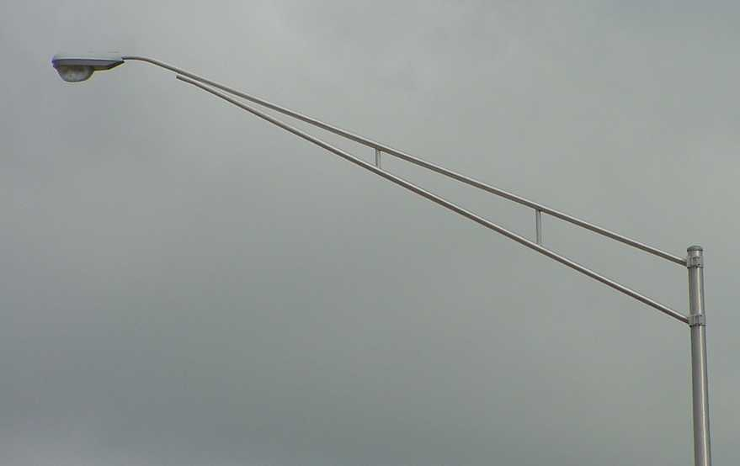

Figure 2-11: Luminaire Bracket Arm

2.8.3.1 Pole Standard LP-1

(Used for Conventional (Cobra Head) or Shoebox Luminaires.) The most common equipment used is the 30-foot to 50-foot pole with a luminaire and bracket arm. The bracket arm typically places the luminaire directly over the edge of the travel lane, as shown in Figures 2-11 and 2‑12.

2.8.3.2 Pole Standard LP-2

(Used for Offset or Shoebox Luminaires.)

The offset pole is typically a 30-foot to 50-foot pole with a luminaire. New offset luminaires are frequently mounted with a 0-degree tilt, or pointing straight down, with single or double tenon as shown in Figure 2-13. The LP-2 Standard may also be used to install a shoebox luminaire.

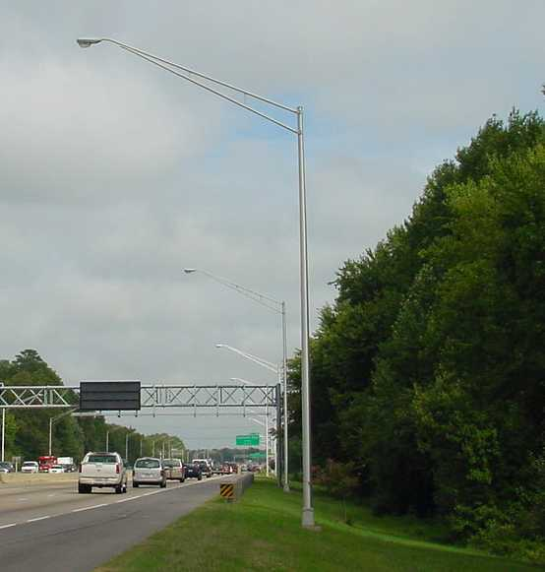

Figure 2-12: Conventional or Cobrahead Lighting Standard

2.8.3.3 Pole Standard LP-3

(Used for High Mast Luminaires.) High mast lighting implies an area type of lighting with 3 to 12, 250-watt, 400-watt, 750-watt, or 1000-watt HPS luminaires mounted on poles or towers, at heights varying from approximately 60 feet to 150 feet as shown in Figure 2-14. At these mounting heights, high-output luminaires develop a uniform light distribution. The luminaire assembly is hoisted to the top of the tower by a winch located in the base of the pole. Although the VDOT Road and Bridge Standards only note standard pole lengths from 70 to 140 feet, other lengths are available from several manufacturers.

2.8.3.4 Transformer Bases

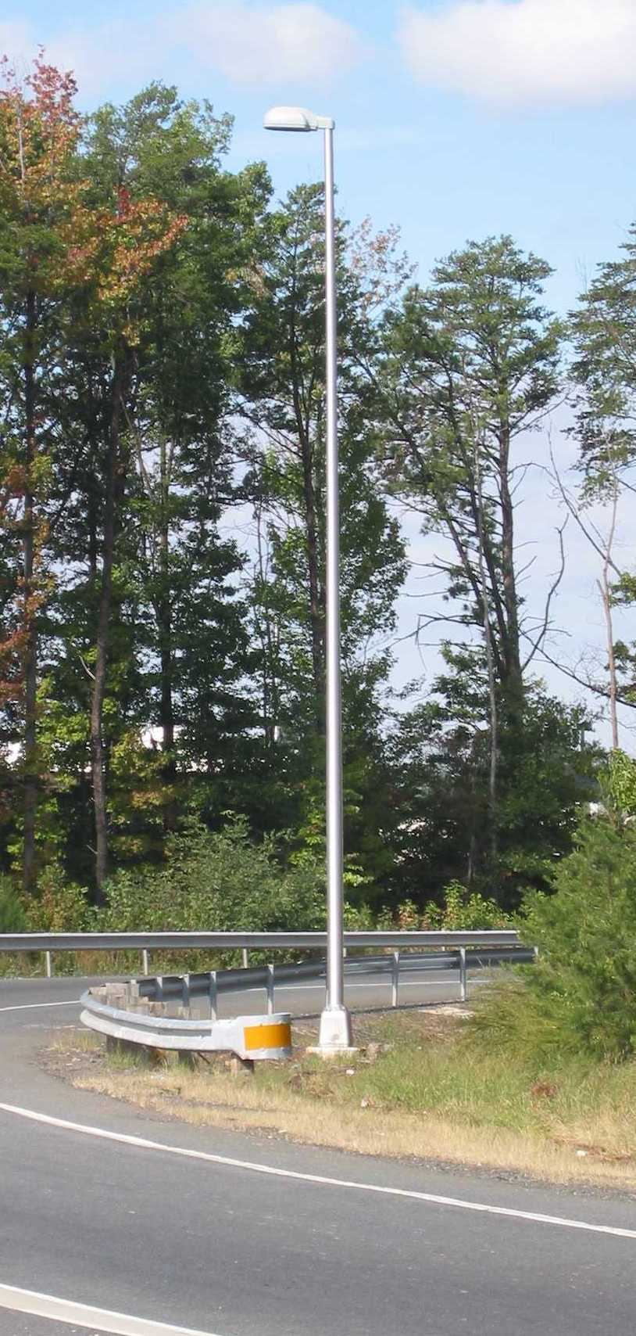

Figure 2-13: LP-2 Offset Lighting Standard

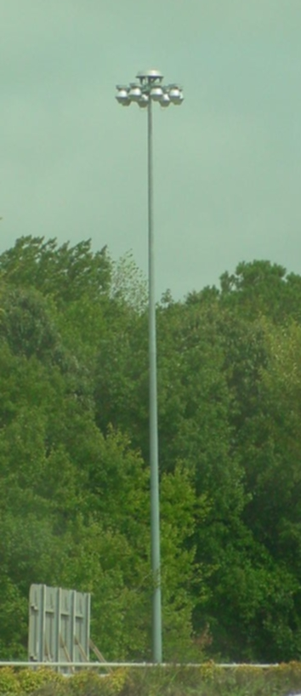

Figure 2-14: LP-3 High Mast Lighting Standard

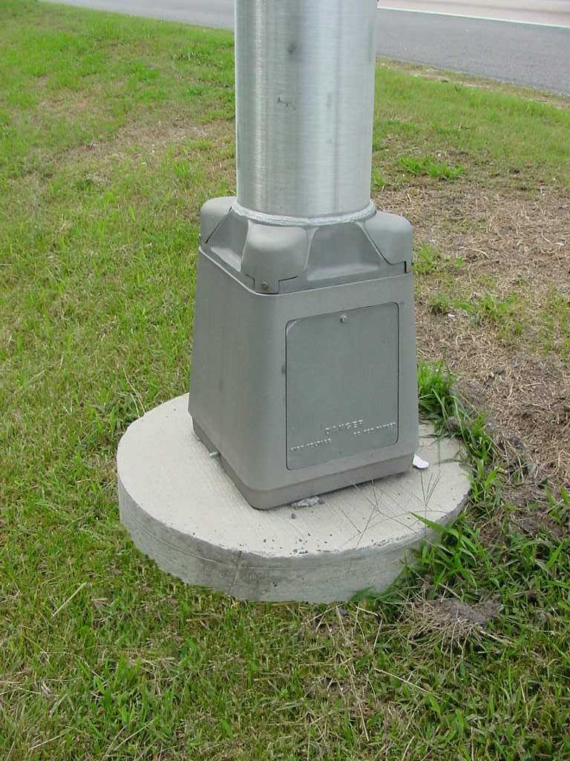

Figure 2-15: Transformer Base on LF-1 Foundation.

Conventional and offset lighting poles may be mounted to the concrete foundation anchor bolts using a transformer base as shown Figure 2‑15. The transformer base provides a convenient splice point for the electrical system and can provide an economical alternative to placing a junction box at the base of each pole.

The requirement to install a transformer base with a light pole does not necessarily imply the use of a breakaway base. The transformer base can be installed with or without a breakaway base. In some cases, the transformer base may be constructed such that it is frangible and thus provides a suitable breakaway base. Chapter 3.5 provides a more complete discussion of the breakaway base.

There is no separate pay item for a transformer base. The item is incidental to the cost of the light pole. However, the lighting plans must make specific note as to any requirement for this item.

### 2.8.4 VDOT Lighting Pole Foundations

2.8.4.1 Conventional and Offset Lighting Standard Pole Foundation (LF-1)

The **VDOT Standard LF-1 Type A Foundation** provides support for the LP-1 and LP-2 lighting standards. This foundation is cast-in-place, 8-feet deep, with a 30-inch diameter. It is also known as a “drilled shaft” foundation.

The design engineer can not assume that this foundation will work in every case. The engineer sealing the lighting plan must recognize soil characteristics and finished grade, along with the light pole loading, to provide a foundation suitable to support the light pole.

2.8.4.2 Non-Standard Pole Foundations

In areas with marshy soil, or shifting sands, or in areas that have very shallow hard rock formations, the lighting designer should consider specifying a special design pole foundation. The Department must approve non-standard foundations.

A **spread footer foundation** will provide the required support in poorly consolidated or hard rock soil conditions. The contractor may provide the final design of the foundation.

A **helical foundation**, as shown in the example plan detail in Figure 2-16, may also be considered for installation of lighting poles less than 20-feet in length. Although a 15-foot test bore is required at each pole location, a substantial cost saving may be possible as a result of a reduction to installation time. Foundations can typically be installed in 15-minutes and poles erected immediately.



Figure 2-16 Helical Foundation

2.8.4.3 High Mast Lighting Pole Foundation

The contractor will provide the design of the high mast pole foundation based on a test bore specified on the plans. All high mast pole foundations require a test bore. The requirements for the structure and test bore are covered in The VDOT Road and Bridge Specifications, Section 700.

2.8.4.4 Bridge Mount Lighting Pole Foundation

The VDOT Standard Bridge Conduit System includes a light pole foundation suitable to support a 40’ cobrahead lighting pole with a 6’ luminaire arm. A more complete discussion of this foundation’s capabilities can be found under the, “Notes to Designer”, for the bridge conduit system.

### 2.8.5 Supporting Electrical Equipment

The selection of the ancillary electrical equipment required to operate a roadway lighting system is largely based on the choice of the luminaires and the general configuration of the lighting system. This section will discuss the various VDOT standard elements of a lighting system and how they are employed. Appendix VB-4 will describe the iterative process required to size wire and conduit.

2.8.5.1 VDOT Electrical Service

VDOT roadway lighting systems are typically powered by 277/480Y VAC 3-phase service. Combination roadway lighting/signal poles operate on 120/240 VAC, single-phase power. Remote sign lights and TMS equipment also operate on 120/240 VAC, single-phase power. The local power companies understand the VDOT requirements and are usually very agreeable to working with lighting designers. The following is a description of the standard electrical services and lighting control centers used by VDOT for roadway lighting. Drawings can be found in the VDOT Road and Bridge Standards, Section 1300.

2.8.5.2 Electrical Service SE-9 Type A and B

* The SE-9 is the primary VDOT standard electrical service used for the distribution of 277/480Y VAC, 3-phase power.

Figure 2-17: Standard VDOT SE-9 Type-A.

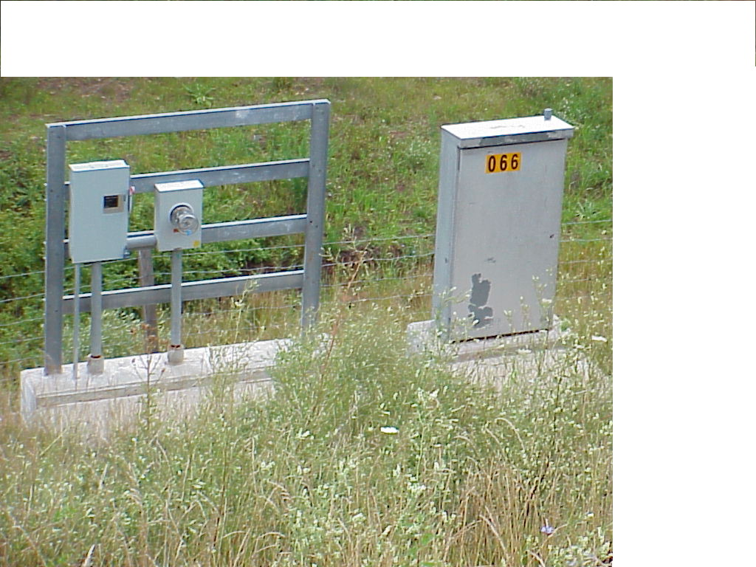

* **The Type A** system, as shown in Figure 2-17, provides a separate concrete foundation for a large lighting control cabinet. This configuration is typically used for most VDOT lighting control centers.
* **The Type B** system provides a small lighting control cabinet mounted to the metal frame. This configuration should be considered when only a few circuits are required and the loads are small (e.g. a 100-amp service and six branch circuits).
* Some situations may require the roadway lighting system to share an electrical service with the TMS system. In this case, a separate Lighting Control Center (CCW-1) and a separate concrete foundation (CF-2) would be required along with a modified SE-9 with 2 safety switches.

2.8.5.3 Electrical Service SE-7, and SE-8, Types A and B

Electrical Service SE-7, and SE-8, Types A and B are used on 120/240 VAC, single-phase power systems. Some lighting systems may be located where 3-phase power is not available, or the systems may have very low power requirements and can operate on 120/240 VAC, single-phase power. This type of power is readily available in most locations.

The **SE-7 and SE-8** Electrical Service include a meter base, a fused safety switch, conduit, grounding equipment, and a wood pole for mounting the hardware.

Figure 2-18: Standard VDOT SE-8 Type-A with CCW-C



**The SE-8** also provides for the installation of a small lighting control cabinet and photocell, as shown Figure 2-18. This system might be used in powering several overhead signs and/or an under bridge lighting system at various locations around an interchange. The **Type A** or **Type B** configurations are chosen depending on the service entrance: overhead or under ground.

2.8.5.4 VDOT Standard Lighting Control Centers

The lighting plans must identify the rating of the contactors and breaker to be installed. The contactors, controlled by the photocell, provide the on-off switching of the lighting system at dusk and dawn. It is not uncommon to oversize them. For example, most roadway lighting contactors’ operating circuits carrying 15-amps to 35-amps, and are rated 60-amps per pole. Circuit breakers are single pole and normally sized at 125% of normal operating current.

VDOT standard **CCW-1 Type D** Control Center is required on roadway lighting projects involving the distribution of 3-phase, 277/480Y VAC power.

VDOT standard **CCW-1 Type C** Control Center is required on roadway lighting projects involving the distribution of single-phase, 120/240 VAC power.

2.8.5.5 VDOT Standard Junction Boxes

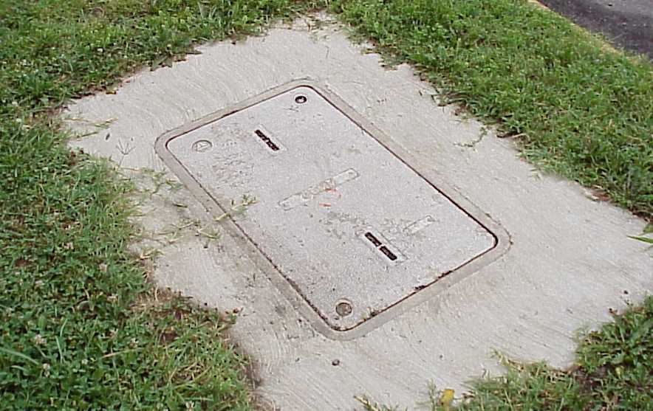

Figure 2-19: Standard VDOT Junction Box

VDOT Standards provide 2 Junction Box styles and has 5 different sizes. It is not uncommon for the VDOT District or Residency to dictate the choice of junction box. The following notes briefly describe each style. The “*” noted below designates the size of the junction box. The designer should reference the VDOT Road and Bridge Standards, Section 1300 for a more detailed description of these components.

* **JB-*R:** The concrete junction box, may be pre-cast or cast in place. This item is preferred for traffic use areas.
* **JB-*S:** The fiberglass junction box. See in Figure 2-19. The bottom of the box is open and placed on 12” of gravel fill. This item is for non-deliberate traffic use areas.

The lighting designer should note:

* Roadway lighting projects normally call for JB-S1, JB-S2, JB-R1 or JB-R2, however, there is no restriction on using any of the other VDOT standard boxes.
* The VDOT standard junction box pay item is a “Junction Box JB-S1, JB-S2, JB-S3, JB-R1 or JB-R2. This standard allows the contractor flexibility in choosing the type of junction box to install. However, if the Regional Traffic Engineer requests a particular style of junction box, the lighting designer must specify that type as a “Non-Standard” pay item. For example, a Regional Traffic Engineer may require the installation of only fiberglass junction boxes.
* The size of the box is dictated by the size of the wires and conduit. This issue is discussed in more detail in Appendix VB-4.
* All VDOT junction boxes are rated “H20” for heavy traffic.

2.8.5.6 Conduit

VDOT specifications recognize all NEC conduit trade sizes. However, the following items have become the preferred standards:

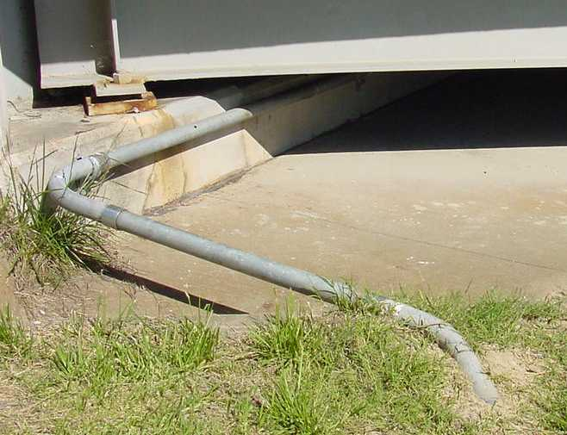

Figure 2-20: Exposed Metal Conduit

* PVC schedule-40 conduit is preferred for all buried conduit runs.
* Metal conduit is preferred for all exposed conduit runs.
* 2” conduit is typically the smallest size used throughout a roadway electrical system, except as branch conduits for under bridge lighting and sign lighting.
* 1” and ¾” metal conduit work best for an under bridge lighting system.
* 3” or 4” conduit sizes are frequently specified when the NEC conduit fill requirements demand a size larger than 2”.
* Placing multiple conduits in the same trench is an acceptable practice.
* When running conductors under a bridge, the exposed bridge abutment can provide a suitable location for the exposed conduit, as shown in Figure 2-20.
* The electrical grounding conductor (EGC) is incidental to the installation of new conduit.
* Metal conduit does not require an EGC.

2.8.5.7 Under Bridge Conduit Support System

Where sufficient room for staging prohibits the installation of jacked pipe under a roadway, conduit and conductor cables can be run using a support system hung under a bridge as shown in Figures 2-21, 2-22, and Table 2-2. This conduit support system can often be installed as part of new bridge construction with proper coordination between the TCD designers and bridge designers. However, when the support system is installed on an existing bridge over an existing roadway, the designer must consider the impact this operation will have on the maintenance of traffic. In this situation, the effort of installing scaffolding and maintaining traffic could cause the cost to exceed that of Jacked Pipe.

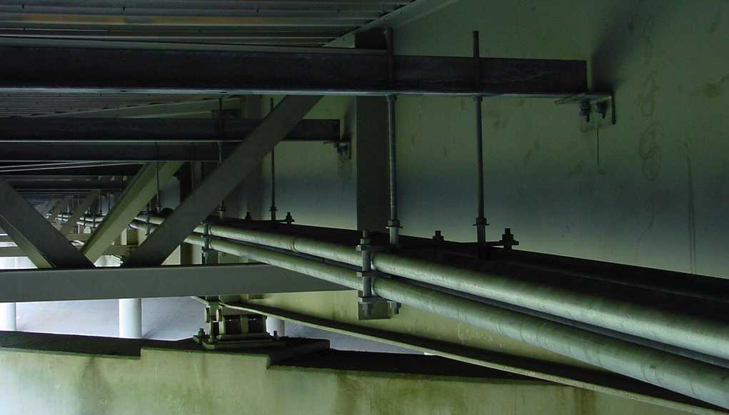

Figure 2-21: Under Bridge Conduit Support System

The VDOT District Structure and Bridge Section should be contacted to insure there are no other concerns with attaching the conduit support system to a particular structure. The designer must provide a detail and state the number of supports required for each support system. The number of supports is based on NEC recommendations. Also, the type of structure must be identified as either steel or concrete.



For example:

The Compton Rd. Bridge, as noted in Table 2-2, is 240 feet in length. The NEC Section on Rigid Metal Conduit recommends supports for 2-inch conduit to be placed every 16-feet. A total of 16 (15, plus 1) supports are required for this system.

There is no standard pay item for an Under Bridge Conduit Support System. The designer must provide a modification of the VDOT Specification (Special Provision Copied Note) and add the item to the contract documents.

2.8.5.8 Jacked Pipe Sleeve and Bored Conduit

Where conduit and conductor cables need to cross an existing roadway, a pipe sleeve, typically no smaller than 6-inches inside diameter, is pushed under the roadway using a jacking operation. This **jacked pipe** provides a passageway for future road crossings.

To facilitate this operation, a staging area must be established to provide a pit for the pipe and a machine to hammer the pipe under the roadway. The material used for the jacked pipe is discussed in the VDOT Road and Bridge Specifications, Section 302. The designer may want to consider sizing the jacked pipe to allow for the addition of future conduit runs.

For example:

A plan requires two, 2-inch conduits to pass under a ramp. A single 6-inch diameter jacked pipe provides enough internal room for both these conduits, but will not allow any future use of this road crossing. The designer may want to consider an 8-inch jacked pipe be installed at this location.

**Bored conduit** (also referred to as Directional Bore) is a method of running pipe under an existing roadway similar to the jacked pipe operation; however, this operation requires less staging area. The procedure requires a hydraulic-driven bit to cut a horizontal bore under the roadway. The direction of the drilling can be controlled to allow the bit to pass under or around an obstruction. Conduit, typically Schedule-40 PVC, is then dragged through the bore.

Bored conduit should be used in areas that have limited area for the jacking operation. The designer should size the bore conduit in the same manor as discussed under Jacked Pipe.

Currently, there is little cost difference between Jacked Pipe and Bored Conduit.

Where jacked pipe or bored conduit is required on a project, the Summary of Quantities should **not** include the pay item Trench Excavation. However, the plans should indicate that the pipe sleeve should be installed in accordance with VDOT Standard ECI-2 as noted in the VDOT Road and Bridge Standards, Section 1300.

2.8.5.9 Pipe Sleeve

On new construction projects, where circuits must cross a proposed roadway, a Pipe Sleeve can be installed prior to laying the roadway. The intention of Pipe Sleeve is similar to Jacked Pipe or Bored Conduit, but considerably less expensive. The operation requires cutting a trench and laying the Pipe Sleeve before the roadway is constructed. The designer should size the Pipe Sleeve in the same manor as discussed under Jacked Pipe.

The current Specifications and Standards do not cover Pipe Sleeve. The designer must provide a modification of the VDOT Specification and add the item to the contract documents. Refer to the TEDM Section 1 – General, Chapter 3, 3.8

- discussion of Special Provision Copied Notes

Where Pipe Sleeve is required on a project, the Summary of Quantities should include (for example):

Trench Excavation ECI-1 Units: Linear Feet

6” Pipe Sleeve Units: Linear Feet

2.8.5.10 Trenching

Installation of conduit in **non-paved** areas is covered under the pay item **Trench Excavation ECI-1**.

The designer should note that patching an existing paved shoulder, as suggested in this example, typically results in ruts and potholes within a short time. This method should only be considered if the shoulder would be re-paved shortly after completing installation of the conduit.

2.8.5.11 Conductor Cable

The VDOT Road and Bridge Specifications, Section 238 for conductor cable run in conduit requires the use of THWN. The following should be applied to each roadway lighting plan:

* The smallest cable size used in any roadway lighting plan should be a #8 AWG. This procedure is required due to the high tensile strength needed to complete a long conduit pull. For short distances, or where cable flexibility is an issue, #10 AWG may be used. For example: retrofit of existing sign structures with sign lighting.
* The largest cable size should be #000 AWG. Larger sizes can be difficult to pull.
* The VDOT Road and Bridge Specifications, Section 705 require all luminaires to be supplied with conductors (typically #10 AWG) from the base of the pole to the luminaire.
* The electrical grounding conductor installed in any non-metal conduit should be the same size as the largest phase/power conductor.