CHAPTER 4: plan development
4.1 SIGNAL DESIGN PROCESS 1
Step 1 – Review Scope of Project 1
Step 2 – Prepare Base Plan 1
Step 3 – Identify Any Additional Survey or Other Information Required 3
Step 4 – Confirm Phasing and Signal Operation Requirements 3
Step 5 – Review Geometric Design Requirements 3
Step 6 – Establish Crosswalks 3
Step 7 – Review Curb Ramp Locations 4
Step 8 – Establish Stop Lines 4
Step 9 – Locate Vehicle / Pedestrian Signal Heads and Push Buttons 4
Step 10 – Locate Signal Poles 4
Step 11 – Identify Electrical Service Connection and Locate Controller Cabinet 5
Step 12 – Locate Vehicle Detectors 5
Step 13 – Locate Junction Boxes and Conduit Runs 6
Step 14 – Develop A Wiring Schematic 7
Step 15 – Sizing Conduits 8
Step 16 – Determine Sign Requirements 9
Step 17 – Detail Mast Arm and Other Poles 9
Step 18 – Develop Intersection Specific Details, Legends, Diagrams, Charts and Notes 10
Step 18 – Develop Intersection Specific Details, Legends, Diagrams, Charts and Notes 11
4.2 PREPARATION OF PLAN SET 17

4.1 SIGNAL DESIGN PROCESS
The signal design process is a sequence of design steps that build on each other to produce a set of traffic signal plans. The following are design steps for producing a traffic signal design plan.

Step 1 – Review Scope of Project
- Obtain preliminary design information (data, studies, etc.).
- Review Maintaining Jurisdiction Questionnaire as provided in Appendix IVB-1.

Step 2 – Prepare Base Plan
The level of detail for a typical traffic signal base plan when prepared from a roadway construction plan is shown below and in Appendix IVA-1 and Appendix IVA-2.

- Prepare base map in accordance with the VDOT CADD Manual Standards.
- Create / Obtain an accurate drawing of the intersection.
- Retain coordinates within CADD file (if possible).
- Check CADD file(s) for corrupt elements.
- Construction baselines must provide sufficient data to determine stationing along the main line and intersecting cross street.
- Show only “Finished” roadway elements.
- Perform a field site visit and review plan/profile drawings to ensure that intersection geometry is appropriate, visibility to the intersection is continuous / unobstructed and to confirm CADD file is accurate, as necessary.
- Identify tree / sign obstructions, vertical alignment and horizontal alignments do not impact view of proposed traffic signal heads.

“Finished” roadway elements are defined as the combined existing and proposed curb lines, roadway edge of pavement, sidewalks, drainage, curb ramps, etc., as well as, existing and proposed right of way that will be in place when the project is complete.

The base plan sheet includes the following (at a minimum):

- North arrow.
- Graphic Scale.
- Metric logo (as necessary).
- Speed limits (as necessary).
- Street names.
- Finished roadway elements (to scale).
- All existing and proposed underground and overhead utilities in place when project is completed.

Existing curb lines and roadway features that are to be removed or relocated during construction are not to be shown in the base plans or traffic signal design plans.

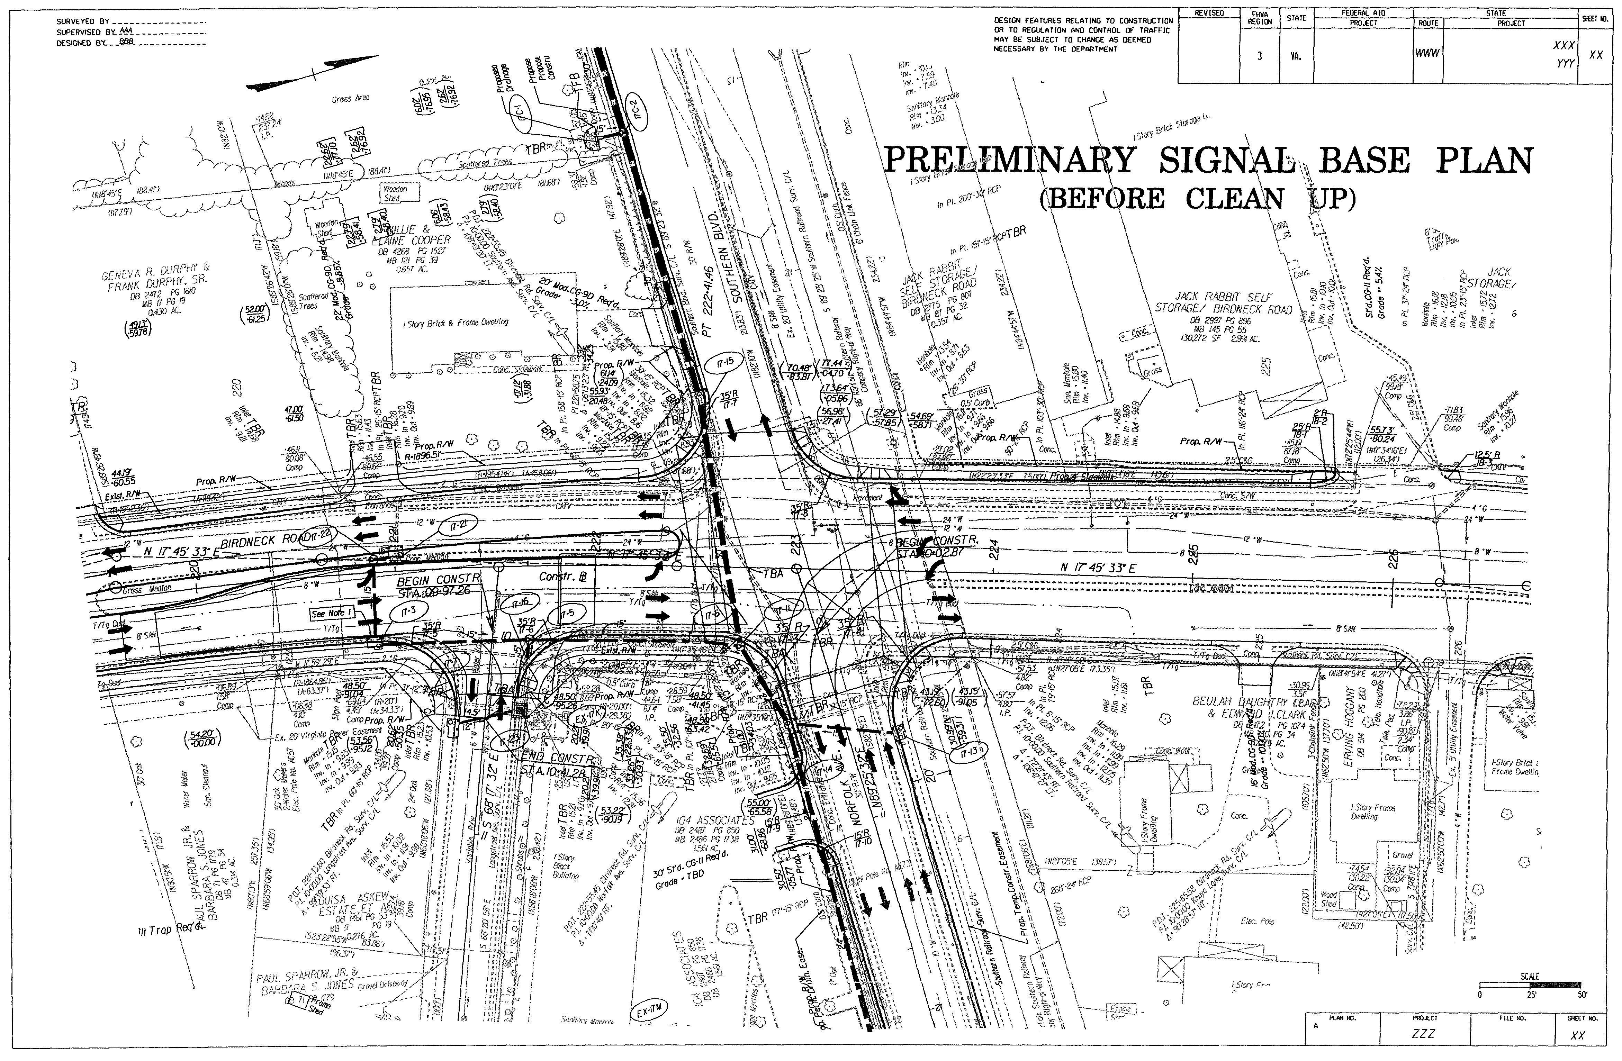
ROAD CONSTRUCTION PLAN SHEET
(See Appendix IVA-1)
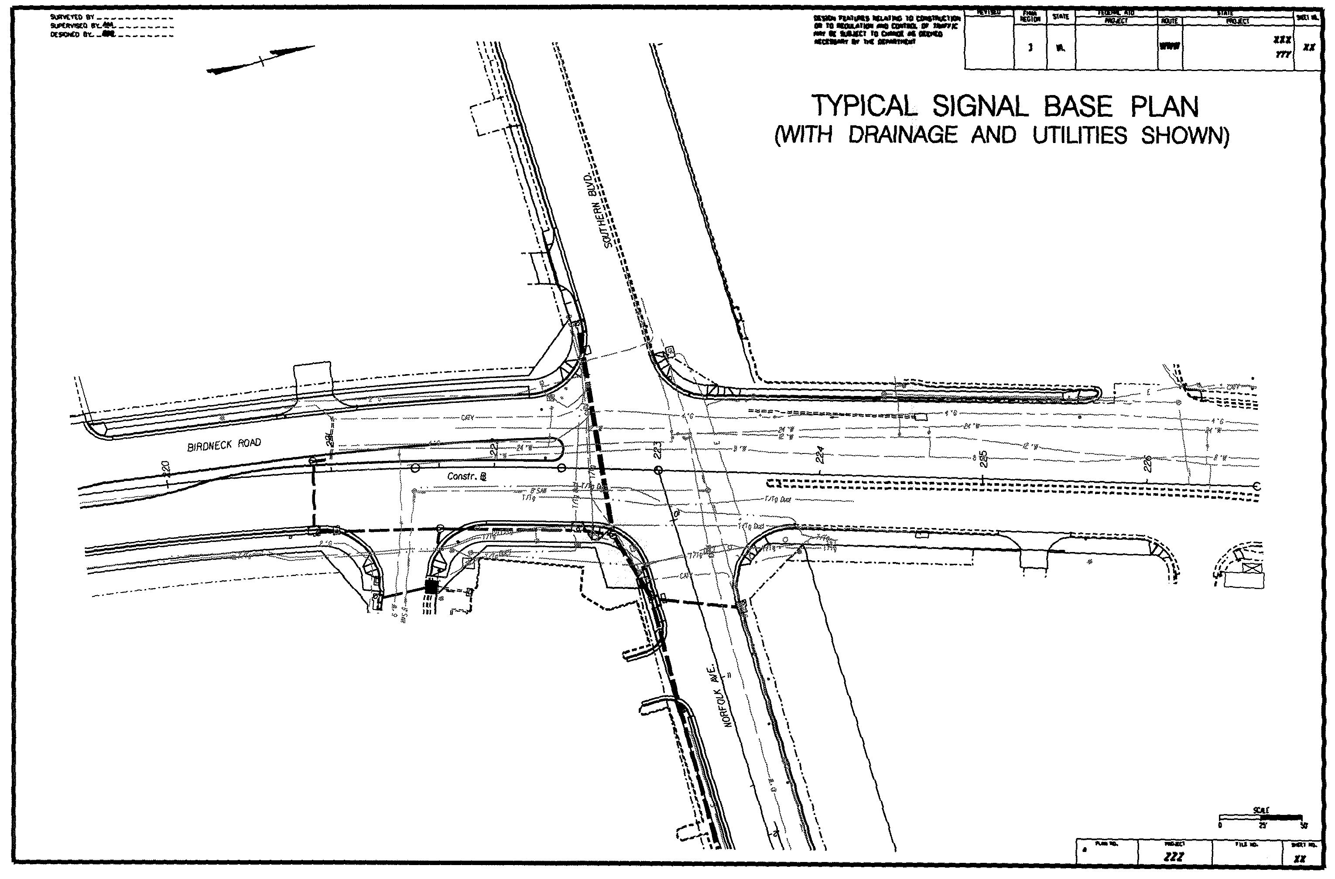
TRAFFIC SIGNAL BASE PLAN SHEET
(See Appendix IVA-2)

Step 3 – Identify Any Additional Survey or Other Information Required
- Perform a field verification of survey at the intersection, as required.

Step 4 – Confirm Phasing and Signal Operation Requirements
- Check the proposed roadway geometry to ensure that the traffic engineering study is in support of the proposed improvements.
- Check vehicle and pedestrian phasing requirements.
- Consider consistency in corridor operations.
- Check for preemption requirements:
- Railroad preemption.
Special sequences for clearance.
Dwell display or cyclical operation during preemption.
Coordinate with railroad.
- Emergency vehicle preemption.
Check horizontal / vertical alignment and consider any additional detection needed.
Check location requirements of confirmation light (when used).
- Other preemption (Transit, LRT, etc.).
- Identify hardware requirements.
- Identify phasing impacts.

Step 5 – Review Geometric Design Requirements
- Verify sight distance requirements for viewing traffic signal heads can be met by referring to the MUTCD Section 4D.15 Size, Number, and Location of Signal Faces by Approach.
- Verify passenger car/truck/bus turning radii are appropriate for left turn / right turn movements.
- Determine functional road classification and design vehicle requirements.
- Use AUTOTURN Software or Turning Vehicle Templates to check that appropriate turning movements can be made within intersection. The Institute of Transportation Engineers (ITE) publishes Turning Vehicle Templates.

Step 6 – Establish Crosswalks
- Locate crosswalks, (Both Marked and Unmarked).
- Location of crosswalks and their associated curb ramps must be evaluated concurrently.
- Location of crosswalks should be placed in accordance with IIM – 55. Ideally, crosswalks should be designed as an extension of the sidewalk.
- Determine whether crosswalks are to be marked. Further information on marking crosswalks is available through (VTRC – Development of Guidelines for the Installation of Marked Crosswalks) and online at:

http://www.vdot.virginia.gov/vtrc/main/online_reports/pdf/05-r18.pdf

- Identify crosswalk type, (Marked Only).
- Parallel lines.
- Zebra.
- Other.

Step 7 – Review Curb Ramp Locations
- Coordinate curb ramp locations. Detailed instructions concerning curb ramps are provided in the Instructional and Informational Memorandum IIM-LD-55.

Step 8 – Establish Stop Lines
- Locate stop lines. Detailed instructions for establishing stop lines are provided in the MUTCD Section 3B.16, Stop and Yield Lines.

Step 9 – Locate Vehicle / Pedestrian Signal Heads and Push Buttons
- Consider signal operations.
- Lane usage: Protected, Protected / Permissive Left Turn, Through Movement
- Right Turn Overlaps.
- Review placement of signals and signs to ensure that existing or planned improvements do not obstruct the visibility to any traffic control device.
- Place vehicle signal heads over receiving lanes, where possible. In the case of horizontal curves, the placement should reinforce proper path choice.
- In addition, verify the vehicle and pedestrian signal heads meet:
- Maintaining Jurisdiction signal head placement practices.
- Requirements of MUTCD Section 4D.15, Size, Number, and Location of Signal Faces by Approach.
- Requirements of Location & Design CADD Section for standard legends.

Step 10 – Locate Signal Poles
- For Any Pole Type:
- Ensure that clear zone requirements are met or an accommodation is made. Clear zone requirements are in the VDOT Road Design Manual, Section A-2 – Clear Zone Guidelines.
- Ensure adequate clearance to overhead utilities. Check NESC requirements and contact local power provider.
- Avoid conflicts with underground utilities.
- Ensure crosswalks, curb ramps and/or required landing areas of curb ramps are unobstructed for pedestrian use.
- Consider pedestrian signal head locations when locating traffic signal poles in order to minimize use of pedestal poles for pedestrian signal use.
- Consider future widening or improvements when locating poles.
- For Pedestal Poles:
- Consider pedestrian use when placing pedestal poles that have pedestrian indications or push buttons.
- Pedestal poles may be used to support left / double left protected phase indications in median sections.

- For Combination Poles (signal poles with luminaires) and Other Street Lighting:
- Check that entire intersection is lit to acceptable standards. TEDM Section V – Roadway Lighting, Chapter 4, 4.5.2 and Chapter 3, 3.10.6 provides further discussion on intersection lighting.
- Check clearance to overhead utilities and structures.
- Check policies and practices of the Maintaining Jurisdiction (District, Municipalities, local power providers) regarding design and maintenance standards.

Step 11 – Identify Electrical Service Connection and Locate Controller Cabinet
- Coordinate with local power provider and Maintaining Jurisdiction, if necessary regarding electrical service point and type of service connection to be provided.
- Document discussions and identify individuals that participate in establishing the service connection location. Include pole number where service is being provided, when possible.
- Identify conduit, cable, riser, and junction boxes, etc. that is required to provide electrical service to the controller cabinet from the electrical service point.
- Refer to VDOT Standards for SE-1 thru SE-5.
- Ensure that electrical service and traffic signal system wiring are kept in separate conduit runs.
- Locate traffic signal controller cabinet as convenient to the electrical service point as possible. In addition:
- Ensure that the controller cabinet location will not be a visibility obstruction for right turn on red movements.
- Ensure grade at proposed cabinet location is adequate and that the controller cabinet is unobstructed for maintenance activities.
- Locate controller cabinet where there is a less likely potential for vehicle collision.
- Evaluate existing and/or proposed Landscaping. For stand-alone signal projects evaluate existing landscaping. For signal projects as part of a roadway construction project evaluate proposed landscaping.
- Visualize whether a technician would have difficulty working in the cabinet.
- If possible locate controller cabinet to allow technician to see as many signal heads as possible. Discuss controller cabinet location with traffic signal maintenance personnel for specific preferences.

Step 12 – Locate Vehicle Detectors
- Select detector technology.
- Refer to the Maintaining Jurisdiction Checklist, if necessary.
- Locate detectors based on signal operation requirements and anticipated approach speeds.
- If loop detectors are used:
- Locate detectors graphically on plan layout sheet.
- Indicate any special features/functions of loop detector
- Determine the appropriate number of turns for each loop detector.
- A Loop Detector Chart as shown below and in Figure 4-1, may be shown on plan if clarity is needed.
- Vehicle detector design details are provided in the Traffic Detector Handbook (FHWA-IP-90-002) and available online at:

http://www.fhwa.dot.gov/tfhrc/safety/pubs/ip002/intro.htm

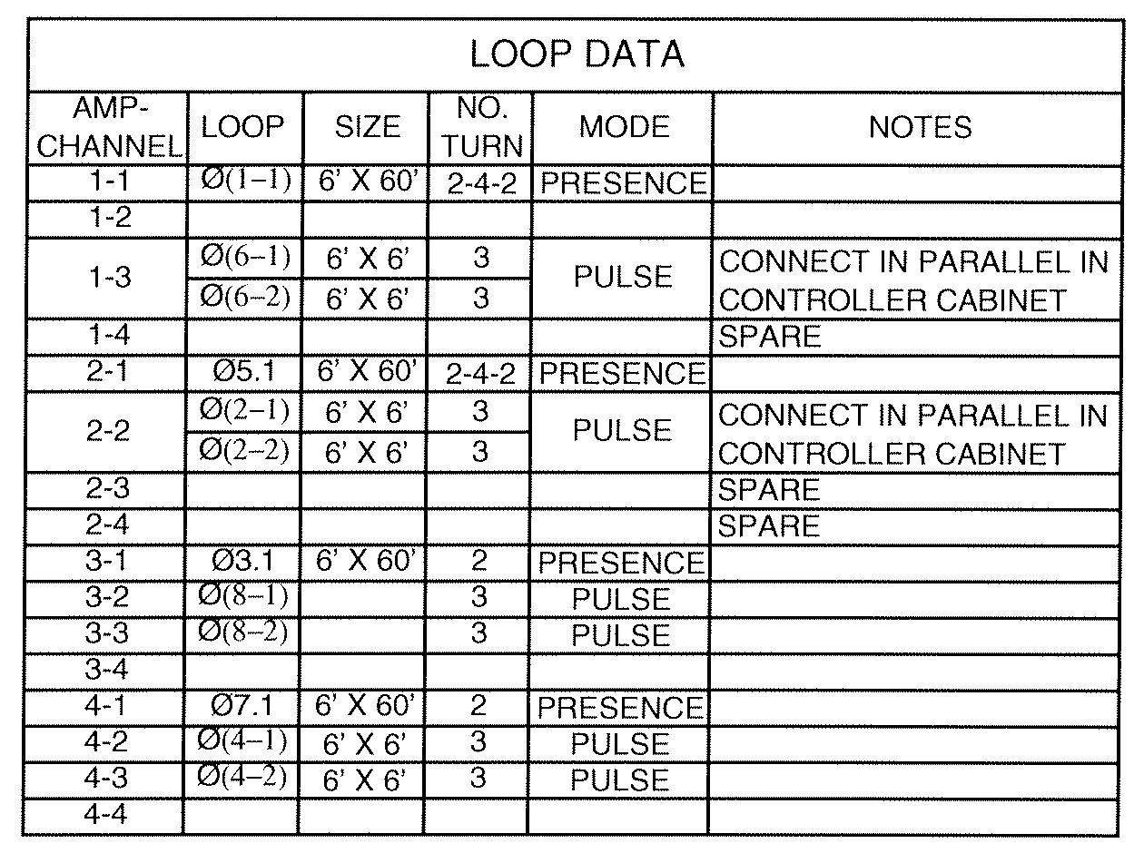
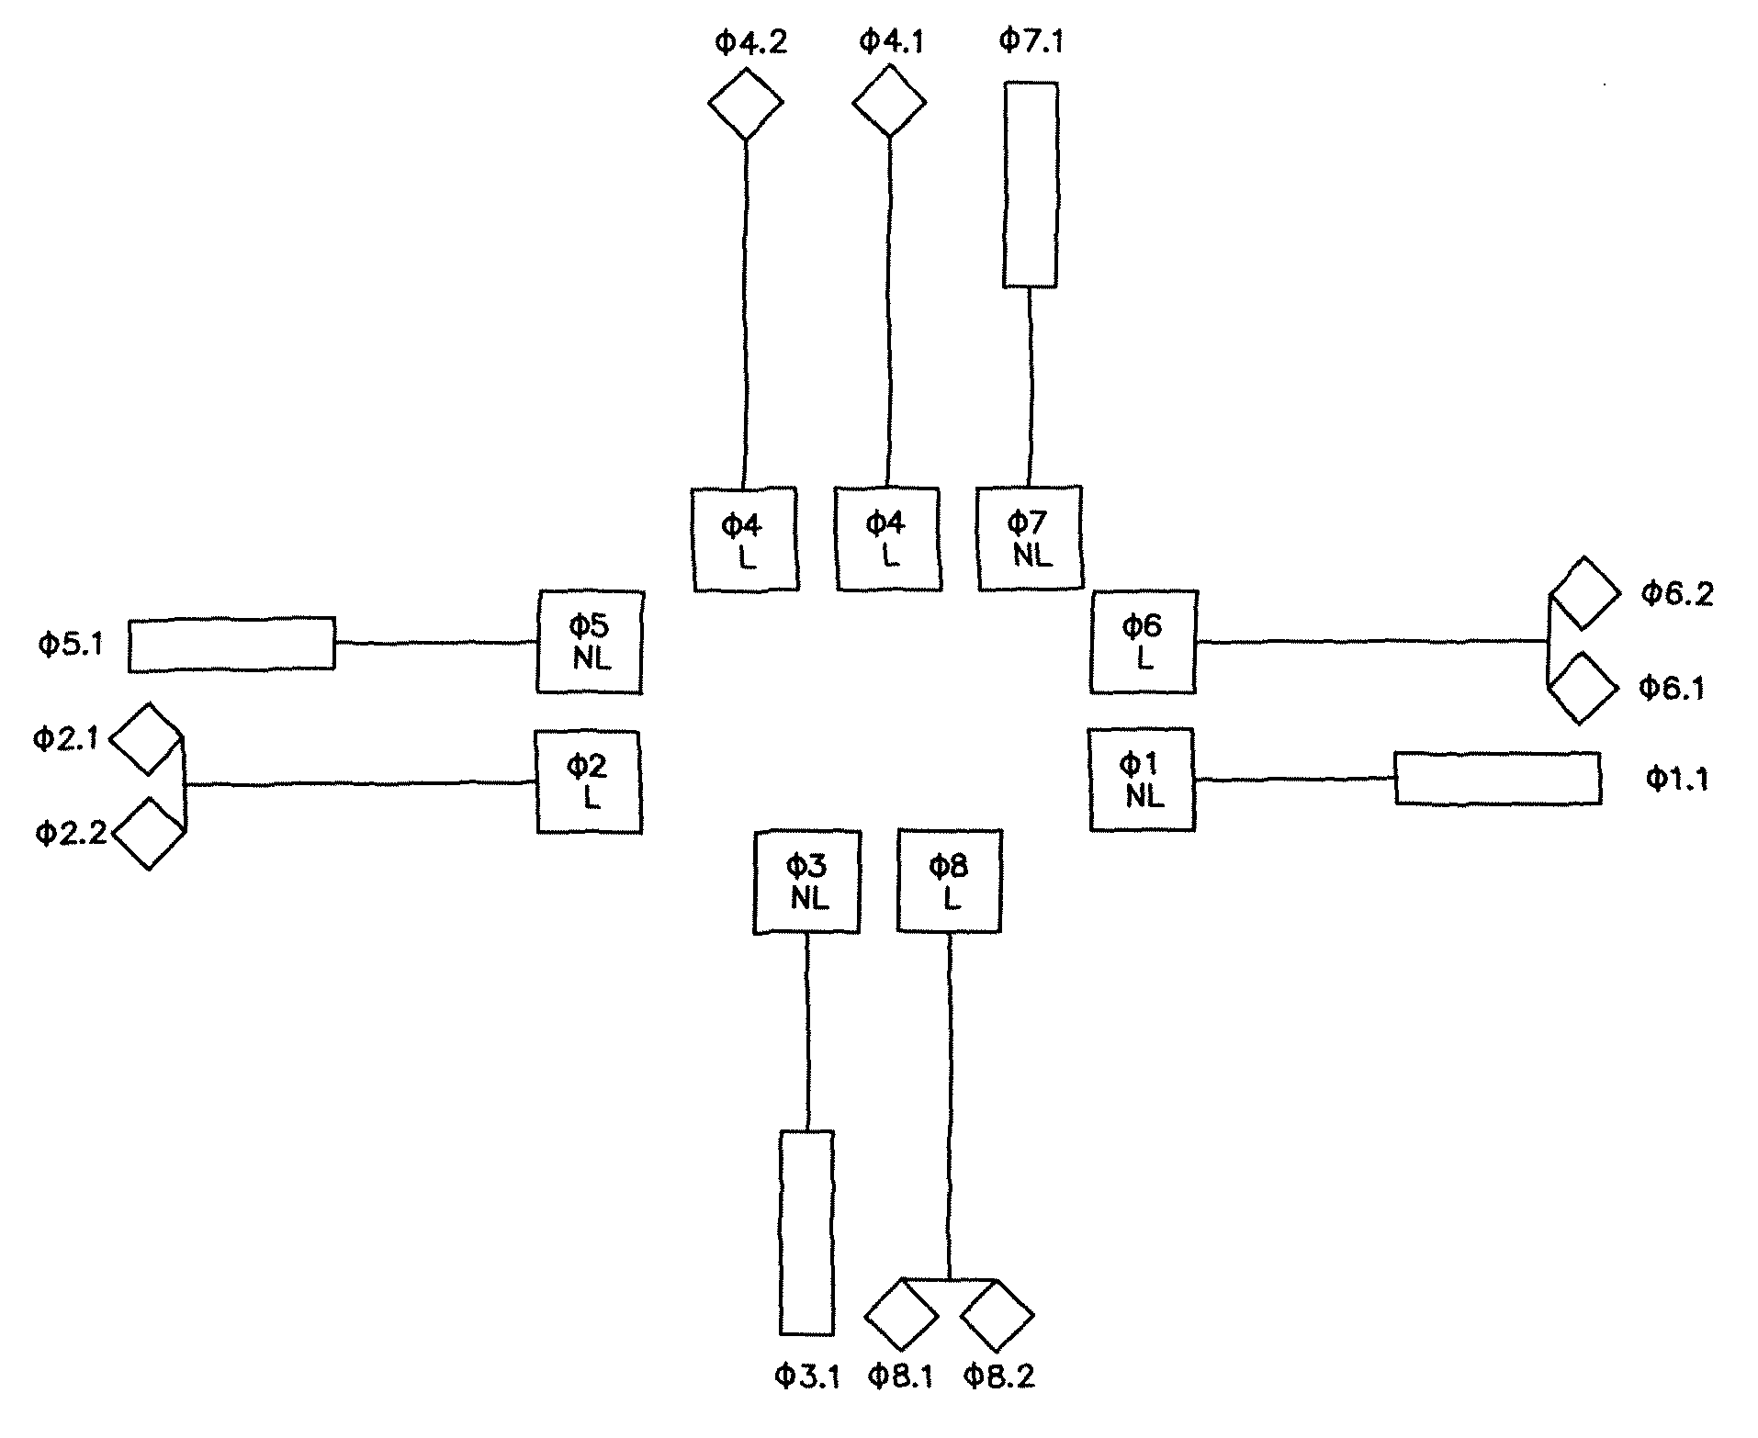

Figure 4–1: LOOP DETECTOR CHARTS

ALTERNATIVE ILLUSTRATIONS

Step 13 – Locate Junction Boxes and Conduit Runs
- Locate junction boxes to serve detectors.
- Locate a junction box for the Electrical Service Connection (if appropriate).
- Refer to VDOT Standards for SE-1 thru SE-5.
- Locate intermediate junction boxes.
- Conduit runs should not be greater than 250-feet without intermediate junction boxes.
- Locate junction boxes to serve signal and pedestal poles.
- Avoid gravel shoulders and close to curbs where errant vehicles may drive over.
- Determine junction box sizes.
- Refer to VDOT Road and Bridge Standards, Volume II, Section 1300 for standard junction box sizes and types.
- Refer to NEC SECTION 370 for properly sizing junction boxes.
- Evaluate where conduits can be placed in order to minimize costs and maximize efficiency
- Minimize total length of conduit used.
- Maximize the utilization of common trenching.
- Three typical methods of conduit installation are:
- Open Trenching Installation.
- Jacked Pipe Installation.
- Directional Boring Installation.

Additional discussion on each of these methods is provided in TEDM Section I – General, Chapter 4, 4.5.

Step 14 – Develop A Wiring Schematic
- Prepare a sketch of the proposed wiring / conductor layout of the intersection.
- The wiring schematic will ensure that all signal components are properly wired.
Figure 4–2: WIRING DIAGRAM
- Show equipment grounding conductors (EGC), (as required).
- VDOT Road and Bridge Specifications, Sections 238 and Section 700 provide discussions and applications of equipment grounding conductors.
- Wiring detail of the traffic signal can be illustrated on the plan sheet by labeling the type and size of conductors. The label itemizes the number and size / type of conductors within each conduit.
- When complex wiring is involved or clarity is needed, an illustration of the Wiring Diagram, as shown below in Figure 4-2, may be used by the signal designer.

Step 15 – Sizing Conduits
- Determine conduits size based on wiring requirements.
- Conduit fill chart shown below and in Appendix IVB-6 will provide cable and conduit sizing requirements.
DESIGN GUIDE FOR CABLE AND CONDUIT SIZING
(See Appendix IVB-6)
- Maximum conductor fill on new conduit installation is 25%.
- Maximum conductor fill to existing conduit is 40%.
- Size pipe sleeve for jacked pipe (as required).
- Conduit that is not metal and is subjected to vehicle loading may require encasement in a metal pipe sleeve that is 2-inches larger in diameter than the diameter of the conduit being carried.
- If pulling new conductors through existing conduit is being considered, verify with the Maintaining Jurisdiction that pull ropes exist. Also, inquire whether the existing conduit has a history of conductor failures, which would indicate that the conduit is damaged.

Step 16 – Determine Sign Requirements
- Consult the MUTCD R-10 Sign Series for appropriate sign requirements.
- Determine who will be fabricating the signs.
- If VDOT or the Maintaining Jurisdiction is fabricating the signs, then the pay item will be for sign installation only. Show all sign dimensions on the plan sheet such that any signs located on the traffic signal structure can be included in the structural analysis by the contractor.
- If the contractor is supplying the signs, then the pay item will be for sign fabrication and installation. A Sign Schedule plan sheet and a Sign Detail plan sheet will be necessary for fabrication of these signs and further discussion is provided in TEDM Section II – Signing, Chapter 4.
- Locate and illustrate street name signs.
- Discuss street name blade design criteria with Maintaining Jurisdiction.
- Coordinate with sign and pavement marking designs:
- If the traffic signal design is part of road construction plans, the traffic signal, sign and pavement marking designs will be in separate plan sets.
- Coordinate with the sign and marking plan sets for continuity of designs.
- Signs mounted on signal mast arms and poles, show on signal plan set. Reference these signs in the sign schedule sheet of sign plan set.
- Show in sign plan set, all ground mounted signs related to signal design.
- If the traffic signal design is a stand-alone project, perform a field investigation of existing signs to ensure continuity with the traffic signal plan set.
- Include in traffic signal plan set, all signs necessary for the safe operation of the traffic signal.
- Provide a sign schedule and sign detail sheet for signs requiring fabrication by the contractor, (e.g. roadway name signs, guide signs, etc.).

Step 17 – Detail Mast Arm and Other Poles
- Determine mast arm length.
- Ensure a minimum 1-foot extension of mast arm beyond the last signal head.
- Mast arm lengths are typically rounded to even numbered increments, (e.g. 20, 32, 44, 56, etc.)
- Determine luminaire arm length, if combination poles are used.
- Determine mast arm and luminaire arm orientation.
- Figure 4-3 provides guidance in determining arm and luminaire arm orientation procedures.
- Detail pole locations
- When signal design is part of road construction project: Use station and offset method.
- When signal design is a stand-alone project: Use triangulation method, where the pole location is fixed by establishing two distances from known objects at the intersection (e.g. fire hydrants, utility poles, etc.)
- Detail signal heads, signs and all devices proposed on the mast arm such as emergency preemption devices and video detection cameras, such that the loading of these devices are included in the signal pole structural calculations.
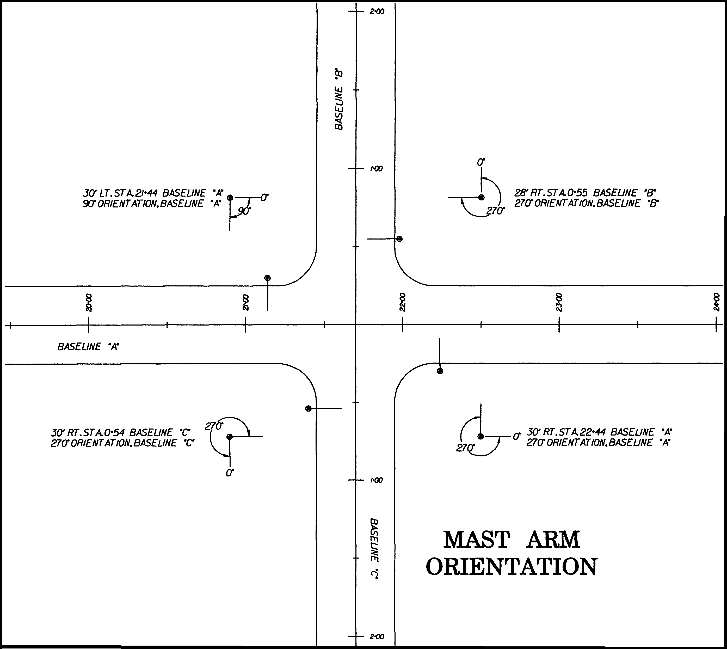
Figure 4–3: GUIDE TO DETERMINE MAST ARM AND LUMINAIRE ARM ORIENTATION

Step 18 – Develop Intersection Specific Details, Legends, Diagrams, Charts and Notes
The following figures are provided as a guide. Specific illustrations, legends, diagrams, charts and notes must be prepared for the intersection and may not always be in the formats shown below. The design requirements of the intersection will dictate the information and formats to be shown on the plans. The following Details, Legends, Diagrams, Charts and Notes are depicted in the example plan set in Appendix IVA-3, Appendix IVA-4, and Appendix IVA-5.
Develop a Signal Pole Detail as shown in Figure 4-4.
- Label signal and pedestal poles on plan sheets.
- Identify pole type.
- Identify pole locations using station and offset method, (if triangulation method is used, show diagrams).
- Identify mast arm length and orientation.
- Identify signal head placement along mast arm, (dimensioned from center of pole).
- Identify sign placement along mast arm, (dimensioned from center of pole).
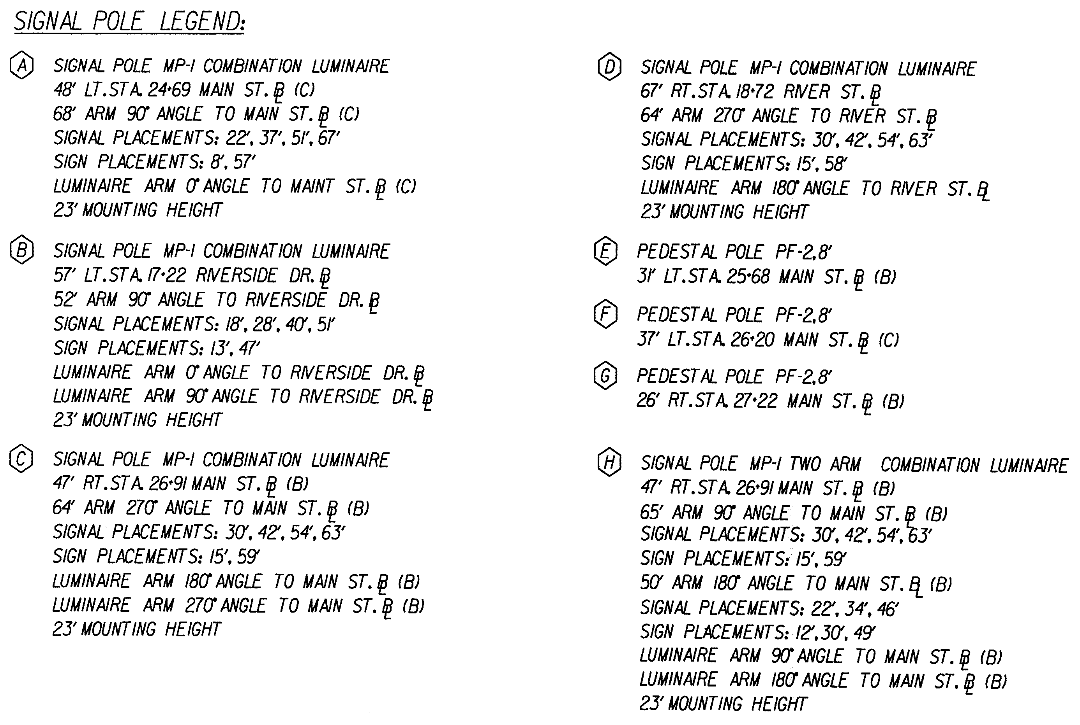
- Identify specialty equipment, (cameras, preemption equipment, etc. and dimension from center of pole).
Figure 4–4: SIGNAL POLE DETAIL
- Identify luminaire arm orientation, if required.
- Identify luminaire arm mounting height, if required.
Develop a Signal Head Detail as shown in Figure 4-5.
- Use phase numbering convention identified in TEDM Section IV – Traffic Signals, Chapter 2, 2.2.7, unless otherwise directed by the Maintaining Jurisdiction.
- Ensure that the signal operation and signal head details are compatible.
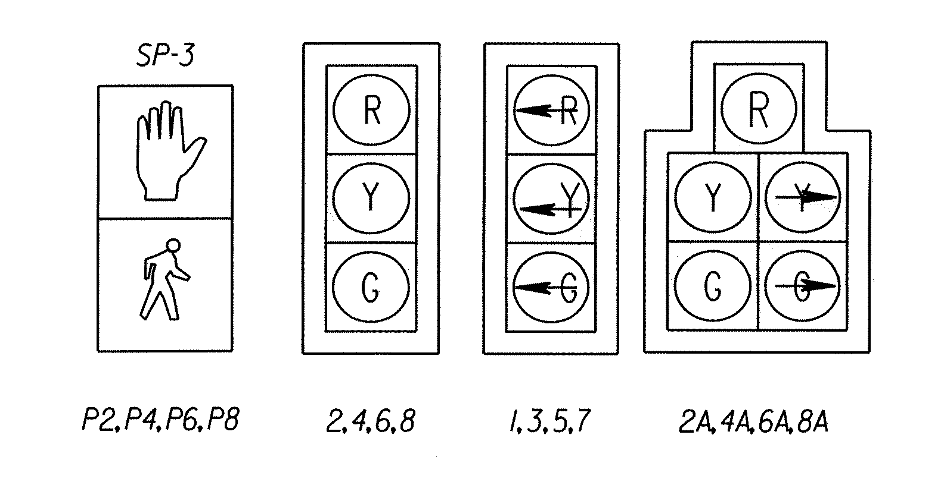
Develop a Sign Detail as shown in Figure 4-6.
Figure 4–5: SIGNAL HEAD DETAIL
- Show dimensions when standard signs dictate
- Identify applicable signs using MUTCD designations in the Sign Detail

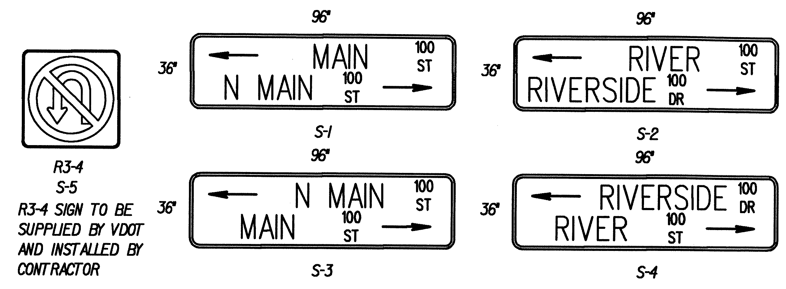

Figure 4–6: SIGN DETAIL

Develop a Phasing Diagram as shown in Figure 4-7.
- Consult the signal operation analysis to ensure approved phasing.
- Show protected turning and through movements as solid lines.
- Show permissive movements and pedestrian movements as dashed lines.
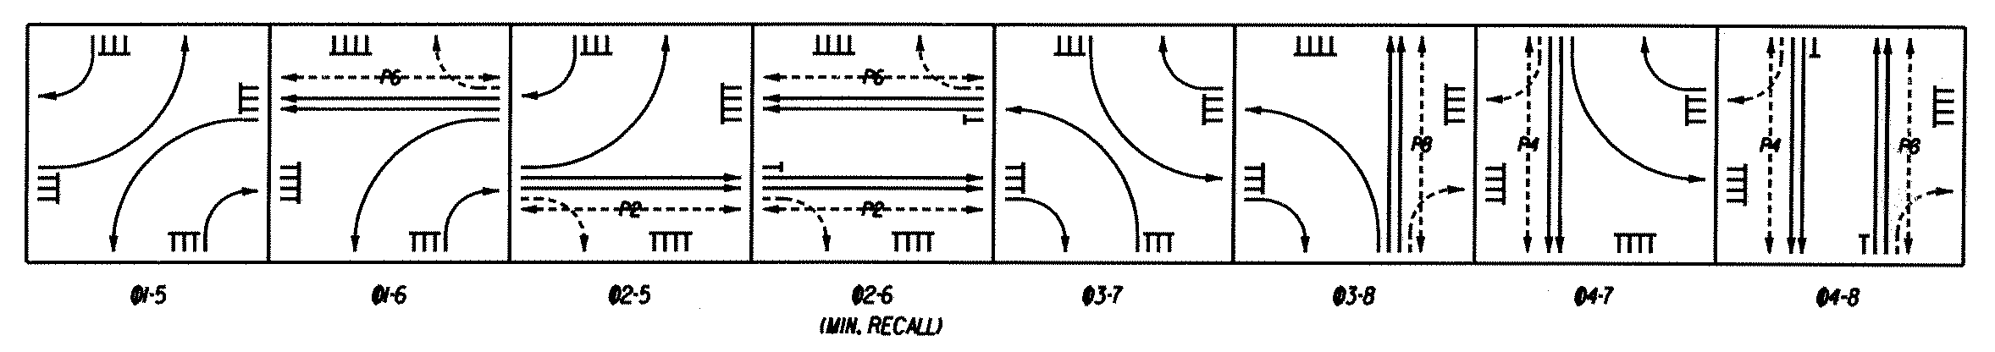
- Figure 4-7 represents an 8-phase signal operation with protected only left turns and right turn overlaps.
Figure 4–7: PHASING DIAGRAM
Develop a Clearance Chart as shown in Figure 4-8.
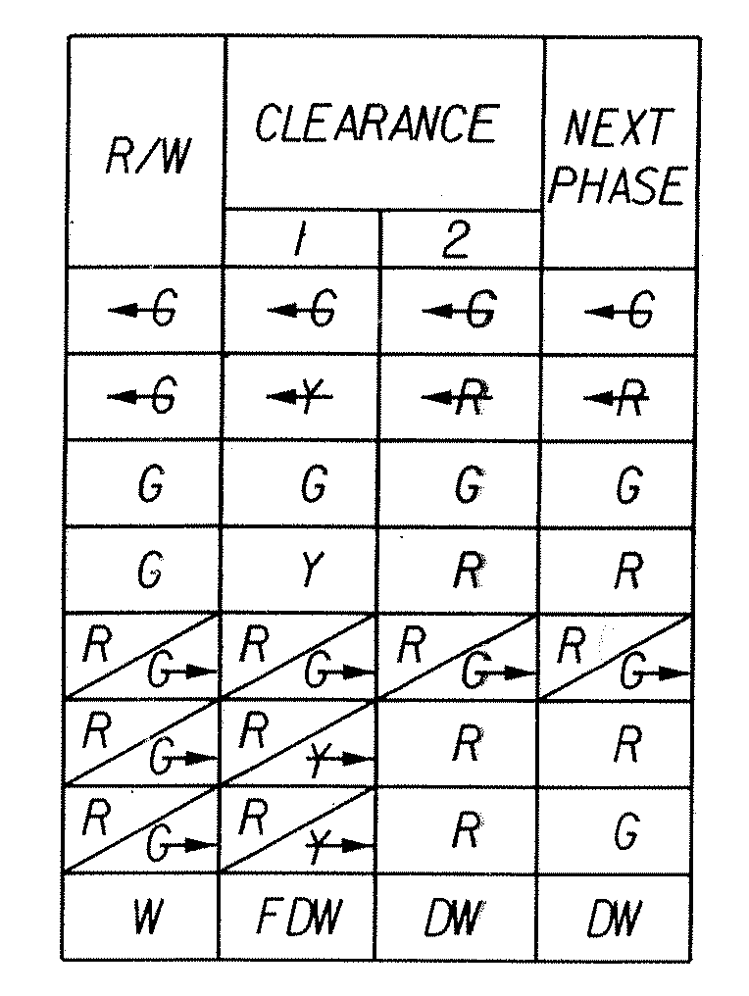
- Determine all possible clearance interval combinations for the intersection and depict on the chart.
Figure 4–8: CLEARANCE CHART
Develop a Color Sequence Chart as shown in Figure 4-9.
- Identify signal head designations along the left-most column, including pedestrian signal heads.
- Identify all possible phases and phase combinations that are permitted during the operation of the signal.
- Show the signal green face that would be indicated during their respective green phases on the chart.
- Show protected left and right turn movements with left and right arrows.
- Show a G to represent a green ball signal face indication.
- In cases where a exclusive / permissive left turn or right turn movement (five section head) is used, illustrate in the same cell when two signal faces are illuminated at the same time for the five section head, such as a left turn arrow and Green circle.
- Show the appropriate signal face indication during Flash operations.
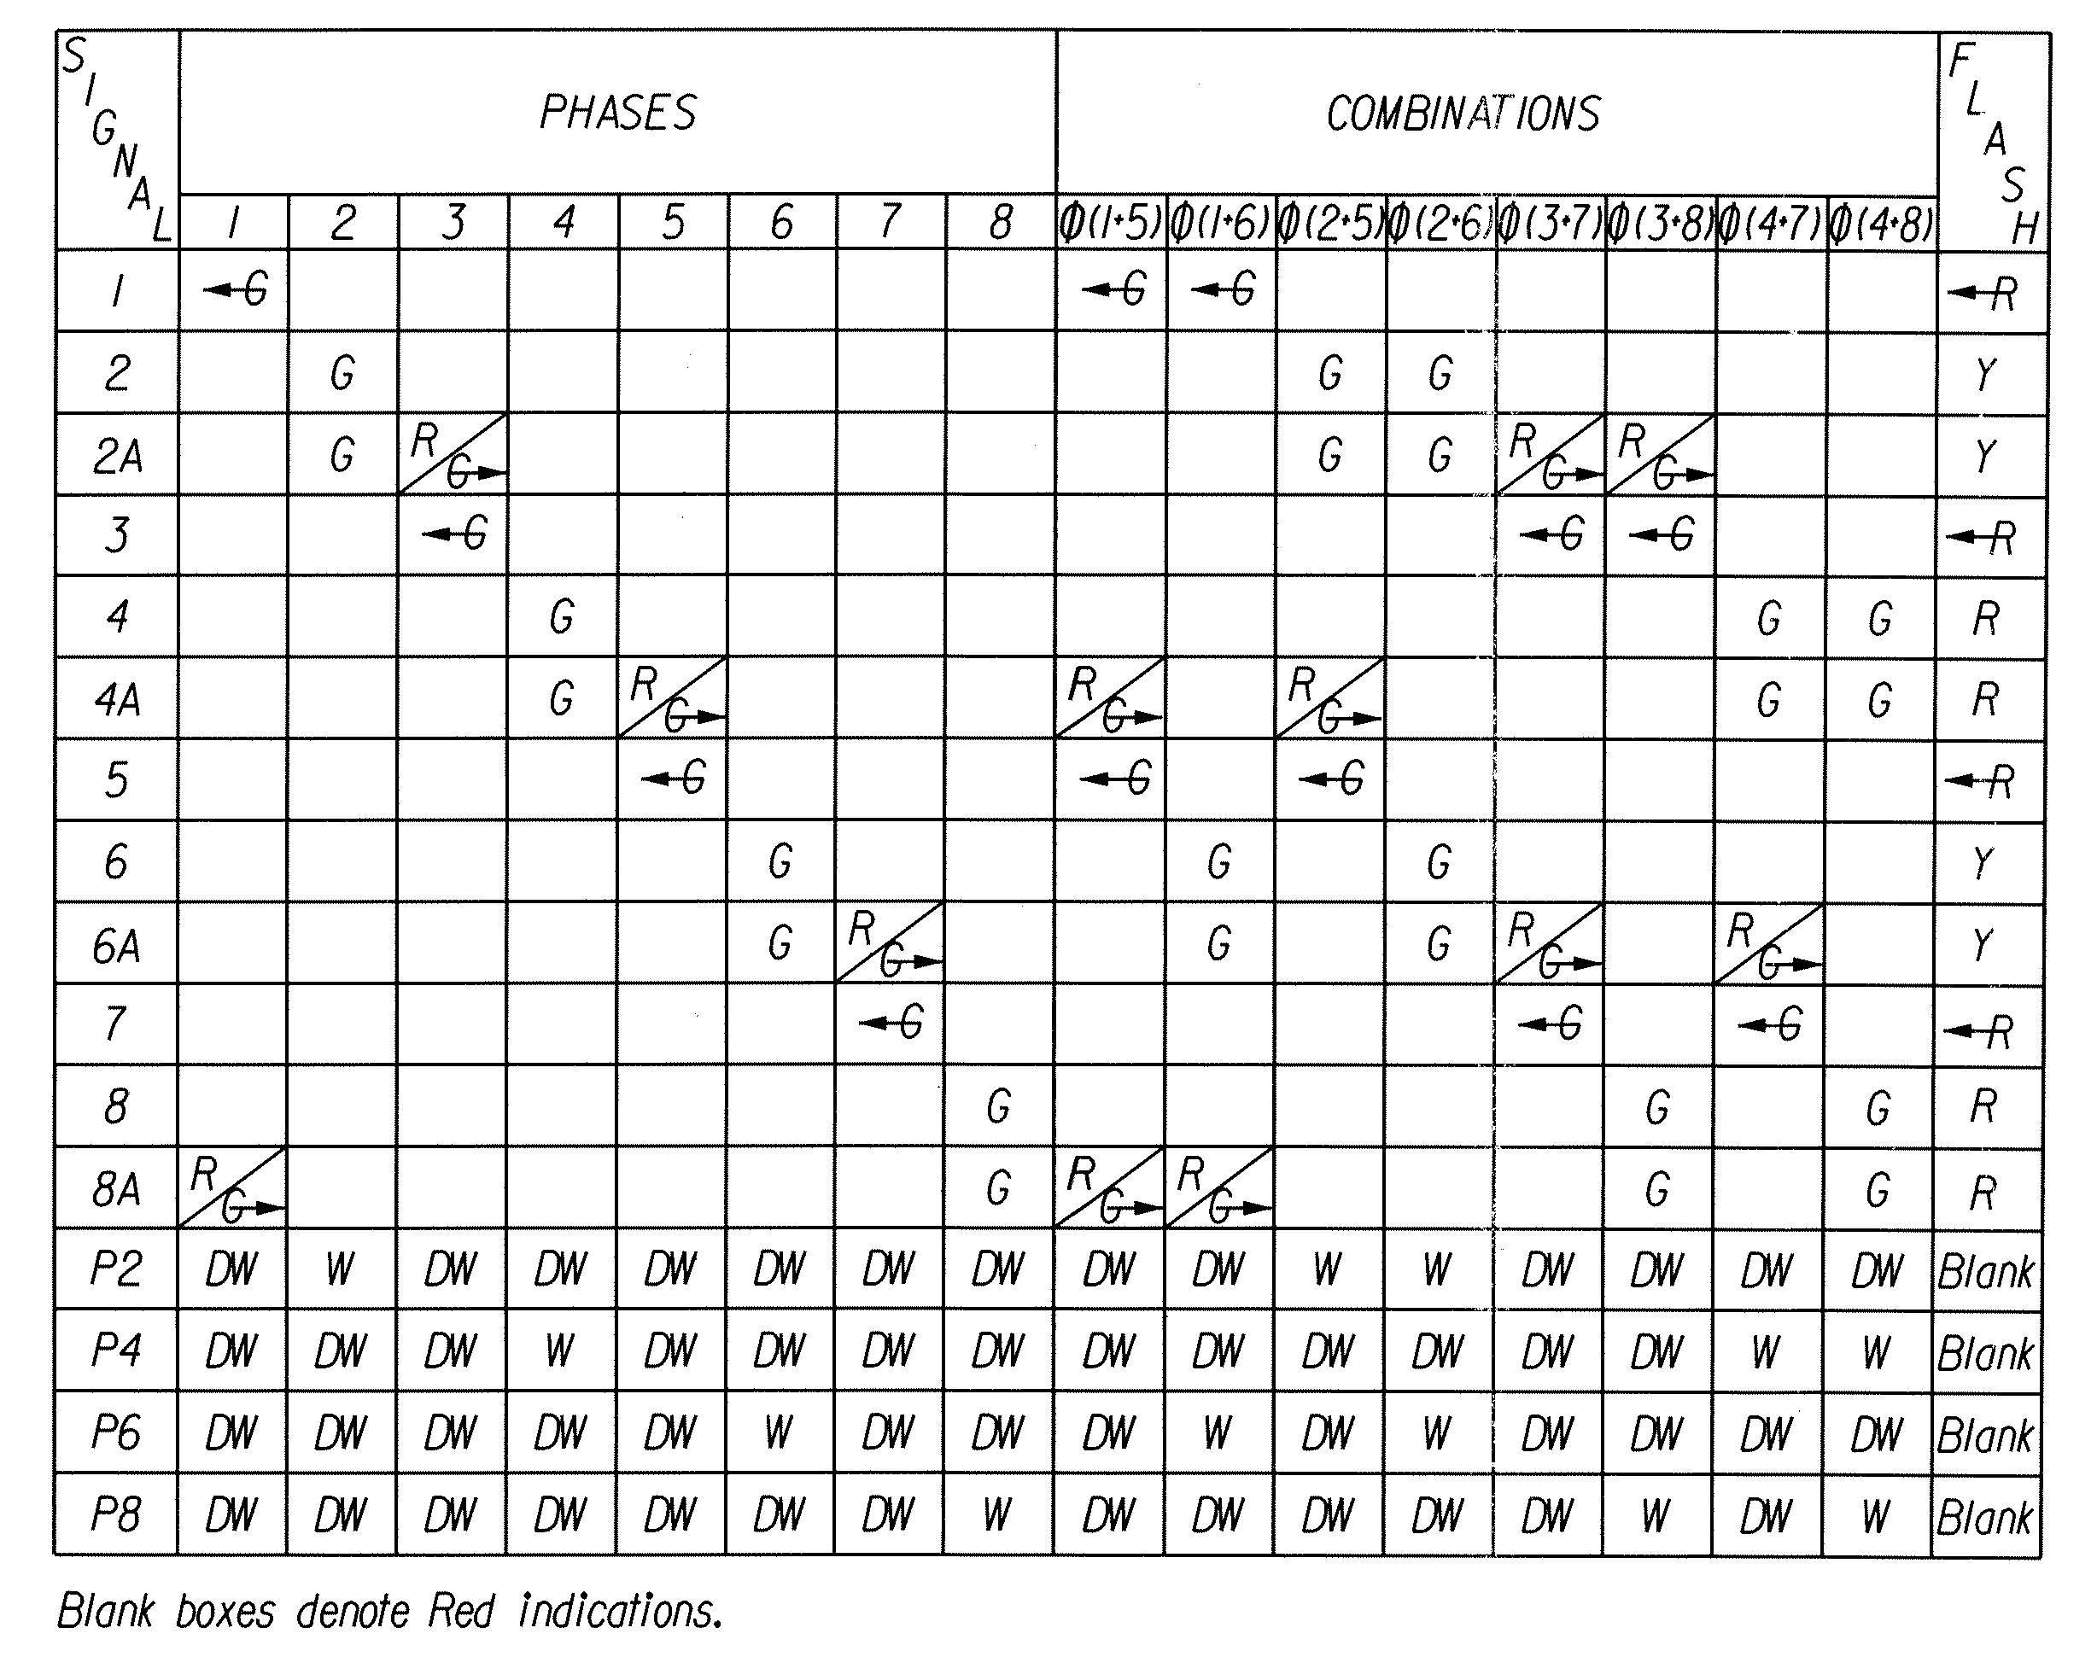
- Show the pedestrian signal face that would be indicated during their respective phases on the chart.
Figure 4–9: COLOR SEQUENCE CHART

Develop General, Summary and Plan Notes
Notes provide clarity and simplification of plans. There are three types of notes typically used on VDOT plans and are defined as follows:

- General Notes
Notes that apply to the entire plan set. General notes are to be numbered sequentially on the “General Notes” sheet. General notes must be tailored to the specific needs of the project. Typical topics that are addressed on the “General Notes” sheet are:

- VDOT contact information
- Maintaining Jurisdiction contact information
- Power Company contact information
- Maintenance of Traffic notes
- Special information specific to the overall project

Several examples of General Notes are:
- “ALL JUNCTION BOXES SHALL BE TYPE JB-3, EXCEPT AS NOTED ON THE PLAN SHEET”.

- CONTROLLER CABINET FOUNDATION SHALL BE IN ACCORDANCE WITH ST’D. CF-1.

- UPON ENERGIZING, A 72 HOUR FLASH PERIOD (IN NO CASE LESS THAN 24 HOURS) PRIOR TO STOP AND GO OPERATION IS REQUIRED UNLESS OTHERWISE APPROVED BY THE DISTRICT TRAFFIC ENGINEER.

- Summary Notes
Notes related to a specific “Pay Item” that has application to the entire plan set. Summary Notes typically provide minor detail regarding a “Pay Item” as it applies to the specific project. If a “Pay Item” requires considerable detailing to be included in the pay item, then a special provision may need to be developed. Summary notes are numbered sequentially and circled. The circled number is associated with the “Pay Item” by placing it in the appropriate pay item block above the pay item description on the Summary Sheet. Examples of Summary Notes are:
1
ITEM TO BE PAID 100% BY CITY

2
INCLUDED IN THE BID COST FOR THIS ITEM ARE THE
FOLLOWING:

56 – 3 SECTION BACKPLATES
2 – 4 SECTION BACKPLATES
2 – 5 SECTION BACKPLATES
186 – TUNNEL VISORS

- Plan Notes
Notes related to the design that is unique to an individual plan sheet. Plan notes are numbered sequentially and shown on the Plan Sheet. An example of a plan note is:

1. “THE CONTROLLER SHALL REST IN (2-6) (MINIMUM RECALL)”

- Examples of General, Summary and Plan Notes:
Additional examples of notes that may be included in the plans are provided in the Appendix IVB-7. The example notes listed above and noted in the Appendix shall be modified in accordance with the specific needs of the traffic signal design.
Develop Other Details, as needed
- Prepare special details, as required.
- Develop signal operation notes, as required.
- Develop electrical service notes, as required.

4.2 PREPARATION OF PLAN SET
An example of a traffic signal plan set is provided in Appendix IVA-3, Appendix IVA-4 and Appendix IVA-5. A Traffic Signal Plan Quality Control Checklist is provided in Appendix IVB-7, which can be used in the preparation of the plan sheets. The following plan sheets are presented in the proper sequence to produce a traffic signal plan set.

Of the plan sheets listed below, those sheets noted as, “For stand-alone projects” are not to be included if they are part of a roadway construction project.

Of the plan sheets listed below, those sheets noted as a “Standard Sheet” requires the designer to reference the VDOT Cell Library for detailed discussion on format, data and sheet numbering.

- Title Sheet (For stand-alone projects)
- This is a Standard Sheet.

- Location Map Sheet (For stand-alone projects)
- A location map is inserted on a sheet giving enough detail to clearly identify the area and location of the project.

- Plan Sheet Index
- Generally, this sheet is not used for traffic signal design projects. However, if there are projects where a number of traffic signal designs are included within the project limits, then a Plan Sheet Index may be appropriate.
- This is a Standard Sheet.

- Right of Way Data Sheet (For stand-alone projects)
- This is a Standard Sheet.

- Revision Data Sheet (For stand-alone projects)
- This is a Standard Sheet.

- General Notes Sheet
- This sheet includes all general notes and if space permits should include “Maintenance of Traffic” notes.
- An example of the General Notes Sheet is provided in Appendix IVA-3.

- Summary Sheet
- This is a Standard Sheet.
- An example of the Summary Sheet is provided in Appendix IVA-4.
- Summary of Quantities include the pay items required for each plan sheet. In computing the amount of conduit, cable and trenching required on a plan sheet, the designer should consider for vertical measurements and conduit bends around the various drainage structures and other features found along the roadway. Similarly, conductor cable will not lie perfectly straight or flat in the conduit. The sum totals of the following items should be increased to compensate for variation encountered during construction. The percentages noted below work well for most projects:

- Conductor cable: increased 10%
- Conduit: increased 5%
- Trench: increased 5%

- Detail Sheet
Occasionally, additional detail may be necessary on the intersection plan sheets to thoroughly illustrate the design intent. These details may include:
- Pavement Marking Details
- Intersection Signing
- Demolition Plan (when appropriate)
- Special Foundation or other structural features
- Design features specifically related to the intersection

- Plan Sheet
Plan sheets will include the following (at a minimum):

- North arrow
- Scale, typically 1”=25’
- Speed limits (as necessary)
- Street names
- Regulatory signs (Mast Arm mounted)
- Intersection geometry (to scale)
- Curb ramps (as required)
- Right of Way
- Lane widths
- Show only underground and overhead utilities that are in proximity to the traffic signal infrastructure or those utilities that provide the contractor sufficient information to properly bid the traffic signal work.
- Show all graphics and illustrations depicting signal system components including:
Pole Locations
Controller Cabinet Location
Vehicle Signal Heads
Pedestrian Signal Heads
Vehicle Detectors
Pedestrian Push Buttons
Luminaires (as required)
Conduits
Pipe (Conduit) Sleeves
Junction Boxes
Span Wire Routes and Connections (as required)
Signal Face Identification
Controller Phasing Diagram
Clearance Chart
Loop Detector Chart
Wiring Information and/or Wiring Diagram (as required)
Electrical Service Identification and Location
Special Equipment, such as Preemption Hardware
Plan notes

