CHAPTER 3: preliminary design
3.1 GENERAL 1
3.2 DATA COLLECTION 1
3.2.1 Traffic Volume Counts 1
3.2.2 Crash Data 3
3.2.3 Intersection Delay Studies 4
3.2.4 Spot Speed Studies 4
3.2.5 Gap Studies 4
3.2.6 Queue Studies 4
3.3 ENGINEERING STUDIES FOR SIGNAL JUSTIFICATION AND DESIGN 4
3.3.1 Advance Engineering Data 5
3.3.2 Warrants for Traffic Signal Installation 7
3.4 PRELIMINARY DESIGN CONSIDERATIONS 8

3.1 GENERAL
The first step in the preliminary signal design process is to perform an engineering study. The purpose of the study is to determine the applicability, design, operation, or installation of a traffic control device. The study will set the design parameters, identify geometric improvements and operational design requirements for the intersection.

A brief description of typical data collection and traffic studies for traffic signal design is presented in this chapter. Also, a Preliminary Design Checklist is provided in Appendix IVB-2, which can be used in the early phases of design to assist in identifying the important physical features of the intersection.

3.2 DATA COLLECTION
Accurate traffic data is essential for preparing sound engineering studies. The traffic data may involve different traffic flow characteristics that must be evaluated individually and as a whole, in order to fully examine the necessary improvements of an intersection. A brief description of typical traffic data collection used in engineering studies is presented below.

3.2.1 Traffic Volume Counts
The most basic form of traffic data is traffic volume counts. Traffic volume counts are taken as vehicles pass a specific location, and are recorded over a period of time. Time periods can vary based on the type of analysis undertaken.

For detailed information regarding traffic volume counts, refer to the Transportation and Traffic Engineering Handbook, ITE.
3.2.1.1 Total Volume Counts
Total volume counts are typically performed using automatic traffic counters. Total volume counts are made by counting vehicles as they pass a point on the roadway regardless of the direction of travel or of the vehicle type. The data is usually recorded over some unit of time. Total volume counts may be used in the development of Average Daily Traffic (ADT) estimates. Total volume counts may be taken for a period of a day, or longer. Total volume counts are typically subtotaled in increments of an hour and are associated with the time of day. Total volume traffic counts readily identify the time periods during the day that the traffic volumes peak. Total volume counts have a limited application in traffic signal warrant analyses.

Total Volume counts may be simply the total traffic volumes along a roadway and do not reflect directional volumes or volumes per lane.
3.2.1.2 Directional Counts
Directional counts are total volume counts that differentiate between the direction of flow in the traffic stream.

3.2.1.3 Turning Movement Counts
A type of directional count often performed at roadway intersections is the Turning Movement Count as shown below and in Appendix IVB-3. The turning movement count quantifies the volume of traffic for each movement by the approach from which the vehicle enters, and by the direction in which it leaves the intersection. Each approach into the intersection may have multiple movements, (left-turn, through, right-turn and pedestrian movements). Turning movement counts are typically performed manually at least during the peak hour periods, (e.g. AM peak, PM peak). Turning movement counts are useful to the designer for determining traffic signal timings, channelization, preferential lane treatment, etc.
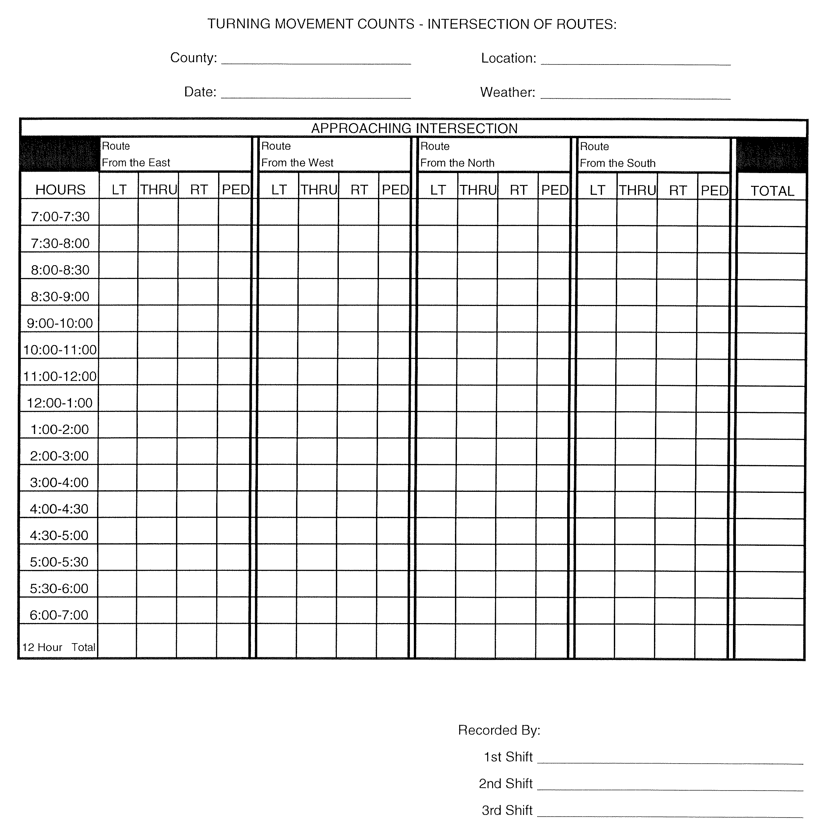

EXAMPLE OF SPREADSHEET

FOR TURNING MOVEMENT COUNTS
(See Appendix IVB-3)

3.2.1.4 Classification Counts
Classification counts identify the types of vehicles using the roadway or intersection. The traffic volume data obtained in a classification count provides information that will assist the designer in geometric design considerations, as well as, capacity and signal timing analyses.
3.2.1.5 Pedestrian Counts
Pedestrian counts are manual counts taken of pedestrians. Sometimes, intersection pedestrian counts may include an estimate of approximate age of the pedestrian to assist the designer.

3.2.2 Crash Data
Crash data is typically compiled on a collision diagram as shown below and in Appendix IVB-5. The compilation of crashes at an intersection or along a roadway are depicted schematically and show general information about the type of collision, severity of the crash (property damage, injuries, or fatalities), time of day, day of week, weather conditions, etc. Collision diagrams are used in traffic signal warrants studies, geometric design development and other considerations.

For detailed information regarding crash studies, refer to the “Manual of Traffic Engineering Studies”, ITE.
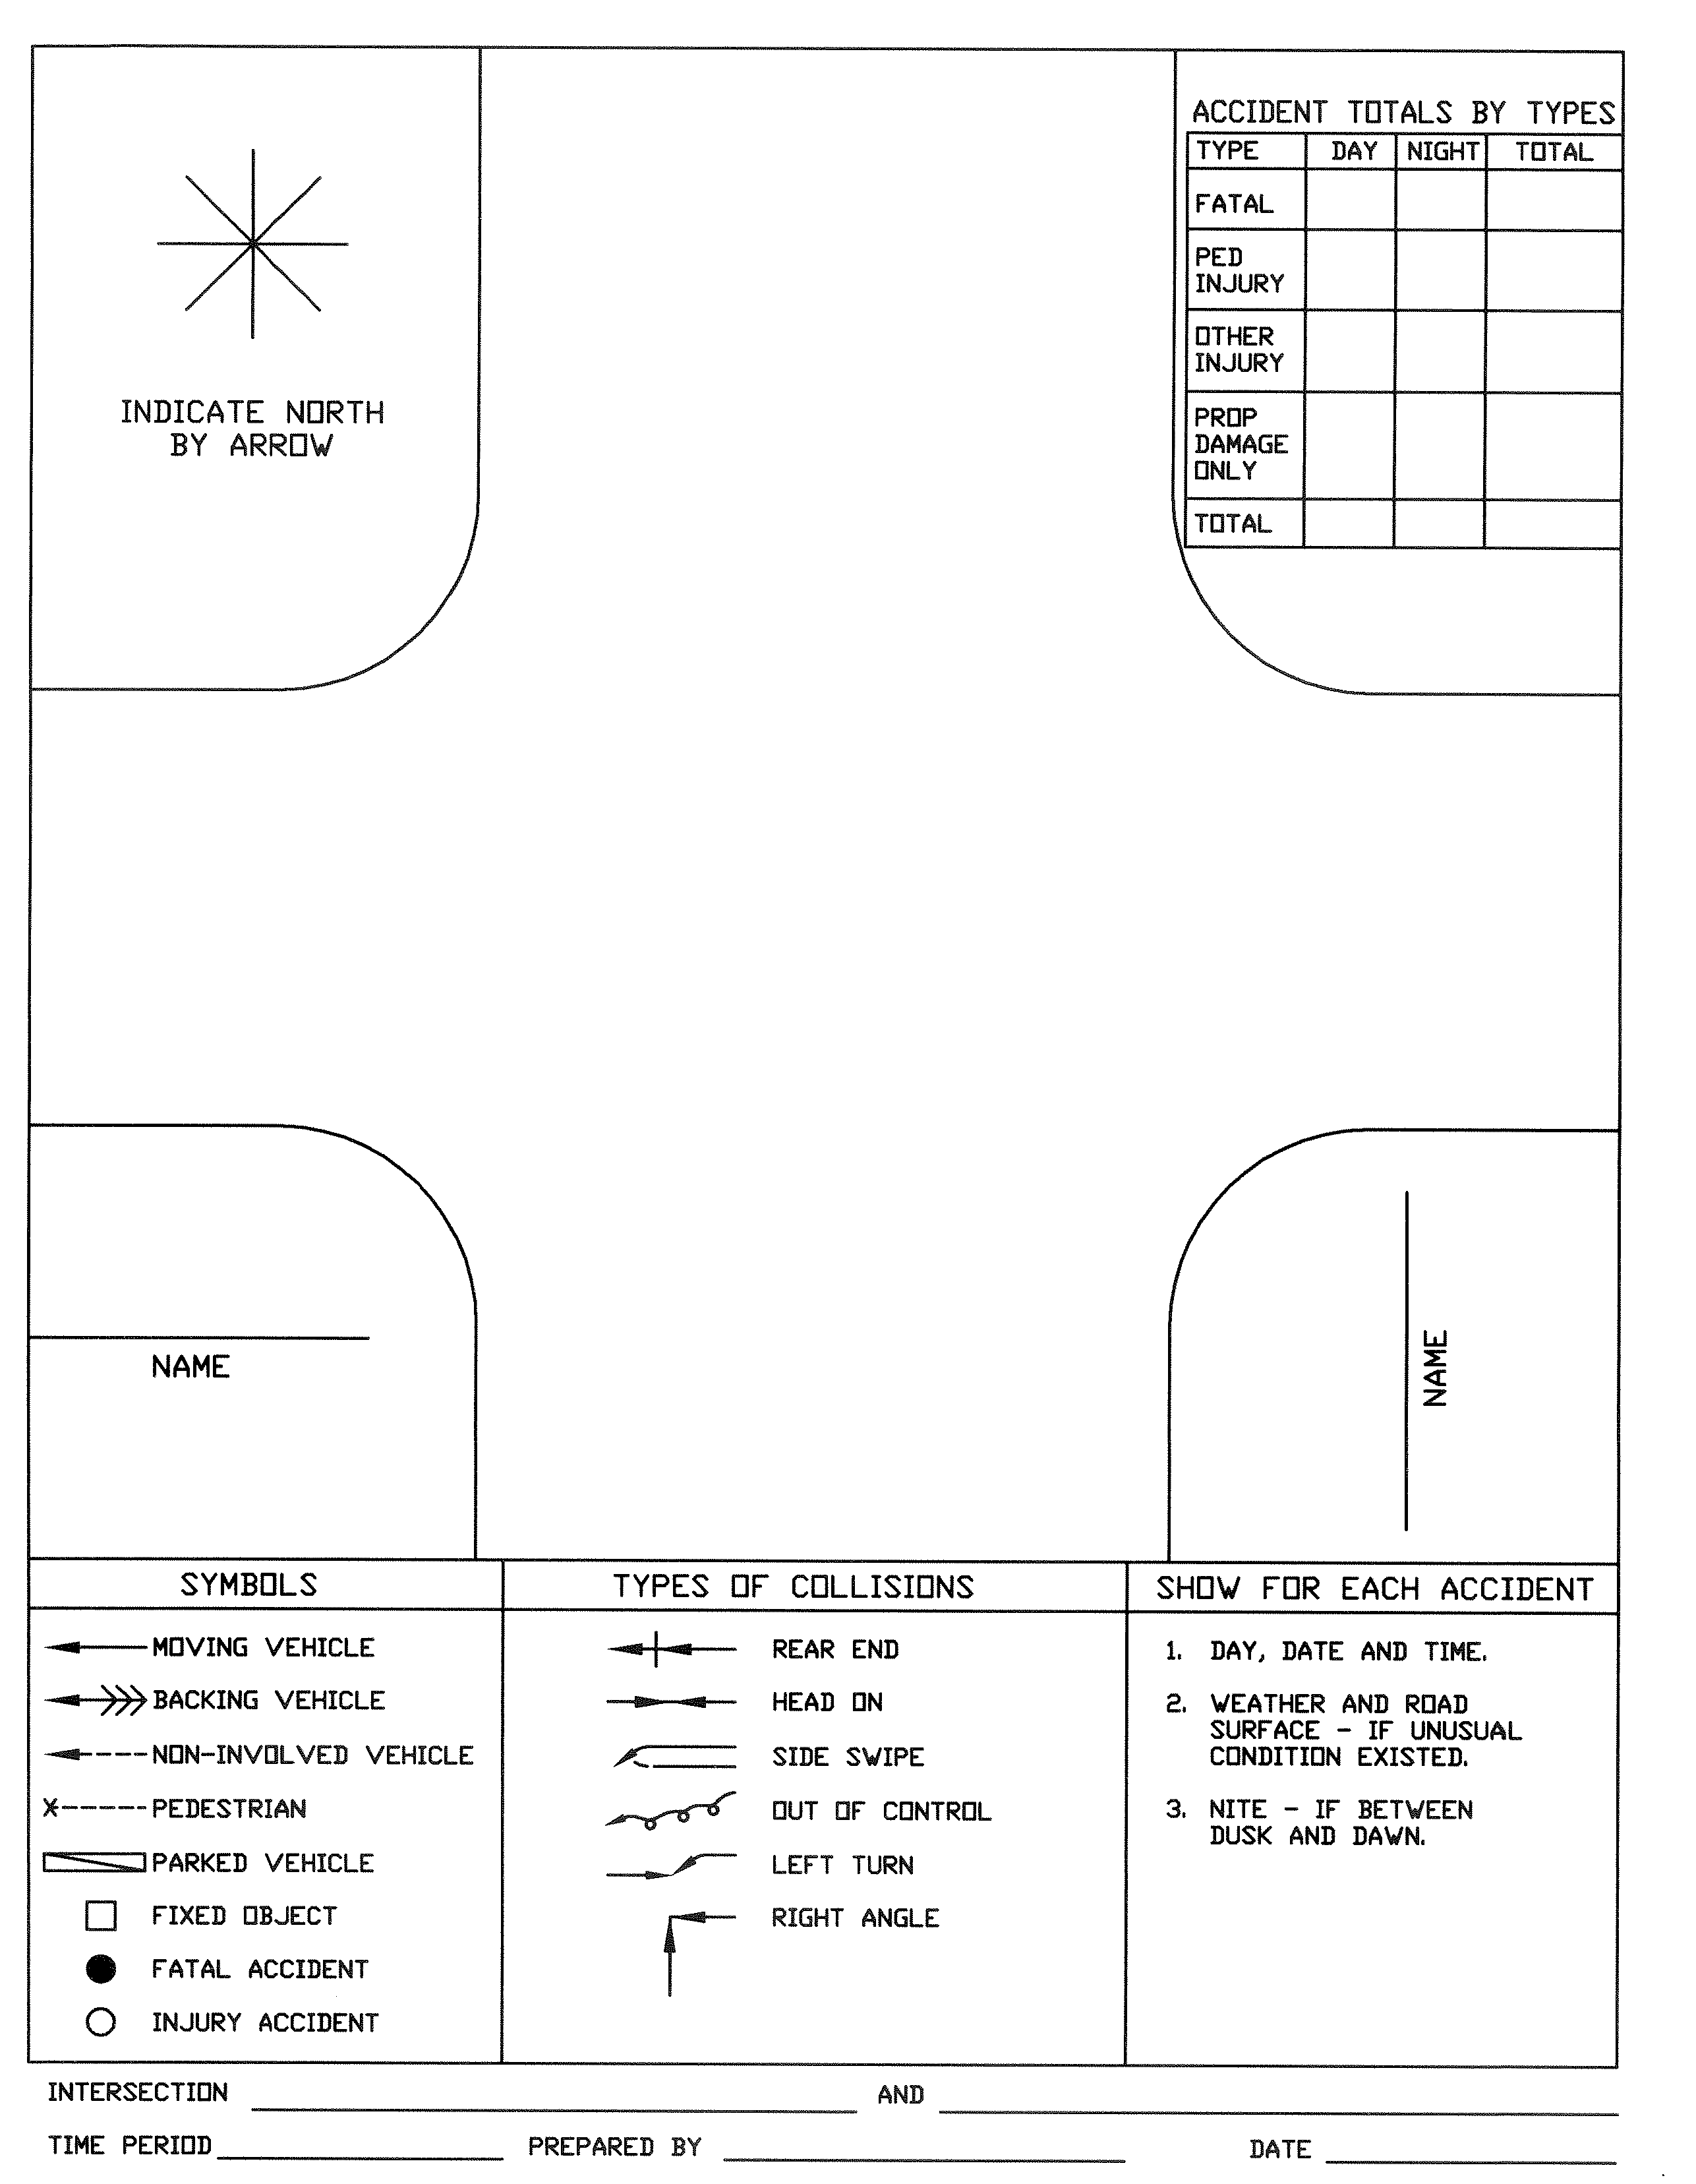

EXAMPLE OF INTERSECTION

COLLISION DIAGRAM
(See Appendix IVB-5)

3.2.3 Intersection Delay Studies
Intersection delay studies quantify the level of delay at an intersection. The signalized intersection level of effectiveness is typically measured in seconds of delay. Intersection delay studies are used to evaluate geometric and signal operational design considerations.

For details on intersection delay studies, reference the Highway Capacity Manual, (HCM).

3.2.4 Spot Speed Studies
Spot speed studies are the measurement of vehicular travel speeds at a specific location. Spot speed studies have many applications in traffic engineering analyses, including developing signal timings.

For detailed information regarding spot speed studies, refer to the Manual of Traffic Engineering Studies, ITE.

3.2.5 Gap Studies
Gap studies provides information on traffic flow. A gap is the measurement of time, in seconds, at a specific location between the end of one vehicle and the beginning of the next vehicle, without regard to which through lane each vehicle is traveling in or which direction of travel along the roadway. A determination of the number of available gaps in traffic and the length of time for each gap are used to assist the designer in geometric, traffic signal timings and traffic signal phasing considerations.

For detailed information regarding gap studies, refer to the Transportation and Traffic Engineering Handbook, ITE.

3.2.6 Queue Studies
Queue studies can be either a queue discharge or queue length study. Queue length studies are the measurement of the number of vehicles per lane at a traffic signal. A queue study is used in delay studies and can be used in evaluating signal timings, detector placement and geometric considerations.

For detailed information regarding queue studies, refer to the Transportation and Traffic Engineering Handbook, ITE.

3.3 ENGINEERING STUDIES FOR SIGNAL JUSTIFICATION AND DESIGN
In accordance with the MUTCD, an engineering study of the traffic conditions, pedestrian characteristics, and physical characteristics of the location shall be performed to determine whether installation of a traffic control signal is justified at a particular location.

3.3.1 Advance Engineering Data
A comprehensive investigation of traffic conditions and physical characteristics of the location is required to determine the necessity for a signal installation. The following data may be considered for inclusion in an engineering study and is often pertinent to the design and operation of a signal.

- Total volume count on each leg of the intersection
- The number of hours for the total volume count may vary, but the period selected must be adequate to fit the requirements of the study.

- Turning movement count for each movement of each approach to the intersection
- These counts may be taken for a minimum time, (typically, a 2-hour period during the morning and afternoon heavy traffic periods), or may proceed continuously for 10 or more hours. Determination of the peak hour period may be determined from a Total Volume Count. The turning movement count may be summarized over the count periods in 15-minute increments, or in some other increment adequate to the design purpose.

- Pedestrian volume count on each crosswalk
- Performed during the same periods as the vehicular counts in paragraph (2) above. Special considerations may require hours of the highest pedestrian volumes to be counted, as with a school crossing. Where young or elderly persons need special consideration, the pedestrians may be classified by general observation and recorded by age groups.

- A spot speed study
- Such a study may identify the 85th percentile speed, 95th percentile speed, speed distribution, average and mean speed of the intersecting streets.

- A diagram showing details of the physical layout, including features such as:
- Intersection geometry
- Channelization
- Grades
- Sight-distance restrictions
- Bus stops and routings
- Parking conditions
- Pavement markings
- Street lighting
- Driveways
- Location of nearby railroad crossings
- Distance to nearest signals
- Utility poles and fixtures, and
- Adjacent land use.

- A collision diagram (minimum of one year) including information such as:
- Type
- Location
- Direction of movement
- Severity
- Time of day
- Day of week

- Additional data to be considered when a more precise understanding of the operation of the intersection is desirable and should be obtained during the same time period established for the turning movement counts:

- Vehicle delay (in seconds) determined separately for each approach
- Number and distribution of gaps in vehicular traffic on the major street
- 85th percentile speed of vehicles on controlled approaches at a point near to the intersection but unaffected by the control
- Pedestrian delay time for at least two 30-minute peak pedestrian delay periods of an average weekday or like periods of a Saturday or a Sunday

The engineering study also should evaluate the existing roadway capacity at the intersection of the proposed traffic signal, if the traffic signal project is not part of a road construction project. Roadway widening for both the major street and the minor street may be desirable to reduce the delays that will be incurred with the installation of a traffic signal.

Minor street widening can have a substantial impact on reducing delays at the intersection. The provision for additional capacity to the minor street will reduce the green time necessary to serve the minor street. The available green time can then be reallocated to the major street or the major traffic movements in the intersection.

Additional considerations or suggestions are:

- Cost effective widening can be achieved by elimination of parking in the vicinity of the intersection approaches
- A minimum of two lanes on each approach is desirable
- The leaving side, as well as the approach side of the intersection, should be evaluated, in order to efficiently clear traffic through the intersection
- Non-actuated approaches will be evaluated to ensure minimum green time for pedestrians can be accommodated

3.3.2 Warrants for Traffic Signal Installation
The Manual on Uniform Traffic Control Devices (MUTCD), Chapter 4C provides detailed discussions on Traffic Signal Warrants. The following eight warrants are addressed in the MUTCD and is available online at:

http://mutcd.fhwa.dot.gov/

- Warrant 1 – Eight – Hour Vehicular Volume
- Warrant 2 – Four – Hour Vehicular Volume
- Warrant 3 – Peak Hour
- Warrant 4 – Pedestrian Volume
- Warrant 5 – School Crossing
- Warrant 6 – Coordinated Signal System
- Warrant 7 – Crash Experience
- Warrant 8 – Roadway Network

The MUTCD recommends that “the study should consider the effects of the right turn vehicles from the minor-street approaches. Engineering judgment should be used to determine what, if any, portion of the right turn traffic is subtracted from the minor-street traffic count when evaluating the count against the above warrants”. Warrant Evaluation Worksheets are provided in Appendix IVB-4, which will assist in developing the traffic signal study.

3.4 PRELIMINARY DESIGN CONSIDERATIONS
The following list of activities and issues should be considered at the initial stages of the project design.

Pre-Design Activities:

- Perform field review.
- Determine L&D Coordinator / Advertisement Date.
- Submit traffic signal design questionnaire, which is provided in Appendix IVB-1 to appropriate agency, when necessary.

Preliminary Design Issues

- Is the proposed signal phasing and detection scheme in agreement with the traffic analysis for the intersection?
- Is R/W adequate for signal infrastructure?
- Can the proposed and existing lanes be transitioned properly?
- Is alignment of lanes through intersection adequate?
- Does right / left turn movements have appropriate turning radii?
- Does right / left turn lanes have appropriate storage capacity?
- Where is the source of power (SOP) located?
- Are overhead wires or structures pertinent to the signal design shown?
- Are underground utilities pertinent to the signal design shown?
- Are sidewalks / paths shown?
- Have sight distances been checked?
- Have curb ramps / pedestrian amenities been analyzed for need?
- Will future improvements, outside of the current scope of work for the project, have an impact on the location of the traffic signal infrastructure for the intersection?
- Will adjacent intersections be affected by traffic queuing from signal?
- Is the lighting level in the intersection adequate?
- Do buildings or structures create visibility obstructions at the intersection?
- Are railroad or emergency facilities in the vicinity?
- Should emergency vehicle preemption (EVP) be provided?
- Is the controller cabinet location accessible and outside the clear zone?
- Is the signal part of a coordinated system and should interconnect (telephone or cable) be provided?
- Are pedestrian signals required, and if so, are pedestrian pushbutton locations easily accessible to all pedestrians?
- Will signal poles conflict with nearby airport or heliport flight path?

