CHAPTER 2: Engineering concepts / guidelines
2.1 GENERAL 1
2.2 TRAFFIC SIGNAL CONTROL CONCEPTS 1
2.2.1 Non-actuated Control 1
2.2.2 Semi-Actuated Control 2
2.2.3 Fully-Actuated Control 2
2.2.4 Actuated Control - Basic vs. Advanced Design 3
2.2.5 Non-Actuated Controller Elements 4
2.2.6 Actuated Controller Elements 6
2.2.7 Phase Numbering Convention 7
2.2.8 Left Turn Phasing 8
2.2.9 Traffic Signal Control Systems 9
2.3 SIGNAL TIMING 10
2.3.1 Preset Intervals 11
2.3.2 Basic Actuated Control Intervals 11
2.3.3 Actuated Control of Advanced Design Intervals 12
2.3.4 Memory Modes 13
2.3.5 Recall Modes 14
2.4 VEHICLE DETECTION 14
2.4.1 Types of Detectors 14
2.4.2 Modes of Operation 16
2.4.3 Detector Functions 16
2.5 APPLICATION 17
2.5.1 Detector Components 17

2.1 GENERAL
A traffic signal must operate efficiently on the day the signal is placed in service and for every day thereafter. Traffic signal timing and planned signal operation should be developed for maximum efficiency on the day the signal is placed in service and for several years thereafter.

Traffic signal operations are divided into three elements within this chapter, traffic signal controls, traffic signal timings and vehicle detection. A brief description of each of these elements is presented in this chapter.

2.2 TRAFFIC SIGNAL CONTROL CONCEPTS
There are three types of traffic signal control: Non-Actuated (fixed timed) Control, Semi-Actuated Control and Fully-Actuated Control. All three types have their advantages and disadvantages depending on such factors as intersection vehicle and pedestrian volumes, predictability of arrivals to the intersection, and whether the intersection is isolated or in a coordinated traffic signal system. Additionally, actuated control may be basic actuated design or advanced design. These various types of traffic signal control are described in the following sections.

2.2.1 Non-actuated Control
Non-Actuated control is sometimes referred to as fixed-time or pre-timed signal control. The traffic signal timing for non-actuated control has intervals, phase sequence, and cycle lengths that remain constant. The traffic signal will cycle through the intervals, phase sequence and cycle length continuously without regard to fluctuations in vehicle or pedestrian volumes.

Characteristics of Non-Actuated Control:
- Vehicle and pedestrian volumes and their movements within the intersection are fairly constant and predictable, as at an intersection in a central business area
- The traffic signal is or will be part of a coordinated system

Advantages of Non-Actuated Control:
- Can be coordinated to provide continuous flow of traffic at a given speed along a particular route, thus providing positive speed control
- Simplicity of equipment
- Ease of operation and maintenance

Disadvantages of Non-Actuated Control:
- Does not recognize or accommodate short-term fluctuations in traffic
- Can cause excessive delay to vehicles and pedestrians during off-peak periods

2.2.2 Semi-Actuated Control
Semi-Actuated control allows a particular movement, usually the major street through movement, to remain in the green phase until a vehicle is detected or a pedestrian activates the pedestrian pushbutton on another phase. Vehicle detectors are typically placed for all traffic movements on the minor streets and, when left turn phases are provided, for the left turn lanes on the major street. There are no vehicle detectors for the major street through lanes.

Characteristics of Semi-Actuated Control:
- Major street through movement has heavy, predictable volumes and minor street arrival volumes fluctuate and are not predictable
- The traffic signal is or will be part of a coordinated system
- The major movement has no detectors and rests in green until there is a conflicting call on a minor movement phase
- Detectors are needed for each minor movement

Advantages of Semi-Actuated Control:
- Substantially reduces delay when compared to Non-Actuated control
- Responds to short-term fluctuations in minor movement traffic flow
- Applies unused green time on the minor movements to the major movement
- May continue in operation at traffic volume levels where Non-Actuated control would ordinarily be placed in a flashing mode
- Operates very efficiently at multi-phase intersections

Disadvantages of Semi-Actuated Control:
- Installation cost is higher than Non-Actuated control
- Controllers and detectors are more complicated than Non-Actuated signal controllers requiring increased maintenance and operation costs

2.2.3 Fully-Actuated Control
Fully-Actuated control allows all movements within the intersection on both the minor and major streets to utilize a variable duration for all phases. The green phases are set with a minimum and maximum green time assigned to each phase. The maximum green time for each phase will be served unless the detector senses excessive gaps between vehicles and terminates the green phase.

Fully-Actuated traffic signals are especially effective at intersections where the major and minor street arrivals have no specific pattern. This type of signal is very useful for isolated intersections. Fully-Actuated signals cannot be employed effectively in coordinated traffic control systems, however an intersection included in a coordinated system may be equipped with detectors to allow semi-actuated operation during periods of coordination and fully-actuated operation during periods of free, or non-coordinated operation.

Characteristics of Fully-Actuated control:
- Detectors are required for all movements within the intersection
- All phases are directly updated or adjusted by detector input
- Ideally suited for isolated intersections

Advantages of Fully-Actuated Control:
- Reduces intersection delay for isolated intersections
- Adapts to short-term fluctuations in traffic flow
- Optimizes available capacity of the intersection by continuously reapportioning green time
- As a safety feature, Fully-Actuated control provides continuous operation under low volume conditions where Non-Actuated or Semi-Actuated signals may be put on flashing operation to prevent excessive delay
- Particularly effective at multiple phase intersections

Disadvantages of Fully-Actuated Control:
- Installation cost is higher than both Non-Actuated and Semi-Actuated control
- Controllers and detectors are more complicated than Non-Actuated and Semi-Actuated signal controllers requiring increased maintenance and operation costs

2.2.4 Actuated Control - Basic vs. Advanced Design
Actuated control may utilize Basic or Advanced design.

Basic Actuated Control:
Generally, basic actuated control is employed on approaches or phases where the approach speed is 30 mph or less and can be designed using either pulse or presence loop detection. Basic actuated control has the capability of providing three timing intervals for each vehicle actuated phase. These intervals are typically referred to as:

- “Fixed Initial”
- “Vehicle Passage”
- “Vehicle Maximum”

Advanced Design Actuated Control:
Advanced actuated control or “volume/density” control is employed on phases where the approach speed is above 30 mph and uses pulse loop detection. Advanced actuated control has the capability of providing a variety of timing options for each vehicle actuated phase. These intervals are typically referred to as:

- “Minimum Initial”
- “Variable Initial” or “Maximum Added Initial”
- “Passage Time”

Several features for adding time to the initial interval may include:

- “Vehicles Waiting” or “Time Waiting” feature
- “Minimum Gap” feature
- “Time To Reduce” feature
- “Time Before Reduction” feature and/or “Last Car Passage” feature

Although a Semi-Actuated controller may employ advanced design on the actuated phases, typically, Advanced Design is most often found on Fully-Actuated controllers.

2.2.5 Non-Actuated Controller Elements
Figure 2-1 shows the timing operation for a basic two-phase or two-traffic movement Non-Actuated controller unit. The upper diagram shows the timing for each of the two phases. The lower diagram shows how traffic movements can be assigned to the two phases. Non-Actuated controllers have fixed timing operations, which include:

- “Green” intervals
- “Yellow Change” intervals
- “Red Clearance” intervals
- Interval sequence
- Cycle length
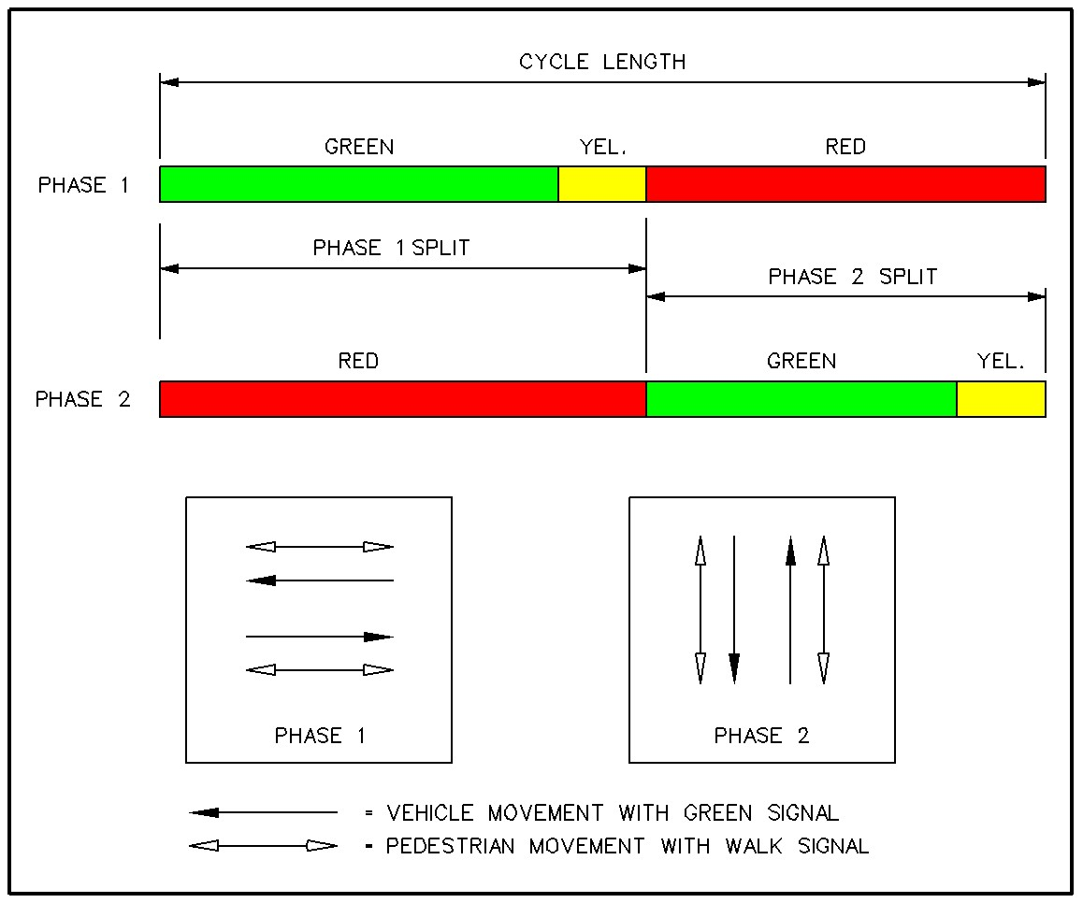

Figure 2-1: BASIC TWO-PHASE NON-ACTUATED

OPERATION

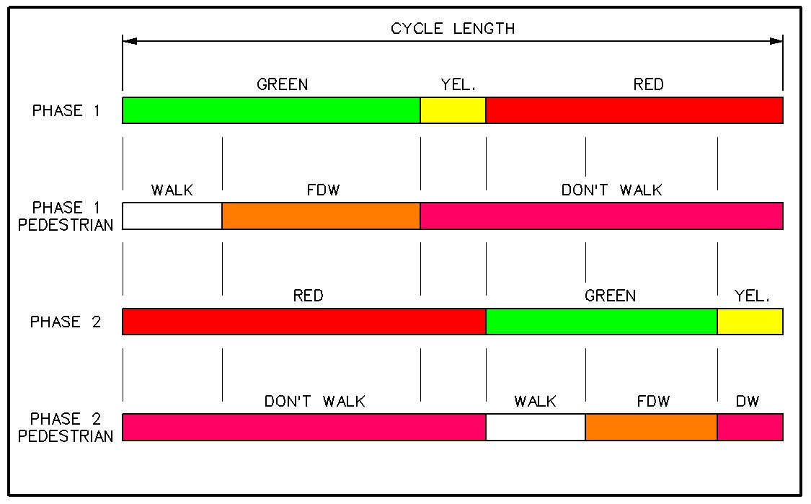

Figure 2-2: BASIC TWO-PHASE NON-ACTUATED

OPERATION WITH PEDESTRIAN INTERVALS

Figures 2-2 and 2-3 represent a two-phase operation with pedestrian intervals and a three-phase operation.

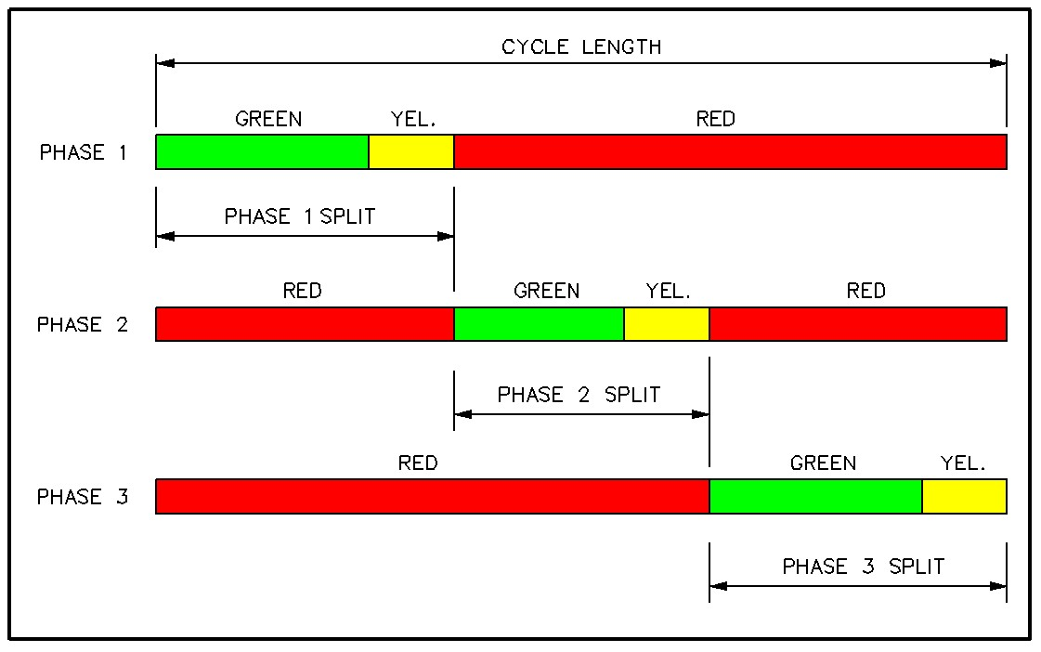

Figure 2-3: BASIC THREE PHASE NON-ACTUATED

OPERATION

2.2.6 Actuated Controller Elements
Actuated controllers, Fully-Actuated or Semi-Actuated, have some similarities to Non-Actuated controllers in that clearance intervals for both pedestrians and vehicles remain constant.

Other intervals for actuated controllers can vary, based on detector input. Phase sequence of the actuated controllers can be constrained or varied. Many Fully-Actuated controllers operate in a “dual ring” configuration as shown in Figure 2-4. The dual-ring controller can employ as many as eight independently timed phases each of which can drive a red, yellow and green display. The eight phases will accommodate eight signalized movements of a typical four-way intersection (four through and four left turns). An example of a typical phase assignment for an eight-phase intersection is:

Ø1, Ø2, Ø5 and Ø6 are assigned to the major street (left side of barrier), where
Ø1 is a left turn movement, and
Ø2 is the opposing through movement to Ø1

Ø5 is the left turn movement opposite Ø1, and
Ø6 is the opposing through movement to Ø5

Ø3, Ø4, Ø7 and Ø8 are assigned to the minor street (right side of barrier), where
Ø3 is a left turn movement and
Ø4 is the opposing through movement to Ø3

Ø7 is the left turn movement opposite Ø3 and
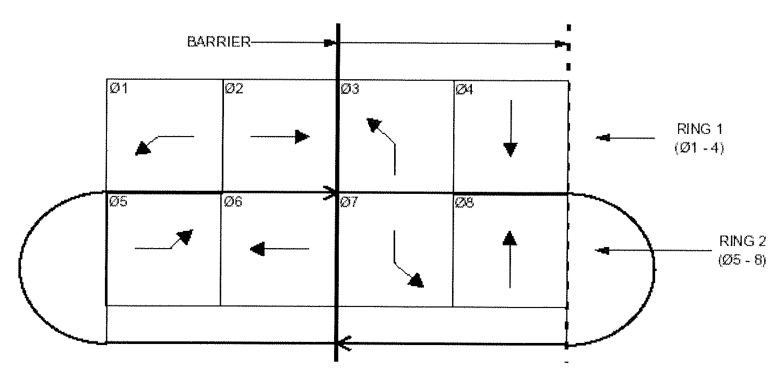
Ø8 is the opposing through movement to Ø7

Figure 2-4: NEMA - DUAL RING CONFIGURATION

The dual-ring controller has two rings. Ring 1 includes phases 1 through 4 (Ø1 – Ø4), and Ring 2 includes phases 5 through 8 (Ø5 – Ø8). A barrier bisects both rings between phases 2 and 3 (Ø2 and Ø3), and phases 6 and 7 (Ø6 and Ø7). Operation of the dual-ring controller allows one phase per ring to be displayed. When so programmed, a dual-ring controller can display two phases concurrently, one from each ring on the same side of the barrier. Note that on both sides of the barrier there are four movements, two in each ring, (usually two through and two lefts). All of the movements from one street must be assigned to the one side of the barrier. Similarly, all movements from the other street must be assigned to the other side of the barrier. The two rings operate independently, except that their control must cross the “barrier” at the same time. Figure 2-5 depicts the basic phasing combination for a dual-ring controller.
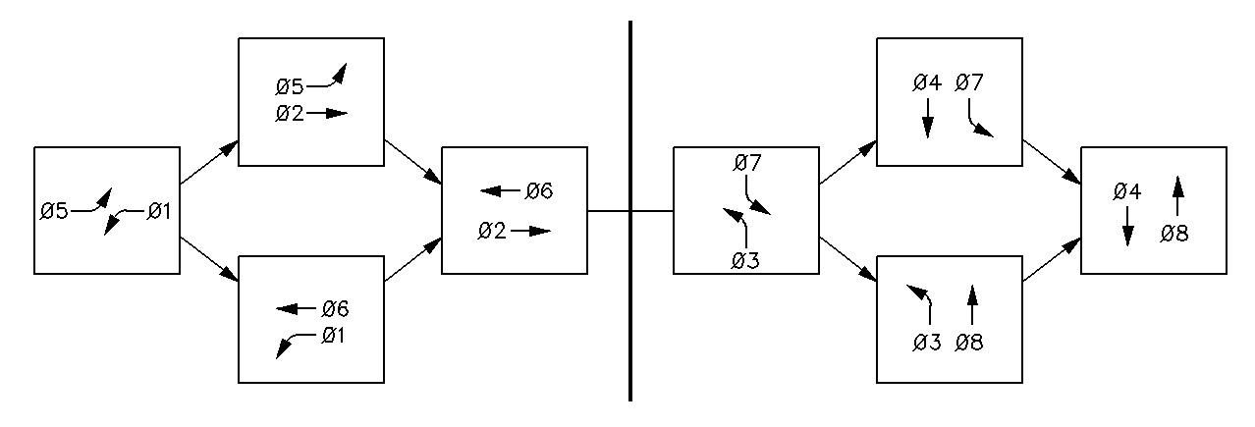

Figure 2-5: BASIC PHASING COMBINATIONS FOR DUAL RING

CONTROLLER

2.2.7 Phase Numbering Convention
Phases for Pre-timed, Semi-Actuated or Fully-Actuated control are numbered with a convention that provides the basis for the numbering system for signal heads and detectors. Phasing diagrams typically use the NEMA phase numbering convention (Ø1, Ø2, Ø3 etc.). In the absence of a phase numbering convention by the Maintaining Jurisdiction, the following convention may be applied in the traffic signal design:

For Dual Ring Controllers,

- Define the major road northbound or eastbound through movement as Ø2
- When both intersecting roadways are major roads, Ø2 is defined as the westbound through phase
- Through phases are numbered with even numbers in a clockwise direction from Ø2
- The left turn phase opposing Ø2 is identified as Ø1
- Left turn phases are numbered in odd numbers, in the clockwise direction from Ø1
- When inhibited phase transitions are necessary, a note below the phase diagram may be employed
- Dual entry phasing is described by the combination of primary phases driving the display, such as (Ø1+ Ø6)
- When split phase operations are employed for the side streets, they are typically identified as Ø3 and Ø4.

For Single Entry, Sequential Phasing (e.g. three phase signals),

- The phase numbering begins with the primary arterial phase, and is numbered sequentially, (Ø1, Ø2, Ø3, etc.)
- Block sequence diagrams identify the planned displays

For other Controllers,

- Ø1 is the through movement of the major road

2.2.8 Left Turn Phasing
Signalized intersections where traffic volumes are heavy or vehicle speeds are high can be problematic for vehicles attempting to turn left across opposing traffic and may constitute significant safety and capacity problems. Therefore the left turn phasing should be considered early in the project. Providing separate left turn phasing should be based on engineering analysis. The “Kentucky Method”, (worksheet provided in Appendix IVB-8), is often used as the initial step in considering whether left phasing is warranted. Further evaluation involves weighing the advantages and disadvantages between safety, capacity, and delay. Separating left turn movements and opposing through movements using protected left turn phasing may produce several different types of results. Protected left turn phasing may:

- Reduce accidents that result from conflicts between left turn and through movements
- Increase left turn traffic capacity, and
- Reduce peak period delay for left turn traffic

However, protected left turn phasing may also:

- Reduce through traffic capacity
- Increase overall intersection delay, and
- Increase off-peak delay for left turn traffic

When left turns are allowed at an intersection, three general phasing types can accommodate the left turn phasing:

- Permissive Only
In this condition, left turns are permitted during the green phase but no special treatment in traffic signal is required.

- Permissive / Protected
Left turns may proceed during the green phase, but are provided with a ”protected” left turn arrow phase at the beginning of the associated green phase.

- Protected Only
Left turns may proceed only during a “protected” left turn arrow phase provided before, after or concurrent to the adjacent through movement, green phase.

In general, it is desirable to allow this permitted left turn movement during the associated green phase unless there are overriding safety concerns, which make such phasing particularly hazardous. Some advantages of “Permissive / Protected” left turn phasing include:

- Permissive left turn movements can significantly reduce overall intersection delay as well as delay to left turn traffic

- Permissive / Protected left turn phasing may reduce the required length of left turn storage on the approach and allow an approach with substandard left turn storage to operate more efficiently

There are certain situations where safety considerations will generally preclude the use of “Permitted / Protected” left turn phasing. In these cases, left turn movements should be restricted to “Protected Only” left turn phases. Examples of these situations include:

- Accident experience or traffic conflict criteria that was used as the basis for installing separate left turn phasing

- Intersections where visibility is inadequate because horizontal or vertical alignment of the road limits sight distance

- High-speed and/or multilane approaches where judging adequate gaps is difficult for left turning drivers

- Geometric or traffic conditions that may complicate the driver’s ability to execute the permissive left turn movement, such as an approach where dual left turn lanes are provided

For additional information on traffic signal phasing techniques, such as lead/lag phasing, split phasing and right turn phasing, refer to Signalized Intersections: Informational Guide FHWA-HRT-04-091, Chapter 4.

http://www.tfhrc.gov/safety/pubs/04091/

2.2.9 Traffic Signal Control Systems
Many combinations of methods, equipment, and techniques can comprise a signal control system. Generally, these systems fall into two basic types, as follows:

- Time-Based Coordinated System
This signal control system provides coordinated operation of a group of controllers that are not physically connected. This type of coordination may be accomplished with features provided within the traffic signal controller, or with auxiliary devices called time-based coordinators. These devices may use the frequency of the power source to keep time, or a number of other time datum sources. Timing plans can be established for “time of day” and “day of week”.

- Interconnected System
In this signal control system, local intersections are usually physically connected to provide coordinated operation. Interconnected systems will “resynchronize” traffic signals that go “out of step” from the traffic signals within the system. The number of timing plans the system may employ is a function of the system hardware and/or software. Timing plans may be selected by time dependent programming or by measurement of some traffic flow parameter. The system master controller may be one of the system controllers or may be an independent device.

Modern signal control systems may be supervised and monitored by a supervising personal computer. The personal computer can update coordinated timing plans and individual intersection timing plans at a remote location. Generally, this type of system consists of the following basic components:

- Central computer station consisting of a personal computer or several networked personal computers, or a Master controller consisting of networked local traffic signal controller operating in a closed loop system

- Communications network consisting of, but not limited to, such items as cable, telephone, radio, fiber optics, lasers, or in combinations thereof

- Field Equipment consisting of the following items:
- Local traffic signal controllers
- System detectors
- Cameras and Variable Message Signs (VMS)
- Other field equipment

2.3 SIGNAL TIMING
In new designs, or in major roadway construction, roadway cross sections and laneage are usually designed to provide capacity in a future year, often twenty years from the anticipated completion date of the facility. Traffic signals, on the other hand, will sometimes be put in service before the project is completed. Phasing and timing plans based on a twenty-year design horizon will perform poorly when the signal is placed in service. Operational timings, therefore, will most likely have to be field developed from a preliminary estimate of signal timing that can be made during design. In the following paragraphs, signal timing considerations are briefly discussed. For detailed information regarding traffic signal timings, refer to the “Manual of Traffic Signal Design”, ITE.

2.3.1 Preset Intervals
In Non-Actuated control, all intervals are preset. In Semi-Actuated or Fully-Actuated control, some intervals are also preset. Preset intervals found in all forms of control include the following:
- “Yellow Vehicle Change” interval
- “Red Clearance” interval
- “Walk” interval
- “Pedestrian Clearance” Interval

The combined length of a Yellow Vehicle Change interval and a Red Clearance interval is the time necessary to clear the intersection before conflicting traffic movements are released. This combination of Yellow and Red time can vary between 3 and 12 seconds. The maximum value for either the Yellow Change interval or the Red Clearance interval is typically 6 seconds.

When pedestrian features are included in an actuated phase, the “WALK” interval is a preset length of time. The maximum length of the “WALK” interval is determined on the basis of pedestrian demand, composition of pedestrians and walking distance. The length of the Pedestrian Clearance interval is, in fact, the length of the flashing “DON’T WALK” interval. The duration of this interval is determined by the time necessary for pedestrians to clear the intersection.

2.3.2 Basic Actuated Control Intervals
In addition to the clearance intervals common to all types of phases, actuated phases have in common at least three additional preset intervals. These intervals are found in Basic or Advanced Design actuated control. These intervals are:

- “Minimum Green”
- “Passage Time”
- “Maximum Green”

The three intervals, “Minimum Green”, “Passage Time” and “Maximum Green”, are the only intervals found in Basic Actuated control related to the length of the vehicle “GREEN” interval. A brief discussion of each of these intervals follows:

“Minimum Green”

- Sometimes referred to as “Initial Interval” or Minimum Initial”
- Defines the minimum time displayed when a phase “GREEN” is initiated
- Typically varies in length from 2 or 3 seconds to 15 or more seconds, depending on application and detector design
- Sometimes is set for the time necessary to allow movement in a stopped queue to begin moving across the detector

“Passage Time”

- Sometimes referred to as “Vehicle Extension” or “Unit Extension”
- Usually established by the time required for a vehicle to cross a detector and enter the intersection
- Reinitiates timing of the interval with each successive detection during “GREEN”

“Maximum Green”

- Sometimes referred to as “Vehicle Maximum”, “Extension Limit” or “Max”
- An actuated phase may have more than one “Maximum Green” available
- Multiple maximums are often called “Max I” and “Max II”
- This interval defines the maximum length that vehicles can actuate the “GREEN” phase

2.3.3 Actuated Control of Advanced Design Intervals
An actuated phase of Advanced Design is often referred to as a “Volume-Density” phase. An actuated phase of Advanced Design has the same predetermined intervals of Basic actuated control, such as:

- “Minimum Green”
- “Passage Time”
- “Maximum Green” (Max I and Max II)
- “Yellow Vehicle Change” interval
- “Red Clearance” interval
- “WALK” interval
- “Pedestrian Clearance” interval

In addition to these intervals, an actuated phase of Advanced Design may have some or all of the following settings for Variable Initial and Gap Reduction intervals:

- “Variable Initial” interval
- “Seconds / Actuation” setting
Establishes the increment of time that is added to the “Minimum Green” time of the phase during the phase’s red period
- “Maximum Initial” setting
Establishes the maximum cumulative time allowed to be added to the “Minimum Green” through successive actuations of the “Seconds / Actuation” interval

- “Gap Reduction” interval
- “Time Before Reduction” setting
Establishes the time period before the “Passage Time” begins to reduce
- “Minimum Gap” setting
Establishes the minimum value in which the allowable gap between actuations can be reduced upon expiration of the time to reduce
- “Time to Reduce” setting
Establishes the time in which the allowable gap is reduced from the passage time to the minimum gap, after the time before reduction has expired.

Figure 2-6 is a schematic diagram of the timing phase for Volume-Density control.
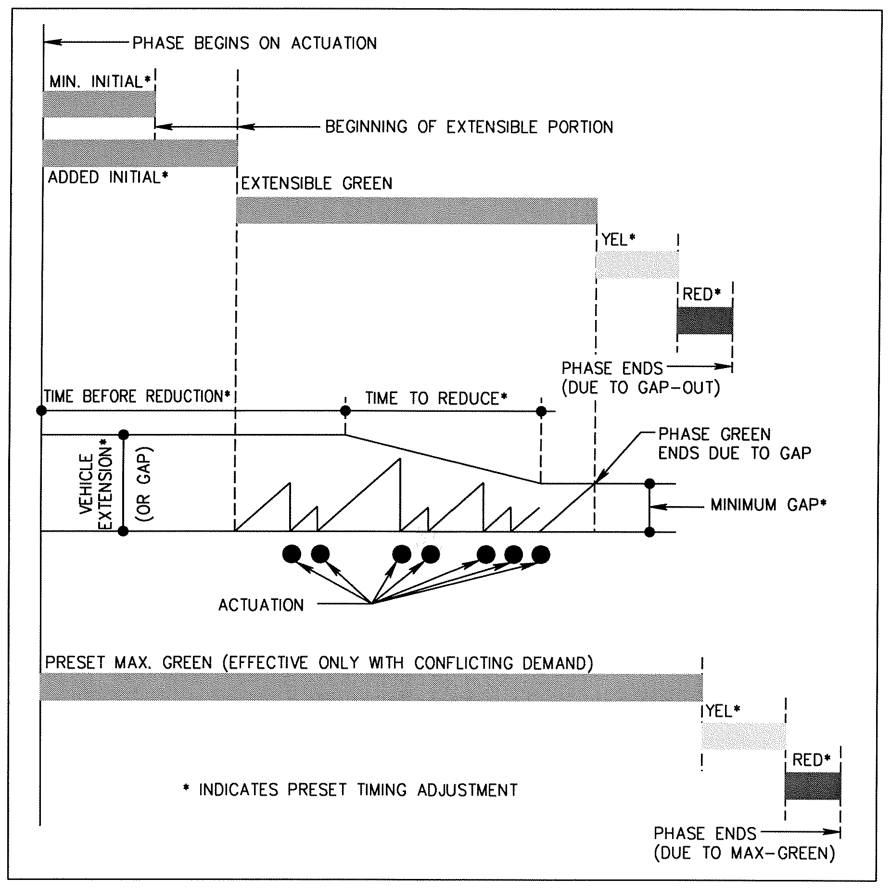

Figure 2-6: SCHEMATIC DIAGRAM OF

VOLUME-DENSITY CONTROL

2.3.4 Memory Modes
Each phase of a modern actuated controller has the capability of “remembering” detector calls received during the phases’ red period, or “forgetting “ a call if the call does not continue. These “Memory Modes” are often called “lock” or “Detector Memory On” for remembering detection calls, and “non-lock” or “Detector Memory Off” for forgetting the detection calls.

2.3.5 Recall Modes
Recall modes provide a means to return the controller automatically to a selected phase once per traffic signal cycle without a detector call on that phase. The recall mode can be placed on the controller for pedestrian calls or vehicle calls. Recall Modes are typically identified as follows:

- “Minimum Recall” or “Recall to Minimum”
- “Maximum Recall” or “Recall to Maximum”
- “Pedestrian Recall”

2.4 VEHICLE DETECTION
- Traffic control at signalized intersections assigns right-of-way or “Green Time” to competing and conflicting movements at intersections. Actuated control regulates the apportionment of “Green Time” to vehicular and pedestrian demand. Traffic demand usually varies across the day. Signal timing may adjust during the course of the day to meet the changing needs of traffic through the use of traffic detectors and actuated controllers with flexible timing features. Generally, traffic approaching the intersection is detected by placing one or more detection devices in the path of approaching vehicles and at a convenient location for the use of pedestrians. Additional information is available in the Traffic Detector Handbook, (FHWA-IP-90-002, 1990) and is available online at:

http://www.fhwa.dot.gov/tfhrc/safety/pubs/ip9002/intro.htm

A brief description of various detection devices and their components are presented in this chapter.

2.4.1 Types of Detectors
Several types of vehicle detectors are available. Some of the more widely used detectors are:

- Inductive loop
- Video
- Radar or Microwave
- Magnetic
- Magnetometer
- Ultrasonic
- Pressure

A brief description of these detectors follows:
2.4.1.1 Inductive Loop Detection
Inductive loop detection is the most commonly deployed detector type. Inductive Loop detectors may be employed as “presence” or “pulse” detectors and are briefly discussed in paragraph 2.4.2. Fundamentally, an inductive loop detector is a coil of wire placed within the roadway, usually embedded under or saw cut into the top course of asphalt, and connected to an “amplifier” via a twisted pair of shielded wires. The amplifier is located in the controller cabinet. The “amplifier” energizes the inductive loop via the twisted pair of wires and creates an “electric field”, with a discreet “resonance”. When a vehicle passes over or is stopped within the inductive loop area, the “resonance” of the inductive loop is changed. The “amplifier” reads the change in “resonance” as vehicle detection, and sends an electrical signal from the “amplifier” to the controller. A number of special operations are available in modern inductive loop amplifiers. These operations are a function of the specific amplifier employed. These special applications include delayed-call detection, extended-call/delayed-call detection and extended-call detection and are briefly discussed in paragraph 2.4.3.
2.4.1.2 Video Detection
The video detector is intended to mimic the function of inductive loop detectors. Detection is accomplished by computer-vision analysis of a video signal provided by a standard surveillance-type video camera viewing the approach area from a position on top of a mast arm, luminaire or other available support structure. The video detector identifies the presence of vehicles in virtual detection windows designated by the user. The field of view of the camera may be directed to include an individual lane or all lanes of a particular approach. The detector may operate as a “pulse” or “presence” detector.
2.4.1.3 Radar Detection or Microwave Detection
Early radar detection operated on the Doppler effect radar wherein microwaves are beamed toward the roadway by the detector unit. The passage of a vehicle through these beams causes them to be reflected at a different frequency back to the sensing unit (antenna). The detector senses the change in frequency, which denotes the passage of a vehicle. Doppler radar detection only detects motion, therefore, cannot be employed for “presence” detection. This type of radar detector is becoming less common because of this limitation. The RTMS (Remote Traffic Microwave Sensor) radar is a low-cost general-purpose all-weather traffic sensor that detects presence and can measure traffic parameters in multiple independent lanes. The RTMS detector is capable of providing “pulse” or “presence” detection for traffic signal control. Both Doppler and RTMS radar detectors may be mounted over the roadway or in a “side-fire” position.
2.4.1.4 Other Types of Detectors
In addition to the more commonly used detectors described above, other types of detectors include magnetic, magnetometers, ultra-sonic, microwave, photoelectric, infrared and pressure. Many of these detectors were commonly deployed before the development of the inductive loop detector. These detectors are briefly described in the following:

Magnetic detectors operate responding to changes in the lines of flux from the earth’s magnetic field created by the presence of a large mass of ferrous material, such as a motor vehicle.

Magnetometers are a special type of magnetic detector designed to sense the presence of a vehicle. This is accomplished by measuring the focusing effect of the earth’s magnetic field, which results when ferrous metal is in the vicinity of the detector.

Ultrasonic detectors transmit pulses of ultrasonic energy through a transducer towards the roadway. The presence of a vehicle causes these beams to be reflected back to the transducer, at a different frequency. Transducers are mounted over the roadway, or in a “side-fire” position. Unlike the radar detector that can only detect motion, ultrasonic detectors can also be used as vehicle-presence detectors.

Pressure detectors are among the oldest operational detector types. Pressure detectors are imbedded in the roadway and are activated by the weight of a passing vehicle. Pressure detectors may operate only in the “pulse” mode.

2.4.2 Modes of Operation
Vehicle detection for traffic signal operation typically includes two types of detection outputs:

- Pulse
- Presence

Pulse detection registers a ”call” or signal to the traffic signal controller that a vehicle has been detected only once, upon recognition of a vehicle. Pulse detection is detection at a “point” on the roadway.

Presence detection registers a “call” or signal continuously to the controller as long as the detected vehicle(s) are within the detection zone. Presence detection is detection within a “zone” on the roadway.

2.4.3 Detector Functions
Inductive loop detector systems, as well as some other detection systems may be equipped with system resident logic that, when combined appropriately with controller settings, may expand the capability of the controller/detector system to respond to traffic. These special functions of the detector system allow the vehicle detection information to be manipulated by the detector system itself before passing the detection information to the controller. These special functions that may be available in a modern inductive loop system are:

- Delay Call Detection
- Extend / Delay Call Detection
- Extend Call Detection

The “Delay” function allows the detector to withhold the call from the controller for a user specified time period. The “Extend” function allows a call to be extended beyond the time a vehicle is detected in the detection zone.

Some of these functions are available in modern traffic signal controllers as a controller function. This simplifies the maintenance requirements when detector special functions are used.

2.5 APPLICATION
Detectors provide the controller with information regarding the presence or movement of traffic. This information is the fundamental information upon which the traffic signal controller apportions “green-time”. The types of timing intervals that are implemented by the intersection controller have an explicit relationship to detection type. Therefore, the detector type should be selected early in the design process. The detector selected for each approach and phase of a given intersection, or group of intersections must be detailed specifically to the control needs of the intersection or group, and will vary depending on a number of factors. These factors include the basic phasing requirements of the traffic signal, the 85th percentile approach speed, the composition of traffic using the intersection on the approaches and preference of the agency maintaining the traffic signal.

2.5.1 Detector Components
Typical detector installation at a traffic signal generally includes three major components:

- Detector Apparatus
- Connection to the Controller Cabinet
- Detector Controller Unit

These components are briefly described in the following:
2.5.1.1 Detector Apparatus
In an inductive loop installation, the device that causes vehicles to be detected is a coil of wire usually embedded in the roadway surface 3” to 4” below the wearing surface. Typically, a sawed slot is provided for coiling the wire. After installation of the coil, the saw slot is encapsulated with epoxy. In a Video Installation, the detection device is a video camera. This device is usually mounted to a stable structure so that the detected traffic is visible to the camera. Other detection systems have apparatus variously called transducers, receivers, emitters, and probes, to name a few. Each detector type has a physical element to be installed in the proximity of the traffic movement to be detected, and each has its specific installation requirements.
2.5.1.2 Connection to the Controller Cabinet
Information collected by the detection device is transferred to the controller cabinet, usually through some type of wiring. This wiring, often called the “detector lead-in”, has a physical requirement specific to the type of detection device deployed. With an inductive loop, this “lead-in” is usually a shielded cable containing a twisted pair of wires. One video camera may require a power supply cable and a coaxial cable to operate it and transfer data to the controller cabinet, where another may require a multi-conductor cable. Each detector type and model within the type may have distinctly different “lead-in” requirements.
2.5.1.3 Detector Controller Unit
The signal transferred from the detection device to the controller may require some type of modification to be in an electrical form that can be properly interpreted and acted upon by the traffic signal controller. In most cases this device is usually referred to as the “detector amplifier” whether the detector apparatus is an inductive loop, magnetic detector, magnetometer, radar and sonic or other type of detector. Video detection systems as well, usually have an interface device sometimes called the “video processor” in the controller cabinet. This “video processor” equipment serves to translate the video signal into a format usable by the controller.

