Separate Left Turn Phase Warrant
“Kentucky Method”

Project No. __________________________

Intersection: ______________________________________________________

The traffic volumes used below in this analysis are for peak hour volumes. The analysis should consider peak hour volumes + 5 year traffic volume projections for design of new traffic signals.

Analysis:
Volume of Left Turn Vehicles X Volume of Opposing Through Vehicles = “X”
Number of Opposing Through Lanes
“X” = Left Turn Conflict Factor

1. If “X” is less than 50,000, a separate left turn phase may not be required.
2. If “X” is equal to or greater than 50,000, a separate left turn phase should be considered.

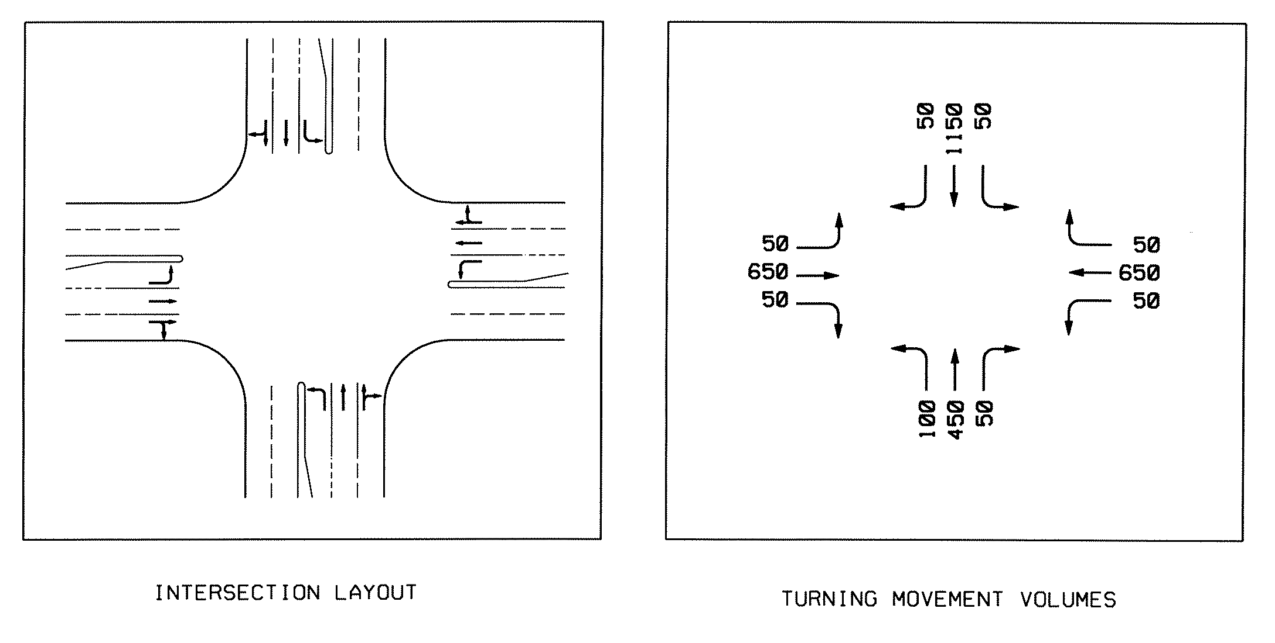
Example Problem

NB 100 X 1150 = 57,500 Greater than 50,000
2

SB 50 X 450 = 11,250 Less than 50,000
2

WB 50 X 650 = 16,250 Less than 50,000
2

EB 50 X 650 = 16,250 Less than 50,000
2

Northbound left turn meets warrants for a separate left turn phase.

