# CHAPTER 3: PRELIMINARY dESIGN

3.1 RESOURCES FOR SIGN DESIGN 1

3.1.1 Guidsign Software by Transoft Solutions 1

3.1.2 SIGNFIX Software 1

3.1.3 Signing Requirements 1

3.1.4 Topographic Drawings/Survey 2

3.1.5 Field Review and Sign Inventory 2

3.1.6 Sign Inventory Method (Recommended) 3

3.1.7 Utilities and Roadway Geometry (Proposed Construction Plans) 4

3.1.8 Preliminary Sign Plans 4

## 3.1 RESOURCES FOR SIGN DESIGN

### 3.1.1 Guidsign Software by Transoft Solutions

This software is designed for use as a tool to create sign panel layouts. It allows CADD configuration of signs and provides sign sizing and message dimensions for placement in a Microstation drawing file. Sign panels can be inserted into multiple drawings and should be used in the development of sign plans.

### 3.1.2 SIGNFIX Software

### Not Applicable.

### 3.1.3 Signing Requirements

The sign design parameters and requirements appropriate for the facility should be addressed at the onset of the sign design and/or the PFI Meeting. The following issues should be addressed:

* Ground mounted signs and/or overheads
* Post types
* Guide sign messages
* Size and type of letter series
* Lighting requirements
* Luminaire retrieval system and/or catwalk
* Supplemental signing
* Logo signing
* Reuse, Dispose, Salvage existing signs/structures

### 3.1.4 Topographic Drawings/Survey

Plans are to be developed using existing sign plans. If these plans are not available, the use of existing topographic drawings, survey drawings, or plans showing existing roadway conditions are to be used. Current or latest available drawings must be used for the sign inventory development. If existing plans are not available, surveys may be required to develop the drawings. The survey drawing, shown below and in Appendix IIA-1 should include limited topographic data, underground and overhead utilities along with right of way.

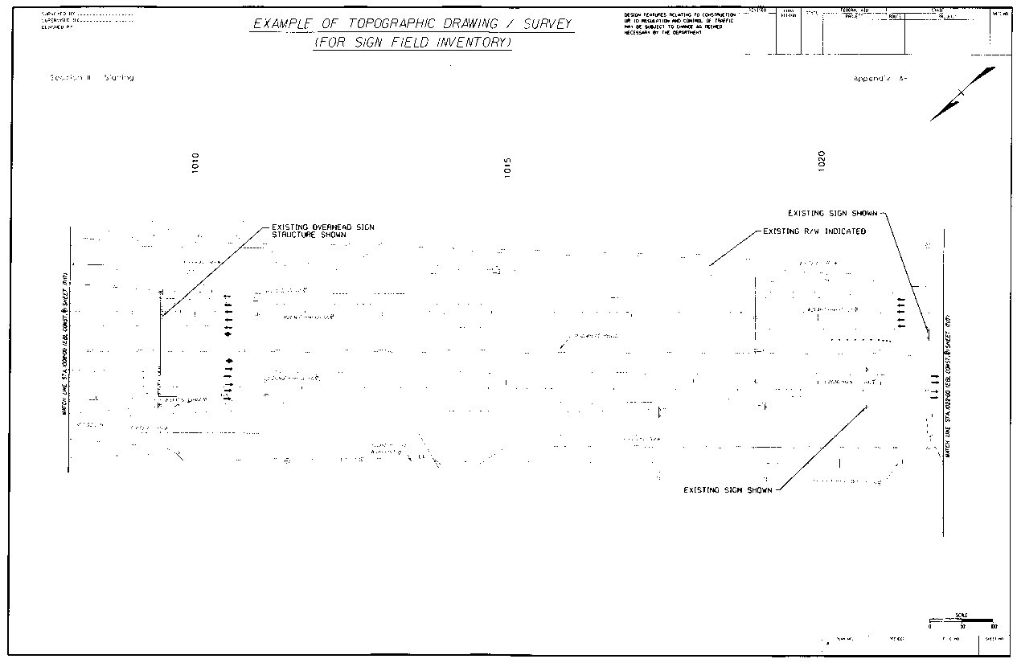

**EXAMPLE OF TOPOGRAPHIC DRAWING / SURVEY**

**(For Sign Field Inventory)**

**(See Appendix IIA-1)**

### 3.1.5 Field Review and Sign Inventory

A sign inventory is performed to document all existing sign data and sign structures.

* The sign inventory includes identifying sign messages, locations, color and size of the sign panels, type of posts, overhead sign structures and span lengths, sign lighting systems, and sign structure walkways.
* All existing signs must be identified on the sign inventory.
* Photographic pictures of existing signs should be documented.
* A sign inventory preparation checklist, video procedure and existing sign data sheet has been developed and provided in Appendix IIB-2, Appendix IIB-3 and Appendix IIB-4, respectively. These sign inventory aides will assist in developing the sign inventory plans, shown below and in Appendix IIA-2.

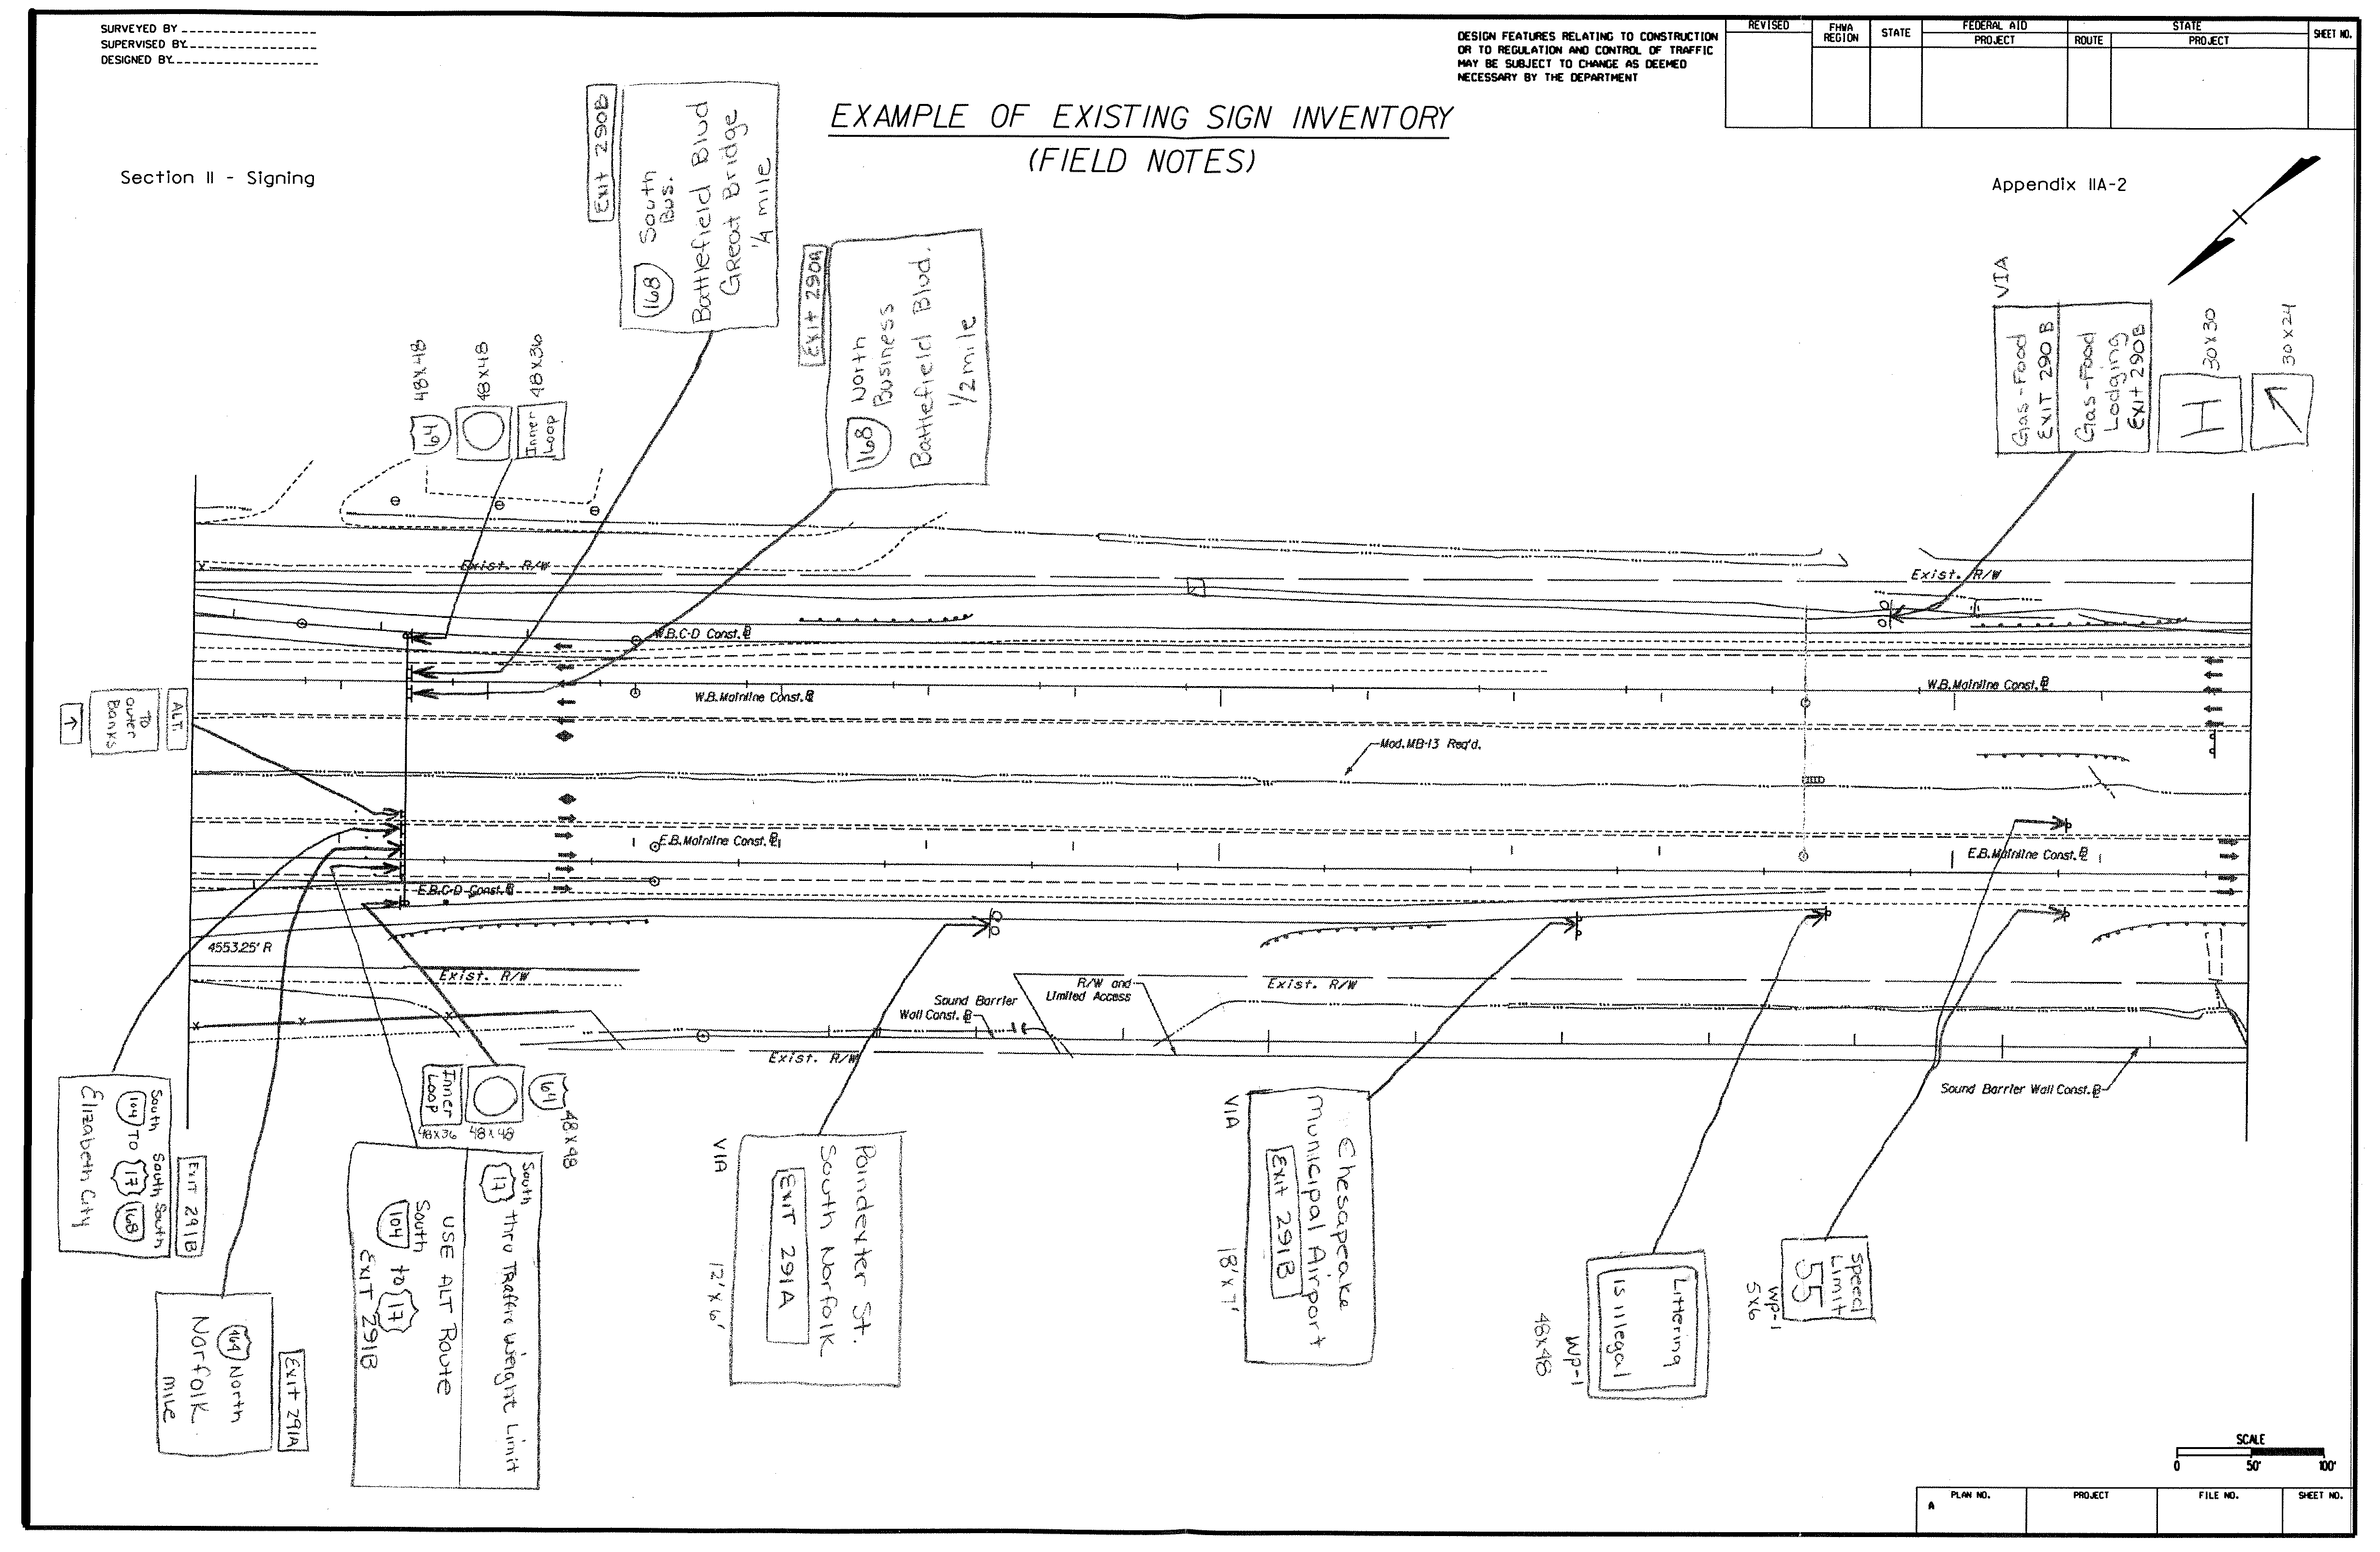

**EXAMPLE OF EXISTING SIGN INVENTORY (Field Notes)**

(**See Appendix IIA-2)**

### 3.1.6 Sign Inventory Method (Recommended)

Video and/or still color pictures are to be taken and hand draw all existing signs within the proposed project on the survey drawing sheet. The existing sign is referenced on the survey drawing sheet with supporting information, which includes the sign message, color, location, dimensions, letter size (upper / lower case), type of post or structure. Sign sizes should be measured in the field whenever possible. If field measurements cannot be attained, the sign sizes should be obtained from the District or estimated as accurately as possible.

### 3.1.7 Utilities and Roadway Geometry (Proposed Construction Plans)

Utility location plans as well as proposed utility adjustments that may be planned for the near future or during the project development period need to be identified.

* Potential geometric deficiencies relative to providing adequate signing at proper spacing need to be noted and reviewed with the project designers and district representatives.
* It is also necessary to identify, as early as practical, proposed plans for retaining walls, noise walls or any obstacle that could be in conflict with sign structure placement.

### 3.1.8 Preliminary Sign Plans

After completion of the existing sign inventory, the existing signs should be shown (dashed) on the proposed construction plans. Conceptual signs are also illustrated on proposed construction plans sheets, shown below and in Appendix IIA-3.

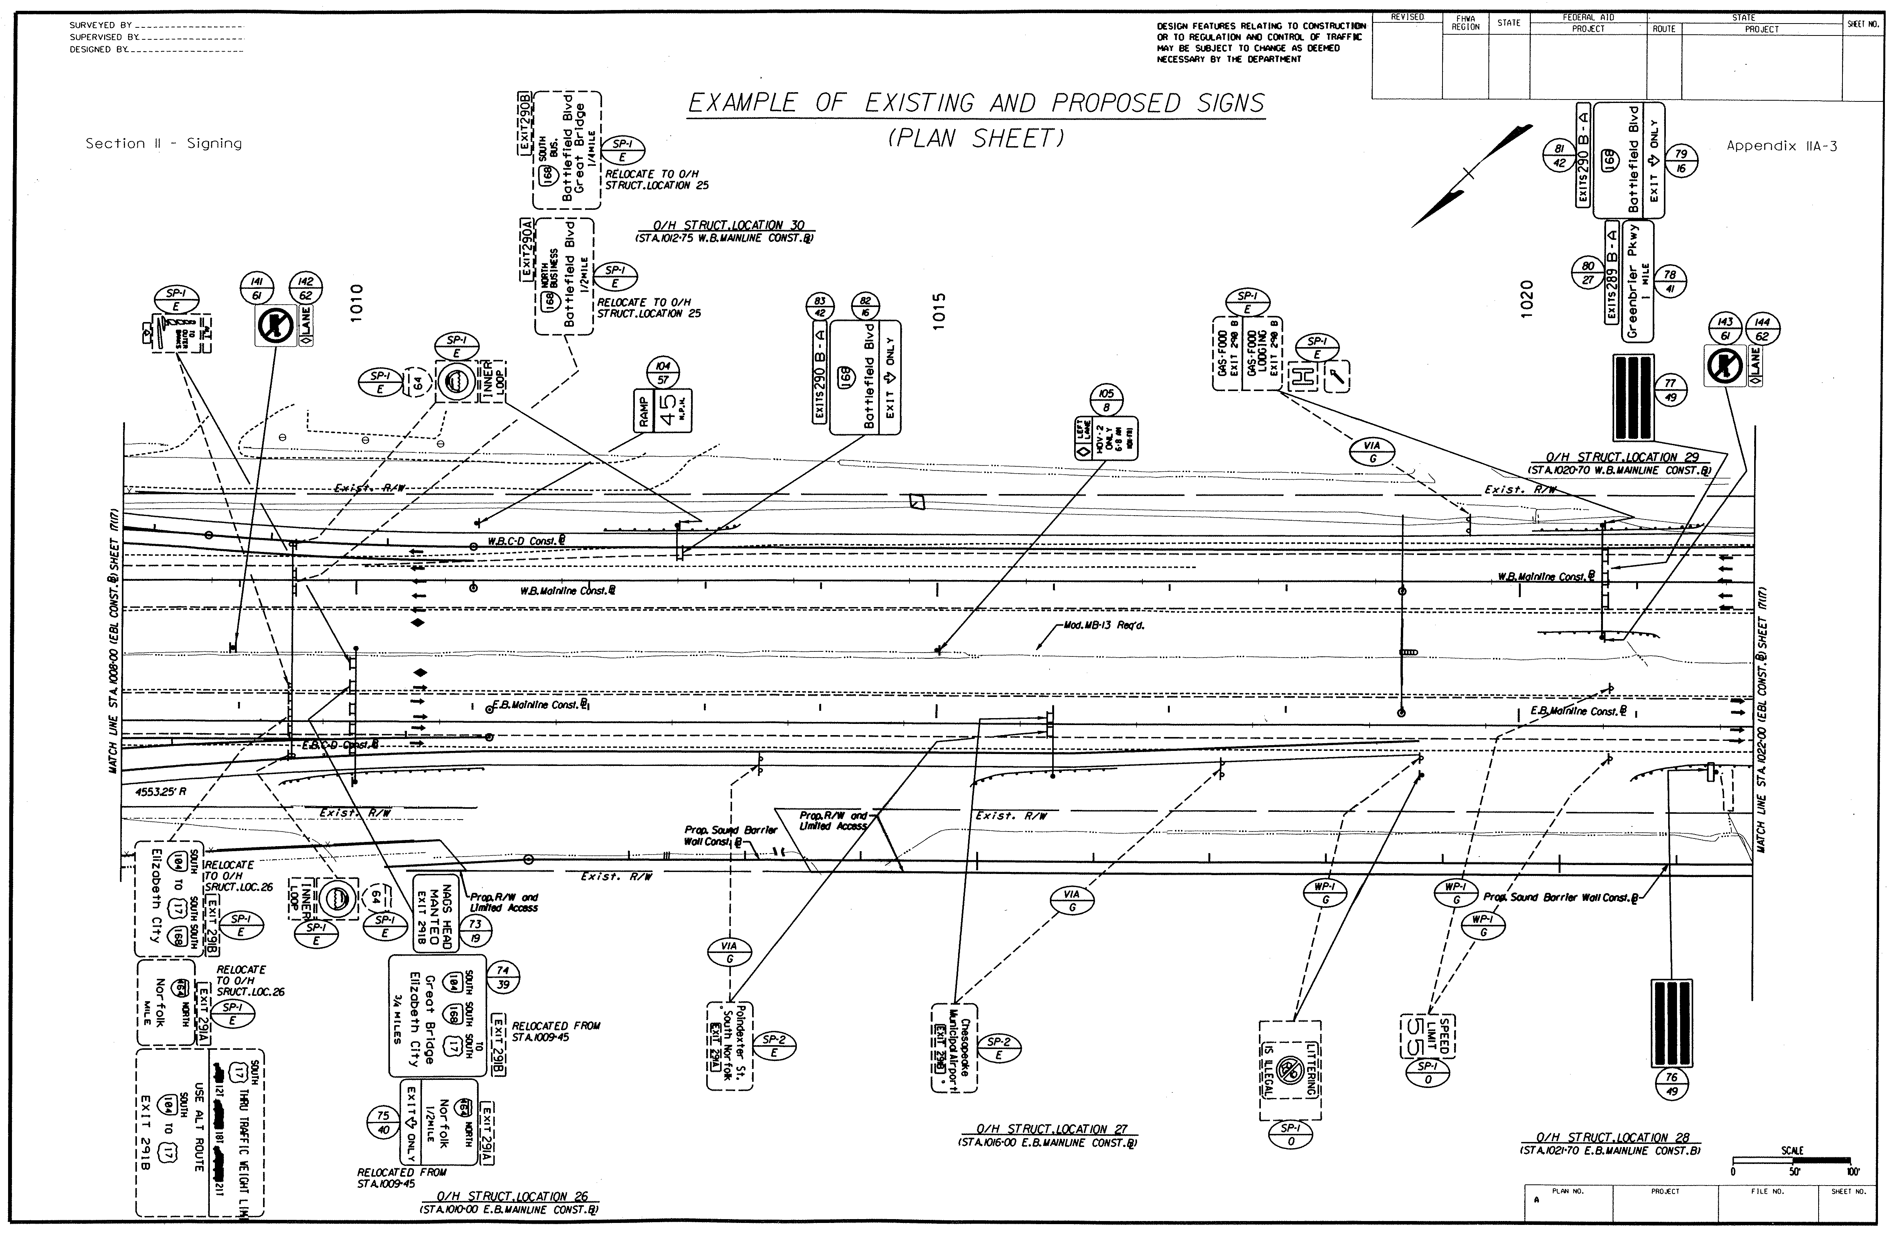

**EXAMPLE OF EXISTING AND PROPOSED SIGN PLAN SHEET**

(**See Appendix IIA-3)**

Concept sign plan development is based on the direction provided during the PFI Phase.

Set up meeting with district, agencies that have an interest in the project sign design to discuss, comment and mark up proposed construction plans that indicate the preliminary existing and proposed signs. This meeting should consider/decide the following:

* Guide sign messages/color
* Regulatory, Warning, Logo and Supplemental signing
* Size and type of letter series (upper and lower case)
* Sign lighting systems
* Placement of signs, longitudinal along roadway
* Utility, wall and drainage structure conflicts must be addressed
* Sign structure types