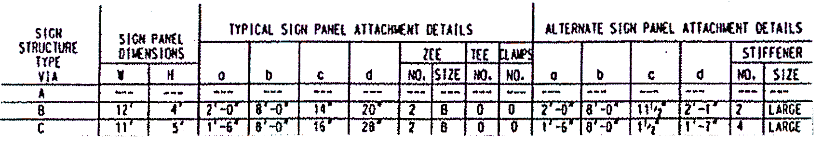
Appendix IIB-45: PARTIAL TITLE BLOCK (Enlarged View)

