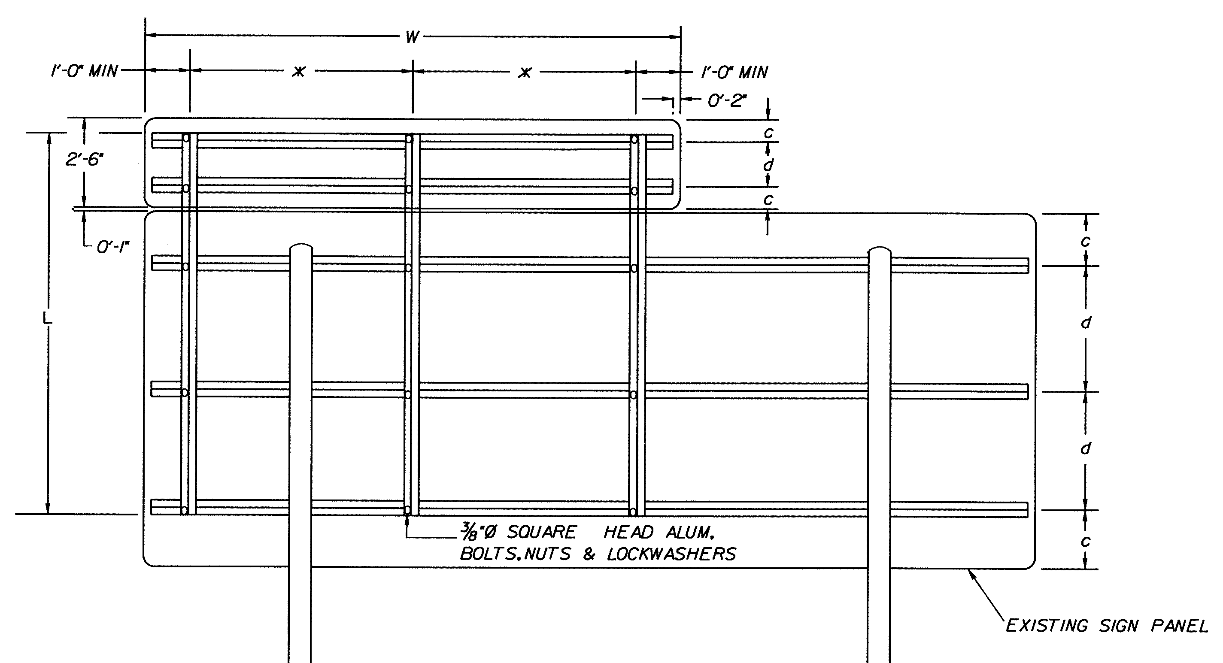
Appendix IIA-10: TYPICAL DETAILS FOR MOUNTING EXIT NUMBER SIGN PANELS (Enlarged View)

