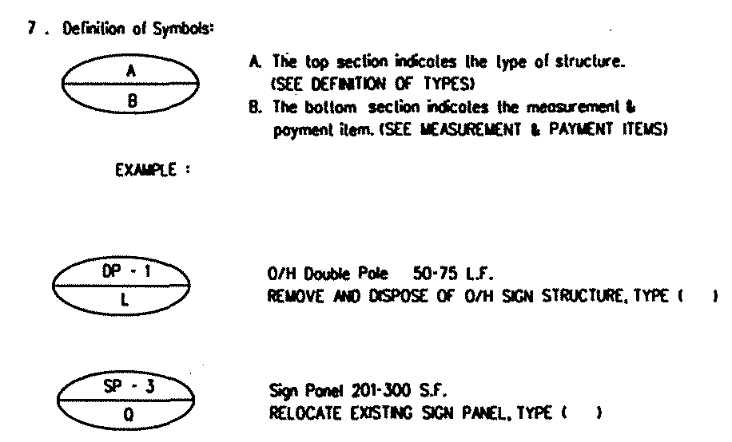
Appendix IIA-9: NOTES FOR SAFETY IMPROVEMENT ITEMS
(Enlarged View)

