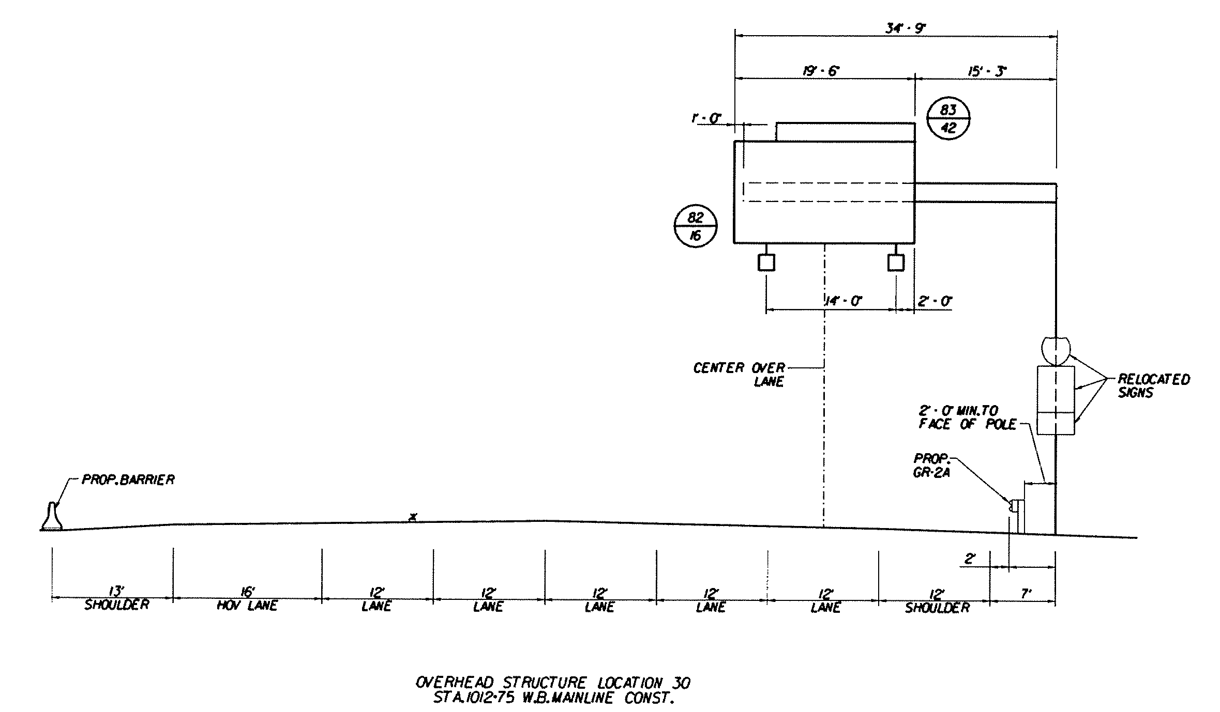
Appendix IIA-8: OVERHEAD SIGN STRUCTURE ELEVATION DETAIL SHEET (Enlarged View)

