CHAPTER 2D - PLAN DESIGN
SECTION 2D – 1 - PROJECT REVIEW

Page
GENERAL 2D-1
SECTION 2D – 2 - PREPARATION OF STUDY REPORTS AND INFORMATIONAL BROCHURES

Page
RESPONSIBILITY 2D-2
PURPOSE OF REPORT OR BROCHURE 2D-2
REVIEW OF DRAFT ENVIRONMENTAL DOCUMENT 2D-2
CONTENTS 2D-2
SECTION 2D – 3 - PREPARATION AND PROCESSING OF PUBLIC HEARING DATA

Page
RESPONSIBILITY OF THE PUBLIC INVOLVEMENT SECTION 2D-4
URBAN AND SECONDARY PROJECTS 2D-4
DATA REQUIRED FROM DESIGNER 2D-4
SECTION 2D – 4 – PRE - PUBLIC HEARING MEETINGS

Page
THE PRE-HEARING MEETING 2D-5
SECTION 2D – 5 - NOTICE OF WILLINGNESS TO HOLD A PUBLIC HEARING

Page
RESPONSIBILITY 2D-6
PROCEDURES 2D-6
Publishing Notice Of Willingness To Hold A Public Hearing 2D-6
NO REQUEST FOR PUBLIC HEARING 2D-6
REQUEST FOR PUBLIC HEARING 2D-7
SECTION 2D- 6 SCHEDULING THE PUBLIC HEARING

Page
ESTABLISHING TIME AND LOCATION 2D-8
PUBLISHING NOTICE OF THE PUBLIC HEARING 2D-8
SECTION 2D-7 PREPARATION OF ENGINEERING COMMENTARY

Page
CONTENTS OF COMMENTARY 2D-9
THE ENGINEER 2D-9

SECTION 2D - 8 - CAPACITY ANALYSIS - PLAN IDENTIFICATION - ALIGNMENT AND GRADES

Page
CAPACITY ANALYSES 2D-10
UPDATING PLAN IDENTIFICATION 2D-10
REFINING HORIZONTAL ALIGNMENT 2D-11
DEPICTING HORIZONTAL ALIGNMENT ON PLANS 2D-11
REFINING VERTICAL ALIGNMENT 2D-15
Sag Vertical Curves 2D-16
Crest Vertical Curves 2D-16
DEPICTING VERTICAL ALIGNMENT ON PLANS 2D-16
DESIGN EXCEPTIONS 2D-18
SECTION 2D - 9 - CROSS SECTIONS AND EARTHWORK QUANTITIES

Page
PLOTTING CROSS SECTIONS 2D-19
DETERMINING WIDTH OF PAVEMENT 2D-19
PLOTTING TEMPLATES 2D-20
DETERMINING AREAS AND QUANTITIES 2D-20
SECTION 2D – 10 - PAVEMENT, ENTRANCES, PROJECT LIMITS

Page
PLOTTING EDGES OF PAVEMENT 2D-22
PLOTTING ENTRANCES AND CROSSOVERS 2D-22
APPLICATION OF STIPPLING 2D-23
DETERMINING PROJECT LIMITS 2D-23
SETTING PROJECT TERMINI 2D-23
PAVEMENT TERMINATION 2D-24
PLOTTING CONSTRUCTION LIMITS 2D-25
SECTION 2D – 11 - REQUEST FOR SUPPLEMENTAL DATA

Page
SOIL INVESTIGATION, PAVEMENT RECOMMENDATIONS AND STAKING 2D-26
BRIDGE DESIGN 2D-26
PUBLIC HEARING DATA 2D-26
SECTION 2D – 12 - CONSTRUCTABILITY QUALITY REVIEW

Page
CONSTRUCTABILITY QUALITY REVIEW 2D-27

SECTION 2D – 13 - CONDUCTING THE PUBLIC HEARING

Page
THE PRE-HEARING MEETING 2D-28
PROCEDURE FOR THE PUBLIC HEARING 2D-28
SECTION 2D – 14 - RESOLUTION OF PUBLIC HEARING QUESTIONS

Page
REVIEW OF PUBLIC HEARING TRANSCRIPT AND POST-HEARING CORRESPONDENCE 2D-30
STUDY OF ALTERNATE SOLUTIONS 2D-30
Recommending A Solution 2D-30
Processing Data To Public Involvement Section 2D-30
SECTION 2D-15 PROJECT APPROVAL

Page
BOARD APPROVAL 2D-31
DISTRIBUTION OF PRINTS 2D-31
FINAL ENVIRONMENTAL DOCUMENT 2D-32
FHWA Approval 2D-32
REQUEST FOR APPROVAL OF MAJOR DESIGN FEATURES (FOR NON-CA PROJECTS WHERE ENVIRONMENTAL DOCUMENT WAS APPROVED AT LOCATION PUBLIC HEARING STAGE) 2D-32
FINAL SCOPING CERTIFICATION 2D-33

list of figures

Page
FIGURE 2D - 1 SAMPLE PLAN SHEET 2D-12
FIGURE 2D - 2 SAMPLE PLAN SHEET 2D-13
FIGURE 2D – 3 SAMPLE PLAN SHEET 2D-14
FIGURE 2D - 4 SAMPLE PROFILE SHEET 2D-17
FIGURE 2D – 5 EARTHWORK QUANTITY EXAMPLE 2D-21
FIGURE 2d – 6 SETTING PROJECT TERMINI 2D-24
FIGURE 2D – 7 SUGGESTED PAVEMENT STUBBING TREATMENT 2D-25

CHAPTER 2D - PLAN DESIGN

SECTION 2D – 1 - PROJECT REVIEW

GENERAL

When the time arrives for presenting a project to the public through the public hearing process, it is the designer's responsibility to review the plans and supporting data to assure that it is current and representative of the section of roadway concerned. Such items include any change in topography, traffic counts or traffic data, project funding and a reassessment as to the actual need and scope of the project.

SECTION 2D – 2 - PREPARATION OF STUDY REPORTS AND INFORMATIONAL BROCHURES

RESPONSIBILITY

The Location and Design Division will prepare study reports for all projects being prepared for Design Public Hearings. Combined Location and Design Public Hearings require informational brochures only, since the environmental document will satisfy the requirements of a study report, or in case of categorical exclusion, the requirement of a study report is waived. Study reports and informational brochures for Urban projects are to be prepared by the Local Assistance Division. Design study reports and informational brochures for Secondary projects are to be prepared by the designer.

PURPOSE OF REPORT OR BROCHURE

Informational brochures and study reports are to be prepared in accordance with the Public Involvement Policy Manual. Such reports are to assist interested citizens in familiarizing themselves with various aspects of the project. They should be prepared in a professional manner, but remain easily understood by the layperson.

REVIEW OF DRAFT ENVIRONMENTAL DOCUMENT

The draft environmental document must be completed prior to this stage, as certain data from this document must be included in the study report or informational brochure. It is essential that data in all publications be consistent with that shown on plans. Close coordination with other divisions and agencies is most important at this time.

CONTENTS

Generally, the informational brochure and study report should contain, as a minimum, the following information:

(1) A general description of the highway system in the area

(2) Project description and length

(3) Design criteria, typical section, traffic data and costs

(4) Summary of environmental considerations

(5) On state funded projects, it may be required to consult the Environmental Division to determine if an air and noise study will be required

(6) Project Schedule

(7) Any other related information

A breakdown of project cost responsibility is to be included on Urban projects. Each project must be considered on an individual basis and the amount of detail and documentation will depend on whether the project has been classified as a major or minor action regarding Federal requirements. Informational brochures or study reports must be reviewed by the Public Involvement Section.

SECTION 2D – 3 - PREPARATION AND PROCESSING OF PUBLIC HEARING DATA

RESPONSIBILITY OF THE PUBLIC INVOLVEMENT SECTION

The Public Involvement Section is responsible for the processing and distribution of all public hearing data. The location site of the public hearing should be identified on this map if possible. It is also responsible for reviewing and assisting in the preparation and coordination of statements and visual aids for presentation and display at public hearing and meetings.

URBAN AND SECONDARY PROJECTS

On applicable projects, the Local Assistance Division work closely with the Public Involvement Section in the processing of the aforementioned data.

DATA REQUIRED FROM DESIGNER

In order to properly fulfill their responsibilities, the Public Involvement Section is to be provided certain data by the project designer, project manager, District Coordination Unit, or Consultant Services Section. All necessary data is to be furnished at least sixty days prior to the scheduled hearing date.

The designer should consult with the moderator of the public hearing and determine what materials will be required to properly present the project to the public. Depending on the complexity of the project, this data may vary from a simple plan layout to a presentation including slides, photographs, perspective drawings, models and other items to serve as aids for public understanding. The more complex displays may require up to 120 days to prepare.

After the needs have been determined, prints of plans and other necessary data are to be provided to the Public Involvement Section for their use in preparing display materials. The designer should also contact the District Administrator and other appropriate persons to determine if there are any special interest groups that require notification of the upcoming public hearing. This information is to be relayed to the Public Involvement Section.

The original study report or informational brochure is to be provided to the Public Involvement Section. This is to be accomplished by the Local Assistance Division on applicable projects. The Public Involvement Section is responsible for the distribution of all necessary materials to the District Administrators' and Resident Engineers' offices and other locations specified in the public hearing notice at the time the notices are posted.

SECTION 2D – 4 – PRE - PUBLIC HEARING MEETINGS

THE PRE-HEARING MEETING

Prior to a scheduled hearing, it may be desirable to hold an open forum meeting. These open forum meetings will permit the public to review and discuss with Department and Municipal (or other) engineers and officials, particular points of concern to them and to become generally familiar with the project to be presented. Mosaics, typical sections and other displays to be presented at the public hearing should be available at this meeting, along with unapproved detailed plans.

A properly conducted pre-hearing meeting may eliminate a great number of questions which would otherwise be asked at the formal hearing and will convey a sense of mutual concern between the Department and the public. As many public hearings are held at night, a period of approximately two hours prior to the formal hearing should normally be provided for this discussion prior to the formal hearing.

If sufficient interest is anticipated, consideration should be given to holding the pre-hearing meeting on the night preceding the hearing; or, if the projects are controversial or of great magnitude, consideration should be given to holding one or more meetings approximately a week in advance of the formal hearing.

SECTION 2D – 5 - NOTICE OF WILLINGNESS TO HOLD A PUBLIC HEARING

RESPONSIBILITY

Requirements for a public hearing may be satisfied by a well-publicized notice of willingness to hold a public hearing. An opportunity to review the project plans and other information is given in this procedure. A public hearing is held if a written request is made and contact by VDOT cannot resolve questions.

Willingness to hold a public hearing may be posted on most Federal-Aid Secondary projects and some Federal-Aid Primary, Urban, and Interstate projects. Responsibility for initiation of the process is vested in the Local Assistance Division for Secondary and Urban Projects, and Location and Design Division for all other projects.

PROCEDURES

Until the Notice of Willingness to hold a public hearing expires, it must be assumed that a hearing will be required. The Department must have sufficient plans, maps and other information concerning the proposed project available for public review in the District and Residency offices. If a public hearing is requested, a study report or informational brochure (as well as other necessary displays such as mosaics) will be prepared for use at the hearing.

Publishing Notice Of Willingness To Hold A Public Hearing

The Public Involvement Section, upon receipt of all the required data, will prepare the public notice and arrange for proper advertisement of the Department's willingness to hold a public hearing. The notice is to be published subsequent to the preparation of the appropriate environmental document on Federal-Aid projects.

NO REQUEST FOR PUBLIC HEARING

If no requests for a public hearing are received within the time limit given in the notice, a hearing is not required and the public hearing requirements are then considered to be satisfied.

The District Location & Design Engineer will write a memorandum to the appropriate Assistant Location and Design Engineer requesting approval with the following statement at the bottom of the letter for approval signature:

"Approval is hereby given to the Location and Major Design Features for this project."

By: ______________________________________
Assistant Location and Design Engineer

A copy will be sent to the Environmental Engineer, who will then prepare the Final Environmental Document.

Approvals for Secondary and Urban funded projects are the responsibility of the Programming Division.

Following approval of location and major design features and the FHWA approval of the Final Environmental Document, the project may be advanced to the right of way stage.

REQUEST FOR PUBLIC HEARING

In some instances, a request for a public hearing is simply a request for information. Unless a large number of requests are received, it may be desirable for a Department official to discuss the project with the person(s) making the request to determine if the question can be answered without a public hearing. If all questions or problems can be resolved to everyone's mutual satisfaction, the Department can ask for written correspondence rescinding the request and this will satisfy the public hearing requirements.

In the event that written correspondence cannot be obtained rescinding the request, a hearing will be held. The procedures in Section 2D-3 thru 2D-7 and Section 2D-12 thru 2D14 -(FINAL ENVIRONMENTAL DOCUMENT) is to be followed.

SECTION 2D- 6 SCHEDULING THE PUBLIC HEARING

ESTABLISHING TIME AND LOCATION

It is the District Administrator's responsibility to determine a time and place, allowing a minimum of sixty days in advance for the hearing, upon request from the Location and Design or Local Assistance Division. If a pre-hearing meeting is to be held, the time and place of this meeting is also scheduled and the Location and Design or Local Assistance Division so advised.

Upon notification of the time and location of the hearing, the designer or project manager will advise the Public Involvement Section so that they may prepare the public notice and arrange for proper advertisement of the hearing.

PUBLISHING NOTICE OF THE PUBLIC HEARING

The Public Involvement Section, upon notification that the hearing has been scheduled, will advise the Office of Public Affairs to publish a notice that a public hearing is to be held.

If a pre-hearing meeting is to be held, the public hearing notice is also to include the time and place of this meeting.

The public hearing notice will also indicate that all pertinent data (including the environmental document) will be available for public review and copying at specified locations. This requires that the appropriate environmental document be prepared and cleared for public availability prior to the preparation of the hearing notice.

SECTION 2D-7 PREPARATION OF ENGINEERING COMMENTARY

CONTENTS OF COMMENTARY

The engineering commentary, which is of vital importance in the public hearing process, should be written and presented in a manner which can be easily understood by the layperson. The commentaries and all written statements shall be coordinated with the Public Involvement Section. In most instances, the commentary should contain the following information relative to the project being presented:

(1) The need for the project and the sequence of events leading up to the public hearing

(2) A brief history of other corridors considered and rejected (if a combined Location and Design Hearing)

(3) The project description and length, approximate lump sum cost (with a participation breakdown from other agencies or municipalities where applicable), and traffic data

(4) A brief summary of environmental effects

(5) Remaining steps required following the public hearing

THE ENGINEER

The Project Designer who prepares the commentary should also make the presentation. He/she should be thoroughly familiar with all facets of the project and should make an on-site inspection prior to writing the commentary. He/she should be proficient in the delivery and be familiar with all visual aids used.

SECTION 2D - 8 - CAPACITY ANALYSIS - PLAN IDENTIFICATION - ALIGNMENT AND GRADES

CAPACITY ANALYSES

The capacity checks previously documented should be reviewed and updated if necessary. The capacity analyses as indicated in Chapter 2B, Section 2B-3 should be performed. In addition, the designer should review the following:

Major at-grade intersection capacity checks:

1. Overall intersection level of service
2. Level of service for each approach
3. Number and length of turning lanes
4. Pedestrian and bicycle influence

Interchange capacity checks:

1. Basic ramp level of service
2. Ramp Termini level of service
3. Entrance - Exit levels of service
4. Weave - merge lane lengths and widths
5. Acceleration - deceleration lane lengths

All capacity checks accomplished during this phase should be reviewed with Mobility Management Division and Transportation and Mobility Planning Division and documented in project files.

UPDATING PLAN IDENTIFICATION

The Supervisor's and Designer's names are to be shown in the top left corner of the border of each plan and profile sheet. Project numbers not previously assigned are to be obtained from the Administrative Support Section thru Form LD-219. State project numbers must be shown on the plan and profile sheets to which they apply. (Federal project numbers are to be shown on the Title Sheet only.) Bridge project numbers are to appear only on the sheets that actually apply to the structure such as the plan sheet showing the bridge, its profile and typical section, the crossroad profile, if applicable, and the title sheet.

The "PE" project number is to be shown on the title sheet only.

REFINING HORIZONTAL ALIGNMENT

Although horizontal alignment is in the proper location at this stage, it must be reviewed for exact tie-ins with adjoining projects, connection tie-ins, interchange ramp tie-ins, traverse tie-ins, etc. Horizontal alignment is to be computed, where possible, to locate special design bridges either completely on tangent or on a curve, with superelevation transitions encroaching neither on the bridge itself nor the approach slabs. Equalities are not to be placed on bridges.

DEPICTING HORIZONTAL ALIGNMENT ON PLANS

P.I.'s, P.C.'s, P.T.'s, etc., curve data, bearings, and tie stations are to be shown where applicable as outlined in Section 2C-5 (Curve Data).

Construction baselines are to be shown by a heavy solid line (see standard symbols in CADD Manual and sample plan sheet Figure 2D-1) with all alignment data clearly noted "Const.", "Survey", etc., where applicable.

Superelevation is to be applied to horizontal curves in accordance with the latest Road and Bridge Standards. The rate of superelevation, length of transition, and design speed are to be shown directly below the applicable curve data.

Where right of way is to be acquired for future design features, the outline of these features is to be shown on the plans with a dashed line. This applies to ultimate interchanges, dual lane highways, etc. The entire configuration of interchanges is to be shown with a dashed line. This will show the reason for acquiring additional right of way and will serve as a means of recording the original design intent. Designs for ultimate interchanges and dual lane highways are to be shown graphically and, if available, computed alignment is to be shown. Ultimate dual lanes are to be labeled on each plan sheet as "Approximate Location Future (NBL, EBL, etc.) baseline." It will also be necessary to show the grades graphically or computed as is the case for horizontal alignment. The proposed future grade is to be labeled on each profile sheet as "Approximate Future (NBL, EBL, etc.) Grade." The ultimate construction limits are to be plotted on the plans showing cuts and fills.

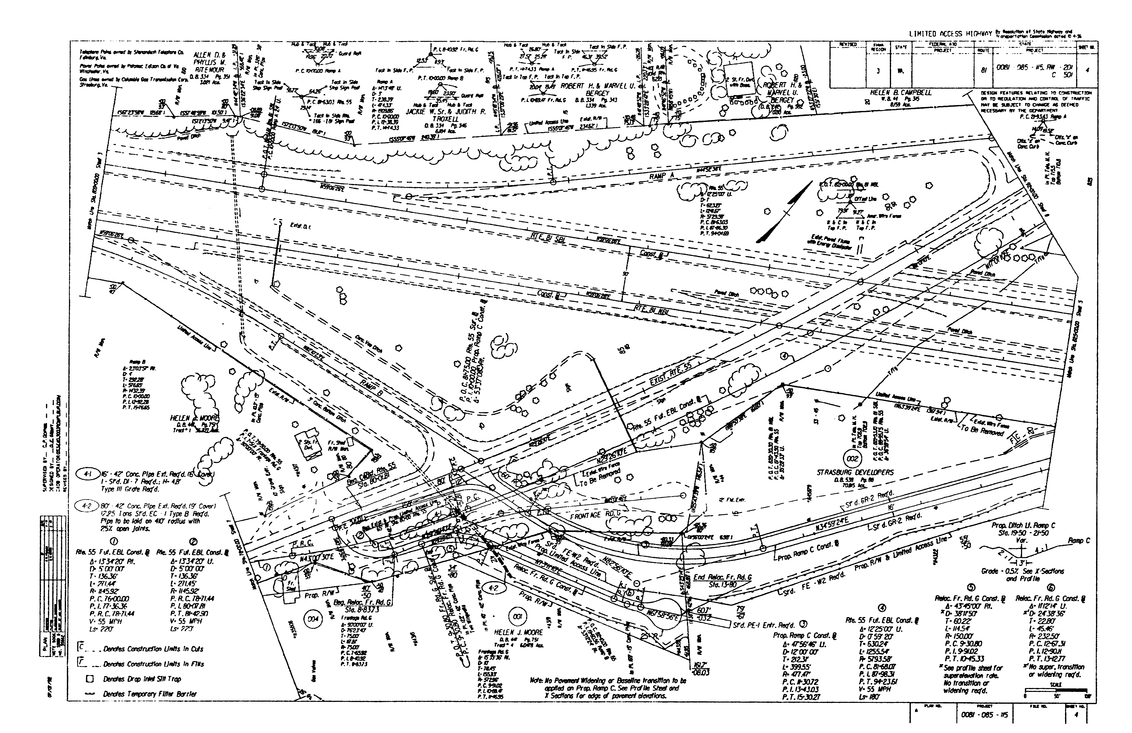
FIGURE 2D - 1 SAMPLE PLAN SHEET
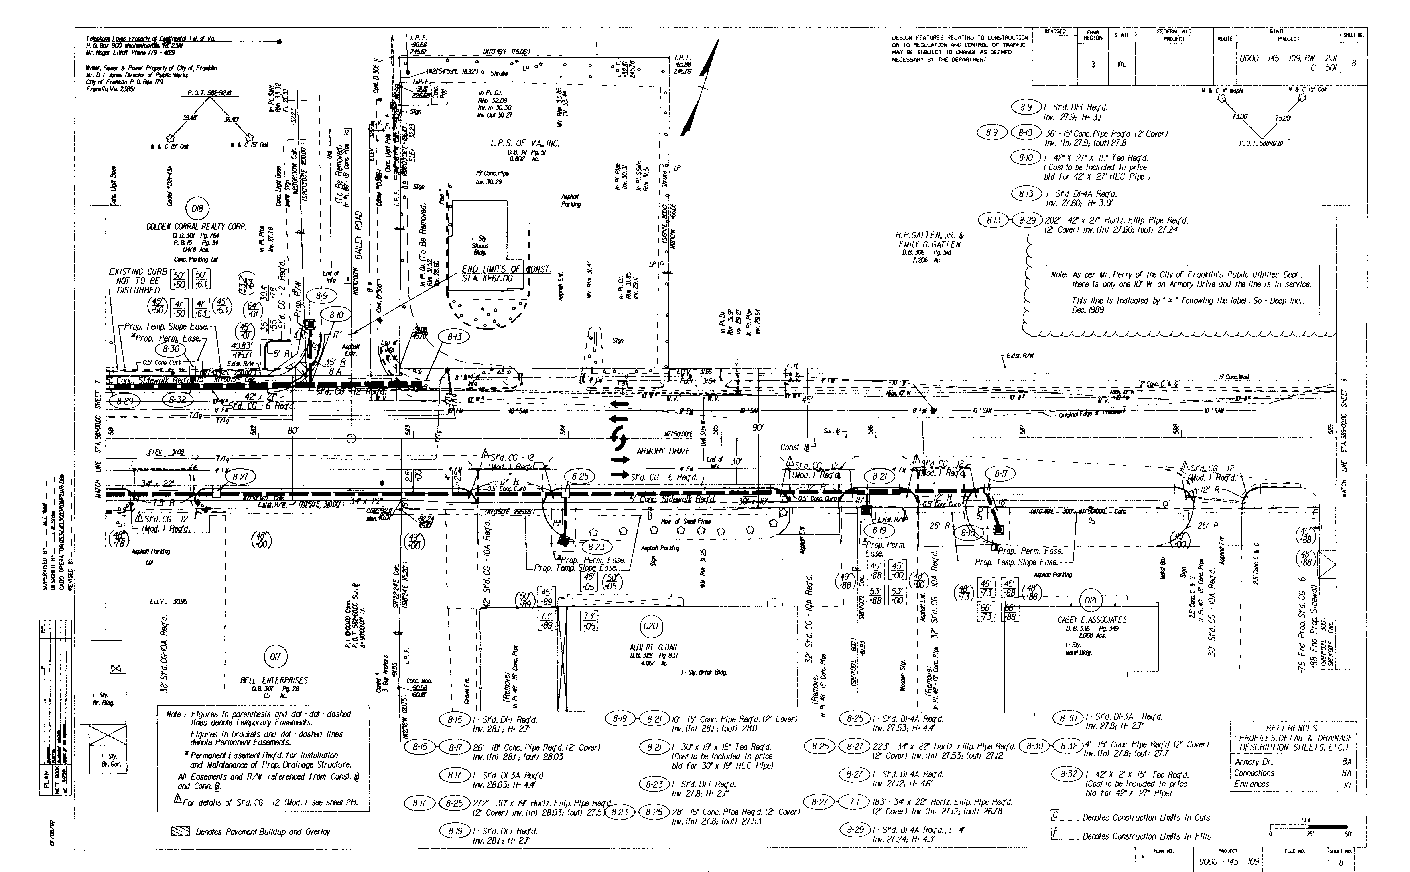FIGURE 2D - 2 SAMPLE PLAN SHEET
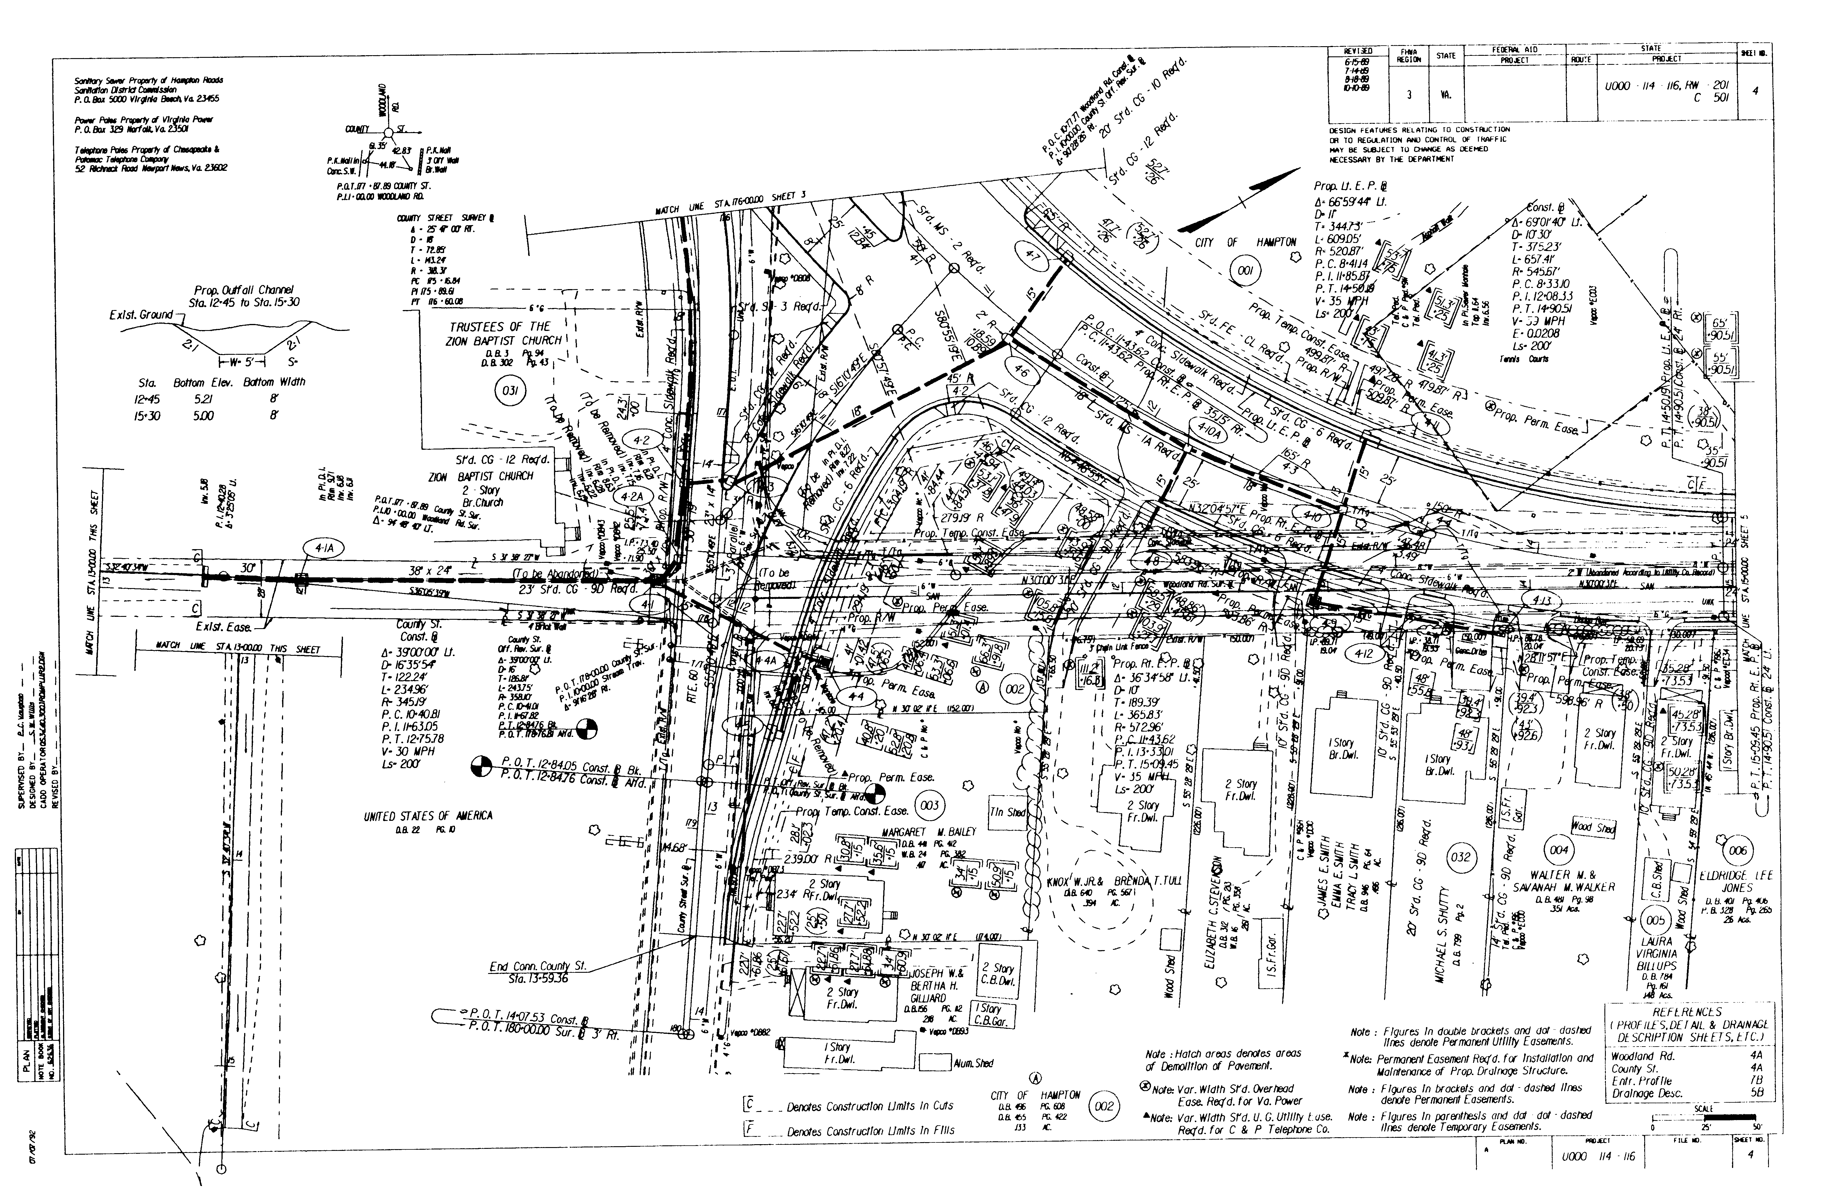
FIGURE 2D – 3 SAMPLE PLAN SHEET

REFINING VERTICAL ALIGNMENT

Vertical alignments or grades are to be reviewed and computed for smooth, exact tie-ins with adjoining projects and existing road elevations. Also, connections, interchange ramps, etc., are to be computed considering pavement crowns, variable widths, etc.

Grades on divided highways are to provide for allowable crossover grades (See Appendix C, Section C-1-CROSSOVER GRADES). Grades are to be checked for proper mainline sight distances at crossovers, connections, and entrances.

Connection grades are to provide for a smooth tie-in with the mainline edge of pavement in accordance with Appendix C, Section C-1-INTERSECTING CROSS ROAD GRADES and are to provide for adequate sight distance.

Current practice is to eliminate scuppers on most bridge designs. For this reason a minimum gradient of 0.5 percent is desirable to facilitate surface run-off. There will be instances where flatter gradients are required, through vertical curves, long water crossings, etc.; therefore, the water should be removed by means of inlets in lieu of open scuppers. Gradients are to be computed to as few decimal places as possible and should be in numbers evenly divisible by four, where feasible.

All grades are to be checked, as accurately as possible at this stage, for proper minimum vertical clearances at underpasses and overpasses.

Minimum vertical clearances for structures or limits of work at grade crossing of railroads are to be obtained from the Department of Rail and Public Transportation.

Drainage of the existing terrain and adequate cover for drainage structures are also important factors to be considered in designing grades.

Conflicts with utilities are to be avoided wherever practicable. See IIM LD-140 for additional analysis information.

The Department's permit policy allows vehicles with excess heights to operate on our highways under an overheight permit. In view of this, 4.3 m (14'0") has been accepted as the maximum allowable height to be provided for during construction, reconstruction, or maintenance operations. Every effort must be made to insure that a minimum vertical clearance of 4.4 m (14'2") is provided on existing grade separation structures during construction, reconstruction, or maintenance. If temporary reduction in the vertical clearance below 4.4 m (14'2") is unavoidable and is apparent in the design stage, the Permit Office is to be advised when the project is turned in to the Scheduling and Contract Division. The following information is to be furnished so that permit holders can be notified:

- Route, County, and Mile Post
- Name of railroad or Route overpass
- Minimum overhead clearance prior to change
- Minimum overhead clearance after change
Date of change
Temporary or permanent

Sag Vertical Curves

Criteria for establishing lengths of sag vertical curves are (1) headlight sight distance, (2) rider comfort, (3) drainage control, and (4) a rule-of-thumb for general appearance. (See AASHTO's A Policy on Geometric Design of Highways and Streets for controls - applicable to both rural and urban projects). (Also see IIM LD- 117).

Crest Vertical Curves

Crest vertical curves are to be in accordance with Geometric Design Guidelines for the Functional Classification, traffic volumes and design speed of the road being designed. (Also see IIM LD- 117).

DEPICTING VERTICAL ALIGNMENT ON PLANS

Proposed grade lines are to be shown in a heavy solid line, except for dual lane highways, in which case one lane should be shown as a heavy dashed line. Both are to be clearly labeled.

Percent of gradient is to be shown on each tangent line.

Grades are to be designed in conformance with the Geometric Design Guidelines shown in Appendix A for the Functional Classification, traffic volumes and design speed of the road being designed.

Finished grade elevations are to be shown in the bottom 25 mm (1") of the profile sheet from beginning to end at prescribed intervals and at chord points. (Chord points are to be shown through the transitions of all horizontal curves. For clarification of chord points, see Road and Bridge Standards.) When showing these elevations on the profile sheet, the pluses shall be shown just ahead of the elevations. If projected grades are computed manually, the St'd. TC-5 Tables are used in computing chord point elevations. Finished grade elevations are also to be shown at change of grade points without vertical curves, at the beginning and end of each profile sheet, at the beginning and end of the project, beginning and end of bridges, at equalities, and equivalent stations.

Begin and end project stations are to be flagged as shown in Figure 2D-4.
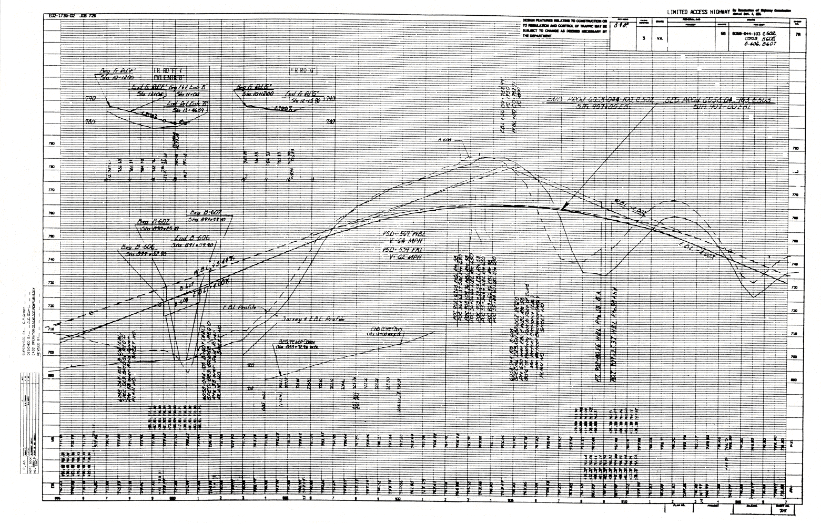
FIGURE 2D-4 SAMPLE PROFILE SHEET
Odd pluses shown for begin and end elevations for connection grades, ramp grades, etc., will preclude the need for flagging in these instances on plan and profile sheets.

Splined (not mathematically computed) grades are to be used only where computed grades are not practical and are to be noted "Spline Grade" with elevations shown, to the nearest five hundredths of a meter (foot) (or more accurately, if available), from beginning to end at 10 meter (25 feet) intervals. Approximate percent of gradient is to be shown on each tangent line and approximate vertical sight distances are to be shown for each crest vertical curve. Approximate design speeds are to be shown in accordance with IIM LD-117. For splined grades, these values are to be clearly marked "approximate".

DESIGN EXCEPTIONS

When plans are being prepared where, for any reason, one or more locations do not meet the criteria for the stated design speed, the location(s) and reason for difference(s) are to be noted on the title sheet. In order to alert everyone concerned, it will be necessary to identify these locations from the earliest stages of plan development. If changes are made during plan development that would alter the situation, then the title sheet must be corrected to reflect the new design. Design exceptions shall have the approval of the State Location and Design Engineer on both State and Federally funded projects. On Federally funded National Highway System projects exceeding $1 million, Interstate Replacement projects exceeding $1 million and projects funded with Interstate completion funds, all exceptions to minimum AASHTO Standards require written agreement from the Federal Highway Administration.

The following methods will be used to show these exceptions:

a. Plans with Functional Classification block:

exceptions to mainline design speed
Sta. To Sta. | Design Speed (mph) | Reasons for Exception
102 + 75 to 104 + 75 | 50 | Crest Vertical Curve
621 + 00 to 624 + 50 | 60 | Horizontal Alignment

The data as indicated in the previous example is to be shown directly below the Functional Classification block.

b. Plans Without Functional Classification block:

Exceptions should be noted inside the title sheet border lines immediately following the design speed classification as follows:

V = 70 mph Exceptions: 102 + 75 - 104 + 75 (50 mph) Crest Vertical Curve
621 + 00 - 624 + 00 (60 mph) Horizontal Alignment

SECTION 2D - 9 - CROSS SECTIONS AND EARTHWORK QUANTITIES

PLOTTING CROSS SECTIONS

On projects utilizing manual cross sections, the sections are plotted from field notes usually with the survey baseline vertically centered on the sheet. Certain conditions will allow two rows of sections to be shown on a sheet. (Secondary projects, connections, service roads, etc.)

Cross sections are to be plotted dark enough to readily reproduce. Buildings, edges of pavement, edges of streams, walls, etc., are to be shown as noted in the field notes.

Survey baselines are to be labeled on the first and last sections on each sheet. Construction baselines are noted similarly, with finished grade elevations shown on the left side of the baseline, readable from the right side of the sheet. Care must be taken in vertical spacing to allow for the templates without overlap.

Datum elevations are to be shown immediately above the datum line in the last block on the right end of the sheet. Datum elevations should be shown every 2 meters ( 5') with no decimal.

Cross sections are generally plotted on a scale of 1:100 Meters (1" = 10' Imperial) and so noted at the top of each sheet. Curb and gutter projects, or other projects requiring greater detail, are plotted on a scale of 1:50 Metric (1" = 5' Imperial).

Book numbers and initials of personnel performing various tasks are to be shown in the space provided in the lower left corner.

Begin and end projects, connections, ramps, frontage roads, etc., are to be shown centered with the baseline, at the appropriate locations.

Computer plotted cross sections are to be requested in the preliminary stage of plan development, kept up-to-date with appropriate changes in the design, and retained by the designer, who will furnish prints of updated sections as required.

DETERMINING WIDTH OF PAVEMENT

Preliminary design typical sections are to be thoroughly checked for compliance with the applicable Geometric Design Standards (see Appendix A). Interchange Ramp typical section geometrics are to be checked for adequate pavement widths for the curvature
used as explained in AASHTO's A Policy on Geometric Design of Highways and Streets. Minimum ramp pavement widths are to be as shown in the Geometric Design Standards (see Appendix A).

PLOTTING TEMPLATES

Templates are to be plotted in a heavy line in accordance with the appropriate typical section, to the finished grade elevation shown. Care must be taken to correctly plot all superelevated sections, pavement widenings, and transitions, in accordance with the appropriate geometric, slope and superelevation standards (see Appendix A).

An index is to be shown on the first cross section sheet showing sheet numbers assigned to the mainline, connections, ramps, frontage roads, etc.

Cross section sheets are to reflect all applicable project numbers in the appropriate blocks and are numbered in order beginning with "1".

DETERMINING AREAS AND QUANTITIES

Earthwork areas are computed to the bottom-most line of pavement trenching. Areas are shown immediately below ground lines with the cut area in the third block to the left of the construction baseline preceded by the letter "C" and the fill area in the third block to the right preceded by the letter "F".

Earthwork quantities are computed as follows:

Metric: Add the areas of adjacent cut or fill, multiply by the distance between stations along the
Construction baseline, and divide by 2.
(See Appendix D, Section D – 1 – QUANTITY TABLES):

English: Add the areas of adjacent cut or fill, multiply by the distance between stations along the
Construction baseline, and divide by 54.
(See Appendix D, Section D – 1 – QUANTITY TABLES):

The quantity is shown centered vertically between sections and in the second block left (for cut) or right (for fill) of the construction baseline in numbers approximately 8 mm (0.3") in height.

On projects where the typical section and cross sections indicate a base or subbase material extended beyond the proposed pavement, curb, or curb and gutter in cut sections, the regular excavation will be computed to a vertical plane bounded by the farthest point.
FIGURE 2D – 5 EARTHWORK QUANTITY EXAMPLE

A quantity is to be included in the plans for backfill of the hatched areas as shown in Figure 2D – 5 above.

On projects which have computer quantities, the designer must code the required computer input forms such as Bridge Spills, Earthwork Volumes, Subsurface Volumes, Supplementary Earthwork Volume, and Earthwork Summary.

SECTION 2D – 10 - PAVEMENT, ENTRANCES, PROJECT LIMITS

PLOTTING EDGES OF PAVEMENT

All edges of pavement are to be plotted on plans, using care to properly apply "TC" standards where applicable. For ramp terminal treatment, see IIM LD -20.

PLOTTING ENTRANCES AND CROSSOVERS

All proposed entrances are to be designed in accordance with VDOT's Minimum Standards of Entrances to State Highways.

Previously located entrances and crossovers are to be shown on plans to proper tie-ins and labeled as to width, type, material, and grade. Grades for entrances are to be depicted as shown in Figure 2D-4. Procedures shown in APPENDIX C, Section C-1 are to be followed.

The Standard CG-9D entrance gutter is to be used for most single family residential entrances with curb and gutter.

The Standard CG-9A, 9B, or 9C entrance gutters should be considered only as a last resort in situations such as extremely narrow lots, closely spaced entrances, or if it is known that the lane adjacent to the curb will be used as a parking lane at all times.

The Standard CG-11 is to be the required method of treatment for ALL entrances with curb and gutter except for single family residential entrances. If the use of Standard CG-11 will result in:

1 - Major drainage problems or excessive drainage costs,
2 - Driver confusion due to the close proximity of an adjacent intersection, or
3 - Closely adjacent entrances on a road with a design speed < 50 km/h (35 mph),
then: consideration may be given to using one of the other Standard entrances.

The minimum entrance radii outlined in the Minimum Standards of Entrances To State Highways should be adhered to in the design of ALL entrances. For Commercial Entrances where a high percentage of trucks are anticipated, consideration should be given to increasing the entrance radii to accommodate the turning requirements of those vehicles.
For entrances at new locations, a centerline with bearing, delta and tie-in station is required.
Site plans for developments adjacent to a proposed project will be reviewed by the designer and proposed entrances will be shown on the site plan. A note reading as follows is to be placed on the roadway plans on the parcels of land affected by the site plan:

"ALERT: SITE PLAN PROPOSED FOR THIS AREA. CHECK FOR THE SITE PLAN CONSTRUCTION AT EACH STAGE OF PROJECT DEVELOPMENT AND ORDER ADDITIONAL SURVEY WHEN CONSTRUCTED. STATUS OF ANY PROFFERED R/W SHOULD BE CHECKED AT R/W STAGE."

APPLICATION OF STIPPLING

Stippling is to be applied, as deemed necessary by the designer, to depict proposed pavement areas by applying dots to the pavement area in accordance with the CADD Manual. Stippling is not necessary for showing proposed pavement on a new location; however, to depict widening of an existing roadway, stippling should be used.

DETERMINING PROJECT LIMITS

Beginning and ending points of projects are generally determined by the first and last full width points of construction. These points are flagged with State right of way and construction project numbers and stations. Temporary construction beyond these points is to be flagged showing beginning and end construction and applicable stations.

SETTING PROJECT TERMINI

Proposed Right of Way Lines and Easements (Permanent and Temporary) should be projected, whenever practical, to allow for any anticipated future construction. Right of Way and Easement should also be projected to any property line within a reasonable distance. This should minimize the need for negotiations with the same property owner on a future project. The Right of Way Project Limits should encompass all proposed, and projected, Right of Way and Easement on the project. Any deviation from the sketch in Figure 2D – 6 (there may be many) should be discussed at the Field Inspection.
FIGURE 2d – 6 SETTING PROJECT TERMINI

PAVEMENT TERMINATION

On projects where dual laning is expected to be extended in the near future, provide for the stubbing of the pavement of the parallel lane. This practice allows the next project to tie in with a minimum of interference with traffic.

Do not provide the pavement stub if a period of over five years is anticipated, due to the deterioration of pavement which is not exposed to traffic.

Figure 2D - 7 is a sketch outlining the method of pavement stubbing. This cannot be accomplished on every project due to super elevation required to tie into the existing pavement, or other circumstances. Pavement stubbing should be discussed in detail at Field Inspection and comments noted in the F.I. Report.

FIGURE 2D – 7 SUGGESTED PAVEMENT STUBBING TREATMENT

PLOTTING CONSTRUCTION LIMITS

Proposed and ultimate (where applicable) construction limits are to be plotted from cross section limits using short dashed lines for cuts and longer dashed lines for fills with "C" and "F" notations separating cuts and fills. A note should be placed on the plan sheets showing cut and fill symbols (See Sample Plan Sheets, Figures 2D-1, 2D-2, and 2D-3).

Construction limits are to be plotted through entrances to the point of normal roadway construction. This distance is to be used for establishing right of way and easements. For entrances on which grades and cross sections are available, show any construction limits

Where rock slopes are used, construction limits for both rock slopes and normal slopes are to be plotted with proposed R/W encompassing normal slopes.

SECTION 2D – 11 - REQUEST FOR SUPPLEMENTAL DATA

SOIL INVESTIGATION, PAVEMENT RECOMMENDATIONS AND STAKING

The location (in Falcon) of plans, profiles, and typical sections, along with Forms LD-252 and LD-312 are sent to the State Materials Engineer requesting soil investigations, pavement recommendations, and staking data (if required). Request is to be made after Final Scoping.

If staking is required (after discussions with Materials Division), it should be so noted in the space provided for remarks on Form LD-252, with a copy to the Assistant Location and Design Engineer in charge of location.

BRIDGE DESIGN

Form LD-153, Form LD-23, and the location of the plans pertaining to each bridge (title sheet, typical sections, plan and profile sheets) are to be sent to the Structure and Bridge Engineer after Final Scoping. Future requests because of changes can be noted via email with the PPMS number and the Falcon location of the plans.

Situation plans are to show all revised alignment data, making certain that the alignment is clearly delineated to insure that the correct line is used in the design of the structure.

Structure and Bridge Division should be requested to provide this information a minimum of 30 days prior to the scheduled Public Hearing date.

PUBLIC HEARING DATA

Form LD-252 and the location of plans on Falcon are to be distributed (as noted on Form LD-419 and in IIM LD- 68) to the applicable divisions whenever a combined Location and Design or a Design Public Hearing is required. Requests for data on Urban projects are the responsibility of the Local Assistance Division.

SECTION 2D – 12 - CONSTRUCTABILITY QUALITY REVIEW

CONSTRUCTABILITY QUALITY REVIEW

Constructability review is defined as the review of plans, specifications, and contract documents from a construction perspective to assure the documents propose an operation that is efficient, cost effective, and buildable. Its emphasis is primarily focused on “how” the documents propose the operation to be built and not on ”what” gets built.

AASHTO defines constructability review as “a process that utilizes construction personnel with extensive construction knowledge early in the design stages of projects to ensure that the projects are buildable, while also being cost-effective, biddable, and maintainable”.

This analysis is normally performed at the Preliminary Field Inspection, Public Hearing, Field Inspection and Pre-Advertisement stage of plan development. Additional reviews can be performed as needed when the plans are further developed.

The constructability review includes the report of findings, a completed checklist, and cost savings report. This report is a detailed tabulation of any anticipated savings identified during the review.

SECTION 2D – 13 - CONDUCTING THE PUBLIC HEARING

THE PRE-HEARING MEETING

Prior to the scheduled hearing, it may be desirable to hold an open forum meeting. This meeting will permit the public to review and discuss with Department and Municipal (or other) engineers and officials, particular points of concern to them and to become generally familiar with the project to be presented. Mosaics, typical sections and other displays to be presented at the public hearing should be available at this meeting, along with unapproved detailed plans. A properly conducted pre-hearing meeting may eliminate a great number of questions which would otherwise be asked at the formal hearing and will convey a sense of mutual concern between the Department and the public.

As many public hearings are held at night, a period of approximately two hours prior to the formal hearing should normally be provided for this discussion prior to the formal hearing.

If sufficient interest is anticipated, consideration should be given to holding the pre-hearing meeting on the night preceding the hearing; or, if the projects are controversial or of great magnitude, consideration should be given to holding one or more meetings approximately a week in advance of the formal hearing.

PROCEDURE FOR THE PUBLIC HEARING

The District Administrator, or a designated representative, moderates all public hearings except in rare circumstances when the Chief Engineer determines otherwise.

At the appropriate time, the engineering commentary (as described in Section 2D-7) is presented. This presentation is made by a representative of the Location and Design Division, District Administrator's office or the Local Assistance Division (on applicable projects). It is desirable to have the project designer, project manager, or a representative, assist in this presentation.

At the conclusion of the presentation, those present are afforded an opportunity to provide comments. Department representatives with expertise in the fields of right of way, environmental quality, etc. should be present and may be called upon by the moderator to answer general questions which may arise. Department representatives should remain as long as necessary at the conclusion of the hearing to discuss individual problems and questions relative to the project.
The moderator is to advise those attending the hearing that ten calendar days will be allowed from the date of the hearing for the submission of written statements to the Department for inclusion in the public hearing record. It is the District Administrator's responsibility to transcribe the proceedings and post the transcript on PCES (Project Cost Estimating System), along with his/her comments and recommendations, to the State Location and Design Engineer.

When the public hearing package (design or location and design) is ready for submission to the Chief Engineer for approval of the public hearing, LD Form 441 must be completed and distributed to the Right of Way and Utilities Division and/or the Environmental Division as appropriate. This should occur approximately 45 to 60 days ahead of the Right of Way submission date. This form will initiate the Right of Way Quality Control and/or the Environmental Re-evaluation process. The Location and Design Project Manager will be notified by email upon completion of the review. Upon receipt of the email, the Location and Design Project Manager will finalize the plans for Right of Way submittal.

SECTION 2D – 14 - RESOLUTION OF PUBLIC HEARING QUESTIONS

REVIEW OF PUBLIC HEARING TRANSCRIPT AND POST-HEARING CORRESPONDENCE

When the transcript of the public hearing is received, it is first reviewed by the Public Involvement Section for their determination of areas of concern which may require further investigation. It is then forwarded to the appropriate Assistant Location and Design Engineer, the Environmental Engineer, the Local Assistance Director for review, comments and recommendations. The FHWA is furnished a copy of the transcript for informational purposes on all Federal-Aid projects. Appropriate members of the Commonwealth Transportation Board are furnished copies of the transcript on all projects.

STUDY OF ALTERNATE SOLUTIONS

Any item of concern requiring further investigation is to be studied by the designer or project manager and discussed with the localities (if appropriate) for possible solutions. All feasible solutions are to be explored, taking into consideration engineering judgment, economics, standard policies, etc.

Recommending A Solution

Upon reaching a conclusion as to the most feasible solution to an area of concern, the designer or project manager will furnish his/her recommendation to the appropriate
Assistant Location and Design Engineer, Urban Engineer or Secondary Roads Engineer for a decision. If further public involvement programs are necessary, the Public Involvement Section is to be contacted for assistance.

Processing Data To Public Involvement Section

When all areas of concern requiring further investigation have been explored, the designer or project manager will prepare a report for the signature of the State Location and Design Engineer to the Public Involvement Section (with a copy to the Environmental Division) outlining the proposed resolution of the questions. Secondary and Urban Projects are the responsibility of the Local Assistance Division.

SECTION 2D-15 PROJECT APPROVAL

BOARD APPROVAL

The Public Involvement Section will assist the State Location and Design Engineer in preparing a memorandum to the Chief Engineer requesting consideration by the Board. This memorandum is to cover the proceedings of the public hearing and the resolution of questions and recommendations. The project is then forwarded to the Vice-Chairman of the Board who arranges to have it placed on the agenda for Board action. After the project has considered by the Board, the Public Involvement Section shall advise the District Administrator of the action taken. The District Administrator advises those who spoke at the hearing or who corresponded with the Department as part of the hearing record of the action taken, including any changes in the proposal presented at the hearing and appropriate responses to the individual's comments or questions. The District Administrator will also advise all other local officials of the action taken. The Public Involvement Section will notify the appropriate mayor and/or chairman of the Board of Supervisors of the Board's action.

The Commonwealth Transportation Board only approves proposed highways on new corridor locations.

Note: On projects where Federal Funds are used to purchase ROW, when the Public Hearing package (Design or Combined Location and Design) is ready for submission to the Chief Engineer for approval, the LD-441 Form must be completed and distributed by the L&D Project Manager to the District Right of Way Manager This should occur approximately 45 to 60 days prior to the Right of Way submission date. This Form initiates the Right of Way Re-evaluation process for Right of Way Authorization. The L&D Project Manager will be notified by the District Right of Way Manager with an email that includes the RW-300 and 301 upon completion of the review. Upon receipt of this email, the L&D Project Manager will make any necessary modifications, and finalize the plans for Right of Way authorization and notify the District Environmental Manager with the LD-441 Form that the plans are available for the Environmental Re-evaluation. Once the Environmental Re-evaluation has been completed the Right of Way Re-evaluation for Right of Way authorization process is complete. See Right of Way Re-evaluation Flow Chart: http://www.virginiadot.org/business/resources/RWReevaluationFlowChart.pdf

DISTRIBUTION OF PRINTS

Distribution of prints is to be made in accordance with IIM LD-68 and the procedure to inform everyone where the plans are located in Falcon.

FINAL ENVIRONMENTAL DOCUMENT

On Federal-Aid projects, the final environmental document must be completed before location and/or design approval is granted by the FHWA. If the document was approved at the Location Public Hearing stage, environmental requirements will have been satisfied (except as noted below in FHWA Approval) and no further action need be taken on the environmental document. If a Combined Location and Design Public Hearing was held, the Public Involvement Section will advise the Environmental Engineer of the Board Action and request that the final environmental document be completed. The designer is to furnish the Environmental Division with updated plans that reflect all modifications resulting from the public hearing process for their use in completing the environmental document.

FHWA Approval

Approval of the Final Environmental Document is the FHWA's concurrence with the project. If this was done at the Location Public Hearing stage for a Certification Acceptance Project, and following adoption of the major design features, the project may now be advanced to the Right of Way Acquisition Stage.

An update of the environmental document is required if significant changes in the project have taken place.

If a Combined Location and Design Hearing was held, the Public Involvement Section will forward the hearing transcript and report (as noted in Section 2D-13, Processing Data to Public Involvement Section) to the FHWA for their review prior to approving the Final Environmental Document. Following approval of the Final Environmental Document by the FHWA, the public is notified and the project may be advanced to the Right of Way Acquisition Stage.

REQUEST FOR APPROVAL OF MAJOR DESIGN FEATURES (FOR NON-CA PROJECTS WHERE ENVIRONMENTAL DOCUMENT WAS APPROVED AT LOCATION PUBLIC HEARING STAGE)

Following approval by the Board, the updated Final Environmental Document (if updating is necessary) is forwarded by the Environmental Division to the FHWA.

Public Hearing Certification, the study report and report (as noted in Section 2D-13-Processing Data to Public Involvement Section) are forwarded to the FHWA along with the request for approval of major design features. The public is notified through the office of Public Affairs of the Department's request for approval and is also notified of the FHWA's response to the request.

Following approval of the major design features by FHWA, the project may be advanced to the Right of Way Acquisition Stage.

FINAL SCOPING CERTIFICATION

Prior to the plans being signed for right of way (or construction when no right of way is needed), the coordinator fills out a certification form stating the project is within original scope or documentation as to deviations.

The State Location and Design Engineer will use Form LD-404 for this purpose.

