Appendix 13B-6 Nomograph for Riprap Size

to Resist Wave Action

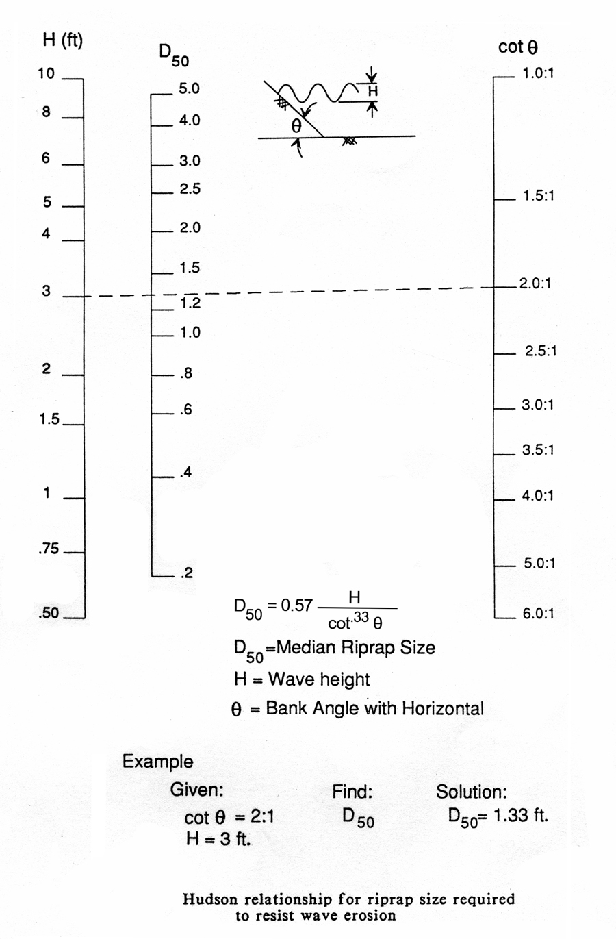

Source: HEC-11

