Appendix 13B-5 Nomographs for Design of

Rock Slope Shore Protection

(For Deep Water)
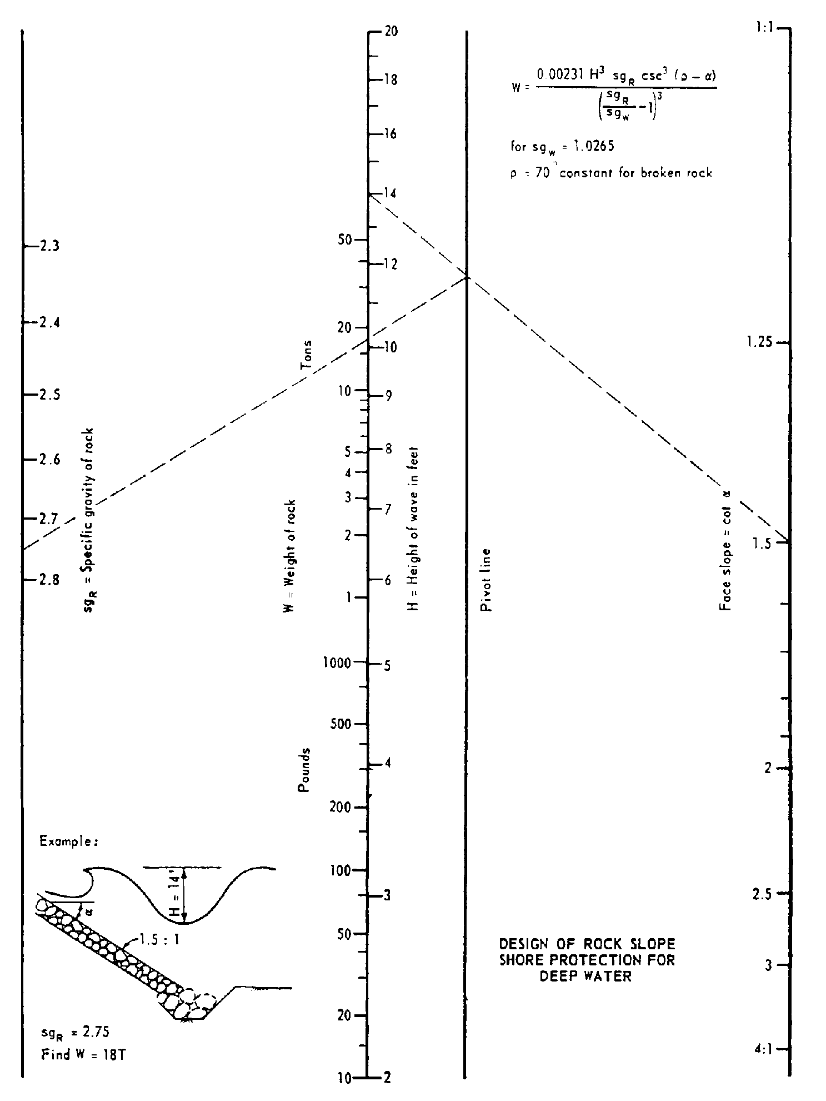

Source: California Highway Design Manual, chapter 870

