Appendix 13B-4 Nomographs for Design of

Rock Slope Shore Protection

(For Shoal Water)
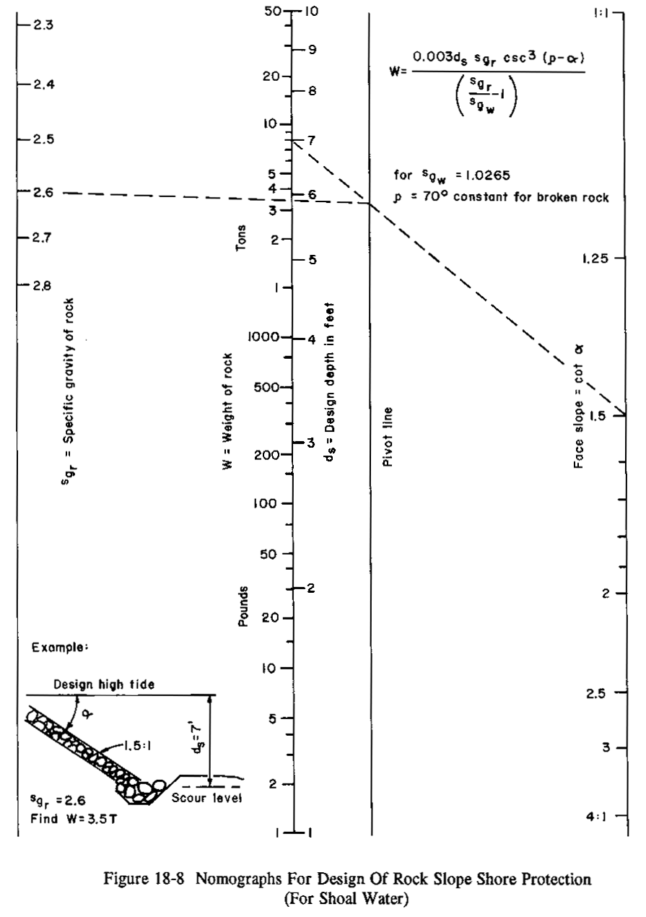

$$W=\frac{0\text{.}\text{003}d_{s }{\text{sg}}_{r }{\text{csc}}^{3}(p−α)}{}$$

Source: California Highway Design Manual, Chapter 870

